Stress analysis of Vessel

Note:
Do not base your design decisions solely on the data presented in this report. Use this information in conjunction with experimental data and practical experience. Field testing is mandatory to validate your final design. Simulation helps you reduce your time-to-market by reducing but not eliminating field tests.

Table of Contents
Table of Contents 2
List of Figures 2
Description 3
Assumptions 3
Model Information 3
Study Properties 3
Units 4
Material Properties 4
Loads and Restraints 5
Connector Definitions 6
Contact 6
Mesh Information 6
Sensor Results 7
Reaction Forces 7
Free-Body Forces 7
Bolt Forces 7
Pin Forces 7
Beams 8
Study Results 8
Conclusion 14

List of Figures
Vessel-Pressure-Mesh Quality-Mesh Quality1 8
Vessel-Pressure-Stress-Stress1 10
Vessel-Pressure-Displacement-Displacement1 11
Vessel-Pressure-Strain-Strain1 12
Vessel-Pressure-Stress-Stress3 13
Vessel-Pressure-Stress-Stress4 14

Description

Summarize the FEM analysis on Vessel

Assumptions

Model Information
Document Name | Configuration | Document Path | Date Modified
Vessel | Default | Z:\314\New_Pressure_Vessel\Vessel.SLDPRT | Mon Apr 25 14:43:46 2011

Study Properties
Study name | Pressure
Analysis type | Static
Mesh Type: | Solid Mesh
Solver type | FFEPlus
Inplane Effect: | Off
Soft Spring: | Off
Inertial Relief: | Off
Thermal Effect: | Input Temperature
Zero strain temperature | 298.000000
Units | Kelvin
Include fluid pressure effects from SolidWorks Flow Simulation | Off
Friction: | Off
Ignore clearance for surface contact | Off
Use Adaptive Method: | Off

Units
Unit system: | SI
Length/Displacement | mm
Temperature | Kelvin
Angular velocity | rad/s
Stress/Pressure | N/m^2

Material Properties
No. | Body Name | Material | Mass | Volume
1 | SolidBody 1(Fillet5) | Alloy Steel (SS) | 68.1317 kg | 0.00884827 m^3

Material name: | Alloy Steel (SS)
Description:
Material Source:
Material Model Type: | Linear Elastic Isotropic
Default Failure Criterion: | Max von Mises Stress
Application Data:

Property Name | Value | Units | Value Type
Elastic modulus | 2.1e+011 | N/m^2 | Constant
Poisson's ratio | 0.28 | NA | Constant
Shear modulus | 7.9e+010 | N/m^2 | Constant
Mass density | 7700 | kg/m^3 | Constant
Tensile strength | 7.2383e+008 | N/m^2 | Constant
Yield strength | 6.2042e+008 | N/m^2 | Constant
Thermal expansion coefficient | 1.3e-005 | /Kelvin | Constant
Thermal conductivity | 50 | W/(m.K) | Constant
Specific heat | 460 | J/(kg.K) | Constant
Hardening factor (0.0-1.0; 0.0=isotropic; 1.0=kinematic) | 0.85 | NA | Constant

Loads and Restraints

Fixture
Restraint name | Selection set | Description
Symmetry-1 <Vessel> | on 3 Face(s) symmetry
Fixed-1 <Vessel> | on 1 Face(s) fixed.

Load
Load name | Selection set | Loading type | Description
Pressure-1 <Vessel> | on 11 Face(s) with Pressure 0.101 N/mm^2 (MPa) along direction normal to selected face | Sequential Loading
Pressure-2 <Vessel> | on 11 Face(s) with Pressure 14.5 N/mm^2 (MPa) along direction normal to selected face | Sequential Loading

Connector Definitions
No Connectors were defined

Contact
Contact state: Touching faces - Free

Mesh Information
Mesh Type: | Solid Mesh
Mesher Used: | Standard mesh
Automatic Transition: | Off
Smooth Surface: | On
Jacobian Check: | 4 Points
Element Size: | 12.929 mm
Tolerance: | 0.64645 mm
Quality: | High
Number of elements: | 28224
Number of nodes: | 47257
Time to complete mesh(hh;mm;ss): | 00:00:05
Computer name:

Sensor Results
No data available.

Reaction Forces
Selection set | Units | Sum X | Sum Y | Sum Z | Resultant
Entire Body | N | 41433.6 | 36054.3 | 2.43367e+006 | 2.43429e+006

Free-Body Forces
Selection set | Units | Sum X | Sum Y | Sum Z | Resultant
Entire Body | N | 0.641291 | -2.53252 | 1.48187 | 3.00347

Free-body Moments
Selection set | Units | Sum X | Sum Y | Sum Z | Resultant
Entire Body | N-m | 0 | 0 | 0 | 1e-033

Bolt Forces
No data available.

Pin Forces
No data available.

Beams
No data available.

Study Results
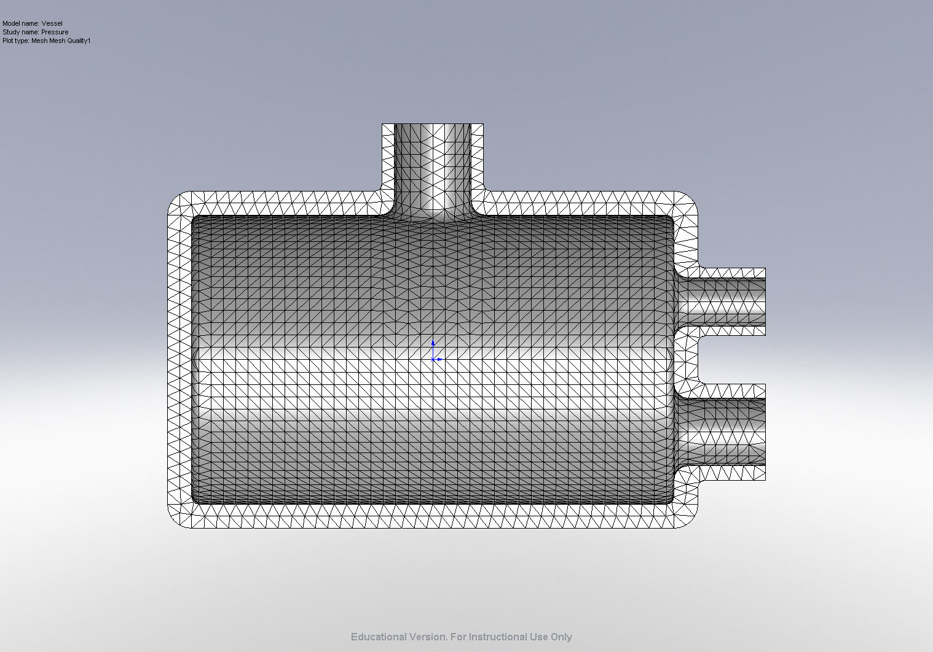
Vessel-Pressure-Mesh Quality-Mesh Quality1

Default Results

Name | Type | Min | Location | Max | Location
Stress1 | VON: von Mises Stress | 2.04686e+006 N/m^2  Node: 15709 | (304.147 mm,  -185.666 mm,  -5.5977 mm) | 5.66429e+008 N/m^2  Node: 1070 | (-276.541 mm,  31.3299 mm,  -147.3 mm)
Displacement1 | URES: Resultant Displacement | 0 mm  Node: 261 | (6.4294e-015 mm,  245 mm,  -52.5 mm) | 2.14935 mm  Node: 4512 | (304.062 mm,  -185.966 mm,  1.04744e-012 mm)
Strain1 | ESTRN: Equivalent Strain | 1.65754e-005  Element: 13760 | (341.492 mm,  -28.913 mm,  -2.78854 mm) | 0.00183211  Element: 7722 | (-249.146 mm,  -144.686 mm,  -6.20016 mm)
Stress3 | SY: Y Normal Stress | -4.25125e+008 N/m^2  Node: 82 | (-52.566 mm,  182.57 mm,  5.14551e-017 mm) | 6.26569e+008 N/m^2  Node: 45492 | (52.999 mm,  179.532 mm,  2.87372e-015 mm)
Stress4 | SZ: Z Normal Stress | -2.78271e+008 N/m^2  Node: 21910 | (-251.483 mm,  -5.54606 mm,  4.52306e-014 mm) | 4.72429e+008 N/m^2  Node: 39478 | (-250.281 mm,  0.923395 mm,  -145.353 mm)

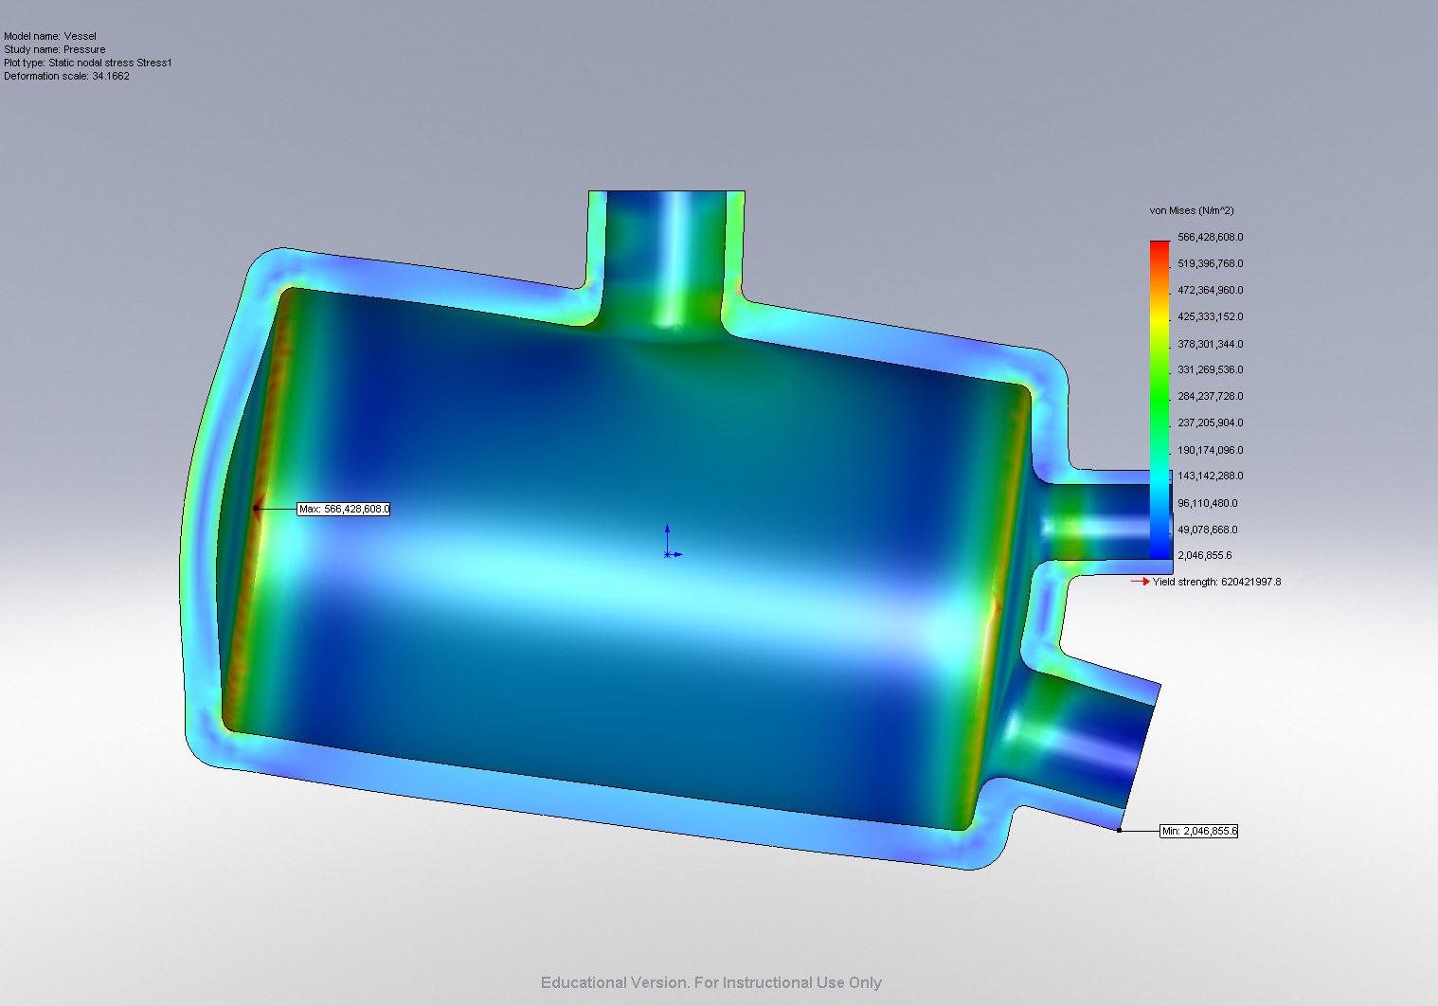
Vessel-Pressure-Stress-Stress1

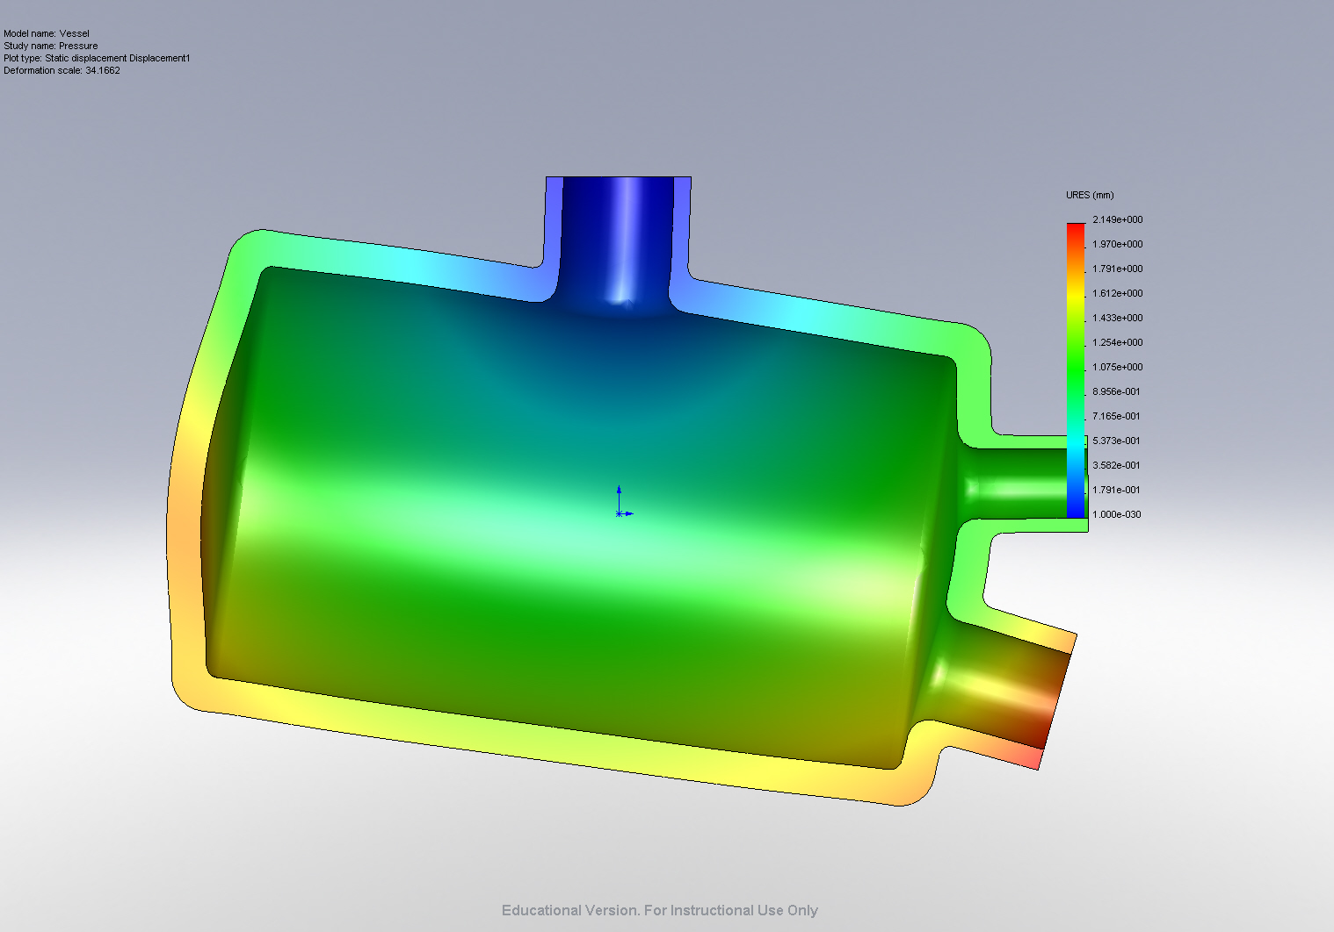
Vessel-Pressure-Displacement-Displacement1

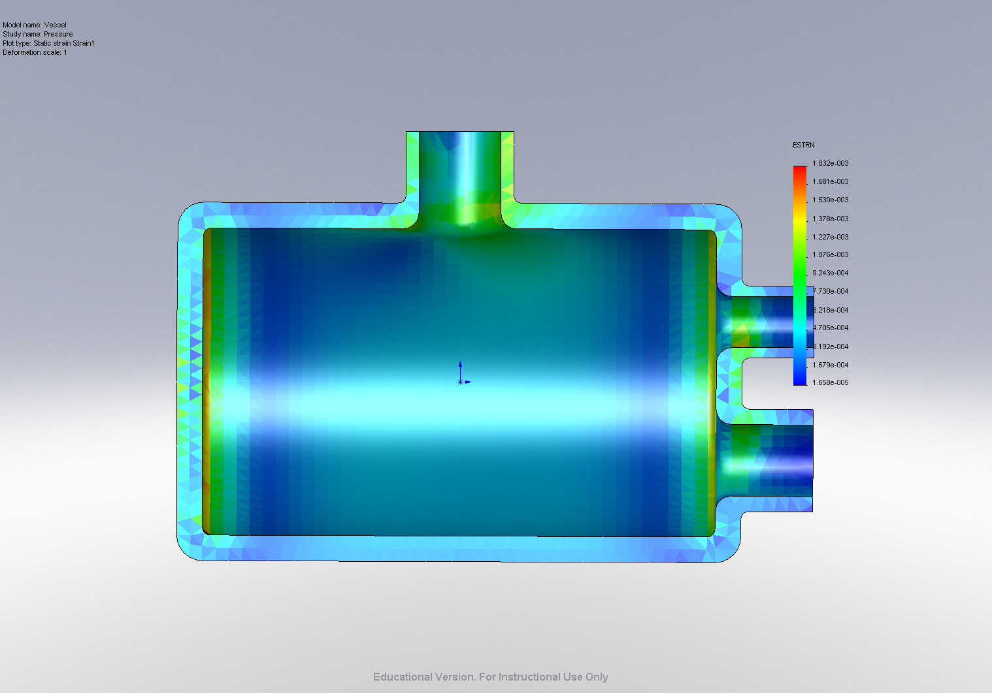
Vessel-Pressure-Strain-Strain1

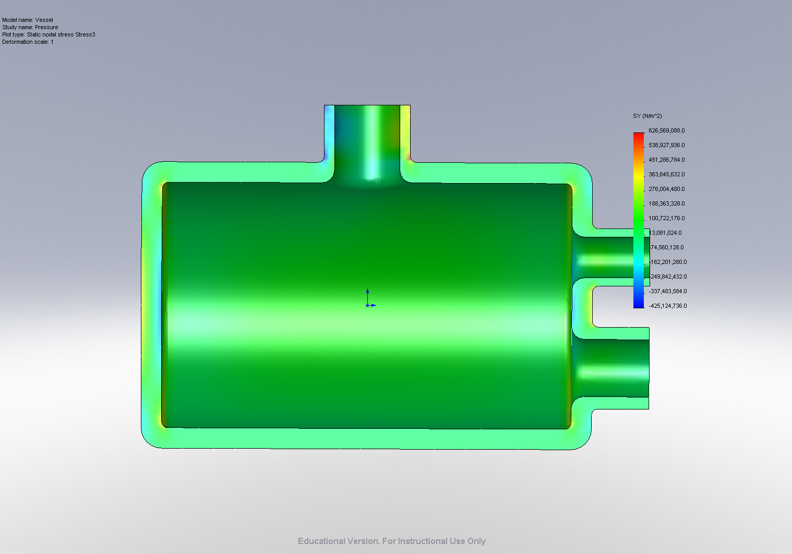
Vessel-Pressure-Stress-Stress3

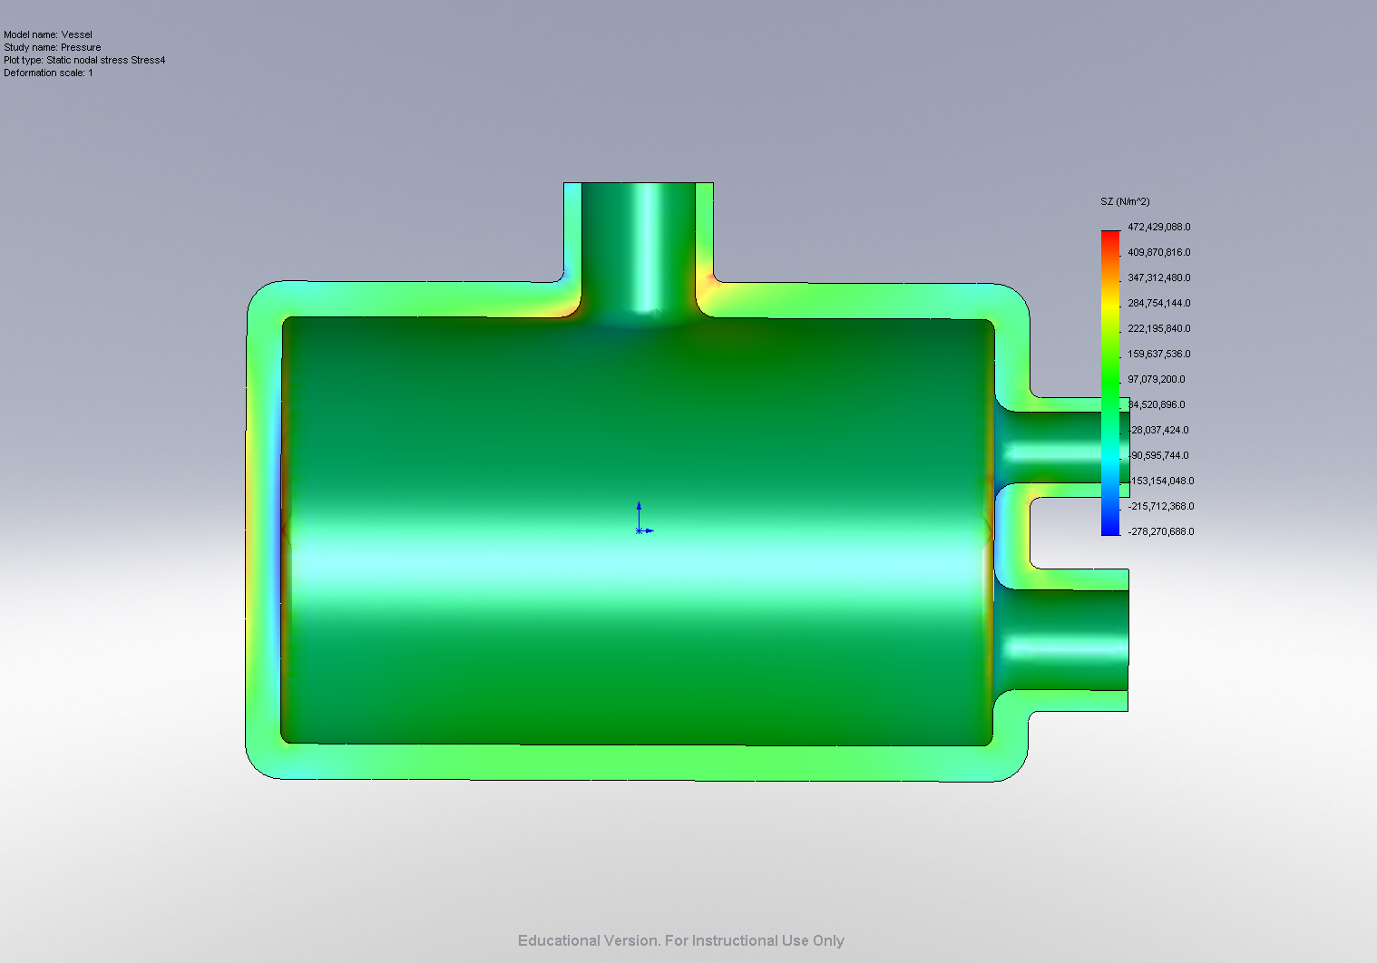
Vessel-Pressure-Stress-Stress4

Conclusion

