San Diego State University

DEPARTMENT OF MECHANICAL ENGINEERING

Stress analysis of Pressure Vessel

Levi Lentz

4/28/2011

Table of Contents

Table of Contents 2

List of Figures 2

List of Tables 3

Description 4

Problem Statement 4

Steps 4

Assumptions 5

Model Information 5

Study Properties 5

Units 6

Material Properties 6

Loads and Restraints 7

Fixture 7

Load 7

Mesh Information 7

Reaction Forces 8

Free-Body Forces 8

Free-body Moments 8

Study Results 9

Conclusion 17

Appendix 1: Hand Calculations 18

List of Figures

Figure 1. Dimensions of the pressure vessel. Shown here with a half view to show detail. 3

Figure 2. External loads and constraints 8

Figure 3. Normal View of the Meshing of the part. 9

Figure 4. Isometric view of the meshing of the part. 9

Figure 5. Normal view of Von-Mises Stress with Max/Min Stress 11

Figure 6. Isometric view of Von-Mises Stress with Max/Min Stress 12

Figure 7. Normal View of displacement of part 12

Figure 8. Isometric View of Radial Stress Plot 12

Figure 9. Normal Radial Stress Plot 13

Figure 10. Normal Stress Probes 14

Figure 11. Radial Stress Probe Plot 15

Figure 12. Isometric view of Tangential Stress Plot 16

Figure 13. Normal View of Tangential Stress Plot 16

Figure 14. Tangential Stress Probes 17

Figure 15. Plot of Tangential Stress Probes 17

List of Tables

Table 1. The graphical key for Figure 2. 9

Table 2. Comparison of classical and FEA results 17

Description

This is a FEM project aimed at analyzing a pressure vessel with an internal pressure of 14.5MPa and an external atmospheric pressure of 101kPa. The goal is the have our results match the hand calculations in the name of expanding the engineering field.

Problem Statement

Analyze a pressure vessel with the geometry shown below in Figure 1 in Solidworks. Show the hand calculations to show the similarities between the two methods. The vessel has an internal pressure of 14.5Mpa and an external pressure of 101kPa.

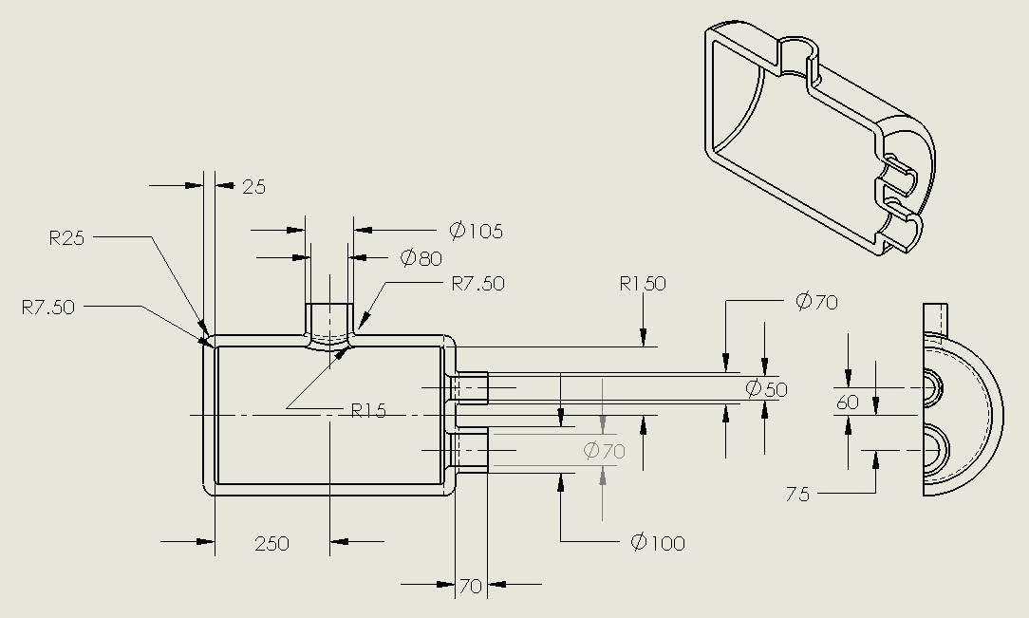

Figure 1. Dimensions of the pressure vessel. Shown here with a half view to show detail.

Steps

1. Apply material and constrain it properly. We used an Alloy Steel with a symmetric constraint on the cut surface of the vessel with a fixed constraint at the open end of the neck. This fully constrained the material and allowed us to properly apply the FEA loads.
2. Apply an internal pressure of 16MPa to the interior surface, and an external pressure of .101kPa to the external surface. Run the FEM analysis
3. Create a stress plot for Von Mises, radial, and tangential stresses in addition to a displacement plot of the cylinder. Use a probe at the center of the cylinder to determine both the radial and tangential stresses at the inner wall and the external wall of the cylinder. Use Solidworks to plot the stress vs. node number
4. Use the thick walled cylinder equations to calculate the theoretical radial and tangential stresses at the interior and exterior walls. Compare this result with the FEM using the percent difference formula shown below:

%𝑑𝑖𝑓𝑓𝑒𝑟𝑒𝑛𝑐𝑒=𝐹𝐸𝐴 𝑅𝑒𝑠𝑢𝑙𝑡𝑠−𝐶𝑙𝑎𝑠𝑠𝑖𝑐𝑎𝑙 𝑅𝑒𝑠𝑢𝑙𝑡𝑠 $\% difference=\left[\left(results from FEA\right)-\left(results from Elasticity\right)\right]*100/(results from FEA)$

Assumptions

We assume the material is an Alloy Steel with the internal and external pressures being applied normal to the faces of the vessel. We assume that the vessel is rigidly constrained at the opening of the neck to allow the vessel to expand in all necessary directions away from the neck.

Model Information

|  |  |  |  |
| --- | --- | --- | --- |
| Document Name | Configuration | Document Path | Date Modified |
| Vessel | Default | Z:\314\New_Pressure_Vessel\Vessel.SLDPRT | Mon Apr 25 14:43:46 2011 |

Study Properties

|  |  |
| --- | --- |
| Study name | Pressure |
| Analysis type | Static |
| Mesh Type: | Solid Mesh |
| Solver type | FFEPlus |
| Inplane Effect: | Off |
| Soft Spring: | Off |
| Inertial Relief: | Off |
| Thermal Effect: | Input Temperature |
| Zero strain temperature | 298.000000 |
| Units | Kelvin |
| Include fluid pressure effects from SolidWorks Flow Simulation | Off |
| Friction: | Off |
| Ignore clearance for surface contact | Off |
| Use Adaptive Method: | Off |

Units

|  |  |
| --- | --- |
| Unit system: | SI |
| Length/Displacement | mm |
| Temperature | Kelvin |
| Angular velocity | rad/s |
| Stress/Pressure | N/m^2 |

Material Properties

|  |  |  |  |  |
| --- | --- | --- | --- | --- |
| No. | Body Name | Material | Mass | Volume |
| 1 | SolidBody 1(Fillet5) | Alloy Steel (SS) | 68.1317 kg | 0.00884827 m^3 |

|  |  |
| --- | --- |
| Material name: | Alloy Steel (SS) |
| Description: |  |
| Material Source: |  |
| Material Model Type: | Linear Elastic Isotropic |
| Default Failure Criterion: | Max von Mises Stress |
| Application Data: |  |

|  |  |  |  |
| --- | --- | --- | --- |
| Property Name | Value | Units | Value Type |
| Elastic modulus | 2.1e+011 | N/m^2 | Constant |
| Poisson's ratio | 0.28 | NA | Constant |
| Shear modulus | 7.9e+010 | N/m^2 | Constant |
| Mass density | 7700 | kg/m^3 | Constant |
| Tensile strength | 7.2383e+008 | N/m^2 | Constant |
| Yield strength | 6.2042e+008 | N/m^2 | Constant |
| Thermal expansion coefficient | 1.3e-005 | /Kelvin | Constant |
| Thermal conductivity | 50 | W/(m.K) | Constant |
| Specific heat | 460 | J/(kg.K) | Constant |
| Hardening factor (0.0-1.0; 0.0=isotropic; 1.0=kinematic) | 0.85 | NA | Constant |

Loads and Restraints

Fixture

|  |  |  |
| --- | --- | --- |
| Restraint name | Selection set | Description |
| Symmetry-1 <Vessel> | on 3 Face(s) symmetry |  |
| Fixed-1 <Vessel> | on 1 Face(s) fixed. |  |

Load

|  |  |  |  |
| --- | --- | --- | --- |
| Load name | Selection set | Loading type | Description |
| Pressure-1 <Vessel> | on 11 Face(s) with Pressure 0.101 N/mm^2 (MPa) along direction normal to selected face | Sequential Loading |  |
| Pressure-2 <Vessel> | on 11 Face(s) with Pressure 14.5 N/mm^2 (MPa) along direction normal to selected face | Sequential Loading |  |

Mesh Information

|  |  |
| --- | --- |
| Mesh Type: | Solid Mesh |
| Mesher Used: | Standard mesh |
| Automatic Transition: | Off |
| Smooth Surface: | On |
| Jacobian Check: | 4 Points |
| Element Size: | 12.929 mm |
| Tolerance: | 0.64645 mm |
| Quality: | High |
| Number of elements: | 28224 |
| Number of nodes: | 47257 |
| Time to complete mesh(hh;mm;ss): | 00:00:05 |
| Computer name: |  |

Reaction Forces

|  |  |  |  |  |  |
| --- | --- | --- | --- | --- | --- |
| Selection set | Units | Sum X | Sum Y | Sum Z | Resultant |
| Entire Body | N | 41433.6 | 36054.3 | 2.43367e+006 | 2.43429e+006 |

Free-Body Forces

|  |  |  |  |  |  |
| --- | --- | --- | --- | --- | --- |
| Selection set | Units | Sum X | Sum Y | Sum Z | Resultant |
| Entire Body | N | 0.641291 | -2.53252 | 1.48187 | 3.00347 |

Free-body Moments

|  |  |  |  |  |  |
| --- | --- | --- | --- | --- | --- |
| Selection set | Units | Sum X | Sum Y | Sum Z | Resultant |
| Entire Body | N-m | 0 | 0 | 0 | 1e-033 |

Study Results

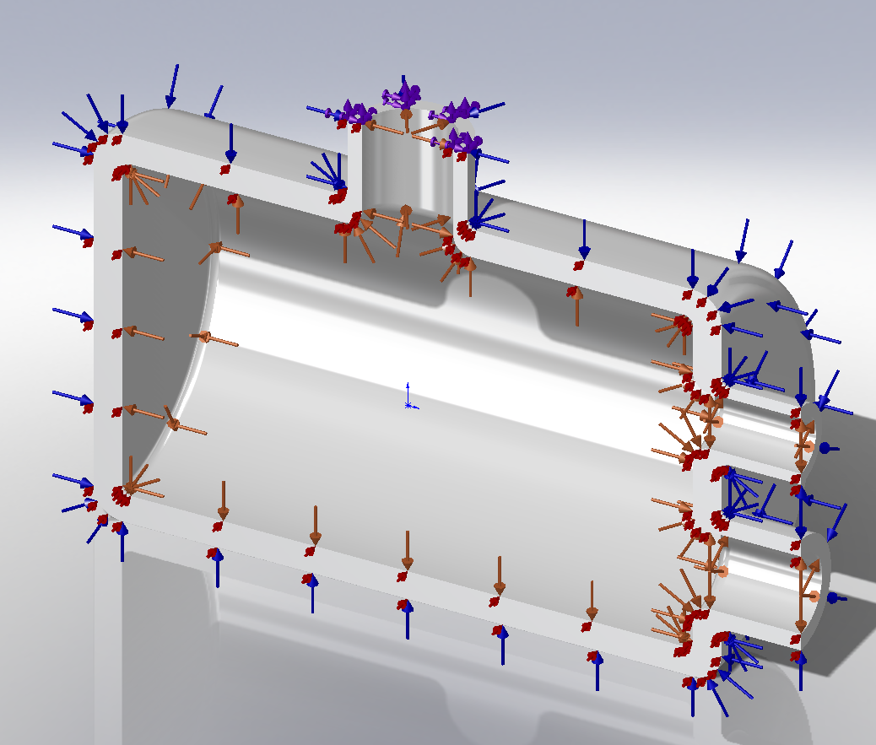

Figure 2. External loads and constraints

Figure 2 above can be evaluated from the following key:

|  |  |  |  |
| --- | --- | --- | --- |
| Orange | Blue | Red | Purple |
| **14.5MPa Internal Load** | .101MPa Atmospheric Load | Symmetric Constraint | Fixed Geometry Constraint |

Table 1. The graphical key for Figure 2.

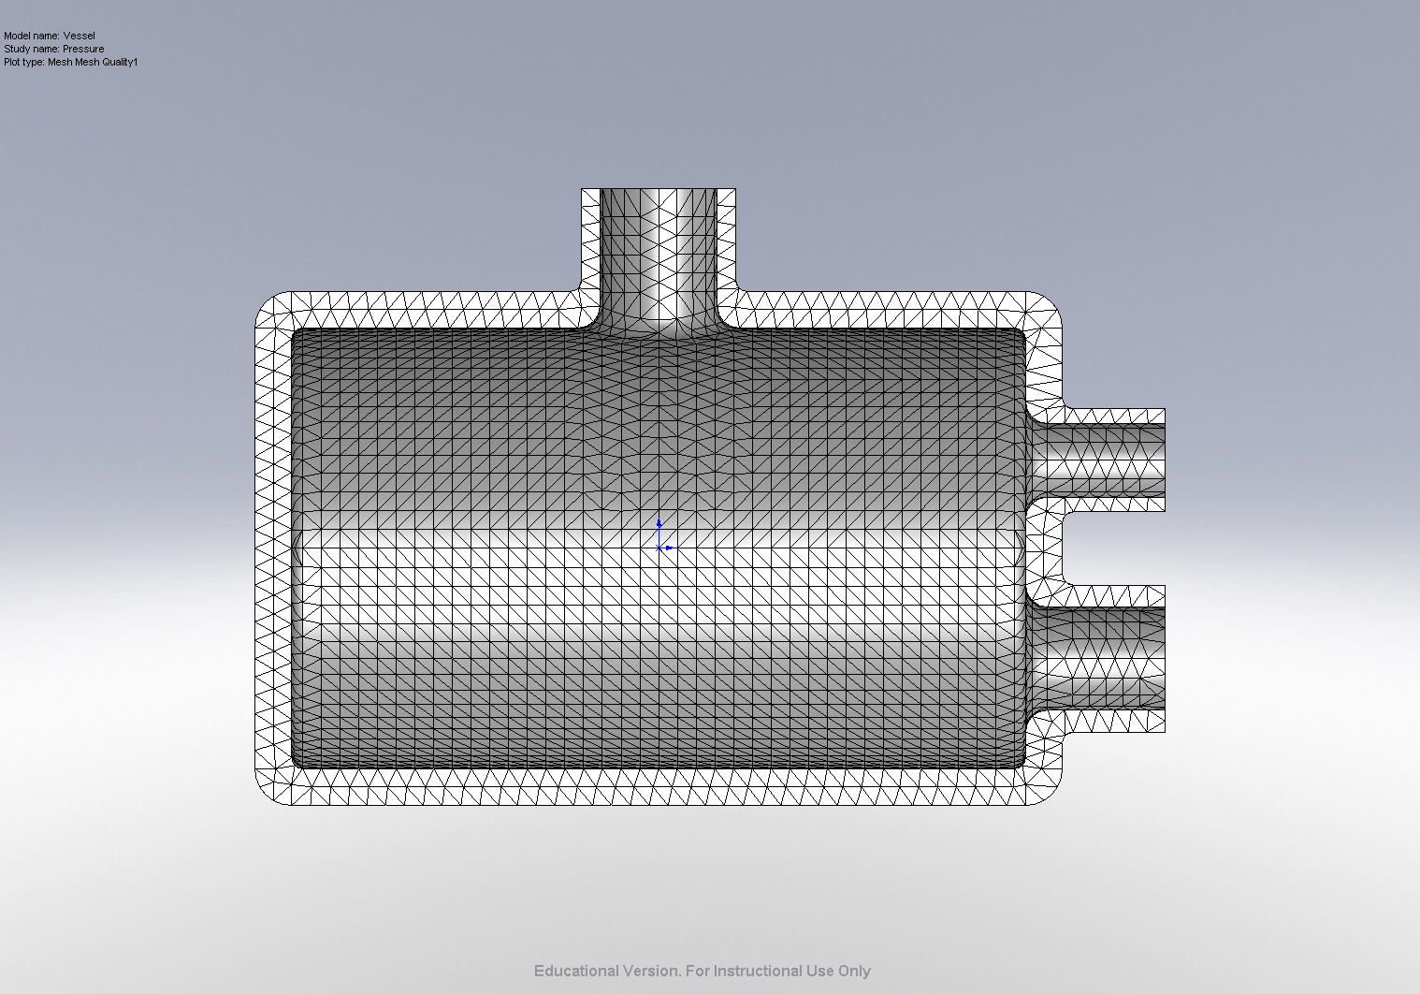

Figure 3. Normal View of the Meshing of the part.

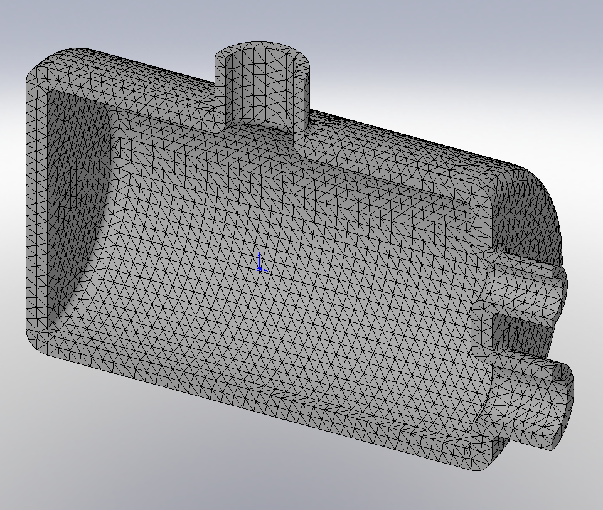

Figure 4. Isometric view of the meshing of the part.

Default Results

|  |  |  |  |  |  |
| --- | --- | --- | --- | --- | --- |
| Name | Type | Min | Location | Max | Location |
| Stress1 | VON: von Mises Stress | 2.04686e+006 N/m^2  Node: 15709 | (304.147 mm,  -185.666 mm,  -5.5977 mm) | 5.66429e+008 N/m^2  Node: 1070 | (-276.541 mm,  31.3299 mm,  -147.3 mm) |
| Displacement1 | URES: Resultant Displacement | 0 mm  Node: 261 | (6.4294e-015 mm,  245 mm,  -52.5 mm) | 2.14935 mm  Node: 4512 | (304.062 mm,  -185.966 mm,  1.04744e-012 mm) |
| Strain1 | ESTRN: Equivalent Strain | 1.65754e-005  Element: 13760 | (341.492 mm,  -28.913 mm,  -2.78854 mm) | 0.00183211  Element: 7722 | (-249.146 mm,  -144.686 mm,  -6.20016 mm) |
| Stress3 | SY: Y Normal Stress | -4.25125e+008 N/m^2  Node: 82 | (-52.566 mm,  182.57 mm,  5.14551e-017 mm) | 6.26569e+008 N/m^2  Node: 45492 | (52.999 mm,  179.532 mm,  2.87372e-015 mm) |
| Stress4 | SZ: Z Normal Stress | -2.78271e+008 N/m^2  Node: 21910 | (-251.483 mm,  -5.54606 mm,  4.52306e-014 mm) | 4.72429e+008 N/m^2  Node: 39478 | (-250.281 mm,  0.923395 mm,  -145.353 mm) |

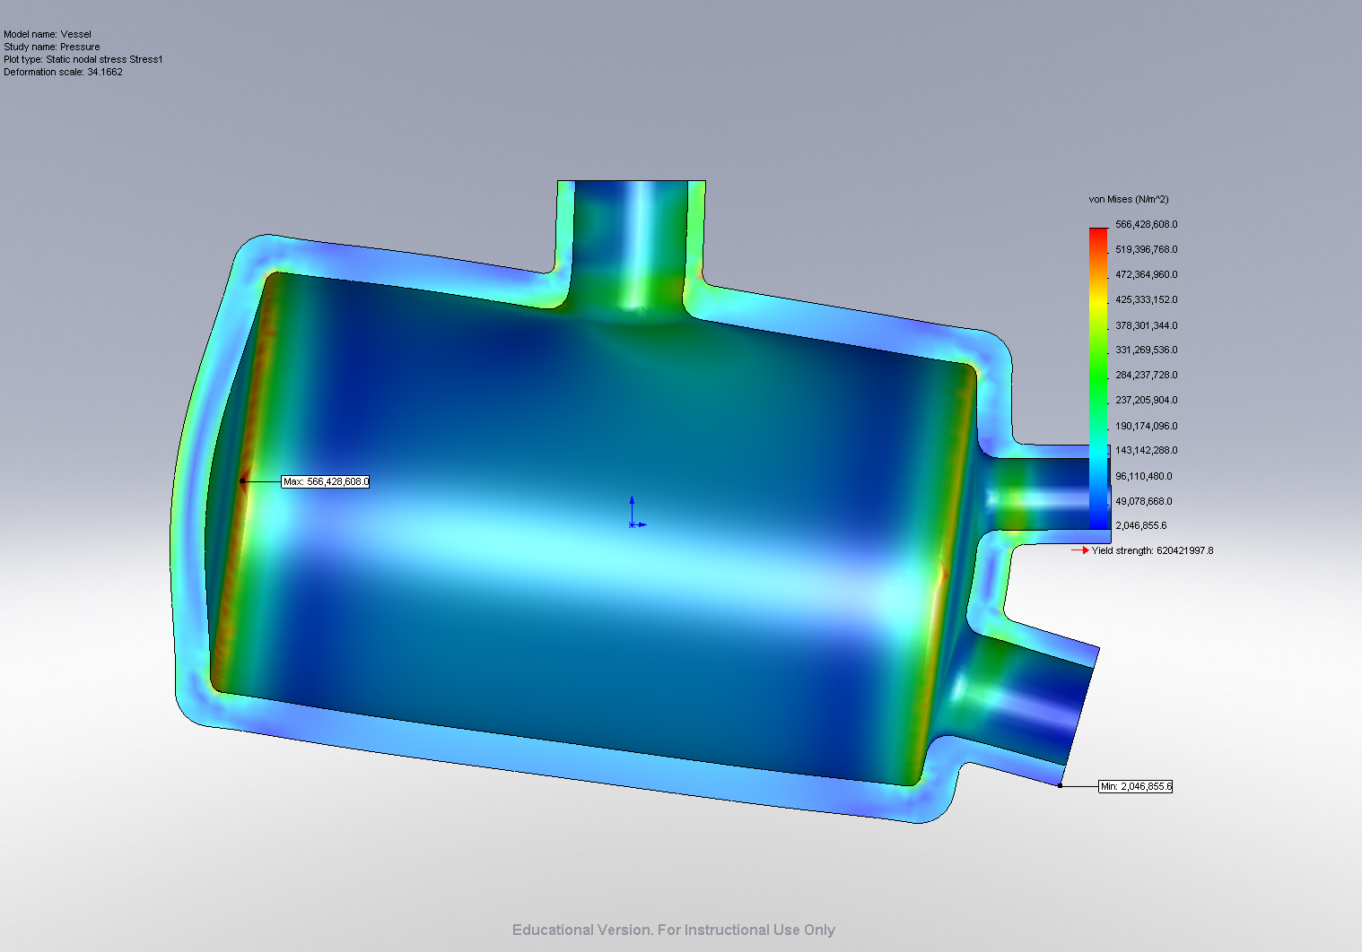

Figure 5. Normal view of Von-Mises Stress with Max/Min Stress

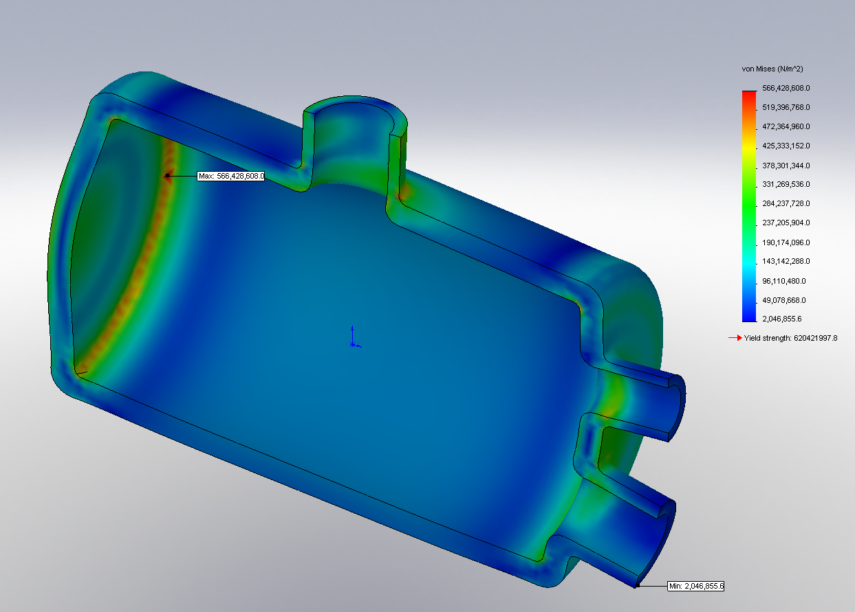

Figure 6. Isometric view of Von-Mises Stress with Max/Min Stress

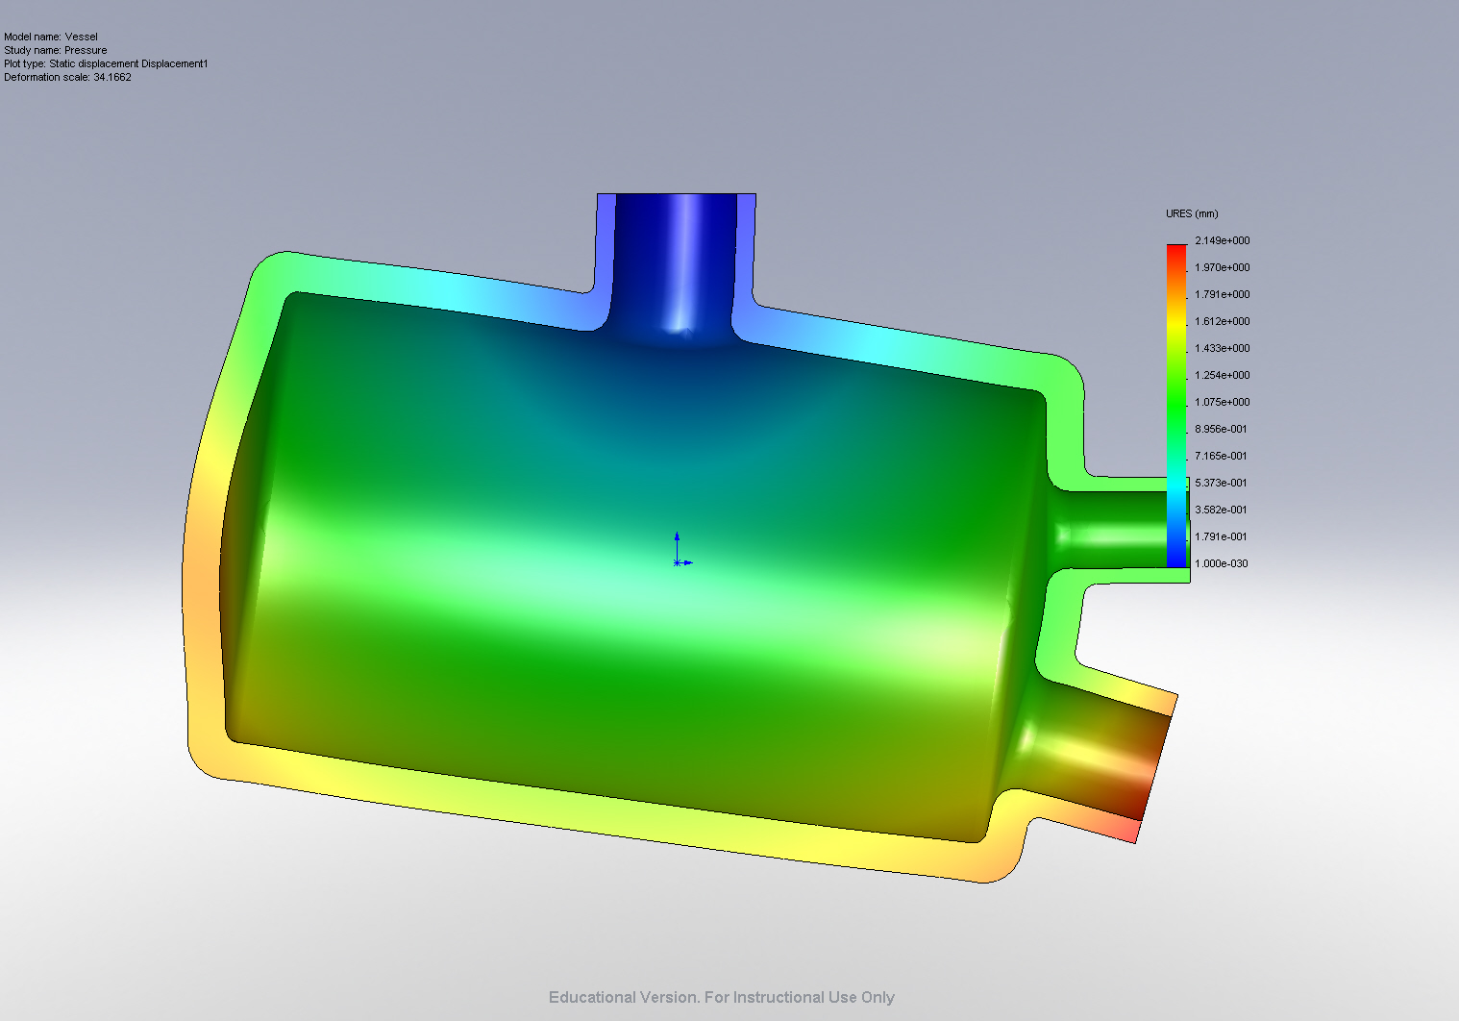

Figure 7. Normal View of displacement of part

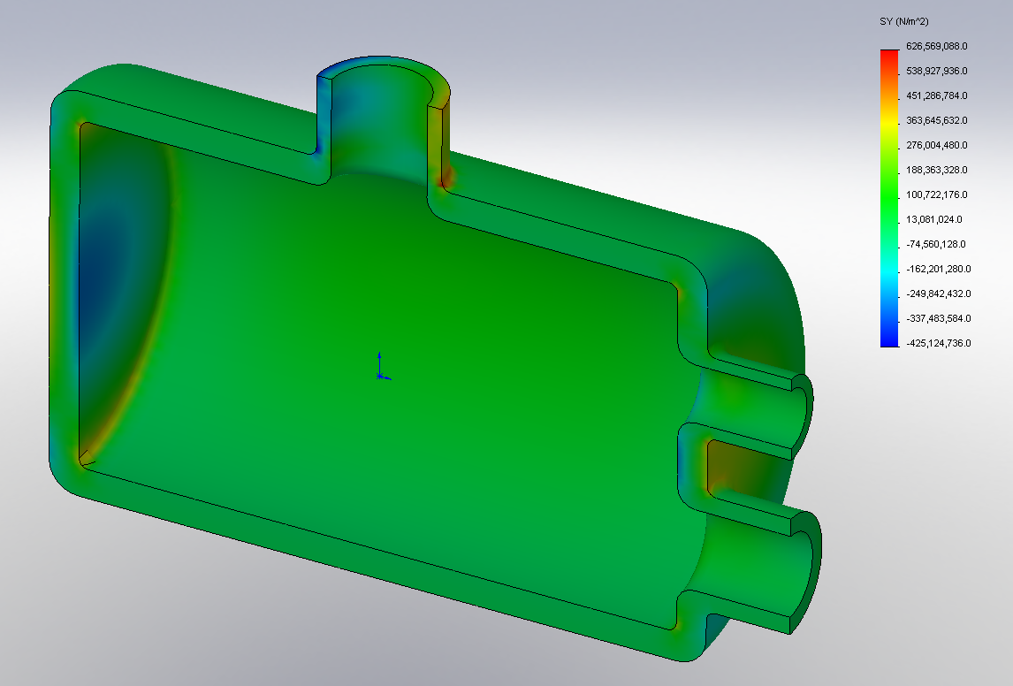

Figure 8. Isometric View of Radial Stress Plot

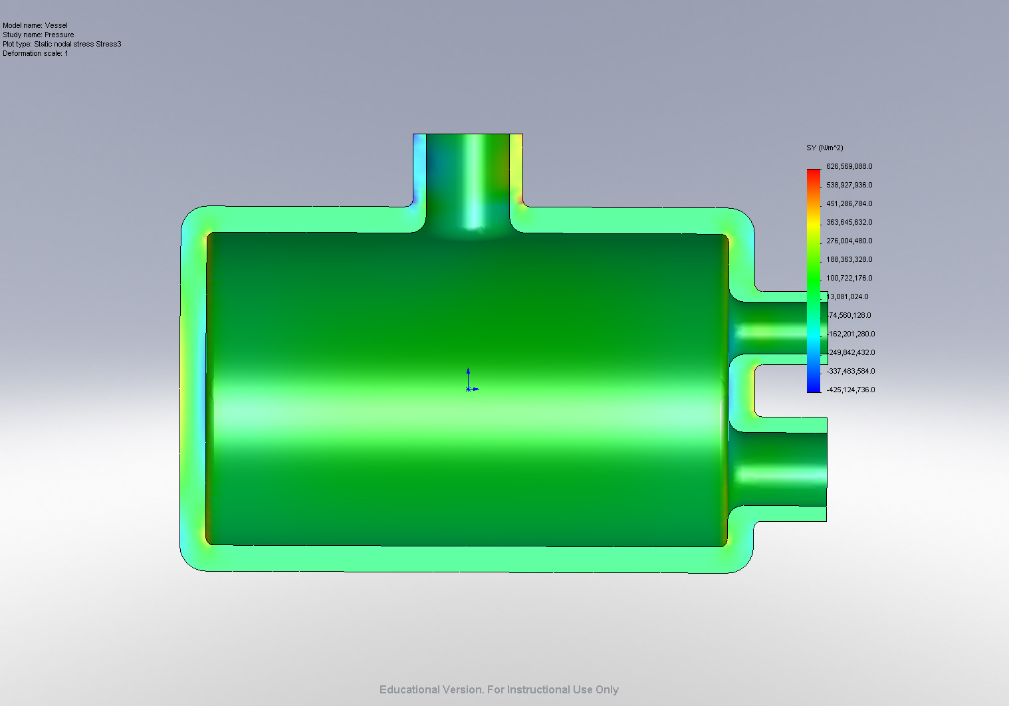

Figure 9. Normal Radial Stress Plot

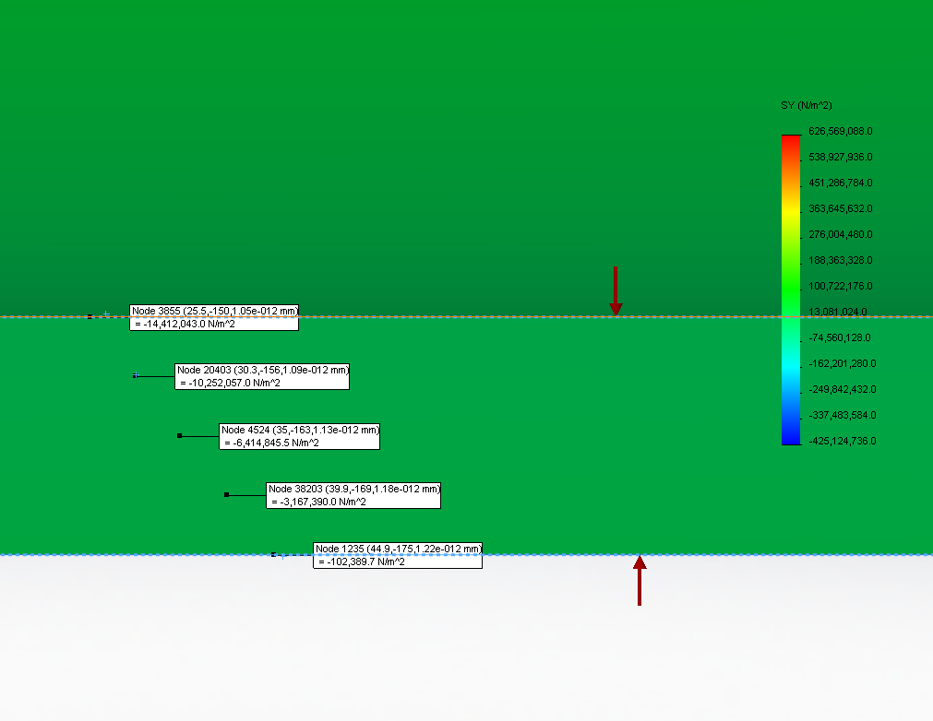

Figure 10. Normal Stress Probes

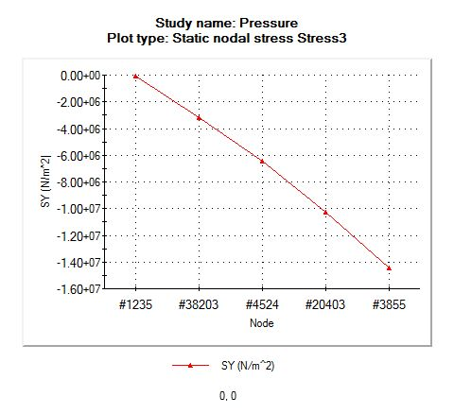

Figure 11. Radial Stress Probe Plot

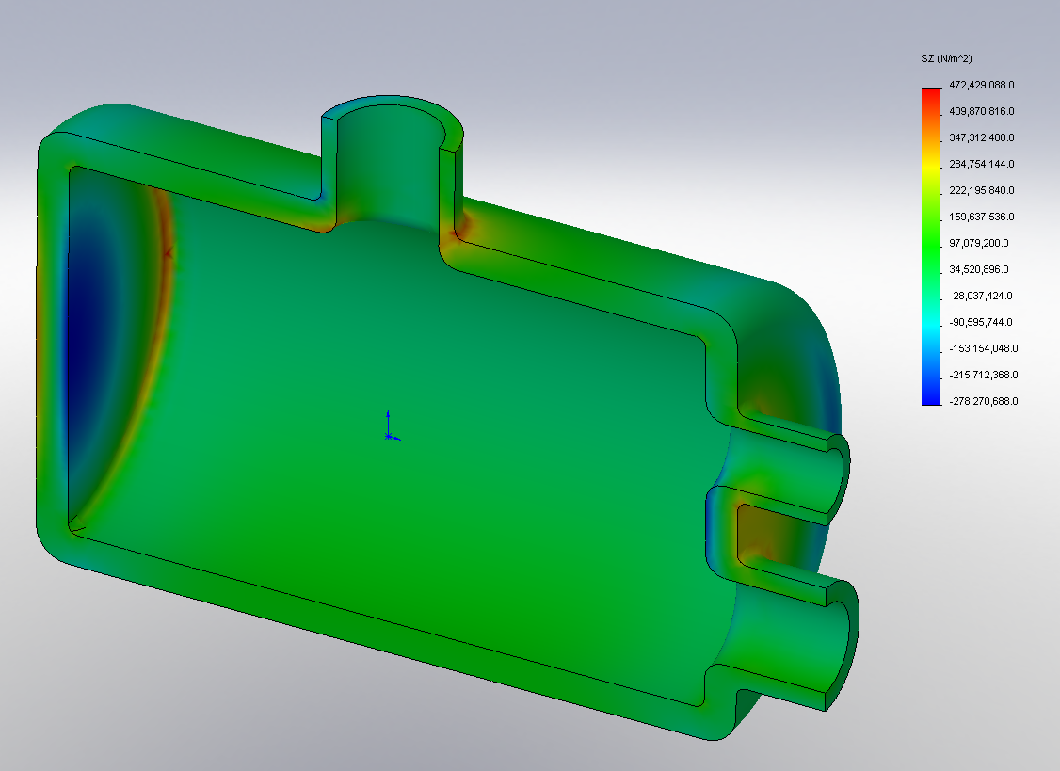

Figure 12. Isometric view of Tangential Stress Plot

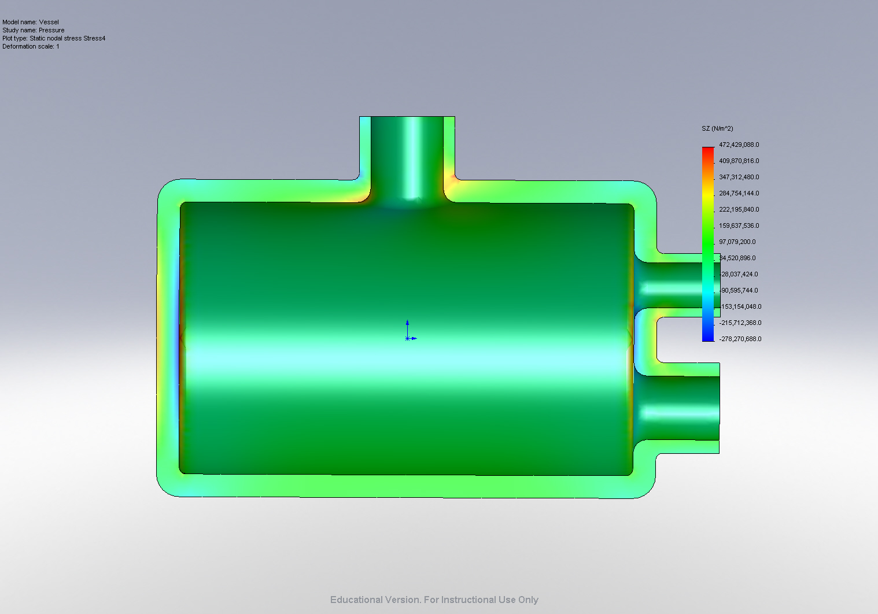

Figure 13. Normal View of Tangential Stress Plot

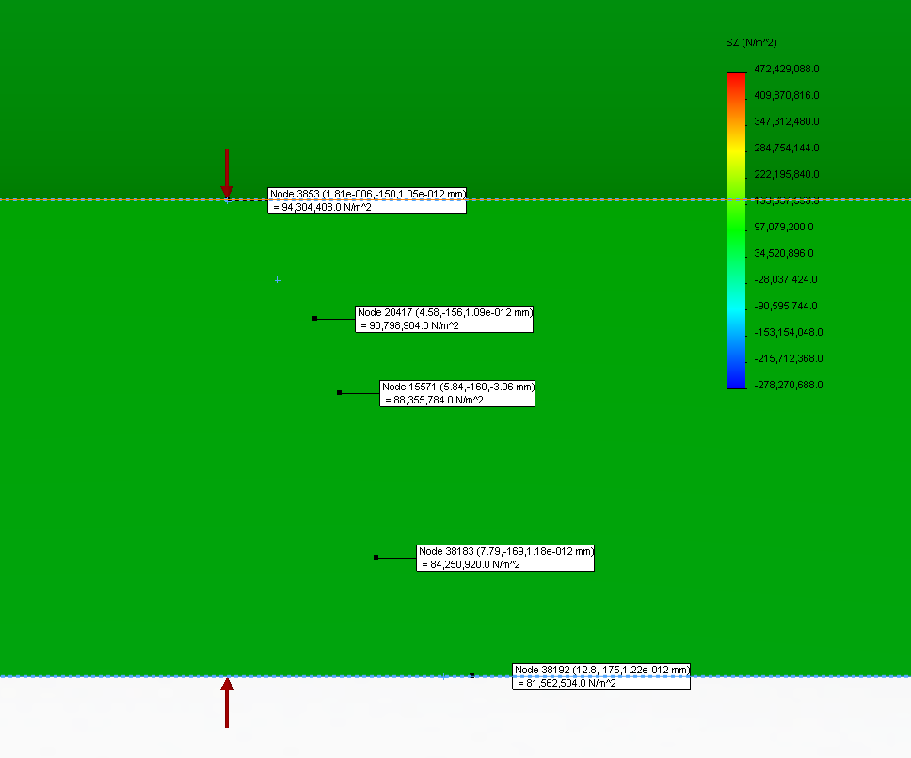

Figure 14. Tangential Stress Probes

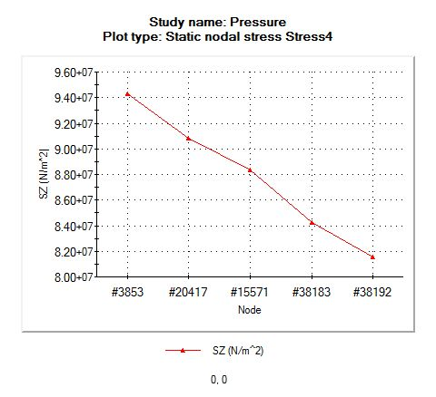

Figure 15. Plot of Tangential Stress Probes

|  |  |  |  |
| --- | --- | --- | --- |
|  | Classical | FEA | % Difference |
| Outer Tangential | 79.65 | 81.6 | 2.389706 |
| Inner Tangential | 94.05 | 93.3 | -0.80386 |
| Outer Radial | -0.101 | -0.102 | 0.980392 |
| Inner Radial | -14.5 | -14.4 | -0.69444 |

Table 2. Comparison of classical and FEA results

Conclusion

After completing our FEM analysis, this pressure vessel was shown to converge almost exactly to what our hand calculations predicted. The larges error was a meager 2.389% on the outer tangential stress. This large error could have been due to a variety of reason, but could be because of the stress concentrations caused by the rather large displacement of the outer walls. The good correlation between our hand calculations and our FEA analysis proves that the numbers that we have found are highly accurate. This model can therefore be assumed to be an accurate representation of the physical loading of the system, especially to analyze the complex geometry around the inlet and exits.

Appendix 1: Hand Calculations