San Diego State University
DEPARTMENT OF MECHANICAL ENGINEERING

Stress analysis of Pressure
Levi Lentz
4/14/11

Table of Contents

Table of Contents 2
List of Figures 2
List of Graphs and Tables 2
Description 3
Problem Statement 3
Steps 3
Assumptions 4
Model Information 4
Study Properties 4
Units 5
Material Properties 5
Loads and Restraints 6
Fixture 6
Load 6
Mesh Information 6
Reaction Forces 7
Free-Body Forces 7
Free-body Moments 7
Study Results 7
Default Results 9

Conclusion 17
Appendix 1: Hand Calculations………………………………………………………………………………………………………………18

List of Figures

Figure 1. Dimensions of the pressure vessel. Shown here with a half view to show detail. 4
Figure 2. Vessel showing applied loads and constraints 9
Figure 3. Isometric view of Mesh Results for the Pressure Vessel 10
Figure 4. Normal View of Mesh showing the number of nodes at cross section 10
Figure 5. Displacement of Pressure Vessel 12
Figure 6. Von-Mises Stress on vessel with displacement 12
Figure 7. Von Mises stress with max and min point 13
Figure 8. Normal View of Tangential Stress Plot 13
Figure 9. Isometric View of Tangential Stress Plot 14
Figure 10. Tangential Stress Probes 14
Figure 11. Normal View of Radial Stress Plot 16
Figure 12. Isometric View of Radial Stress Plot 16
Figure 13. Stress Probes for the Radial Stress Plot 17

List of Graphs and Tables
Plot of Tangential Stress Probes 15
Plot of Radial Stress Probes 17
Table 1. Classical vs. FEM for Stresses 18

Description
This is a FEM project aimed at analyzing a pressure vessel with an internal pressure of 16MPa and an external atmospheric pressure of 101kPa. The goal is to have our results match the hand calculations in the name of expanding the engineering field.

Problem Statement
Analyze a pressure vessel with the geometry shown below in Figure 1 in Solidworks. Show the hand calculations to show the similarities between the two methods. The vessel has an internal pressure of 16Mpa and an external pressure of 101kPa.
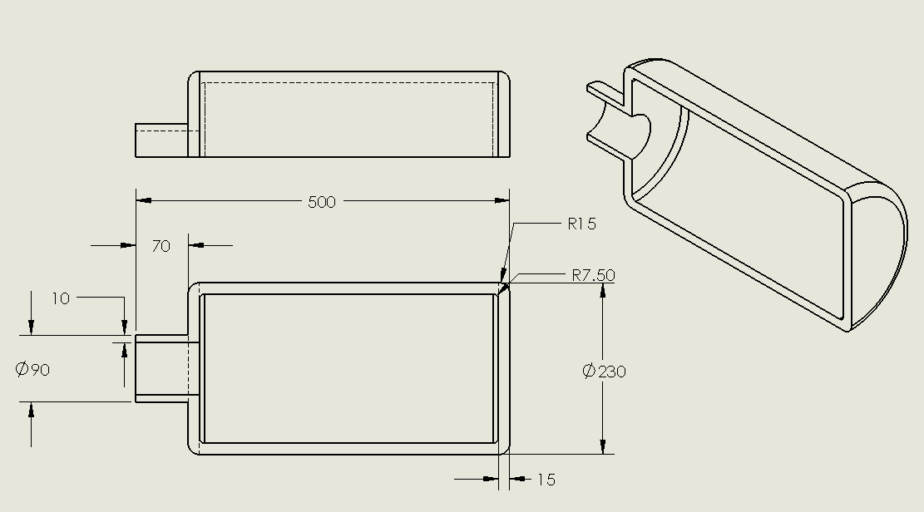

Figure 1. Dimensions of the pressure vessel. Shown here with a half view to show detail.

Steps
- Apply material and constrain it properly. We used an Alloy Steel with a symmetric constraint on the cut surface of the vessel with a fixed constraint at the open end of the neck. This fully constrained the material and allowed us to properly apply the FEA loads.
- Apply an internal pressure of 16MPa to the interior surface, and an external pressure of .101kPa to the external surface. Run the FEM analysis
- Create a stress plot for Von Mises, radial, and tangential stresses in addition to a displacement plot of the cylinder. Use a probe at the center of the cylinder to determine both the radial and tangential stresses at the inner wall and the external wall of the cylinder. Use Solidworks to plot the stress vs. node number
- Use the thick walled cylinder equations to calculate the theoretical radial and tangential stresses at the interior and exterior walls. Compare this result with the FEM using the percent difference formula shown below:
%𝑑𝑖𝑓𝑓𝑒𝑟𝑒𝑛𝑐𝑒=,,𝐹𝐸𝐴 𝑅𝑒𝑠𝑢𝑙𝑡𝑠−𝐶𝑙𝑎𝑠𝑠𝑖𝑐𝑎𝑙 𝑅𝑒𝑠𝑢𝑙𝑡𝑠-𝐹𝐸𝐴 𝑅𝑒𝑠𝑢𝑙𝑡𝑠..∗100

Assumptions
We assume the material is an Alloy Steel with the internal and external pressures being applied normal to the faces of the vessel. We assume that the vessel is rigidly constrained at the opening of the neck to allow the vessel to expand in all necessary directions away from the neck.

Model Information
Document Name | Configuration | Document Path | Date Modified
Pressure | Default | F:\314\Pressure_vessle\Pressure.SLDPRT | Wed Apr 06 21:13:26 2011

Study Properties
Study name | Thick Wall Pressure Vessel
Analysis type | Static
Mesh Type: | Solid Mesh
Solver type | FFEPlus
Inplane Effect: | Off
Soft Spring: | Off
Inertial Relief: | Off
Thermal Effect: | Input Temperature
Zero strain temperature | 298.000000
Units | Kelvin
Include fluid pressure effects from SolidWorks Flow Simulation | Off
Friction: | Off
Ignore clearance for surface contact | Off
Use Adaptive Method: | Off

Units
Unit system: | SI
Length/Displacement | mm
Temperature | Kelvin
Angular velocity | rad/s
Stress/Pressure | N/m^2

Material Properties
No. | Body Name | Material | Mass | Volume
1 | SolidBody 1(Revolve1) | Alloy Steel | 20.6531 kg | 0.00268223 m^3

Material name: | Alloy Steel
Description:
Material Source:
Material Model Type: | Linear Elastic Isotropic
Default Failure Criterion: | Max von Mises Stress
Application Data:

Property Name | Value | Units | Value Type
Elastic modulus | 2.1e+011 | N/m^2 | Constant
Poisson's ratio | 0.28 | NA | Constant
Shear modulus | 7.9e+010 | N/m^2 | Constant
Mass density | 7700 | kg/m^3 | Constant
Tensile strength | 7.2383e+008 | N/m^2 | Constant
Yield strength | 6.2042e+008 | N/m^2 | Constant
Thermal expansion coefficient | 1.3e-005 | /Kelvin | Constant
Thermal conductivity | 50 | W/(m.K) | Constant
Specific heat | 460 | J/(kg.K) | Constant

Loads and Restraints

Fixture
Restraint name | Selection set | Description
Symmetry-1 <Pressure> | on 1 Face(s) symmetry
Fixed-1 <Pressure> | on 1 Face(s) fixed.

Load
Load name | Selection set | Loading type | Description
Pressure-1 <Pressure> | on 6 Face(s) with Pressure 1.6e+007 N/m^2 along direction normal to selected face | Sequential Loading
Pressure-2 <Pressure> | on 6 Face(s) with Pressure 1.01e+005 N/m^2 along direction normal to selected face | Sequential Loading

Mesh Information
Mesh Type: | Solid Mesh
Mesher Used: | Standard mesh
Automatic Transition: | Off
Smooth Surface: | On
Jacobian Check: | 4 Points
Element Size: | 9.033 mm
Tolerance: | 0.45165 mm
Quality: | High
Number of elements: | 25969
Number of nodes: | 44207
Time to complete mesh(hh;mm;ss): | 00:00:03
Computer name: | LEVICOMPUTER

Reaction Forces
Selection set | Units | Sum X | Sum Y | Sum Z | Resultant
Entire Body | N | 30429.6 | 9.54022 | -1.36437e+006 | 1.36471e+006

Free-Body Forces
Selection set | Units | Sum X | Sum Y | Sum Z | Resultant
Entire Body | N | 0.0438523 | -0.762021 | -2.52593 | 2.63874

Free-body Moments
Selection set | Units | Sum X | Sum Y | Sum Z | Resultant
Entire Body | N-m | 0 | 0 | 0 | 1e-033

Study Results
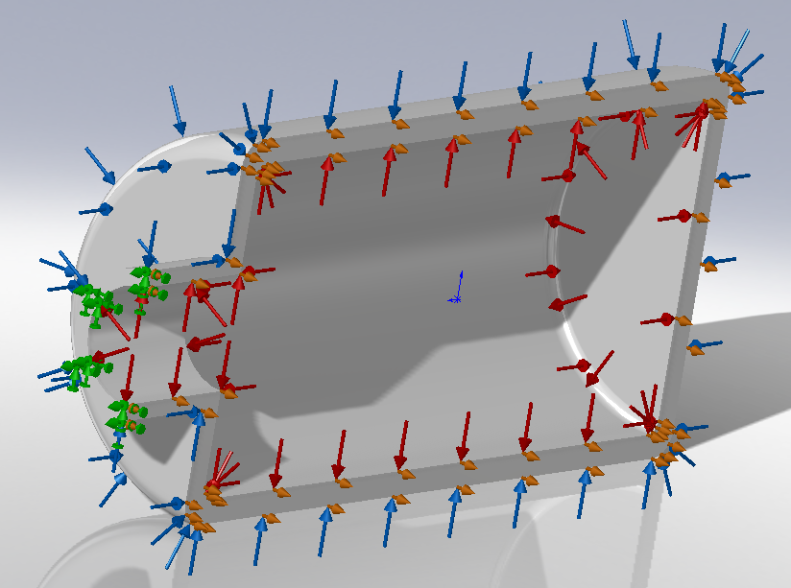

Figure 2. Vessel showing applied loads and constraints
Blue arrows represent the atmospheric load. Red arrows represent the internal pressure. The green arrows are the fixed constraint at the pipe inlet. The orange arrows are the symmetry constraint.
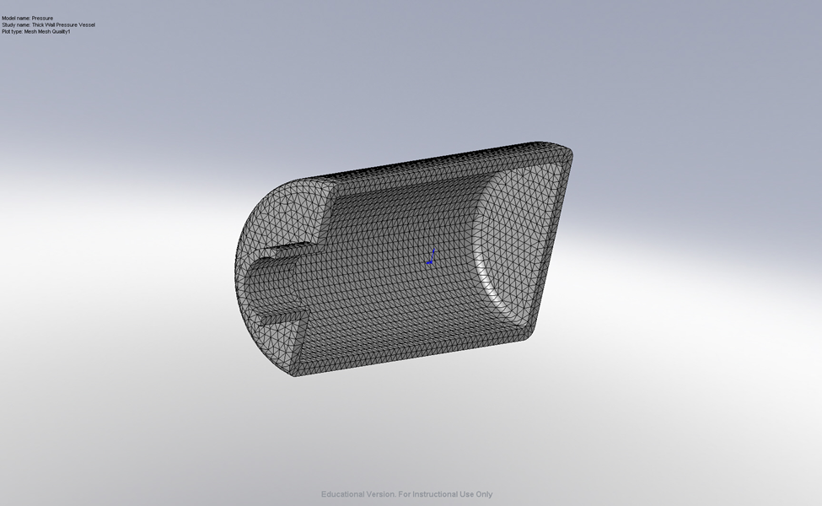

Figure 3. Isometric view of Mesh Results for the Pressure Vessel
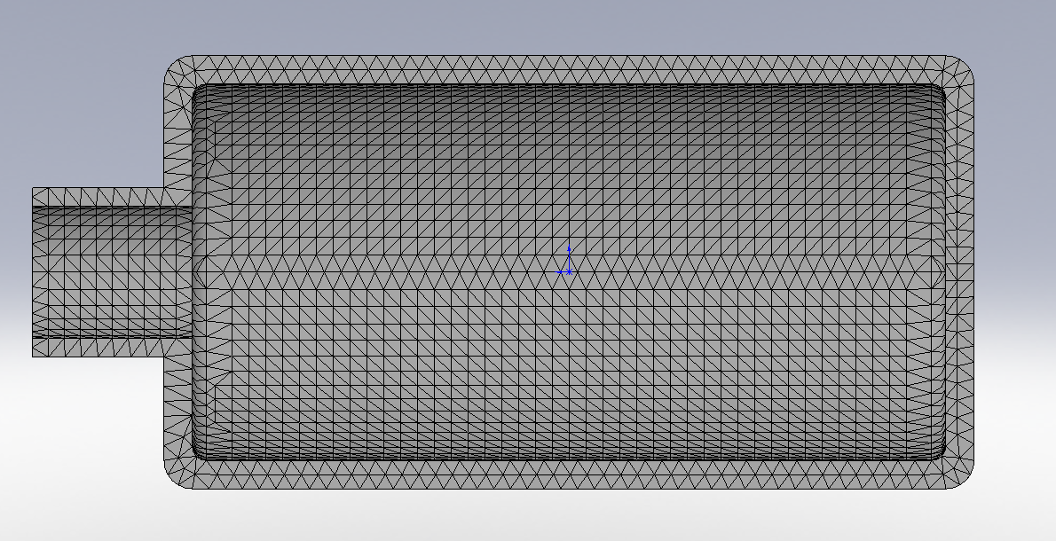

Figure 4. Normal View of Mesh showing the number of nodes at cross section

Default Results
Name | Type | Min | Location | Max | Location
Displacement2 | URES: Resultant Displacement | 0 m  Node: 1066 | (285 mm,  -45 mm,  -3.28011e-013 mm) | 0.00100992 m  Node: 12613 | (-256.071 mm,  0.140566 mm,  8.32434e-021 mm)
Stress1 | VON: von Mises Stress | 4.81211e+006 N/m^2  Node: 42859 | (153.355 mm,  -114.902 mm,  4.51518 mm) | 5.60104e+008 N/m^2  Node: 29914 | (-221.699 mm,  0.139119 mm,  94.5453 mm)
Stress2 | SZ: Z Normal Stress | -3.63674e+008 N/m^2  Node: 29527 | (-200 mm,  -1.72295e-006 mm,  -1.20313e-020 mm) | 5.29785e+008 N/m^2  Node: 29914 | (-199.429 mm,  -3.62182e-013 mm,  95.3701 mm)
Stress3 | SY: Y Normal Stress | -3.62855e+008 N/m^2  Node: 29527 | (-200 mm,  -1.72295e-006 mm,  -1.20313e-020 mm) | 5.42001e+008 N/m^2  Node: 29578 | (-199.429 mm,  -95.3701 mm,  1.13728e-006 mm)

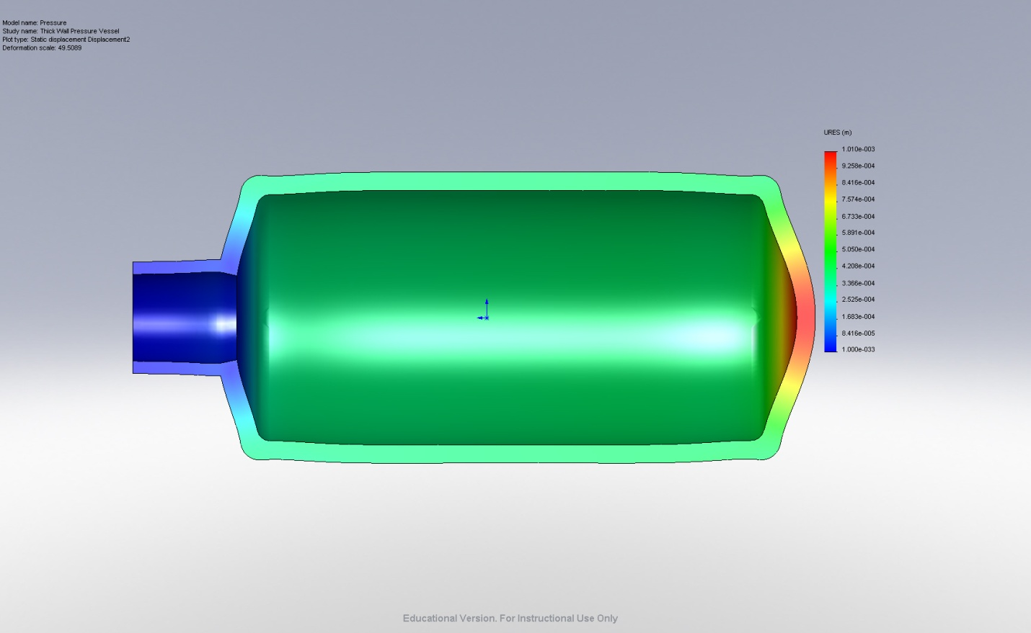

Figure 5. Displacement of Pressure Vessel
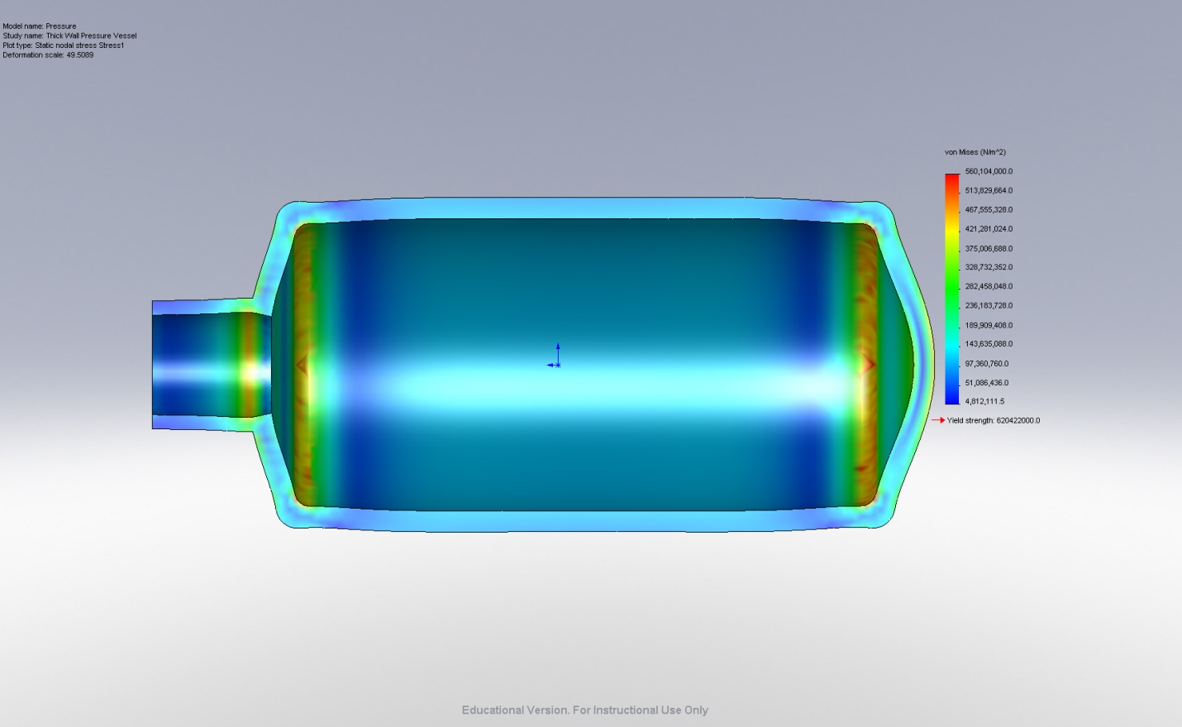

Figure 6. Von-Mises Stress on vessel with displacement
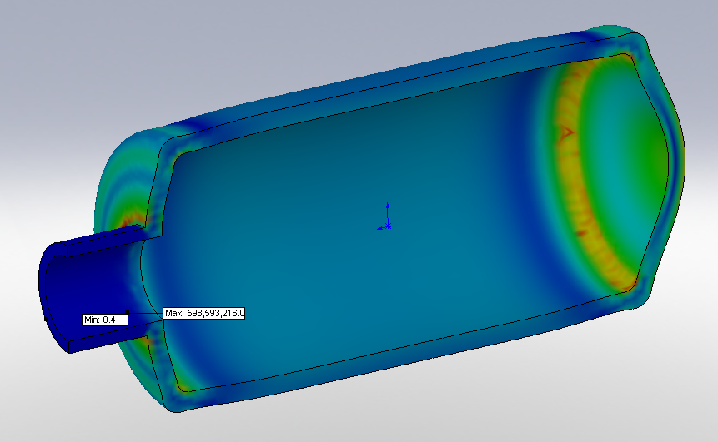Figure 7. Von Mises stress with max and min point
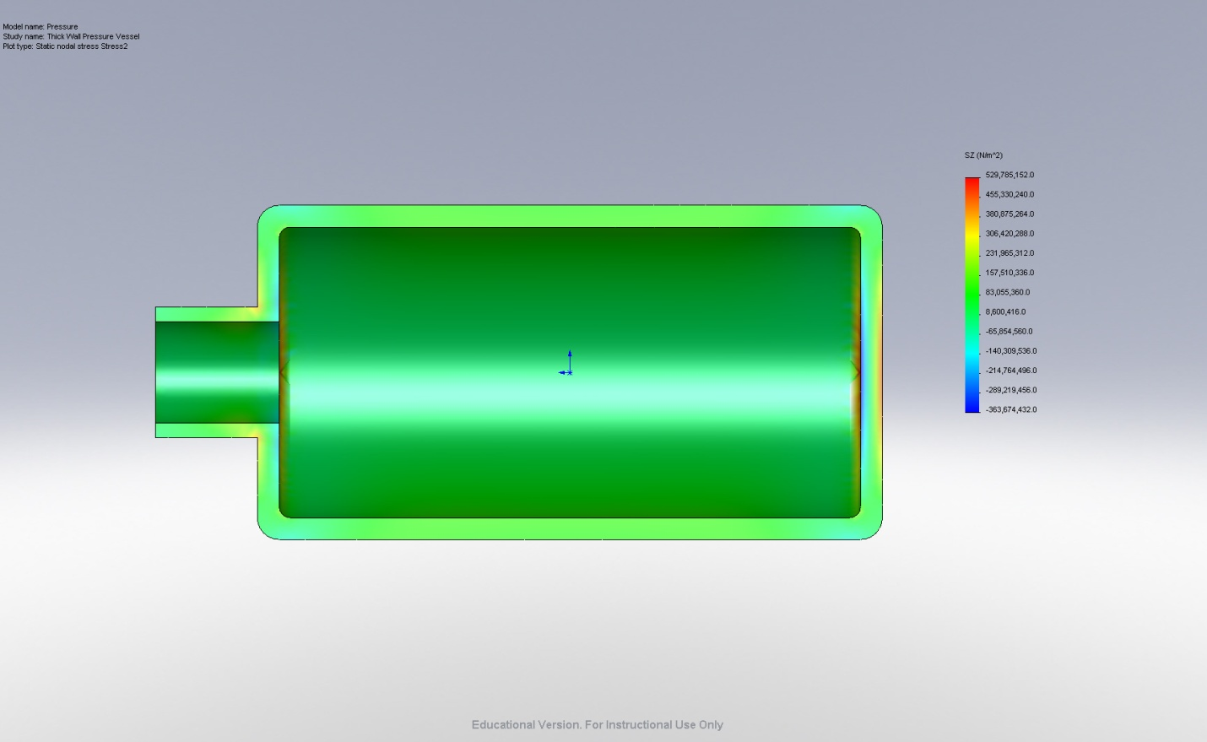

Figure 8. Normal View of Tangential Stress Plot
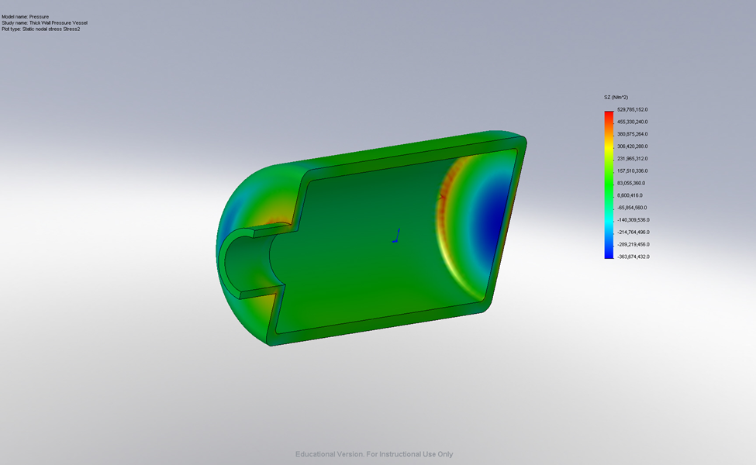

Figure 9. Isometric View of Tangential Stress Plot
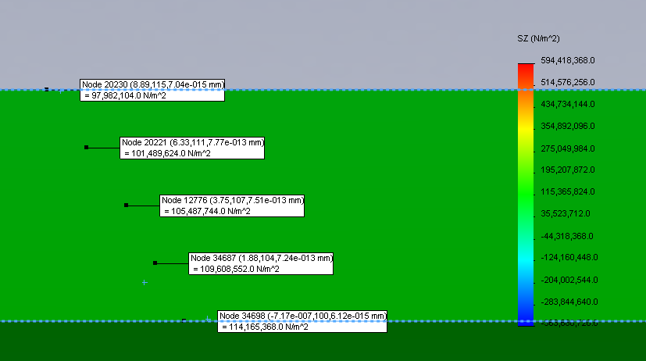

Figure 10. Tangential Stress Probes
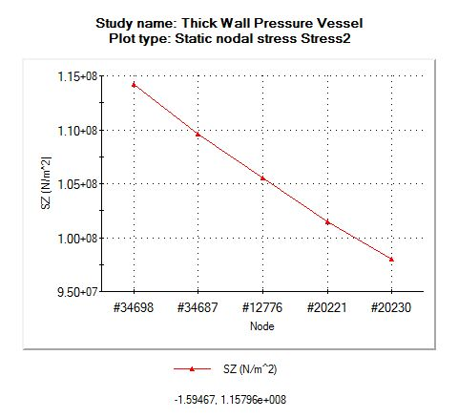

Plot of Tangential Stress Probes

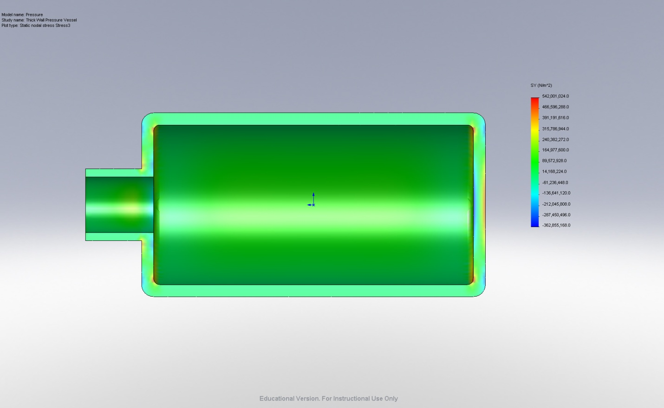

Figure 11. Normal View of Radial Stress Plot
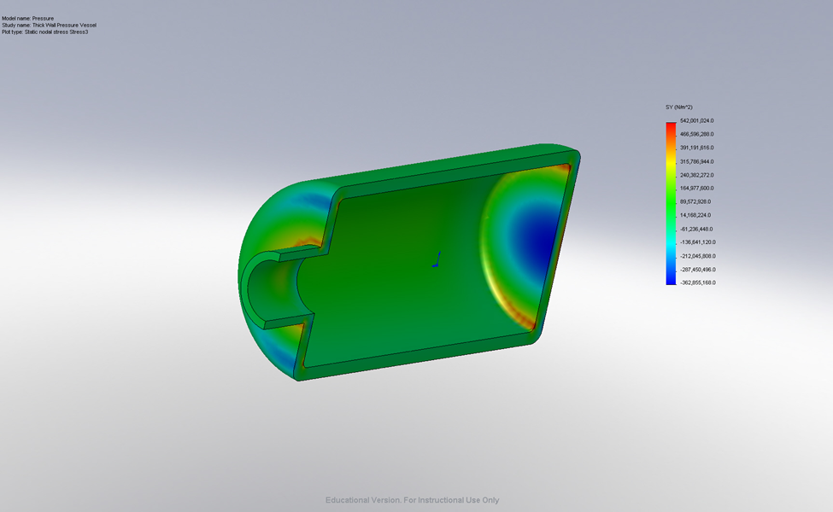

Figure 12. Isometric View of Radial Stress Plot
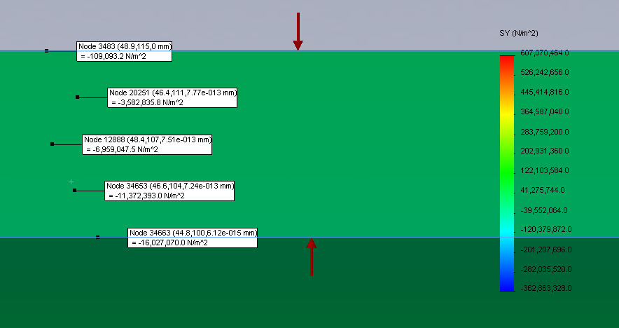

Figure 13. Stress Probes for the Radial Stress Plot
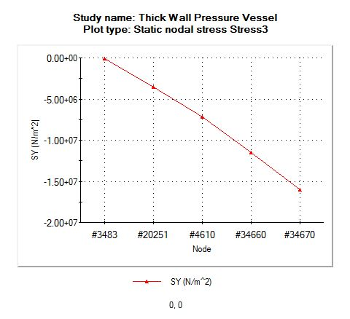

Plot of Radial Stress Probes

 | Classical (MPa) | FEA (Mpa) | % Difference
Outer Tangential | 98.49 | 97.98 | -0.51%
Inner Tangential | 114.4 | 114.2 | -0.18%
Outer Radial | -0.101 | -0.109 | 7.34%
Inner Radial | -16 | -16.027 | 0.17%
Table 1. Classical vs. FEM for Stresses

Conclusion
After completing our FEM analysis, the pressure vessel was shown to converge to stress values very similar to what we hand calculated. The hand calculations can be seen in the Appendix 1 below. The max error that we have is 7.34%, in the radial direction on the exterior surface. This high error could be due to many factors, but in all likely hood was due to a discontinuity at the point in the FEM analysis. The other calculated values are all within 1% of our hand classical results. The model can therefore be assumed to be an accurate representation of the physical loading of the system.

Appendix 1: Hand Calculations

