San Diego State University

DEPARTMENT OF MECHANICAL ENGINEERING

Stress analysis of Pressure Vessel

Levi Lentz

4/14/11

Table of Contents

Table of Contents 2

List of Figures 2

List of Graphs and Tables 2

Description 3

Problem Statement 3

Steps 3

Assumptions 4

Model Information 4

Study Properties 4

Units 5

Material Properties 5

Loads and Restraints 6

Fixture 6

Load 6

Mesh Information 6

Reaction Forces 7

Free-Body Forces 7

Free-body Moments 7

Study Results 7

Default Results 9

Conclusion 17

Appendix 1: Hand Calculations………………………………………………………………………………………………………………18

List of Figures

Figure 1. Dimensions of the pressure vessel. Shown here with a half view to show detail. 4

Figure 2. Vessel showing applied loads and constraints 9

Figure 3. Isometric view of Mesh Results for the Pressure Vessel 10

Figure 4. Normal View of Mesh showing the number of nodes at cross section 10

Figure 5. Displacement of Pressure Vessel 12

Figure 6. Von-Mises Stress on vessel with displacement 12

Figure 7. Von Mises stress with max and min point 13

Figure 8. Normal View of Tangential Stress Plot 13

Figure 9. Isometric View of Tangential Stress Plot 14

Figure 10. Tangential Stress Probes 14

Figure 11. Normal View of Radial Stress Plot 16

Figure 12. Isometric View of Radial Stress Plot 16

Figure 13. Stress Probes for the Radial Stress Plot 17

List of Graphs and Tables

Plot of Tangential Stress Probes 15

Plot of Radial Stress Probes 17

Table 1. Classical vs. FEM for Stresses 18

Description

This is a FEM project aimed at analyzing a pressure vessel with an internal pressure of 16MPa and an external atmospheric pressure of 101kPa. The goal is to have our results match the hand calculations in the name of expanding the engineering field.

Problem Statement

Analyze a pressure vessel with the geometry shown below in Figure 1 in Solidworks. Show the hand calculations to show the similarities between the two methods. The vessel has an internal pressure of 16Mpa and an external pressure of 101kPa.

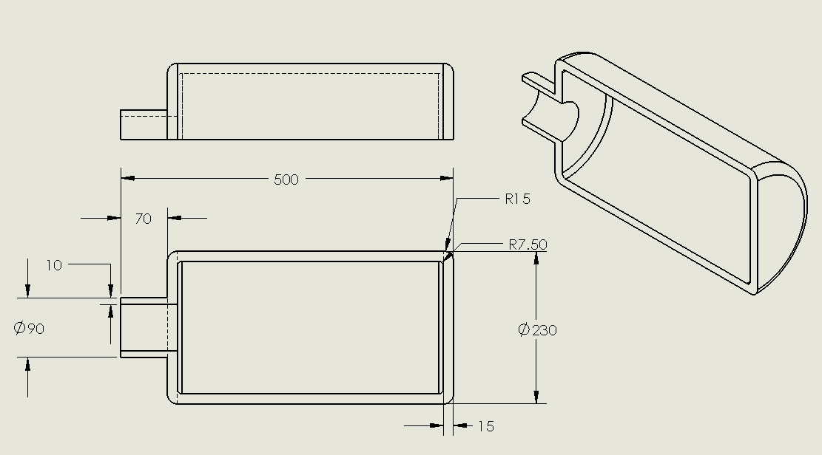

Figure . Dimensions of the pressure vessel. Shown here with a half view to show detail.

Steps

1. Apply material and constrain it properly. We used an Alloy Steel with a symmetric constraint on the cut surface of the vessel with a fixed constraint at the open end of the neck. This fully constrained the material and allowed us to properly apply the FEA loads.
2. Apply an internal pressure of 16MPa to the interior surface, and an external pressure of .101kPa to the external surface. Run the FEM analysis
3. Create a stress plot for Von Mises, radial, and tangential stresses in addition to a displacement plot of the cylinder. Use a probe at the center of the cylinder to determine both the radial and tangential stresses at the inner wall and the external wall of the cylinder. Use Solidworks to plot the stress vs. node number
4. Use the thick walled cylinder equations to calculate the theoretical radial and tangential stresses at the interior and exterior walls. Compare this result with the FEM using the percent difference formula shown below:

%𝑑𝑖𝑓𝑓𝑒𝑟𝑒𝑛𝑐𝑒=𝐹𝐸𝐴 𝑅𝑒𝑠𝑢𝑙𝑡𝑠−𝐶𝑙𝑎𝑠𝑠𝑖𝑐𝑎𝑙 𝑅𝑒𝑠𝑢𝑙𝑡𝑠𝐹𝐸𝐴 𝑅𝑒𝑠𝑢𝑙𝑡𝑠∗100

Assumptions

We assume the material is an Alloy Steel with the internal and external pressures being applied normal to the faces of the vessel. We assume that the vessel is rigidly constrained at the opening of the neck to allow the vessel to expand in all necessary directions away from the neck.

Model Information

|  |  |  |  |
| --- | --- | --- | --- |
| **Document Name** | **Configuration** | **Document Path** | **Date Modified** |
| Pressure | Default | F:\314\Pressure_vessle\Pressure.SLDPRT | Wed Apr 06 21:13:26 2011 |

Study Properties

|  |  |
| --- | --- |
| Study name | Thick Wall Pressure Vessel |
| Analysis type | Static |
| Mesh Type: | Solid Mesh |
| Solver type | FFEPlus |
| Inplane Effect: | Off |
| Soft Spring: | Off |
| Inertial Relief: | Off |
| Thermal Effect: | Input Temperature |
| Zero strain temperature | 298.000000 |
| Units | Kelvin |
| Include fluid pressure effects from SolidWorks Flow Simulation | Off |
| Friction: | Off |
| Ignore clearance for surface contact | Off |
| Use Adaptive Method: | Off |

Units

|  |  |
| --- | --- |
| Unit system: | SI |
| Length/Displacement | mm |
| Temperature | Kelvin |
| Angular velocity | rad/s |
| Stress/Pressure | N/m^2 |

Material Properties

|  |  |  |  |  |
| --- | --- | --- | --- | --- |
| **No.** | **Body Name** | **Material** | **Mass** | **Volume** |
| 1 | SolidBody 1(Revolve1) | Alloy Steel | 20.6531 kg | 0.00268223 m^3 |

|  |  |
| --- | --- |
| **Material name:** | **Alloy Steel** |
| Description: |  |
| Material Source: |  |
| Material Model Type: | Linear Elastic Isotropic |
| Default Failure Criterion: | Max von Mises Stress |
| Application Data: |  |

|  |  |  |  |
| --- | --- | --- | --- |
| **Property Name** | **Value** | **Units** | **Value Type** |
| Elastic modulus | 2.1e+011 | N/m^2 | Constant |
| Poisson's ratio | 0.28 | NA | Constant |
| Shear modulus | 7.9e+010 | N/m^2 | Constant |
| Mass density | 7700 | kg/m^3 | Constant |
| Tensile strength | 7.2383e+008 | N/m^2 | Constant |
| Yield strength | 6.2042e+008 | N/m^2 | Constant |
| Thermal expansion coefficient | 1.3e-005 | /Kelvin | Constant |
| Thermal conductivity | 50 | W/(m.K) | Constant |
| Specific heat | 460 | J/(kg.K) | Constant |

Loads and Restraints

Fixture

|  |  |  |
| --- | --- | --- |
| **Restraint name** | **Selection set** | **Description** |
| Symmetry-1 <Pressure> | on 1 Face(s) symmetry |  |
| Fixed-1 <Pressure> | on 1 Face(s) fixed. |  |

Load

|  |  |  |  |
| --- | --- | --- | --- |
| **Load name** | **Selection set** | **Loading type** | **Description** |
| Pressure-1 <Pressure> | on 6 Face(s) with Pressure 1.6e+007 N/m^2 along direction normal to selected face | Sequential Loading |  |
| Pressure-2 <Pressure> | on 6 Face(s) with Pressure 1.01e+005 N/m^2 along direction normal to selected face | Sequential Loading |  |

Mesh Information

|  |  |
| --- | --- |
| Mesh Type: | Solid Mesh |
| Mesher Used: | Standard mesh |
| Automatic Transition: | Off |
| Smooth Surface: | On |
| Jacobian Check: | 4 Points |
| Element Size: | 9.033 mm |
| Tolerance: | 0.45165 mm |
| Quality: | High |
| Number of elements: | 25969 |
| Number of nodes: | 44207 |
| Time to complete mesh(hh;mm;ss): | 00:00:03 |
| Computer name: | LEVICOMPUTER |

Reaction Forces

|  |  |  |  |  |  |
| --- | --- | --- | --- | --- | --- |
| **Selection set** | **Units** | **Sum X** | **Sum Y** | **Sum Z** | **Resultant** |
| Entire Body | N | 30429.6 | 9.54022 | -1.36437e+006 | 1.36471e+006 |

Free-Body Forces

|  |  |  |  |  |  |
| --- | --- | --- | --- | --- | --- |
| **Selection set** | **Units** | **Sum X** | **Sum Y** | **Sum Z** | **Resultant** |
| Entire Body | N | 0.0438523 | -0.762021 | -2.52593 | 2.63874 |

Free-body Moments

|  |  |  |  |  |  |
| --- | --- | --- | --- | --- | --- |
| **Selection set** | **Units** | **Sum X** | **Sum Y** | **Sum Z** | **Resultant** |
| Entire Body | N-m | 0 | 0 | 0 | 1e-033 |

Study Results

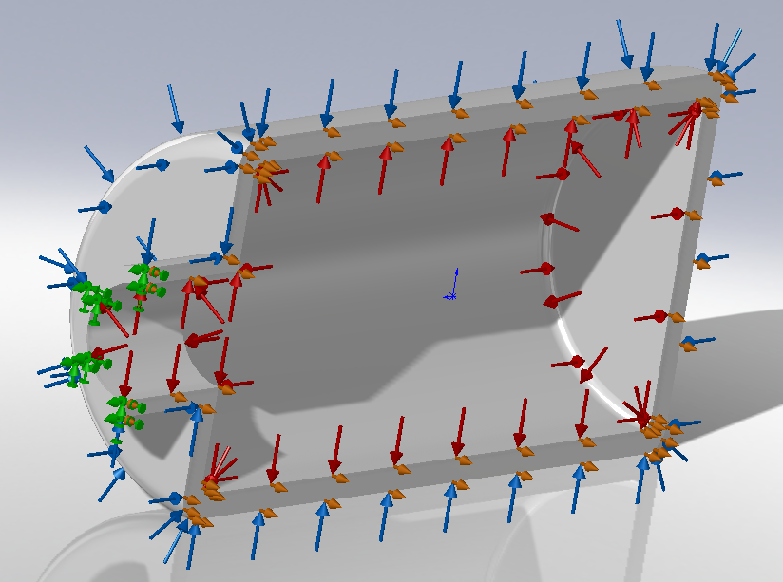

Figure . Vessel showing applied loads and constraints

Blue arrows represent the atmospheric load. Red arrows represent the internal pressure. The green arrows are the fixed constraint at the pipe inlet. The orange arrows are the symmetry constraint.

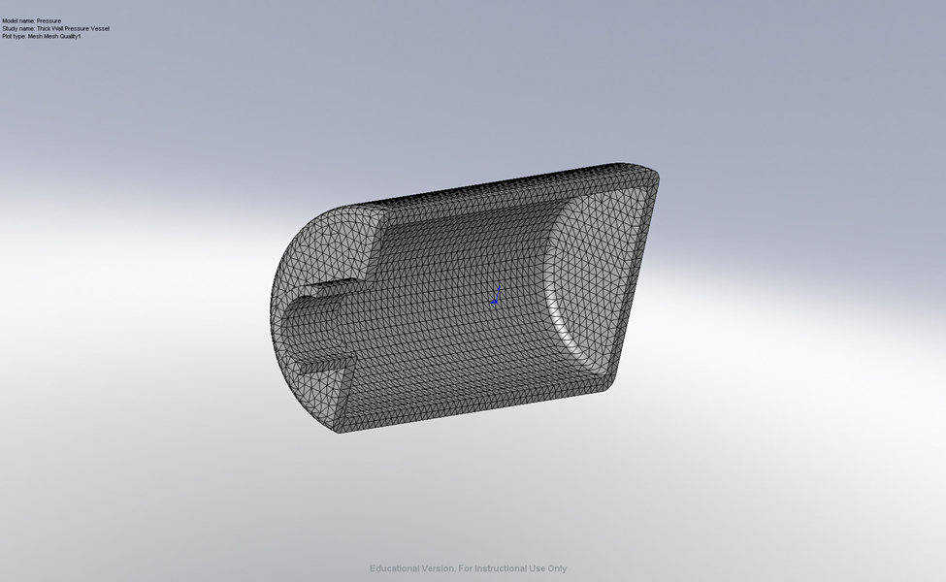

Figure . Isometric view of Mesh Results for the Pressure Vessel

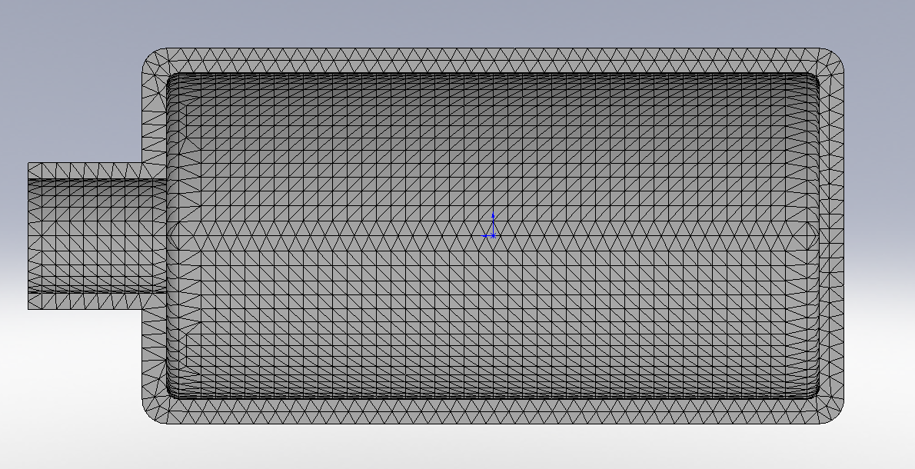

Figure . Normal View of Mesh showing the number of nodes at cross section

Default Results

|  |  |  |  |  |  |
| --- | --- | --- | --- | --- | --- |
| **Name** | **Type** | **Min** | **Location** | **Max** | **Location** |
| Displacement2 | URES: Resultant Displacement | 0 m  Node: 1066 | (285 mm,  -45 mm,  -3.28011e-013 mm) | 0.00100992 m  Node: 12613 | (-256.071 mm,  0.140566 mm,  8.32434e-021 mm) |
| Stress1 | VON: von Mises Stress | 4.81211e+006 N/m^2  Node: 42859 | (153.355 mm,  -114.902 mm,  4.51518 mm) | 5.60104e+008 N/m^2  Node: 29914 | (-221.699 mm,  0.139119 mm,  94.5453 mm) |
| Stress2 | SZ: Z Normal Stress | -3.63674e+008 N/m^2  Node: 29527 | (-200 mm,  -1.72295e-006 mm,  -1.20313e-020 mm) | 5.29785e+008 N/m^2  Node: 29914 | (-199.429 mm,  -3.62182e-013 mm,  95.3701 mm) |
| Stress3 | SY: Y Normal Stress | -3.62855e+008 N/m^2  Node: 29527 | (-200 mm,  -1.72295e-006 mm,  -1.20313e-020 mm) | 5.42001e+008 N/m^2  Node: 29578 | (-199.429 mm,  -95.3701 mm,  1.13728e-006 mm) |

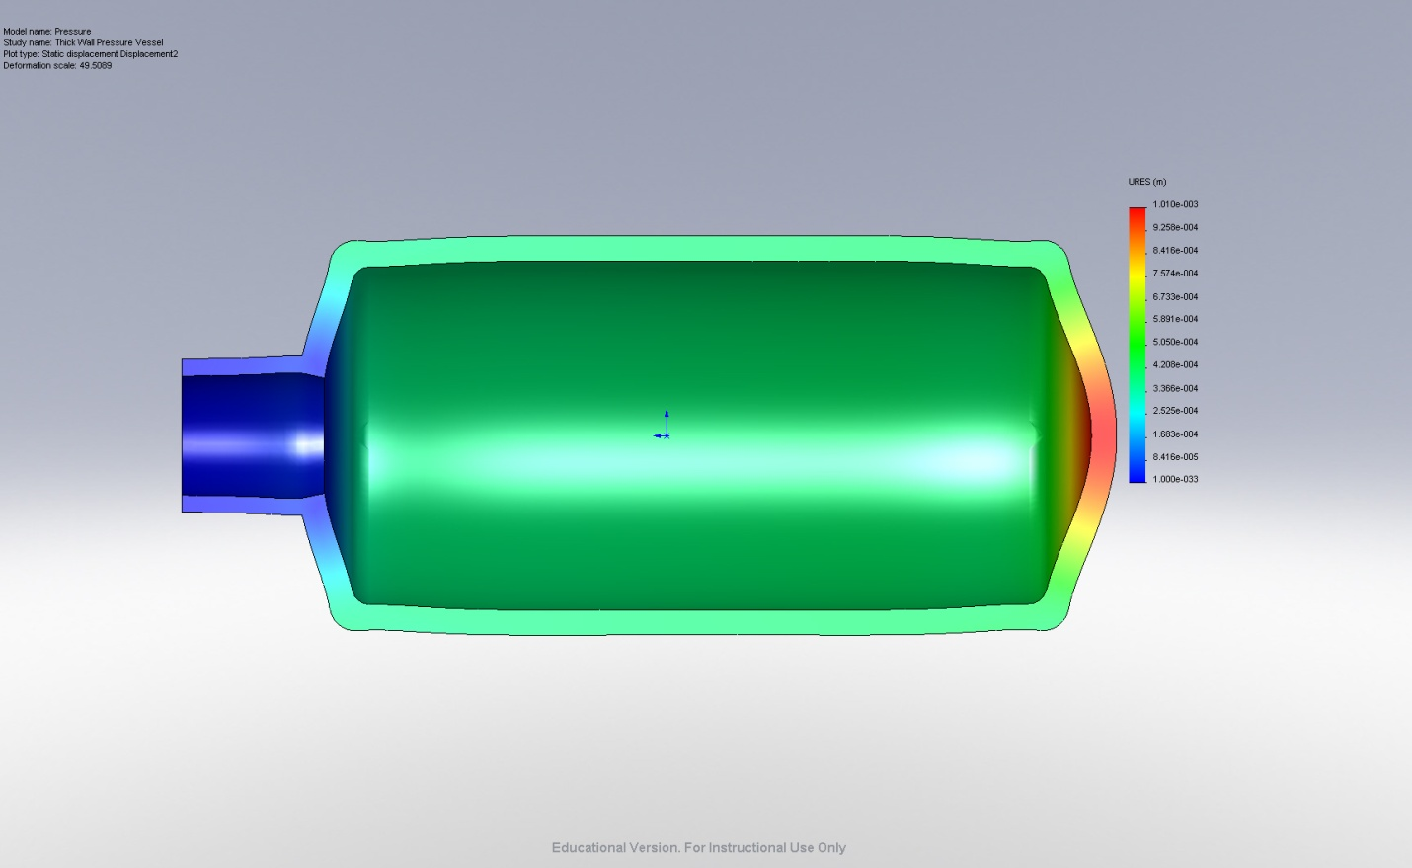

Figure . Displacement of Pressure Vessel

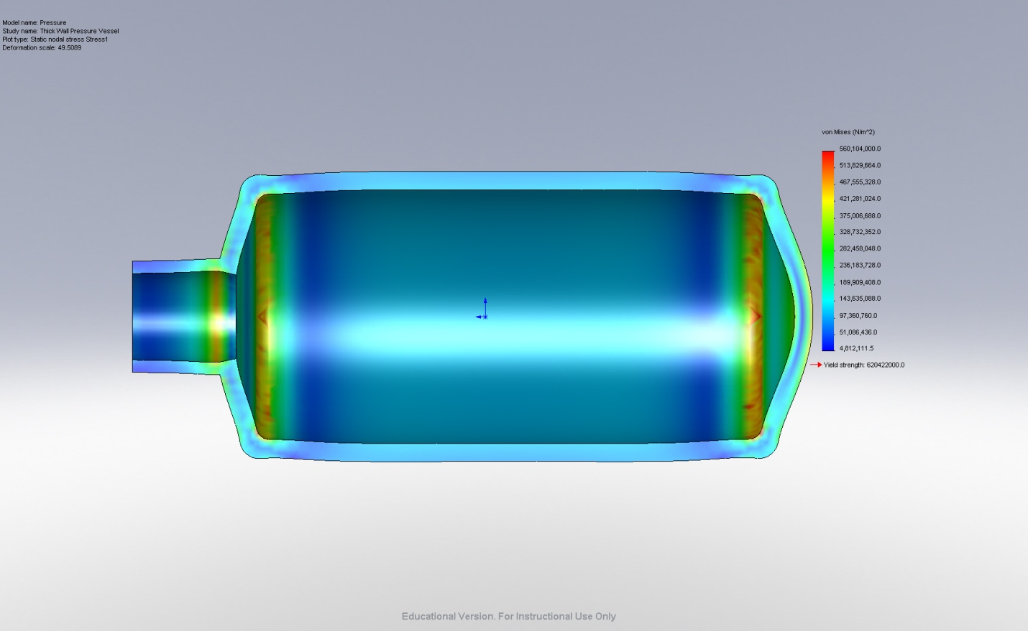

Figure . Von-Mises Stress on vessel with displacement

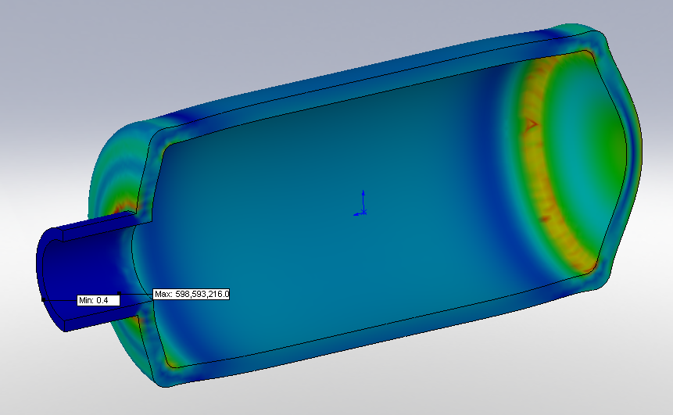Figure . Von Mises stress with max and min point

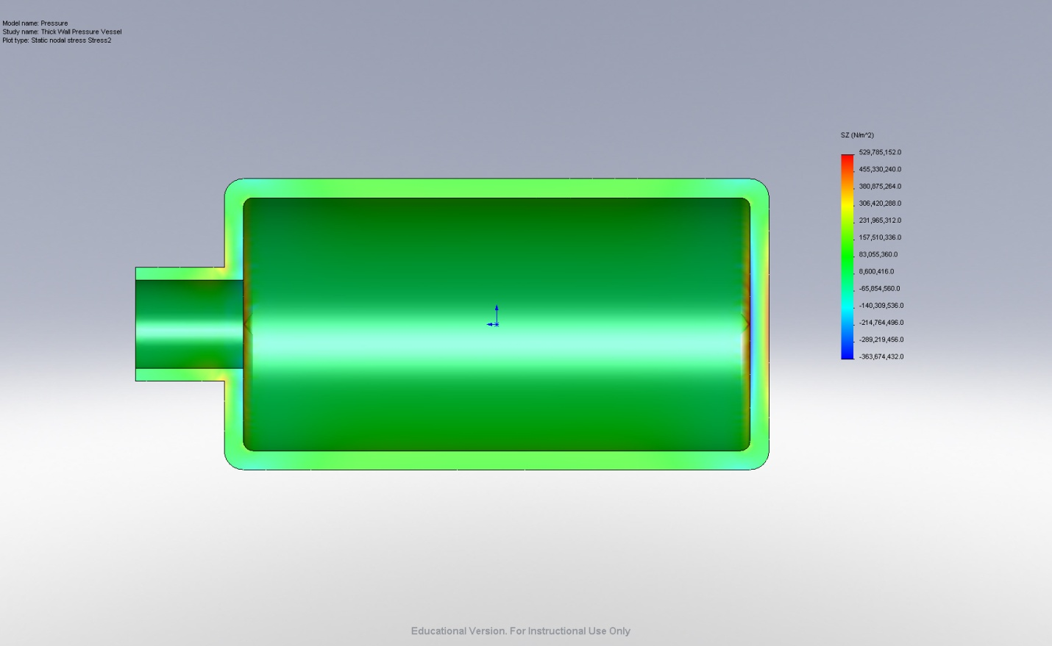

Figure . Normal View of Tangential Stress Plot

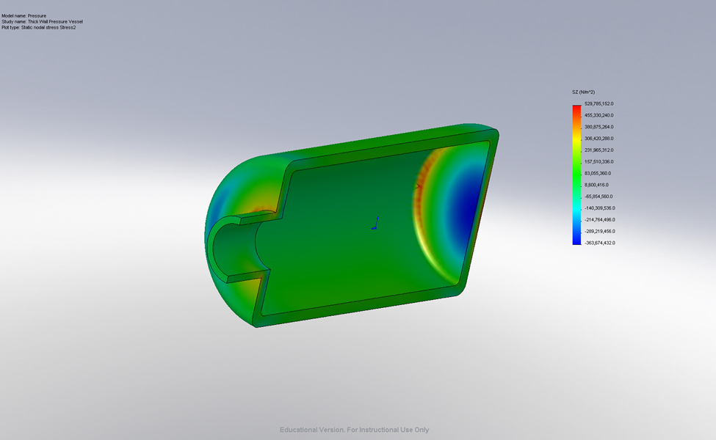

Figure . Isometric View of Tangential Stress Plot

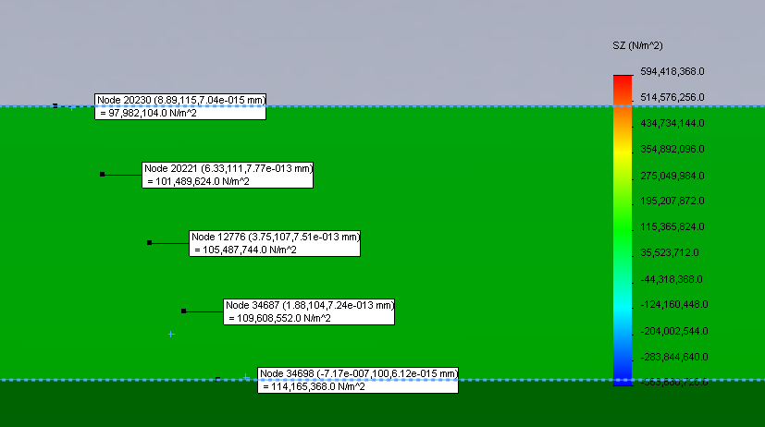

Figure . Tangential Stress Probes

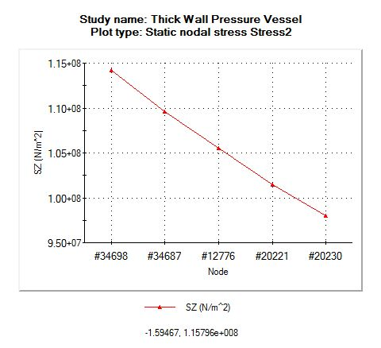

Plot of Tangential Stress Probes

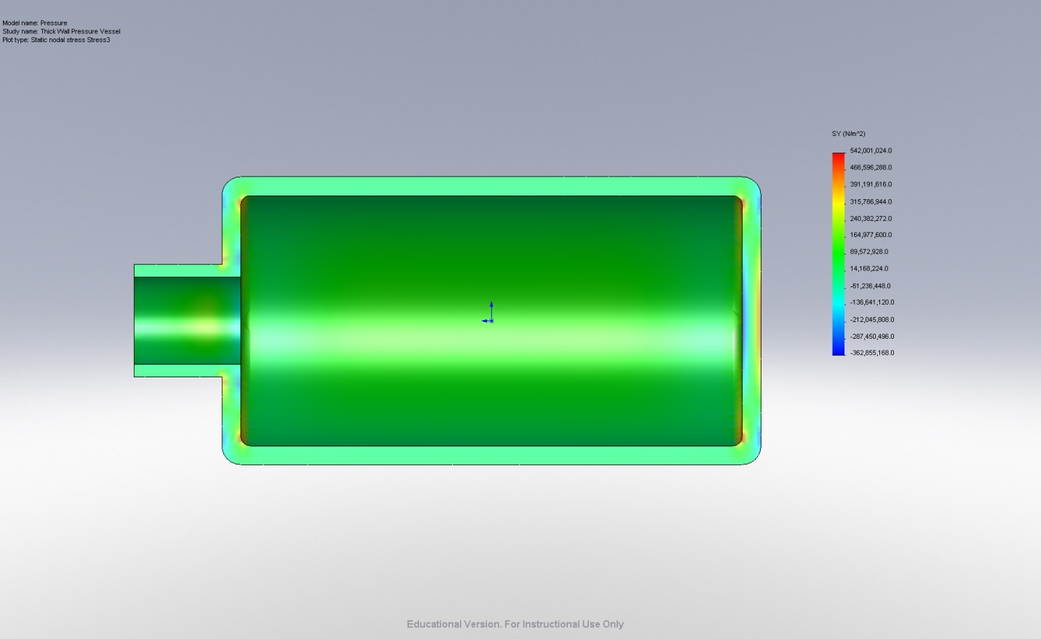

Figure . Normal View of Radial Stress Plot

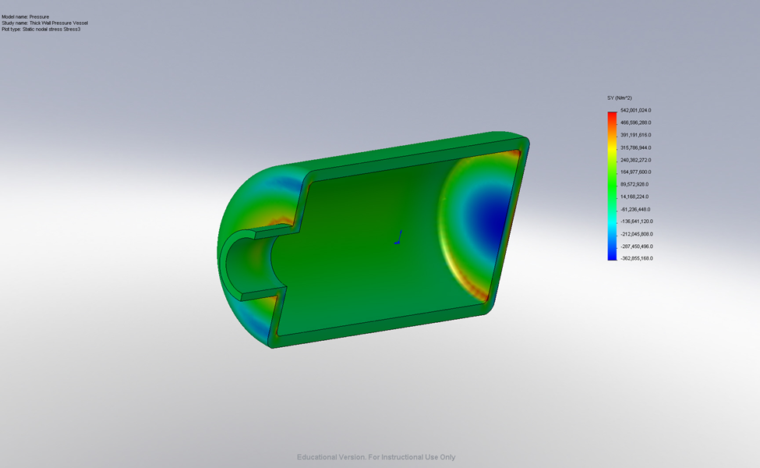

Figure . Isometric View of Radial Stress Plot

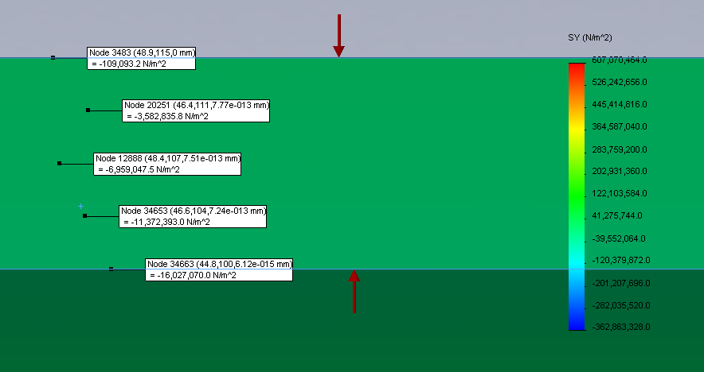

Figure . Stress Probes for the Radial Stress Plot

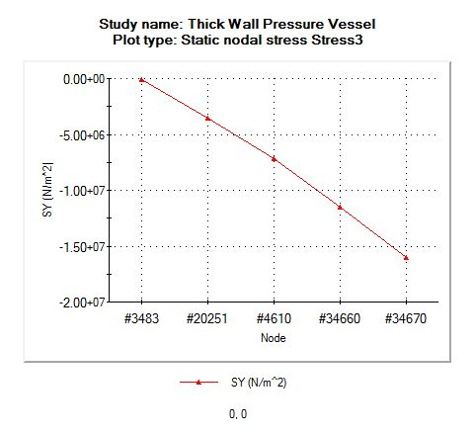

Plot of Radial Stress Probes

|  |  |  |  |
| --- | --- | --- | --- |
|  | **Classical (MPa)** | **FEA (Mpa)** | **% Difference** |
| **Outer Tangential** | 98.49 | 97.98 | -0.51% |
| **Inner Tangential** | 114.4 | 114.2 | -0.18% |
| **Outer Radial** | -0.101 | -0.109 | 7.34% |
| **Inner Radial** | -16 | -16.027 | 0.17% |

Table 1. Classical vs. FEM for Stresses

Conclusion

After completing our FEM analysis, the pressure vessel was shown to converge to stress values very similar to what we hand calculated. The hand calculations can be seen in the Appendix 1 below. The max error that we have is 7.34%, in the radial direction on the exterior surface. This high error could be due to many factors, but in all likely hood was due to a discontinuity at the point in the FEM analysis. The other calculated values are all within 1% of our hand classical results. The model can therefore be assumed to be an accurate representation of the physical loading of the system.

Appendix 1: Hand Calculations