

**ME 495 – Mechanical and Thermal Systems Lab**

**Ratio of Volumes – Experiment Number 7**

**Group F**

Kluch, Arthur

Le-Nguyen, Richard

Levin, Ryan

Liljestrom, Kenneth

Maher, Sean

Nazir, Modaser

Lentz, Levi – Project Manager

Professor S. Kassegne, PhD, PE

September 21, 2011

I. Table of Contents

I. Table of Contents 2

1. Objective of the Experiment – Modaser Nazir 3

2. Equipment – Arthur Kluch 4

3. Experimental Procedure – Richard Le 6

4. Experimental Results – Ryan Levin 7

5. Discussion of Results – Sean Maher 9

6. Lab Questions – Kenny Liljestrom 9

7. Conclusion – Levi Lentz 10

8. References 11

1. Objective of the Experiment – Modaser Nazir

Using the TH5-B equipment, our goal is to find the ratio of volumes for air in the two vessels by using an isothermal (constant temperature) expansion process. An isothermal process precludes any changes in temperature to the gas. Basic Thermodynamic elements such as properties of an ideal gas, conservation of energy, and conservation of mass will be implemented in this experiment.

The idea behind this experiment is that the mass of the system will be conserved between the two vessels (henceforth, our “system”). The system will have one vessel raised to a pressure of 30KPa above ambient pressure with the other vessel at a slight vacuum. A needle valve connects the two vessels. By the completion of the experiment, the mass will be evenly distributed among both containers. The process must remain isothermal, so the valve is opened at an extremely slow pace so as to prevent the temperature changing in the cylinder. The mathematical derivation is shown below.

The following derivation is from the document “RATIO OF VOLUMES - EXPANSION PROCESSES OF A PERFECT GAS (TH5-B)” written by Dr. Kassegne for the ME495 Laboratory [2].

According to the ideal gas equation of state:

m1 = $\frac{Vol1 P1abss}{RT}$ for the volume of the first vessel,

and m2 = $\frac{Vol2 P2abss}{RT}$ for the volume of the second vessel.

Substituting in to equation 1 then gives:

Pf =

Cancelling R and T, and rearranging gives:

Pf

Dividing top and bottom by Vol2, we get:

Pf =

This can be rearranged to give the equation for the volume ratio of the vessels,

$\frac{Vol1}{Vol2}$ = $\frac{P2abss-Pf}{Pf-P1abss}$

However, the above equation must be modified to account for a unit error. In this lab we will be using the following equation to calculate the ratio of volumes:

$R=\frac{Vol1}{Vol2}$ = $\frac{P2abss-P1absf}{P1absf-P1abss}$

This corrects the units as the pressure has to be both in absolute terms. The above equation will be used to calculate the ratio of the volumes. Note its high dependence on the pressure differences. It is imperative that these are measured as accurately as possible for an accurate experiment. The nomenclature for the symbols can be found in Table 1 below.

|  |  |
| --- | --- |
| **Term** | **Value** |
| Vol1 | Volume in vessel 1 [m^2] |
| Vol2 | Volume in vessel 2 [m^2] |
| p1abss | Initial absolute pressure in vessel 1 [N/m^2] |
| p2abss | Initial absolute pressure in vessel 2 [N/m^2] |
| pabsf | Final absolute pressure [N/m^2] |
| ps | Initial pressure in vessel 1 [N/m^2] |
| Vs | Initial vacuum in vessel 2 [N/m^2] |
| p1absf | Final pressure in vessel 1 [N/m^2] |

**Table 1. Nomenclature used for this laboratory [2]**

2. Equipment – Arthur Kluch

The equipment comprises of:

* Two floor standing interconnected rigid vessels on a common base plate, the larger vessel is for operation under pressure and the smaller vessel is for operation under vacuum. Both can be seen in Figure 3 below.
* A free-standing electrically operated air pump (in combination with ball valves on top-plate also allow for vacuum).
* 3 larger quarter-turn ball valves, shown in Figure 2 below
* 3 smaller quarter-turn ball valves, shown in Figure 2 below
* Associated tubing and fittings to connect pump to vessels
* Electrical console with current protection devices and an RCD for operator protection. The electrical console can measure pressure in increments as sensitive as 10 Pa and temperature as sensitive as 1 Ohm (resistance is inversely proportional to the temperature).
* PC for data collection
* IDF5 interface device

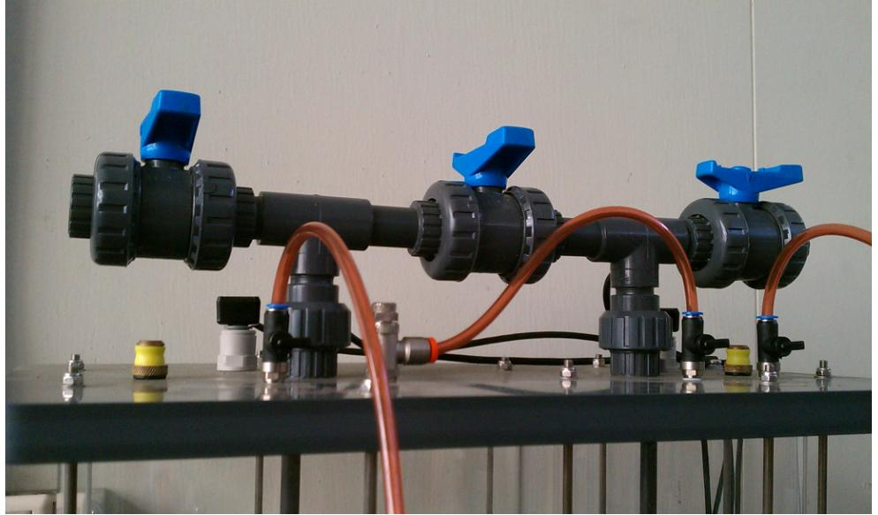

Figure 1 Valve assembly located on top-plate

Each vessel incorporates the following features:

* connection to the air pump via an isolating valve to allow the vessel to be pressurized/evacuated
* connection to a piezo-resistive sensor to measure the pressure/ vacuum inside the vessel (range of both sensors ±34.5kN/m2)
* connection to a large bore pipe and valve to allow depressurization/ pressurization of the vessel to/from the atmosphere (the valve is rapidly opened and closed to provide a small step change in pressure)
* interconnection between the two vessels via a large bore pipe and valve (fast change) and small bore pipe and needle valve (gradual change).
* fast response thermistor (T1 and T2) to monitor air temperature inside the vessel
* relief valve to prevent over-pressurization

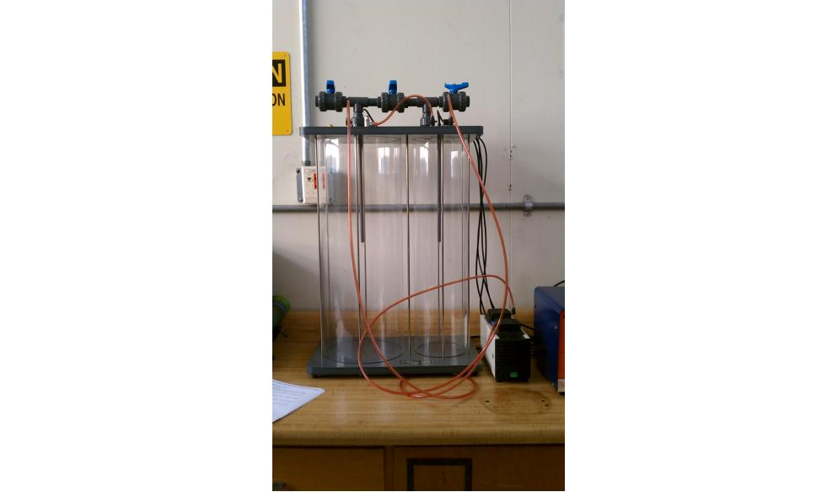

Figure 2 Rigid vessels with base and top-plates and associated valves and tubing

The Vessel Assembly has the following dimensions:

* Height:800mm
* Width:460mm
* Depth:280mm

The Electrical Console has the following dimensions:

* Height:220mm
* Width:220mm
* Depth:300mm

The two vessels shown in Figure two above are what are responsible for the entire experiment. The vessel on the left will be pressurized to approximately 30psi by the pump immediately to the right of the vessels. An electronic box immediately to the right of the pump will be responsible for capturing all data required for the experiment using an Armfield Interface Device (IFD-5).

3. Experimental Procedure – Richard Le

The following is the procedure that our group completed by following the guidelines outlined in the document “Ratio of Volumes – Expansion Processes of a Perfect Gas (TH5-B).” We found that we did not have to deviate from the established procedure.

Before beginning the experiment, make sure all of the equipment is working properly. This is done by opening all of the valves and checking that all tube connections are secure. Also turn on the pump to verify that the valves work properly, verifying that the pressure does not change after the pump is switched off. Next check that the computer and the pump are plugged in. When everything is ready to be used, turn on the computer. Open the experiment program and set Patm to be 760mm of Hg.

Close all the valves except V1 and V3 to allow air into the vessels. This starts the experiment at atmospheric pressure. Close V1 and V3 while opening V4. Turn the air pump on to pressurize the large vessel. Watch the electrical console to note the pressure. Wait until the pressure passes 30 kN/m2. When it reaches about 32 kN/m2, turn off the air pump. This pressure is required for the air to settle at 30 kN/m^2. Close V4 immediately and wait until the pressure in the vessel stabilizes to a number that does not fluctuate more than 1 kN/m2. Record the pressure as the starting pressure, Ps. Similarly, record the volume as the starting volume, Vs.

On the computer, click the “Configure” button. Type in “1” for the sample interval length in seconds. Click “Start” to begin the data logging. The computer will start collecting data on a table.

Make sure that valve V5 is completely closed and open valve V6. Slowly, open valve V5 by turning the knob to let air into the second vessel. This has to be done carefully. Make sure that the pressure is dropping slowly while the temperature remains constant. If the temperature change this process is no longer isothermal, and this run is now invalid.

Wait for the pressure to stabilize at a pressure that does not fluctuate more than 1 kN/m2. Record this final pressure as Pf. Click “Stop” on the computer program. Save the data table and repeat the experiment for a total of five runs.

4. Experimental Results – Ryan Levin

|  |  |  |
| --- | --- | --- |
| **PARAMETER** | **SYMBOL / EQUATION** | **UNIT** |
| Constant Temperature for both vessels | T | °C |
| Atmospheric Pressure | Patm | 101325 N/m2 |
| Initial Pressure for first vessel (Measured) | Ps | N/m2 |
| Initial Pressure for first vessel (Absolute) | P1abss = Patm + Ps | N/m2 |
| Initial Vacuum for second vessel (Measured) | Vs | N/m2 |
| Initial Pressure for second vessel (Absolute) | P2abss = Patm - Vs | N/m2 |
| Final pressure (Measured) | Pf = -Vf | N/m2 |
| Final Pressure (Absolute) | P1absf = Pf + Patm | N/m2 |

**Table 2: Symbols and units used for each parameter [2]**

|  |  |  |  |  |  |  |  |  |  |
| --- | --- | --- | --- | --- | --- | --- | --- | --- | --- |
| **Trail** | **Initial Pressure [N/m^2]** | | | | **Final Pressure [N/m^2]** | | **R =** | **R0** | **ERROR** |
| **Ps** | **P1abss** | **Vs** | **P2abss** | **Pf** | **P1absf** |
| **1** | 29430 | 130755 | -330 | 101655 | 20990 | 122315 | -0.735 | -0.78 | 5.78% |
| **2** | 29620 | 130945 | -330 | 101655 | 21070 | 122395 | -0.733 | -0.78 | 5.97% |
| **3** | 30180 | 131505 | -330 | 101655 | 21520 | 122845 | -0.729 | -0.77 | 5.38% |
| **4** | 29850 | 131175 | -330 | 101655 | 21160 | 122485 | -0.732 | -0.78 | 6.20% |
| **5** | 29790 | 131115 | -330 | 101655 | 21260 | 122585 | -0.732 | -0.77 | 4.96% |
|  |  |  |  |  |  |  |  | Average Error ± Std Dev: | 5.66% ± .49% |

**Table 3: Recorded values from Experiment 7.**

**Figure 3: Graph of the Percent Error vs. Run Number.**

The above Table 3 is the data that we have collected from the experiment. The R-Value was calculated using the following formula:

$R=\frac{Vol1}{Vol2}$ = $\frac{P2abss-P1absf}{P1absf-P1abss}$

Again note that this formula is slightly different from the formula presented in the procedural manual. The manual presents *P1absf* above as *Pf*, however, this would create incorrect units in the equation as one would be measured relative to atmospheric pressure, while the other would be measured in absolute terms.

5. Discussion of Results – Sean Maher

Throughout the five trials of our experiment, the data we recorded stayed relatively normal. The first three runs especially had an error difference of no more than 0.4%. While there was a slight discontinuity in the error between the first three runs and the next two, in the last two runs the error difference was only 1.24%. This percentage represented the largest difference between all of our runs, showing that there was a large amount of consistency between the runs. The base error was 5%, an error contributed largely due to human error and equipment error. However, the low scatter in the data we received from this lab is due to the patience and efficiency of our group. In each trial we let the initial pressure settle to a stable value before opening the needle valve to equalize the vessels, not rushing for the sake of time. Additionally, each run it was continuously verified that the process was isothermal, as we opened the valve slow enough to stop the temperature from changing in any amount. The ambient temperature was also very close to room temperature, allowing for much more accurate equalization of the pressure as we did not have to worry about the temperature of the surroundings interfering with the isothermal process.

6. Lab Questions – Kenny Liljestrom

**1. Why is this an isothermal process?**

An isothermal process is when the temperature for an ideal gas remains constant during a process. And if we recall that the internal energy is proportional to the temperature for an ideal gas, the internal energy remains constant if there is no variation in temperature [1]. In the Ratio of Volumes lab, provided by Dr. Kassegne, we pressurized a single vessel of the TH5 Expansion Processes of a Perfect Gas Apparatus, and once stabilized, slowly let air into the second evacuated vessel via the needle valve, V5, until the pressures equalized [2]. Since the air was released from the first vessel slowly, the temperature of the gas remained constant, thus the process is isothermal.

**2. How well do the results obtained compare to the expected results? Give possible reasons for any differences.**

**Error = $\frac{\left|R-Ro\right|}{Ro}$ X 100 %**

Using the equation above for percent error, we were able to calculate the difference in our experimental results and the theoretical results from a perfect experiment. As a whole, our results were fairly accurate which shows we took the time to carefully perform the experiment each time. The average percent error was 5.66% with a standard deviation of $±$.49. There is still an error in the experiment, assuming the equipment is perfect, there is the possibility of human error during each run. We had to slowly release the air from the pressurized chamber to the evacuated chamber without being able to see the air flowing or being able to hear the air being released due to the noise from the other labs. This made it difficult for our group to judge the flow of air leaving the pressurized chamber.

**3. Comment on the effect if the rate of change of pressure was sufficient to affect the temperature of the air inside the vessels.**

When a system is pressurized, the molecules of a perfect gas move more slowly because there is less space for the gas molecules to move around. Since we released the air slowly through the needle valve, the air molecules did not move rapidly enough to cause a large enough change in the temperature. The temperature variation recorded by the computer did not vary more than 1°C which shows the flow of air interchanged between the cylinders was slow enough to neglect a temperature change in the system which resulted in an isothermal process.

7. Conclusion – Levi Lentz

With the low level of experimental error and high consistency, t Through the experiment we were able to have the gas expand at a rate slow enough to prevent any significant change in temperature of the gas, maintaining the gas in both cylinders at a constant temperature. This ensured the gas was expanded as an isothermal process and hence had no variation in internal energy. Because of our experience with the equipment, we were able to keep the error percentage both low and relatively constant. We had an average error of 5.66% with a standard deviation of only .49%. With operator error would have contributed to this error, this low level of scatter in the data implies that each run was run consistently throughout the experiment, conversely indicating that it may have been a systemic error caused by the equipment. Some errors could have come from the rate at which the valve was open or the sensitivity that the valve had to the rate of flow through it. Overall, the low level of error and run-to-run accuracy shows that this was a well-run experiment. The results could be used as a benchmark so long as the level of error is noted.

8. References

[1] Nave, Rod. *Hyperphysics*. N.p., Aug. 2000. Web. 17 Sept. 2011. <http://hyperphysics.phy-astr.gsu.edu/hbase/thermo/isoth.html>.

[2] Kassegne, S. “ME495 Lab - Heat Capacity Ratio of Perfect Gas - Expt Number 6." Mechanical Engineering Department. San Diego State University. Fall 2011.