**RATIO OF VOLUMES - EXPANSION PROCESSES OF A PERFECT GAS (TH5-B)**

**Objective**

The objective of this experiment is to determine the ratio of volumes for air in the two vessels by using an isothermal expansion process. This demonstration gives students the experience with properties of an ideal gas, adiabatic processes, and the first law of thermodynamics. It also illustrates how P-V-T data can be used to measure other thermodynamic properties. In this exercise, TH5-B equipment is used to introduce students to a range of basic thermodynamic processes using air as the working fluid.

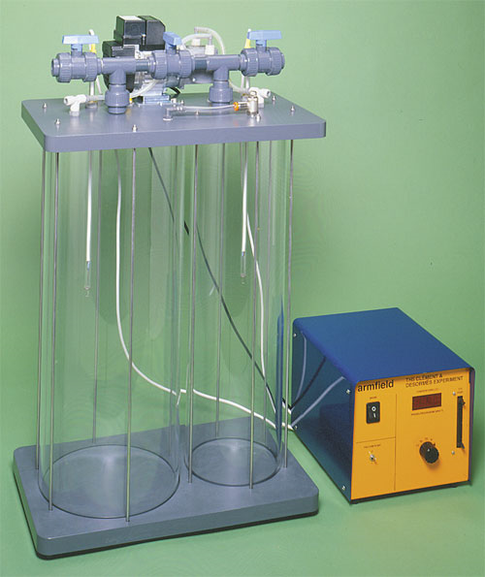

**Figure 1:** TH5 Expansion Processes of a Perfect Gas Apparatus, Armfield Limited.

**Introduction**

TH5 is a small scale unit designed to introduce students to a perfect gas using air to demonstrate basic thermodynamic processes. The equipment comprises two floor-standing interconnected rigid vessels on a common base-plate, the larger vessel (3) equipped for operation under pressure (pressurized vessel) and the smaller vessel (6) equipped for operation under vacuum (evacuated vessel). A free-standing electrically operated air pump, together with valves and toppings on the top-plate allow the appropriate vessel to be pressurized or evacuated as required. The vessels can be used independently or together to allow different thermodynamic processes to be evaluated. Both vessels are constructed from clear rigid plastic which affords light insulation between the air inside the vessels and the surroundings to reduce heating/cooling but allows each vessel and its contents to return to ambient temperature reasonably quickly.

A number of appropriate valves and tappings are fitted to allow different thermodynamic processes to be evaluated.

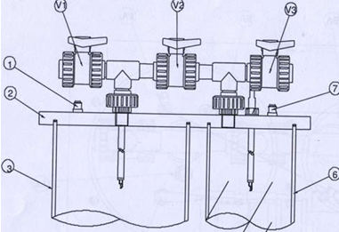 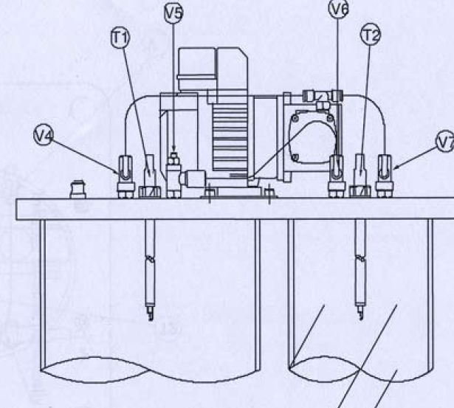

**Figure 2:** Equipment Diagrams

|  |  |
| --- | --- |
| **VALVE / TAPPING** | **FUNCTION** |
| V1 (Ball Valve) | It allows air to exit the pressurized vessel to the atmosphere when the vessel has been pressurized. |
| V2 (Ball Valve) | It allows air to flow from the pressurized vessel to the evacuated vessel when a pressure difference exists between the two vessels. |
| V3 (Ball Valve) | It allows air to enter the evacuated vessel after vacuum has been created in it. |
| V4 (Isolating Valve) | It allows the pressurized vessel to be isolated from the air pump. |
| V7 (Isolating Valve) | It allows the evacuated vessel to be isolated from the air pump. |
| V5 (Needle Valve) | It forms an interconnection between the two vessels by means of a small bore pipe thereby enabling gradual changes to occur.It can be adjusted to change the rate at which air flows between the two vessels. |
| V6 (Isolating valve) | Since V5 cannot be fully closed, isolating valve V6 allows this connection to be closed and also allows the setting of V5 to be preserved between demonstrations. |
| Pressure Relief Valves | A pressure relief valve (1) on the pressurized vessel and (7) on the evacuated vessel help to prevent over-pressurization of either vessel. |

**Pressure Sensors**

Two pressure sensors are used, both of which are piezo-resistive and produce a voltage output that changes linearly with the varying pressure.

|  |  |  |
| --- | --- | --- |
| **SENSOR** | **FUNCTION** | **RANGE** |
| P | It measures pressure inside the larger pressurized vessel. | +/- 34.48 kN/m2 |
| V | It measures vacuum inside the smaller evacuated vessel. |

**Temperature Probes (T1 & T2)**

Each temperature probe consists of a miniature semiconductor thermistor bead, incorporating extremely fine connecting leads, that is installed between two support wires at the tip of the temperature probe assembly. The thermistor is a thermally sensitive variable resistor that exhibits a highly non-linear and negative characteristic (resistance falls with increasing temperature). The extremely small size of the thermistor bead and connecting leads means that the thermal capacity of the small and therefore the first-order time constant is extremely small (the speed of the response is fast when the air temperature changes). The response of the thermistor can never be as fast as the pressure sensor because of the finite size of the bead and connecting leads but it is sufficiently fast to indicate the temperature changes that accompany the changes in pressure.

**Air Pump**

An air pump is used to supply air for evaluating the thermodynamic properties of a perfect gas. The inlet on the air pump is connected to the tapping on top of the evacuated vessel, and the outlet is connected to the tapping on the top of the pressurized vessel.

**Electrical Console**

All power supplies are connected in a simple electrical console which incorporates the necessary electrical connections for the air pump and the sensors. The pressure P, vacuum V and temperatures T1 & T2 measured inside the two vessels are displayed on a common digital meter with a rotator selector switch.

**IFD5**

An I/O Data Port connector on the right hand side of the console allows the voltage signals from each of the measurements to be connected to a suitable PC using an Armfield interface device (IFD5). The IFD5 connects to the electrical console via a 50-way data cable, and to the PC by means of the USB cable. The 50-way IDC header carries signals to and from the equipment. A red ‘Power’ LED lights when the unit is connected to the PC, and a green ‘**Active’** LED lights when the unit has been recognized by the PC.

**Determination of Ratio of Volumes**

The final equilibrium pressure Pabsf can be determined from the ideal gas equation of state:

Pabsf =

Where m is the sum of initial mass present in the two vessels, m1+m2

Vol is the total volume of the two vessels, Vol1 + Vol2

T is the final equilibrium temperature.

Substituting in for m and V gives:

Pabsf = (Eq. 1)

Both vessels are at room temperature before the valve is opened. As the process is isothermal, the initial temperature will be the same as the final temperature, (T1 = T1s = T1f = T2f)

According to the ideal gas equation of state:

m1 = $\frac{Vol1 P1abss}{RT}$ for the volume of the first vessel,

and m2 = $\frac{Vol2 P2abss}{RT}$ for the volume of the second vessel.

Substituting in to equation 1 then gives:

Pf =

Cancelling R and T, and rearranging gives:

Pf

Dividing top and bottom by Vol2, we get:

Pf =

This can be rearranged to give the equation for the volume ratio of the vessels,

$\frac{Vol1}{Vol2}$ = $\frac{P2abss-Pf}{Pf-P1abss}$

**Converting Resistance Values to Temperature**

Readings of T1 and T2 from the electrical console are resistance values for the thermistor inside each vessel. These resistance readings can be converted to the corresponding temperature values T1 and T2 using the table given in the appendix.

**System Set-Up**

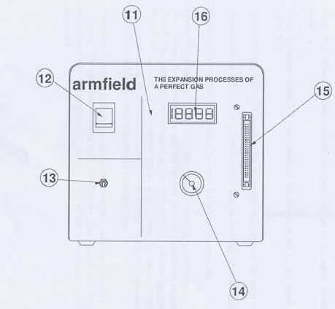 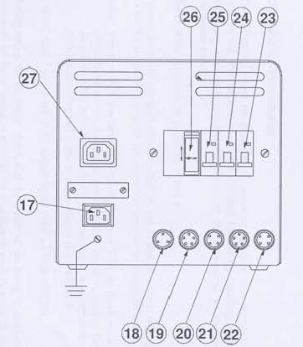

**Figure 3:** Electrical Console; (A) Front View, (B) Back View

1. Ensure that the Mains on/off switch (12) on the electrical console is in the OFF position and the air pump switch (13) is also set off.
2. Ensure that the ball valves V1, V2, V3 on the top of the vessels are fully open.
3. Ensure that the isolating valves V4 & V7 from the air pump to the pressurized and evacuated vessels are fully open.
4. Connect the inlet on the air pump to the tapping on top of the evacuated vessel, and the outlet to the tapping on the top of the pressurized vessel.
5. Connect the lead from the socket marked AIR PUMP (18) at the rear of the electrical console.
6. Connect the lead from each of the sensors to the appropriate socket at the rear of the electrical console as follows:

|  |  |
| --- | --- |
| **SENSOR** | **ELECTRICAL CONSOLE SOCKET** |
| P | PRESSURE SENSOR TANK 1 (19) |
| V | VACUUM SENSOR TANK 2 (21) |
| T1 | THERM TANK 1 (20) |
| T2 | THERM TANK 2 (22) |

1. Ensure that the mains electrical supply is connected and switched on.
2. Check the operation of the RCD (26) by pressing the TEST button. The RCD must trip when the button is pressed.
3. Ensure that the RCD and the three miniature circuit breakers marked PUMP (25), CTRL (24), and O/P (23) on the rear of the electrical console are in the ON position.
4. Set the mains on/off switch on the front of the electrical console to the ON position, and observe that the digital panel meter (16) is illuminated.
5. Set the rotary selector switch (14) to each position in turn and check that the readings are as follows:

* With the selector switch set to P or V, observe that the pressure and vacuum readings are zero.
* With the selector switch set to T1 or T2, observe that the resistance of the thermistor is indicated in Ohms, 2000Ω at 25°C.

1. Close the ball valves V1 & V2, and the isolating valve V6. Ensure that the isolating valve V4 is open to allow the air pump to pressurize the pressurized vessel.
2. Set the selector switch (14) to position P to observe the pressure inside the pressurized vessel. Switch ON the air pump (9) on the electrical console. Observe that the pressure P gradually rises. When the pressure reaches approximately 30 kN/m2, close isolating valve V4 and switch OFF the air pump.
3. Set the selector switch to T1 and observe that the temperature of the air has risen slightly (indicated by a small fall in the resistance of the thermistor T1).
4. Rapidly open and close ball valve V1 to allow a small amount of air to escape from the pressurized vessel. Observe that the pressure falls instantly then gradually recovers to a value below the original pressure. Check that the pressure P settles down after a few minutes and does not continue to fall (a continuing fall in pressure indicates a leak ).
5. Close ball valve V3, and ensure V7 is open to allow the air pump to evacuate the small vessel.
6. Set the selector switch to position V to observe the vacuum inside the evacuated vessel. Switch on the air pump and observe the vacuum V gradually rises. When the vacuum reaches approximately 30 kN/m2, close isolating valve V7 and switch OFF the air pump.
7. Set the selector switch to T1 and observe that the temperature of the air has risen slightly (indicated by a small fall in the resistance of the thermistor T1).
8. Rapidly open and close ball valve V3 to allow a small amount of air to escape from the pressurized vessel. Observe that the pressure falls instantly then gradually recovers to a value below the original pressure. Check that the pressure V settles down after a few minutes and does not continue to fall (a continuing fall in pressure indicates a leak).
9. Open the valves V1, V2 and V3 to return the vessels to atmospheric pressure.
10. Switch OFF the equipment using the mains switch (12) on the electrical console.

**Lab Exercise**

The objective of this exercise is to determine the ratio of volumes for two vessels using the TH5-B apparatus.

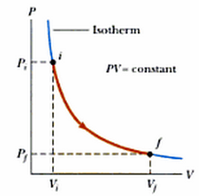

In this exercise, the vessel is initially pressurized and allowed to stabilize at ambient temperature. Subsequently, air is allowed to leak very slowly from the pressurized vessel into another vessel of different size via a needle valve (V5). This process is isothermal.

**Procedure**

1. Before starting the exercise, ensure that both the rigid vessels are at atmospheric pressure by opening valves V1 and V3 on top the vessels, and close all other valves.
2. The Patm is assumed to be 760mm of Hg (or 10130N/m2).
3. Close ball valves V1, V3, V5; and open V4.
4. Pressurize the large vessel by switching ON the air pump. When P reaches approximately 30 kN/m2 (indicated on the electrical console), switch OFF the air pump and close valve V4.
5. Wait until the pressure P in the large vessel has stabilized (P will fall slightly as the vessel contents cools to room temperature).
6. Record the starting pressure, Ps.
7. Click on the ‘CONFIGURE’ button on the mimic diagram screen. Configure the software to take samples at 1 second interval.
8. Select ‘**Start Sample’** to begin data logging.
9. Ensure that the needle valve V5is fully closed, and open the isolating valve V6. Open needle valve V5 very slightly to allow air to leak from the pressurized vessel to the evacuated vessel.
10. Adjust V5 so that P falls slowly with no change in T1 or T2 (if the flow of air is too fast then T1 and T2 will change and the exercise must be repeated).
11. As the pressure P falls in the large pressurized vessel and the pressure rises in the small evacuated vessel (negative readings for V) valve V5 can be slightly opened to reduce the duration of the exercise.
12. Allow the vessel contents to return to stabilize in pressure and temperature, and then record the final pressure, Pf.
13. Select ‘Stop Sample’ to stop logging the sensor readings.

**Data Reduction**

1. Record the following parameters:

|  |  |  |
| --- | --- | --- |
| **PARAMETER** | **SYMBOL / EQUATION** | **UNIT** |
| Constant Temperature for both vessels | T | °C |
| Atmospheric Pressure | Patm | 101325 N/m2 |
| Initial Pressure for first vessel (Measured) | Ps | N/m2 |
| Initial Pressure for first vessel (Absolute) | P1abss = Patm + Ps | N/m2 |
| Initial Vacuum for second vessel (Measured) | Vs | N/m2 |
| Initial Pressure for second vessel (Absolute) | P2abss = Patm - Vs | N/m2 |
| Final pressure (Measured) | Pf = -Vf | N/m2 |
| Final Pressure (Absolute) | P1absf = Pf + Patm | N/m2 |

1. For each step response, calculate the volume ratio for air as follows:

$\frac{Vol1}{Vol2}$ = $\frac{P2abss-Pf}{Pf-P1abss}$

1. Record the data as follows:

|  |  |  |  |  |  |  |  |  |  |
| --- | --- | --- | --- | --- | --- | --- | --- | --- | --- |
| **TRIAL** | **INITIAL PRESSURE** | | | | **FINAL PRESSURE** | | **R= $\frac{Vol1}{Vol2}$** | **Ro** | **ERROR** |
| **Ps** | **P1abss** | **Vs** | **P2abss** | **Pf** | **P1absf** |
| **1** |  |  |  |  |  |  |  |  |  |
| **2** |  |  |  |  |  |  |  |  |  |
| **3** |  |  |  |  |  |  |  |  |  |
| **4** |  |  |  |  |  |  |  |  |  |
| **5** |  |  |  |  |  |  |  |  |  |

Error can be calculated as follows:

**Error = $\frac{\left|R-Ro\right|}{Ro}$ X 100 %**

Where Ro = expected value of the ratio of volumes (from the data logger)

R = calculated value of the ratio of volumes.

1. Observe the transient changes in the air pressure and temperature following each step change using the data logger. The increasing resistance of the thermistor means decreasing temperature.

**Questions:**

1. Why is this an isothermal process?
2. How well does the result obtained compare to the expected result? Give possible reasons for any difference.
3. Comment on the effect if the rate of change of pressure was sufficient to affect the temperature of the air inside the vessels.

**Appendix**

Relationship between Resistance and Temperature for Thermistors used on TH5-B (Nominal Values)

