

**ME 495 – Mechanical and Thermal Systems Lab**

**Laser Vibrometry**

**Group F**

Kluch, Arthur

Le-Nguyen, Richard

Levin, Ryan

Liljestrom, Kenneth

Maher, Sean

Nazir, Modaser

Lentz, Levi – Project Manager

Professor S. Kassegne, PhD, PE

September 28, 2011

i. Table of Contents

i. Table of Contents 2

1. Object of Experiment – Modaser Nazir 3

2. Equipment – Arthur Kluch 6

3. Experimental Procedure – Richard Le 9

4. Experimental Results – Ryan Levin 10

5. Discussion of Results – Sean Maher 15

6. Lab Guide Questions – Kenneth Liljestrom 15

7. Conclusion – Levi Lentz 18

8. References 19

1. Object of Experiment – Modaser Nazir

A Polytec, PDV 100 Laser Doppler Vibrometer (LDV) will be used to measure the displacement, velocity, and acceleration of the mechanical vibrations in a speaker. The LDV lets us measure the vibrations by illuminating a laser at the surface of the speaker. Then we play different music and sounds at unique frequencies and the empirical measurements will be used to determine the damping ratio. This will also give us a good measure of how much power the system (cone speaker) can handle. The main purpose of Laser Vibrometry is that it shows us a way to accurately measure and decipher surface vibrations in a mechanical system. This excitation of the system will allow us to determine the dampening ratio of the system, to be described below.

Vibrations occur due to mechanical systems going through cyclic loading and unloading or constant motion and irritability. These vibrations can have a major impact on the lifespan of the machinery as well as the quality of work it will provide over time. That is why it is important to consider the side effects of vibrations when designing a system. Some everyday examples of materials under constant cyclic loading and unloading are shelves, benches, and bridges.

Acceleration, displacement, and velocity will be measured as a response to the harmonic input of the speaker. The forces that are present in this system are its mass (inertial force contribution), spring force (elastic stiffness), and some damping forces.

Damping ratio is important in a mechanical system because it can decrease the vibrations which in turn decreases the chances of the system failing. Vibrations are defined by the natural frequency. By increasing damping, you simultaneously decrease the strain on the material and thus increase the lifespan of the system.

The following derivations, equations, and figures are from the document “Laser Vibrometry – Experiment 8” written by Dr. Kassegne for the ME495 Laboratory. This derivation will be used to calculate the required values for the lab. [2]

The speaker system will be modeled as a spring-mass-dampener as shown below:

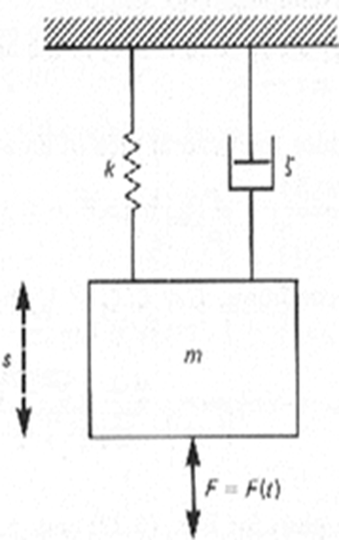

**Figure 1. A basic diagram of a Spring-Mass-Dampener.**

 (1)

Where S is the displacement, m is the mass, c is the damping coefficient, and k is the spring constant. F(t) the input force that excites the system, can be harmonic or a step input.

The damping coefficient is related to the damping ratio by the equation:

 (2)

For a second order system with a step input, the underdamped (ζ<1)solution to equation (1) is:

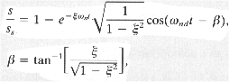 (3)

Where ωnd is the natural frequency.

The overdamped (ζ>1)solution to the equation would be:

 (4)

The image below shows an example of overdamped, underdamped, and critically damped responses of a second order system to a step input.

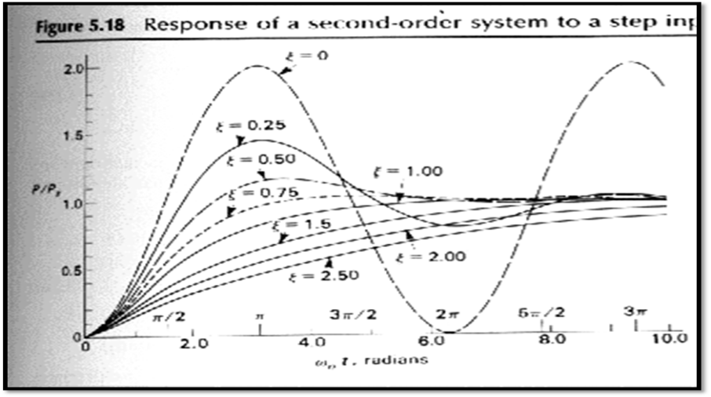

Figure 1: Second Order System Response to a step input

For a harmonically excited system:

F(t)=Fosin(Ωt) (5)

And thus, the solution to equation (1) becomes

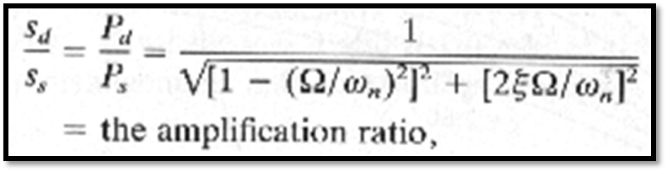 (6)

This solution gives the normalized amplitude where sd is the amplitude of the periodic steady state displacement and

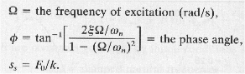 (7)

One method to estimate the damping is to harmonically excite the system through a series of frequencies, plot the amplitude ratio vs frequency ratio to obtain a curve like the one shown in figure 1. A precise determination of damping ratio can be obtained by also measuring the amplitude of the velocity, acceleration, and displacement at one frequency and using equations 1 and 2 to calculate the damping ratio.

Please note the equation numbers were corrected above for consistency throughout the document. We will be using these equations to calculate the dampening ratio from the dynamics of the system.

2. Equipment – Arthur Kluch

Below is the list of the equipment that was used in the experiment:

* PDV 100 Portable Digital Vibrometer Sensor
* BNC Cable
* USB Polytec Hardlock
* PDV 100 Portable Digital Vibrometer Power supply
* ArtDio Portable Computer Speaker
* USB Cable
* Polytec VIB – E – 220 Data Acquisition System
* Tripod
* Laptop Computer

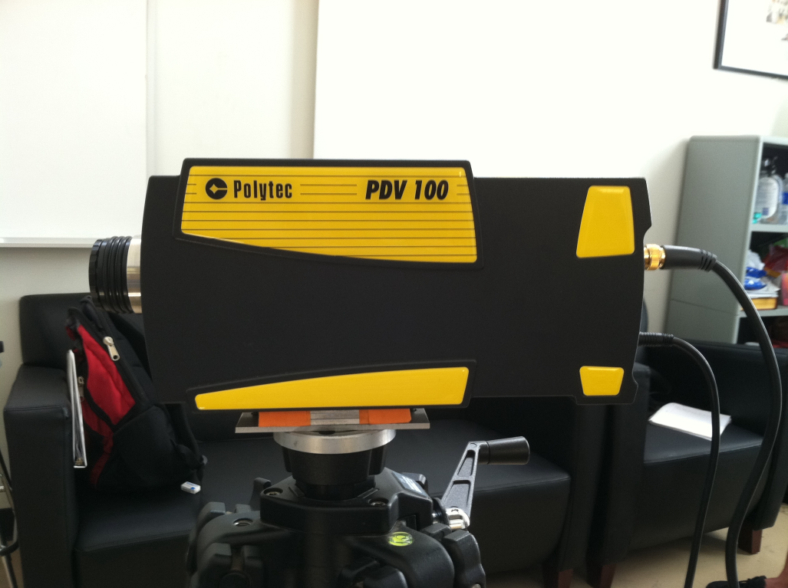

Figure 2 Polytec PDV 100 Digital Vibrometer mounted on tripod

Vibrometers are indispensable tools for loudspeaker design identifying Diaphragm resonances that are deleterious to sound quality. Vibrometer measurements provide an experimental basis for sophisticated acoustic investigations like structural-acoustic response (sound field) predictions, acoustic imaging and anti-sound research. Also the development of microphones, mobile phones and hearing aids benefits from LDV measurements. Vibrometers also have many other applications such as: automotive and aerospace design, micro and nano technologies, biomedical, and materials research. See the tables below for the sensitivity for the vibrometer used in this lab.

|  |  |  |  |
| --- | --- | --- | --- |
| General specifications | | | |
| Decoder type | DSP velocity decoder, 3 Measurement ranges | | |
| Frequency range | 0 - 22kHz (digital output); 0.5 - 22 kHz (analog output) | | |
| Measurement ranges | 3 | | |
| Full scale peak (mm s-1) | 20 | 100 | 500 |
| Scaling factor (mm s-1/V) | 5 | 25 | 125 |
| Velocity resolution | <0.02 | <0.02 | <0.1 |
| Maximum acceleration (m s2) | 2,760 | 13,800 | 69,000 |
| Working distance | 0.1 - 30 m | | |
| Laser safety | Eye-safe class II visible HeNe laser | | |

**Table 1. The general specifications for the Polytec PDV 100 Protable Digital Vibrometer. [4]**

|  |  |
| --- | --- |
| Output Signals | |
| **Analog velocity output** | |
| Output voltage swing | ±4V (24 bit DAC) |
| Frequency range | 0.5 - 22 kHz |
| Dynamic range | >90 dB |
| Calibration accuracy | ±1% (20 - 22 kHz) |
| **Digital velocity output** | |
| Electrical S/P - DIF interface | 24 bit, 48 kSa/s |
| Frequency range | 0 - 22 kHz |
| Calibration accuracy | ±0.2 % (0.05 - 22 kHz) |
| **Output filter** | |
| Digital low pass filter (FIR type) | 1, 5, 22 kHz (-0.1 dB), roll off > 120 dB/dec |
| Analog high pass filter | 100 Hz (-3 dB), roll off -60 dB/dec |

**Table 2. The output signal parameters of the PDV 100. [4]**

Between the PDV 100 and the computer is the Polytec VIB – E – 220 Data Acquisition System. The USB 2.0 breakout box provides two acquisition channels (signal and reference) and is powered directly by the USB cable. This allows for easy integration in standard notebook computers running Windows© XP Pro or Vista. The following are the features and benefits of the VIB – E – 220 Data Acquisition System:

* 2 channel, 20 kHz
* ± 10V input
* IEPE (ICP) support for reference channel
* Up to 204,800 FFT lines
* Export filters and macro programming
* No driver installation
* 64 MSamples continuous sampling

The Polytec VIB – E – 220 Data Acquisition System was attached to a Dell Vostro 1520 notebook computer. The computer is a 64-bit Intel Core 2 Duo running Windows XP Professional.

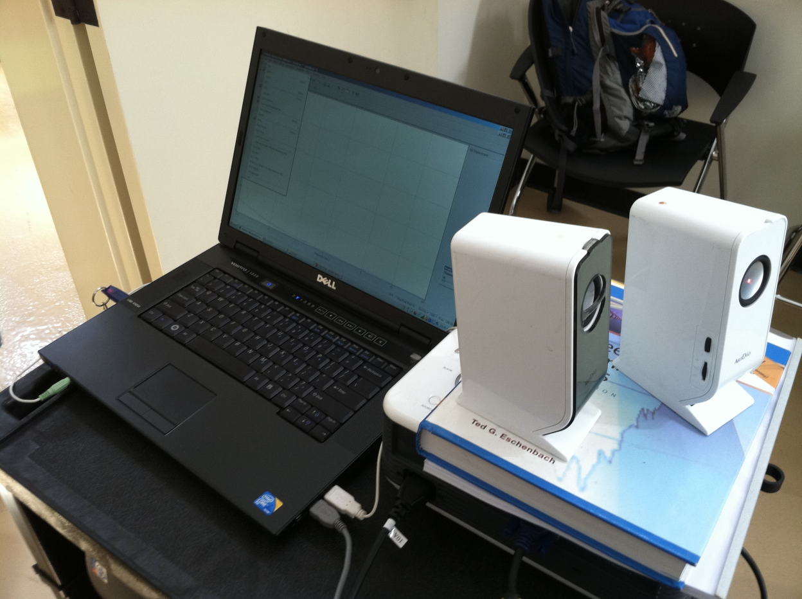

Figure 3 Dell laptop with USB Hardlock and ArtDio speakers

Providing the test signals for the experiment were a pair of ArtDio UC-117 speakers. The specifications on the speakers include:

* Total output: 2 watts (1W per channel)
* Speakers have 2x1.5" full-range drivers and frequency response of 200Hz - 18kHz
* Power source: USB
* Size: 5.9"H x 2.17"W x 3.93"D
* 3.5mm Stereo Input Connection

3. Experimental Procedure – Richard Le

The following is the procedure that our group completed by following the guidelines outlined in the document “Laser Vibrometry Lab.” We found that we did not have to deviate from the established procedure.

Before beginning the experiment, ensure that all equipment is working properly.  The computer was turned on and the lens was removed from the Laser Vibrometer. The laser was aligned with the center of the speaker. Both experiments were then commenced, all data being recorded on the computer.

In the first experiment, the VibrSoft Software was opened to measure the displacement. We followed the procedures given in the document and opened FFT, Magnitude, and Cursor. The vertical line was moved to the Frequency of 1 kHz. The Displacement screen was opened, pressing F8 to start recording data. We opened the Setting menu and chose “Channel” on the pop up window. In order to set the vibrometer channel, we clicked the Active box, set the direction to Y+, set the Coupling to DC, clicked ICP, and set the Quantity to Displacement. “Peak” was selected in the General tab. Audacity was opened, choosing “Sine” for the waveform, 1000 Hz for Frequency, 1 for Amplitude, and 30 seconds for Length. Audacity was used to generate the waveform output.

Once all settings were setup, “Generate Tone” and the Play buttons were pressed to begin the run. The run lasted ten seconds, with F10 being used to terminate the data recording. The magnitude of each run was recorded in the log book. It was ensured that the data was exported as well as all graphs for use in compiling the lab report. We used VibrSoft to change the graph to a Time Domain.

The above procedure was repeated again, in principle, to determine the acceleration of the speaker cone. However, the Signal was set to Acceleration to record the acceleration of the cone. In the vibrometer channel, the Quantity was set to Acceleration. Again, the run was completed by playing the tone with F8 starting the data recording, and F10 stopping it after 5 seconds. Then we wrote down the magnitude that we recorded. The data and graphs were again exported as prescribed above. The VibraSoft software was used to graph the recorded data in both the time and frequency domains.

Once more, the same procedure was used to record the velocity of the cone of the speaker. During this run, the Signal and Quantity were set to Velocity. Again, the tone was generated for five seconds, using F8 to start, and F10 to stop, the data recording. The magnitude was similarly recorded in the lab manual. Once again, the data was exported to excel to be used in the lab report. Once again, the VibrSoft data was graphed in both the time and frequency domains.

The second stage of the experiment was a rehash of the first stage; however as opposed to generating a sine wave, two different types of music were played through the speakers. One is a classical piece, while the other is “Electronic Music.” The classical piece used was “1812 Overture” by Tchaikovsky. The electronic piece was Daft Punk’s “Harder, Better, Faster, Stronger.” Each song was played separately for 25 seconds, using F8 and F10 to start and stop the data recording, recording the displacement of the cone. The data was exported to be individually compared to each other.

4. Experimental Results – Ryan Levin

|  |  |  |
| --- | --- | --- |
| **Run Type** | **Maximum Magnitude** | **Units** |
| Displacement @ 1kHz | 1.293 | mm |
|  |  |  |
| Velocity @ 1kHz | 1.314 | mm/s |
|  |  |  |
| Acceleration @ 1kHz | 1.284 | mm/s2 |

**Table 3. Recorded data from the sine wave output of 1kHz.**

Figures four through nine, below, are the data outputted by the VibrSoft software for a speaker outputting a 1kHz tone for ten seconds. This data is required to determine the dampening ratio of the speakers.

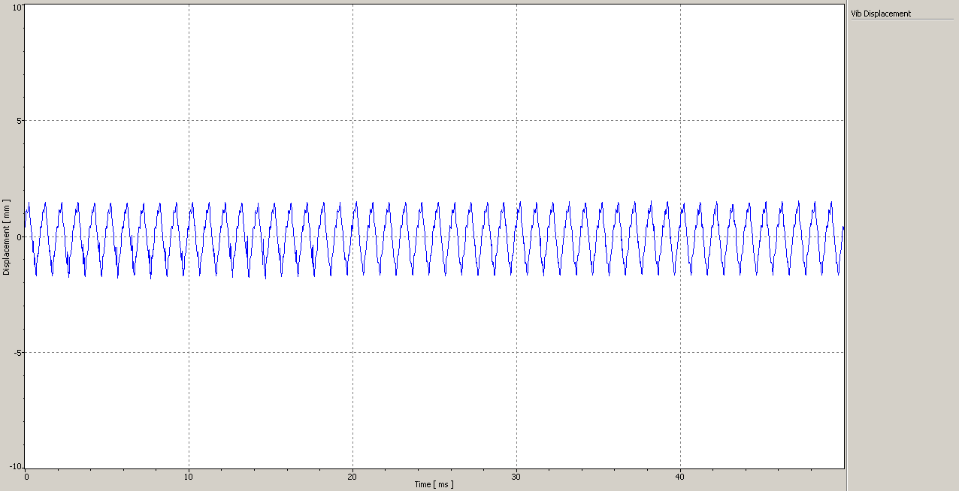

**Figure 4. Graph of Displacement Vs. Time**

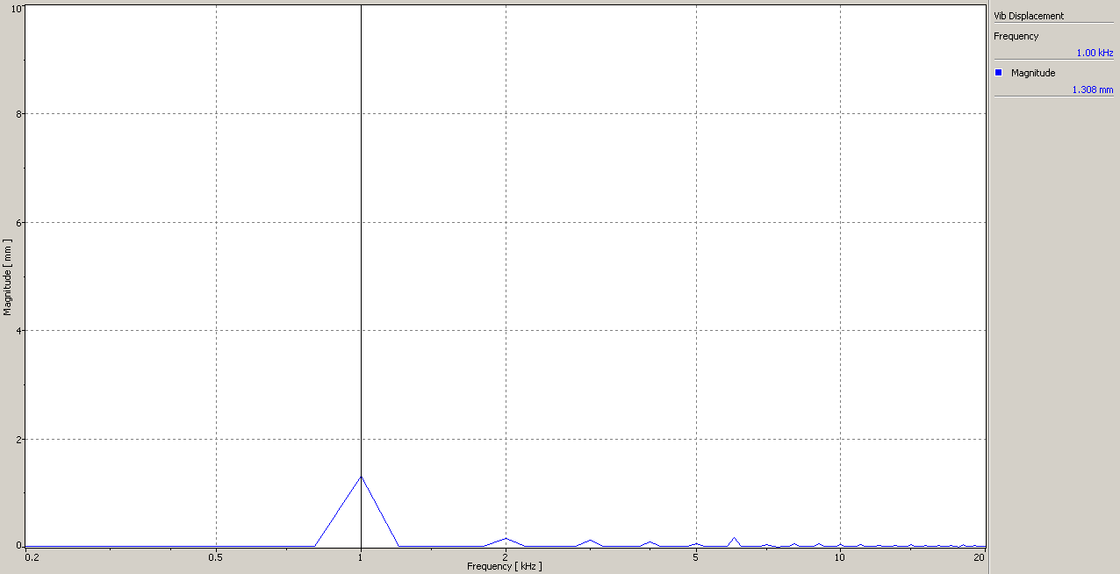

**Figure 5. Graph of Magnitude of Displacement vs. Frequency.**

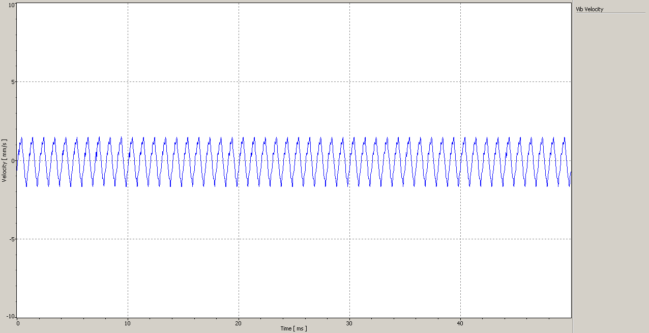

**Figure 6. Graph of Velocity vs. Time.**

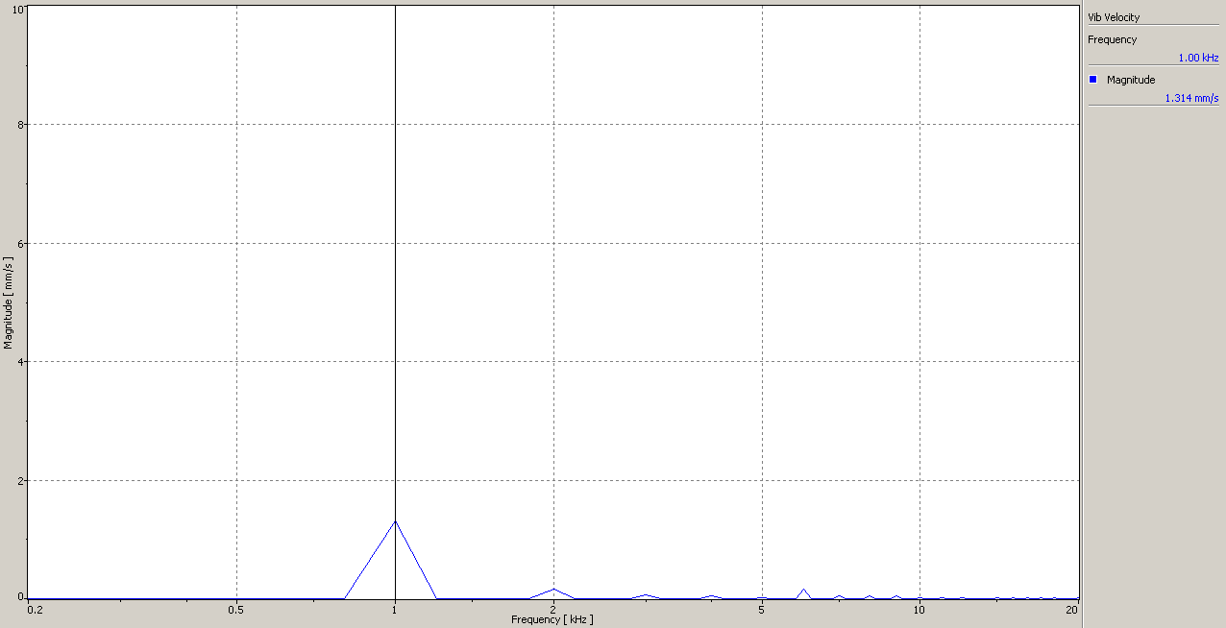

**Figure 7. Graph of Magnitude of Velocity vs. Frequency**

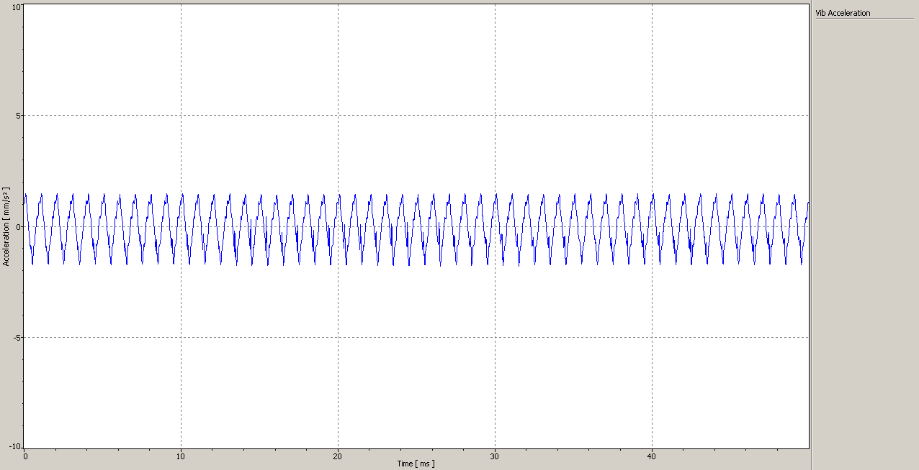

**Figure 8. Graph of Acceleration vs. Time**

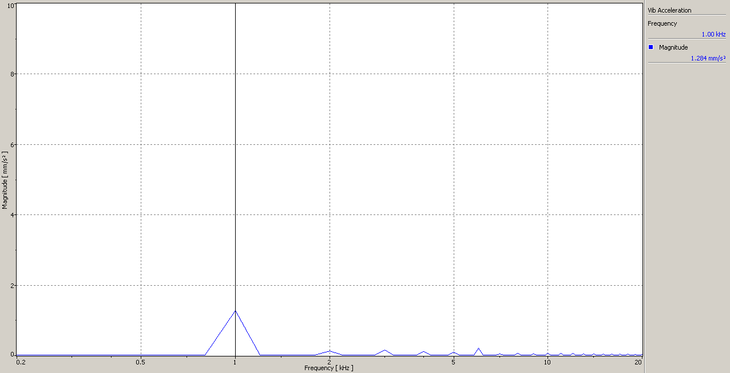

**Figure 9. Graph of Magnitude of Acceleration vs. Frequency.**

**Figure 10. Displacement vs. Time for two different types of music.**

**Figure 11. Displacement vs. Frequency for two sampled music.**

5. Discussion of Results – Sean Maher

The data for this run appears to be extremely reliable. During all recorded data, the peak for each of the recorded values was 1kHz for displacement, velocity, and acceleration. At 1 kHz we found that there was a maximum displacement of 1.293 mm, a maximum velocity of 1.314 mm/s, and a maximum acceleration of 1.284 mm/s^2. After running the experiment with or Electronic and Classical Music we found that as the frequency grew, the displacement shrunk. Because the cone has to vibrate much faster at higher frequencies, this implies that the data was very consistent with empirical predictions. Numerically, when the frequency was around .2kHz we had a displacement of approximately 2.3mm. Likewise, then the frequency was around 20kHz, we has a displacement of less than .05mm. While there is no benchmark to judge these results by, numerically, the data we obtained appears to be very accurate. Any error that was incurred was because of the experimental setup; the experimental rig had no way of ensuring each run was consistent. The speakers themselves were on top of a projector and a book, all of which was on top of a movable cart. Additionally, there was no scientific way of aligning the laser with the center of the cone. Any error that was incurred was due to equipment error as there was no room for operator error after the run was setup. A more accurate system would be able to get more reliable data from the speakers. Even with this, the consistency of the frequency with the displacement implies that the data from this run was reliable and can be used to calculate the dampening ratio.

6. Lab Guide Questions – Kenneth Liljestrom

**1. Determine the phase angle for the data from the first experiment.**

Equations in this section are referenced from *Theory of Vibration with Applications* by William T. Thomson [1]. We were asked to calculate the phase angle, φ, for the first experiment in which we pointed a laser vibrometer at the middle of an ArtDio speaker. When the speaker vibrates while playing a song, the laser vibrometer calculates the velocity of the speaker cone, where the displacement and acceleration can then be calculated as well. In order to do this we must recognize the system is in harmonic motion due to the output of the sine frequency by the speakers. This can be represented by the equation,

$$m\ddot{x}+c\dot{x}+kx= F_{o}sin⁡(ωt)$$

The recorded data from the vibrometer were 1.293 $mm$, 1.314 $\frac{mm}{s}$, and 1.284 $\frac{mm}{s^{2}}$ for the displacement, velocity, and acceleration respectively. The constants provided by Dr. Kassegne came from the lab manual for experiment 8 entitled “Laser Vibrometry”[2] are as follows:

$k=63 \frac{g}{mm}*g$*g* = 9.81 $\frac{m}{s^{2}}$*m* = 7 $g$*F(t) = $1sin⁡(2πft)$*

Given these constants and the data recorded from the lab we were required to calculate the phase angle, φ which is defined as,

$$ϕ=\tan^{-1}\frac{2ζ\frac{ω}{ω_{n}}}{1-{\left(\frac{ω}{ω_{n}}\right)}^{2}}$$

In order to calculate the phase angle we first need to calculate ω, $ω_{n}$ and ζ. The equation for the frequency ratio, which is the frequency (ω), divided by the natural frequency ( $ω_{n})$ is

$$\frac{ω}{ω_{n}}= \frac{2πf}{\sqrt{\frac{k}{m}}}= \frac{2π1 kHz}{\sqrt{\frac{63\frac{kg}{m}*9.81\frac{m}{s^{2}}}{7E^{-3}kg}}}= \frac{6.283 \frac{rad}{s}}{297.136\frac{rad}{s}}=0.02$$

We can calculate the damping ratio via the relationship between the damping ratio ( ζ ) and the damping coefficient ( *c* ) in the equation,

$$ζ= \frac{c}{2\sqrt{km}}$$

We also have an unknown in this equation being the damping coefficient ( *c* ). To solve for *c* we must go back and solve the equation for harmonic motion of a system. By plugging in the values recorded for the magnitudes of the displacement, velocity, and acceleration.

$$m\ddot{x}+c\dot{x}+kx= F_{o}sin⁡(ωt)$$

$$\left[\left({7E}^{-3} kg\right)(1.284E^{-3} \frac{m}{s^{2}}\right]+ c\left[1.319E^{-3}\frac{m}{s}\right]+ \left[\left(618.03 \frac{N}{m}\right)\left(1.293 E^{-3} m\right)\right]= 1sin⁡(2π\left(1 kHz\right)\left(0.03823 s\right))$$

$$c=80 \frac{N*s}{m}$$

Plugging *c* into the damping ratio equation,

$$ζ= \frac{80 \frac{N*s}{m}}{2\sqrt{\left(618.03 \frac{N}{m}\right)\left(7E^{-3}m\right)}}=19.23$$

Now that we have all the unknowns needed to solve for the phase angle, so plugging in our values yield,

$$ϕ=\tan^{-1}\frac{2\left(19.23\right)(0.02)}{1-{\left(0.02\right)}^{2}}=37.58°$$

**2. Find c when the system is critically damped.**

Knowing that the system is critically damped (ζ = 1), we can solve for the damping coefficient, c, via the equation for the damping ratio.

$$ζ= \frac{c}{c_{cr}}=\frac{c}{2\sqrt{km}}$$

Solving for the damping coefficient, c

$$c=2ζ\sqrt{km}$$

$$c=2*1\sqrt{618.03\frac{N}{m}*7E^{-3}kg}$$

c = 4.15991 $\frac{N*s}{m}$

**3. What can you say about the frequency contents of the two music pieces in Experiment 2?**

The two songs chosen to analyze were “1812 Overture” by Tchaikovsky as the classical piece and “Harder, Better, Faster, Stronger” by Daft Punk for the electronic piece. The frequency of the two pieces differed such that the range of the classical piece was played at a higher frequency throughout and the electronic was played at a much lower frequency. The classical piece was played with high frequency instruments like violins and cellos as opposed to the lower frequency instruments such as the bass and drums used in electronic music.

**4. How is 'beat' of music related to frequency?**

The beat of music is related to frequency because when two different interfering sound waves approach the ear, they interfere with each other which produces noise. The two frequencies are constructive and destructive interferences, which when subtracted from each other, the magnitude of the two values is equal to the frequency [3].

7. Conclusion – Levi Lentz

The completion of this experiment has taught the entire group a good deal about experimentally discovering properties of a mechanical system. This experiment has prepared us to be able to setup experiments to determine the dampening ratio of more advanced systems in the future. All the data that was acquired in the lab point to an accurately run experiment as the displacement of the cone tapered off as the frequency was increased. The primary problem with interpreting this data is that there is no empirical benchmark with which to compare our results to. The calculated dampening ratio, 19.23, appears to be rather large making this system excessively overdamped. However, the speaker was not supplied with a mechanical dampening ratio that we could compare this number to. The best way to verify this result would be to run this experiment again with a third party team to see the error difference between the two experiments. With all facts considered, this experiment can be considered accurate and a great way to introduce engineering student to the basics of vibration theory.

8. References

[1] Thomson, William T. *Theory of Vibration with Applications*. Third ed. Englewood Cliffs, N.J.: Prentice Hall, 1988.

[2] Kassegne, S. “ME495 Lab – Laser Vibrometry - Expt Number 8." Mechanical Engineering Department. San Diego State University. Fall 2011.

[3] Nave, Rod. *Hyperphysics*. N.p., Aug. 2000. Web. 22 Sept. 2011. <http://hyperphysics.phy-astr.gsu.edu/hbase/sound/beat.html>.

[4] Polytec Corp, *PDV100 Specifications*, Accessed August 26, 2011. <http://www.polytec.com>