Objective:

Using a Polytec, PDV 100 Laser Doppler Vibrometer (LDV) we will measure the displacement, velocity, and acceleration of the mechanical vibrations in a speaker. The LDV lets us measure the vibrations by illuminating a laser at the surface of the speaker. Then we play different music and sounds at unique frequencies and the empirical measurements will be used to determine the damping ratio. This will also give us a good measure of how much power the system (cone speaker) can handle. The main purpose of Laser Vibrometry is that it shows us a way to accurately measure and decipher surface vibrations in a mechanical system.

Theory:

Vibrations occur due to mechanical systems going through cyclic loading and unloading or constant motion and irritability. These vibrations can have a major impact on the lifespan of the machinery as well as the quality of work it will provide over time. That is why it is important to consider the side effects of vibrations when designing a system. Some everyday examples of materials under constant cyclic loading and unloading are shelves, benches, and bridges.

Acceleration, displacement, and velocity will be measured as a response to the harmonic input of the speaker. The forces that are present in this system are it’s mass (inertial force contribution), spring force (elastic stiffness), and some damping forces.

Damping ratio is important in a mechanical system because it can decrease the vibrations which in turn decreases the chances of the system failing. Vibrations are defined by the natural frequency. By increasing damping, you simultaneously decrease the strain on the material and thus increase the lifespan of the system.

The following derivations, equations, and figures are from the document “Laser Vibrometry – Experiment 8” written by Dr. Kassegne for the ME495 Laboratory.

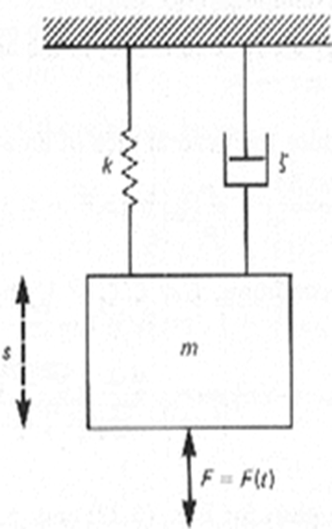

 (1)

Where S is the displacement, m is the mass, c is the damping coefficient, and k is the spring constant. F(t) the input force that excites the system, can be harmonic or a step input.

The damping coefficient is related to the damping ratio by the equation:

 (2)

For a second order system with a step input, the underdamped (ζ<1)solution to equation (1) is:

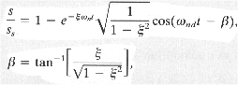 (3)

Where ωnd is the natural frequency.

The overdamped (ζ>1)solution to the equation would be:

 (4)

The image below shows an example of overdamped, underdamped, and critically damped responses of a second order system to a step input.

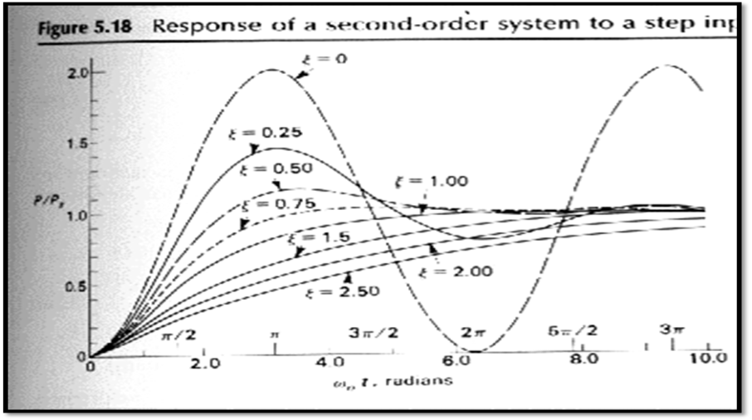

Figure 1: Second Order System Response to a step input

For a harmonically excited system:

F(t)=Fosin(Ωt) (4)

And thus, the solution to equation (1) becomes

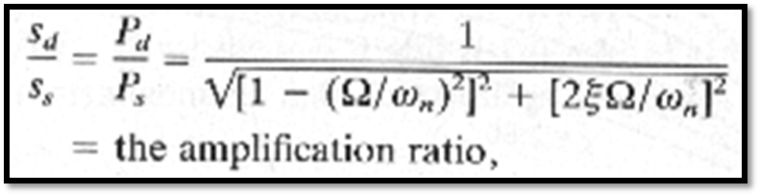 (5)

This solution gives the normalized amplitude where sd is the amplitude of the periodic steady state displacement and

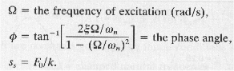 (6)

One method to estimate the damping is to harmonically excite the system through a series of frequencies, plot the amplitude ratio vs frequency ratio to obtain a curve like the one shown in figure 1. A precise determination of damping ratio can be obtained by also measuring the amplitude of the velocity, acceleration, and displacement at one frequency and using equations 1 and 2 to calculate the damping ratio.

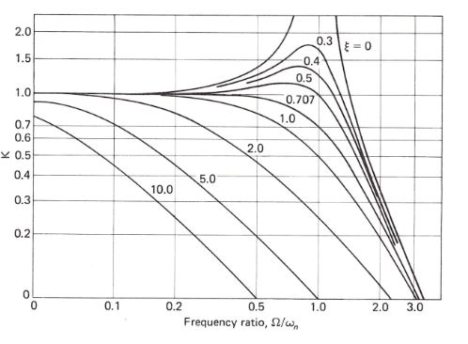

**Figure 2: Theoretical damping curves [1].**