**San Diego State University, Mechanical Engineering**

**ME 495 – Mechanical & Thermal Systems Lab**



**Brayton Cycle (Gas Turbine Power Cycle)**

|  |
| --- |
| Group C |
|  |
| Eakin, Kevin – Project Manager |
| Ederer, Christopher |
| Elam, Joshua |
| Grell, Nicholas |
| Grover, Thomas |
| Guardia-W, Diego |

Professor Sam Kassegne, PhD, PE

November 17, 2010

**Table of Contents**

Objective of the Experiment (Josh) 3

Equipment (Nick) 5

Experimental Procedure (Diego) 6

Experimental Results (Chris) 7

Discussion of Results (Josh) 10

Lab Guide Questions (Tom) 11

Conclusion (Kevin) 14

References (All) 15

**Objective of the Experiment**

(Josh)

State the purpose or the goals of the experiment and what you expect to accomplish by performing the experiment (4)

The objective of this lab was to obtain working, practical knowledge of the Brayton Cycle. An SR-30 turbojet engine (built by Turbine Technologies, LTD) was used to conduct this experiment, and empirical readings were taken at various times and locations throughout the experiment for use in equations. Performing a basic thermodynamic analysis will allow us to understand physically what goes on in a Brayton cycle.

Describe in detail the theory and principle behind the experiment. Include the equations you will be using. (4)

Properly define all symbols and acronyms (2)

The Brayton cycle uses the cold air standard assumption that specific heats are constant at room temperature, and all processes are internally reversible. This cycle consists of four stages.

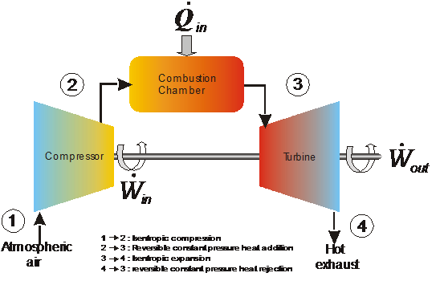

Figure X. Standard Brayton Cycle

In the first stage, atmospheric air is brought into the compressor and is compressed isentropically in order to increase the temperature of the air (this high temperature raises the efficiency of the system). Next, this high pressure and temperature air is mixed with fuel in the combustion chamber, is ignited by spark, and undergoes constant pressure heat addition. This hot gas then enters the turbine region of the apparatus, and expands isentropically, turning the turbine. Then the gas undergoes constant pressure heat rejection and is relocated to the air intake from the exhaust. This last step is theoretical; in reality there is a constant source of air intake so the exhaust does not need to be recycled in a closed loop.

In this lab, we will calculate the overall thermal efficiency of the system, which is given by the equation:

*nth, Brayton = 1 – 1 .*

*rp ^((k-1)/k)*

In this equation, rp is the pressure ratio, and k is the specific heat ratio of air. We will also be calculating the thermal efficiency of the turbine and compressor at each engine speed using the standard equations derived from the first law of thermodynamics:

*nc* = ( T*out,s –* T*in) / (* T*out,a –* T*in)*

*nT* = (T*out,a –* T*in) / (* T*out,s –* T*in)*

In these equations, Tin is the temperature at the inlet to the device, Tout, s is the ideal (isentropic) outlet temperature, and Tout, a is the actual outlet temperature. We will also be calculating the back work ratio using the following relations:

*bwr* = *wCOMP / wTURB*

- *wTURB = Cp,T (Tt,out – Tt,in)*

*wCOMP = Cp, c (Tc, out - Tc, in)*

The work in the compressor and turbine are calculated using the inlet and exit temperatures of the device, as well as the specific heat, Cp, evaluated at the average of the inlet and exit temperatures.

**Equipment**

(Nick)

The equipment for this experiment was contained within the test bench and lab computer. The two items included the TTL Mini-Lab test bench manufactured by Turbine Technologies Ltd.(pictured below) and the Dell desktop computer.

* + TTL Mini-Lab manufactured by Turbine Technologies Ltd
    - SR-30 Engine
    - Pressure gages
    - RPM readout
    - Thrust out
    - Controls
  + Dell desktop computer
    - Virtual bench
  + Hearing protection

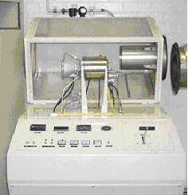

**Figure 2:** TTL Mini-Lab manufactured by Turbine Technologies Ltd. (TTL) [Ref 1]

**Experimental Procedure**

This experiment requires the operators to be very aware of all components of the SR-30 turbojet for safety reasons. The first step is to become familiar with the controls and gauges of the turbojet. Once the operators are familiar with the turbojet’s control the next step is to set up the computer to record data during operation of the turbojet. From the desktop of the computer launch VirtualBench and follow the procedure for entering the filename to save the data to.

When this is complete the experiment is ready to begin. To start the engine turn on the Master Key and the El. Master Key. Make sure the throttle handle is pushed all the way forward. Then simultaneously turn on the Ignition and Air Start. The compressed will start the engine. Once the engine has reached 8,000 RPM turn the Fuel switch on. This injects kerosene into the engine for ignition and the increase in sound will be a sign that the engine has ignited. Once the engine has reached 20,000 RPM the Air Switch and Ignition can be turned off. Now using the throttle handle, manipulate the engine to the desired RPM. When the desired RPM has been reached signal to the computer operator to begin recording data. The computer operator will push start in the software and record roughly 8 data points before pushing stop. While the computer is recording data, another group member should be hand recording the temperature, engine speed, and fuel pressure to compare with the computer data for errors as well as for safety. If the temperature exceeds 500ºC the engine must be turned off immediately. When enough data has been recorded stop the software and turn off the engine by cutting the fuel.

Follow the same procedure for all other desired RPMs. Make sure all of the data is saved and power down all equipment.

**Experimental Results**

(Chris)

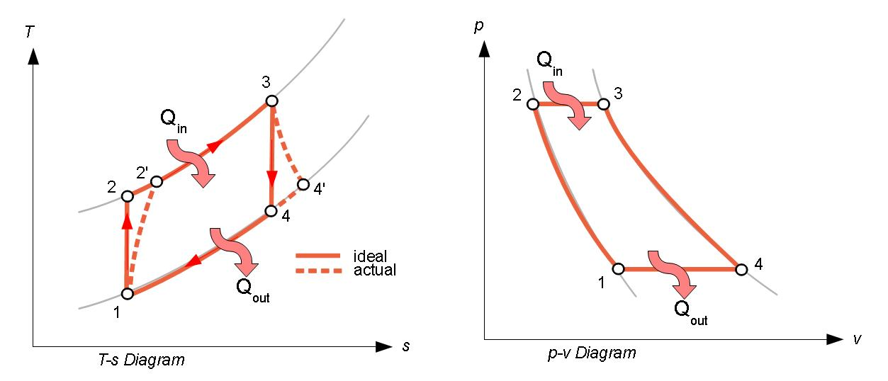

Fig. X T-s and p-v diagrams for the brayton cycle [non-referenced].

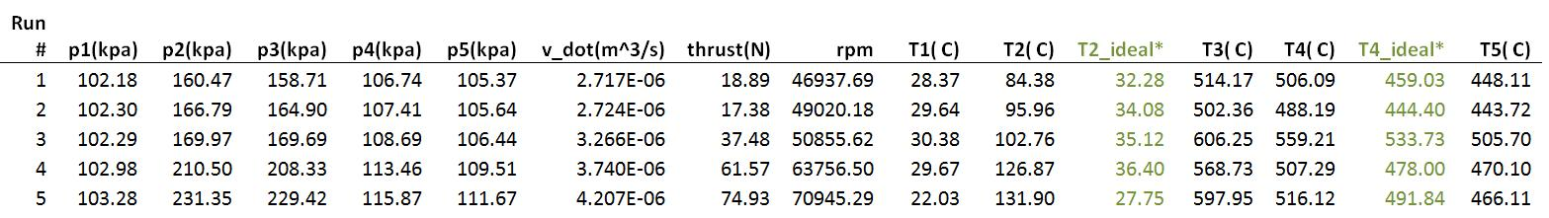

Fig. X Average results from experiment. Values shown in **green** were calculated using the Perfect Gas Daemon from [http://thermofluids.net/](http://www.google.com/url?q=http%3A%2F%2Fthermofluids.net%2F&sa=D&sntz=1&usg=AFQjCNGCJWoSADhCdYt3b_9HhxiyOcDThA) [2]

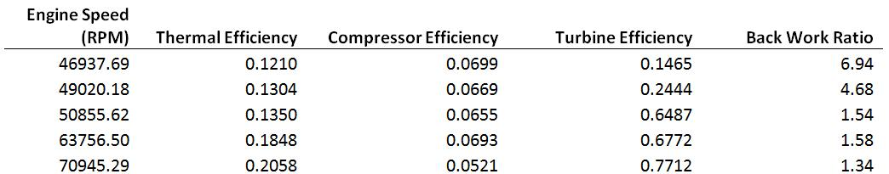

Fig. X Calculations based from results shown in figure X above.

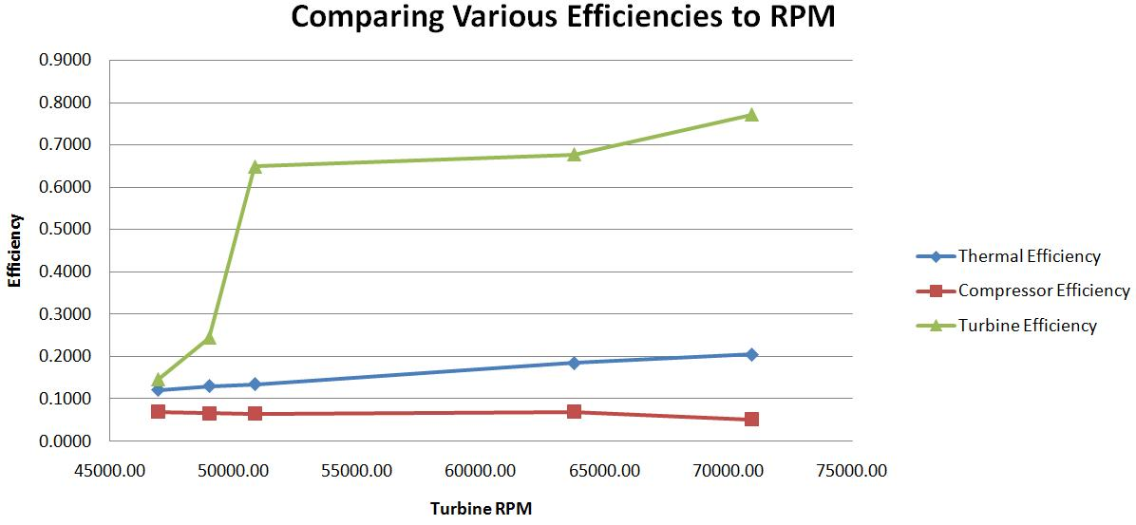

Fig. X Comparison of Thermal, Compressor, and Turbine efficiencies with dependence on RPM.

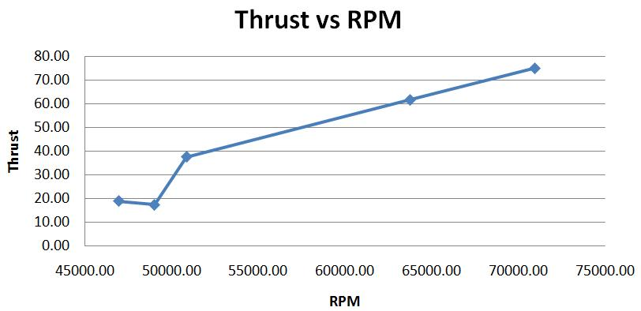

Fig. X Relationship of thrust in Newtons, to RPM.

**Discussion of Results**

(Josh)

Discuss the experimental data obtained (5)

The data obtained was accurate overall, with the exception of bad sensors in the first 3 runs that affected our data. All of the data was recorded in a log using computer software, and was used to calculate various parameters.

Discuss the possible sources of the experimental error and how it affected the results (10)

There were many possible sources of biased experimental error in this lab. First of all, our thermocouples and pressure sensors appeared to be malfunctioning during our first 3 runs by giving us incorrect temperatures, negative thrusts, and fluctuating pressures. This skewed our results one way, because most calculations in this lab are dependent on temperature. We initially tried to fix this problem by cleaning the thermocouples and pressure sensors, and when this did not help, we shut down the software and unplugged the data cable to the computer. There were bent prongs and visible residue on the cable, and when these problems were fixed the thermocouples and pressure sensors functioned perfectly.

Another source of biased error could be the strain gauge which measures thrust. When calibrating this gauge before the lab, the display showed fluctuation in the thrust, even when no one was touching it. The fluctuation was always positive. This could be due to bad hardware in the strain gauge, or vibrations in the test bench. Fortunately, no other calculations are dependent on thrust. Thrust was measured to give a benchmark idea of what type of power the turbojet generated.

A source of random error is the fluctuation in the engine speed. The rpm was controlled by group members via a lever, and it was very hard to set the speed exactly where we wanted it and hold it steady. Because of this change in rpm, we have data for several ranges of rpm values, instead of data for individual speeds.

Provide a correlation or comparison of your experimental results with those that you predicted or expected from theories or theoretical analysis. Explain any discrepancy (5)

Our experimental results are very close to what we expected in the last 3 runs, once the sensors were functioning properly. We used some data from other groups to replace these runs, so that when we analized the data the numbers would be more accurate. The data showed that as engine speed increased, thermal efficiency, compressor efficiency and turbine efficiency also increased. For the first three runs, we compared our data to data from another group which performed the same experiment on 11/3/10. With the exception of the aforementioned sensors, all of the data matched up well with what the other group had. These results coincide with widely accepted Brayton cycle theory.

**Lab Guide Questions**

**(Tom)**

1. What can be observed about the turbine engine’s efficiency in relation to its RPM?

According to figure x ,there is a linear relationship between efficiency and increased turbine speed. This shows that the turbines ideal rpm is greater than the range that this experiment encompassed. Point 3 on the turbine efficiency graph appears to be an outlier in the overall trend of the graph. This could be due to a sensor error as well as the slew rate of the system. The same problem also appears to be the case for point 5 of compressor and turbine efficiency. Outliers aside, there is definitely a linear relationship between the turbine engine’s efficiency and the RPM.

2. What type of relationship (constant, linear, exponential, etc.) exists between RPM and thrust?

The relationship between Thrust and RPM as shown in figure X is also linear. With the exception of point 2, which should be disregarded as another outlier. This makes sense because the entire turbine is operated on the same shaft. To make more thrust come out the turbine it would have to spin faster. Any amount of increase in spin with the turbine is duplicated by the same spin of the compressor. This is why there is a linear relationship between the two.

**Conclusion**

(Kevin)

**References**

(All as applicable)

[1] ME- 495 Laboratory Exercise – Number 1– Brayton Cycle - ME Dept, SDSU - Kassegne

[2]Bhattacharjee, S., 2009, "TEST: The Expert System for Thermodynamics," Electronic Resource, Entropysoft, Del Mar, CA, http://www.thermofluids.net.