

**ME 495 – Mechanical and Thermal Systems Lab**

**Experiment 1: Brayton Cycle Analysis**

**Group F**

Kluch, Arthur

Le-Nguyen, Richard

Levin, Ryan

Liljestrom, Kenneth

Maher, Sean

Nazir, Modaser

Lentz, Levi – Project Manager

Professor S. Kassegne, PhD, PE

October 05, 2011

i. Table of Contents

i. Table of Contents 2

1. Objective of the Experiment 3

2. Equipment 3

3. Experimental Procedure 3

4. Experimental Results 3

5. Discussion of Results 3

6. Lab Guide Questions 3

7. Conclusion 3

8. References 4

1. Objective of the Experiment

Using a model SR-30 turbojet in a portable propulsion laboratory, we can analyze all four basic processes that the Brayton cycle consists of. First, low-pressure atmospheric air is brought into the compressor and is compressed to achieve a better air to fuel ratio. Then, the heated and compressed air is mixed with fuel in the combustion chamber and burns at constant pressure. When the air and fuel is mixed, there is a reversible heat addition at constant pressure. The new hot gas goes in the turbine where it experiences isentropic expansion. The turbine is connected to the compressor by a shaft, and the leftover shaft work is used to drive the compressor. Lastly, the gas undergoes reversible constant pressure heat rejection to complete the cycle.

A basic gas turbine has three main parts: a compressor, combustion chamber, and a turbine section. For the most part, the gas turbine is used to power and propel aircrafts and large ships. Gas turbines are also used to drive large electrical generators in power plant applications. Shaft work is used to drive the compressor and power electrical systems, propel helicopters, and drive gear/transmission boxes.

Each component analyzed is modeled as a control volume; this is necessary in order to perform the thermodynamic analysis on each cycle. The main objective of this lab is to learn practical knowledge of the Brayton cycle. The Brayton cycle uses the cold-air standard assumption model of a gas turbine power cycle. We will apply the basic equations for Brayton cycle. All analysis for states will be using the cold air standard which models the combusting gas as heated air at a constant specific heat.

The following terms will be used in calculating the required values:

|  |  |
| --- | --- |
| **Term** | **Value** |
| Q | Heat [kJ/kg] |
| W | Work [kJ/kg] |
| h | Specific enthalpy [kJ/kg] |
| T | Temperature [Celcius] |
| P | Pressure [psig/psia] |
| cp | Specific heat at constant pressure [kJ/kg · K] |
| cv | Specific heat at constant volume [kJ/kg · K] |
|  | Thermal efficiency [unitless] |
| k | Specific heat ratio [unitless] |
| BWR | Back-Work-Ratio (pump work/turbine work) [unitless] |

**Table 1. Terms used in this lab.**

The following derivation is from the document “BRAYTON CYCLE” written by Dr. Kassegne for the ME495 Laboratory [1].

The thermal efficiency of the ideal Brayton cycle is:



Processes 1 -2 and 3 -4 are isentropic, and P2 = P3 and P1 = P4 therefore:



Using these relationships the thermal efficiency simplifies to:

*ηth,Brayton = 1 – 1 .*

*rP(k-1)/k*

Where *rP*is the pressure ratio = *P2/P1* and *k* is specific heat ratio, which is 1.4 for air at room temperature.

The back work ratio is defined as the ratio of compressor work to turbine work and is given as:

*rbw* = *wCOMP,in/wTURB,out*

## Image2

Figure 2: SR-30 Engine.



Figure 3: Basic Brayton cycle.



Figure 4: *T – s* and *P -v* diagrams for the ideal Brayton cycle.

## a) Compressor Section

Ideally there is no heat transfer from the control volume to the surroundings. Under steady-state conditions (and neglecting potential and kinetic energy effects) the First Law for the control volume is:



Figure 5: Compressor, control volume model.

This can be rewritten in a more specific form of the First Law considering there is one flow into and one flow out of the control volume:



The terms are rearranged and the enthalpy is rewritten using the equation of state: *dh* = *cpd*T, which sumes the working fluid is an ideal gas and constant specific heat.



For accurate analysis of the compressor the specific heat of the fluid should be evaluated at the linear average between the inlet temperature and the outlet temperature: (T*in* -T*out*)/2.

The irreversibility present in the real process can be modeled by calculating the efficiency (*η*) of the compressor:

*ηC* = *wc,s* = *hout,s – hin* = T*out,s –* T*in*

*wc,a* *hout,as – hin* T*out,a –* T*in*

Where the subscript “*s*” refers to the ideal or isentropic process and the subscript “*a*” refers to the real or actual process. For a perfect gas the above equation is reduced to:

*ηC* = T*out,s –* T*in*

T*out,a –* T*in*

**b) Combustion Section**

In the ideal combustion section no work is transferred to the surroundings from the control volume. Under steady-state conditions, and neglecting kinetic and potential energy effects, the first law application is:





Figure 6: Combustion chamber, constant pressure model.

Considering that we have one flow in and one flow out of the control volume, we can use a more specific form of the first law.



Or, rearrange by grouping the terms associated with each stream: *qB = hout – hin.* Assuming ideal gasses and constant specific heats, enthalpy differences are readily expressed as the temperature differences as:

*qB = Cp,B (TB,out – TB,in)*

Again, to be more accurate, the specific heat of each fluid should be evaluated at the linear average between its inlet and outlet temperature.

**C) Turbine Section**

No heat is transferred to the surroundings in the ideal conditions for a control volume turbine section. Under steady-state conditions, and neglecting kinetic energy and potential energy effects, the first law for this control volume is then written:





Figure 7: Turbine, control volume model

Rearranging the terms associated with each stream gives *wT*= *hout – hin.* Assuming ideal gasses and constant specific heats, enthalpy differences are readily expressed as the temperature differences as:

*wT = Cp,T (TT,out – TT,in)*

To be more accurate, the specific heat of each fluid should be evaluated at the linear average between its inlet and outlet temperature.

The irreversibility present in the real process can be modeled by calculating the efficiency (*η*) of the compressor:

*ηT* = *wc,a* = *hout,a – hin* = T*out,a –* T*in*

*wc,s* *hout,s – hin* T*out,s –* T*in*

Where the subscript “*s*” refers to the ideal or isentropic process and the subscript “*a*” refers to the real or actual process. For a perfect gas the above equation is reduced to:

*ηT* = T*out,a –* T*in*

T*out,s –* T*in*

Because the brayton cycle is modeled as a cold-air process, the isentropic efficiencies will be calculated with the following formula:

$$T_{s}=T*{\left(\frac{P_{1}}{P_{2}}\right)}^{\frac{k-1}{k}}$$

The pressure ratio will change depending on if we are using the pump or the turbine (as shown above).

The above theory will be used to calculate all efficiencies of the system combined with the heat required of the system and the work of both the compressor and turbine. This lab will reinforce all previously studied thermodynamic theory that we have learned previously.

2. Equipment – Art Kluch

The equipment for this experiment was contained within the test bench and lab computer. The SR-30 Turbo Jet engine mounted to the TTL Mini-Lab test bench manufactured by Turbine Technologies Ltd.(pictured below) and the Dell desktop computer.

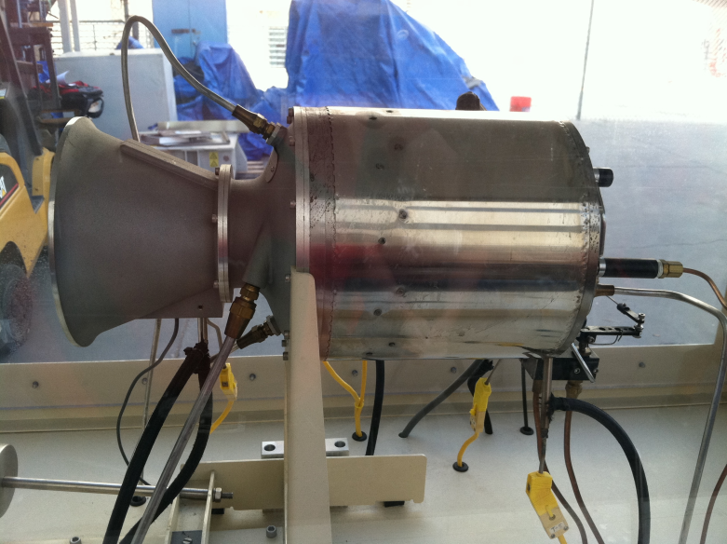  
Figure SR-30 Turbo Jet engine with cabinet

* TTL Mini-Lab manufactured by Turbine Technologies Ltd
  + SR-30 Turbo-Jet engine

This compact engine as a centrifugal flow compressor, reverse flow annular combustor and an axial flow turbine. The engine is operated on kerosene fuel, and has an air assist start system. Table 2 shows engine operating conditions and limitations.

|  |  |
| --- | --- |
| Maximum Thrust | 40 lbf |
| E.G.T | 720° C |
| Maximum RPM | 87,000 |
| Compression Ratio | 3.4 |
| Pressure Ratio | 30 |
| Engine Diameter | 6.8" |
| Engine Length | 10.8" |
| Combustor Components | Iconel® 718 alloy |
| Turbine Wheel | CRM 247 super alloy |

Table 2 Engine Data

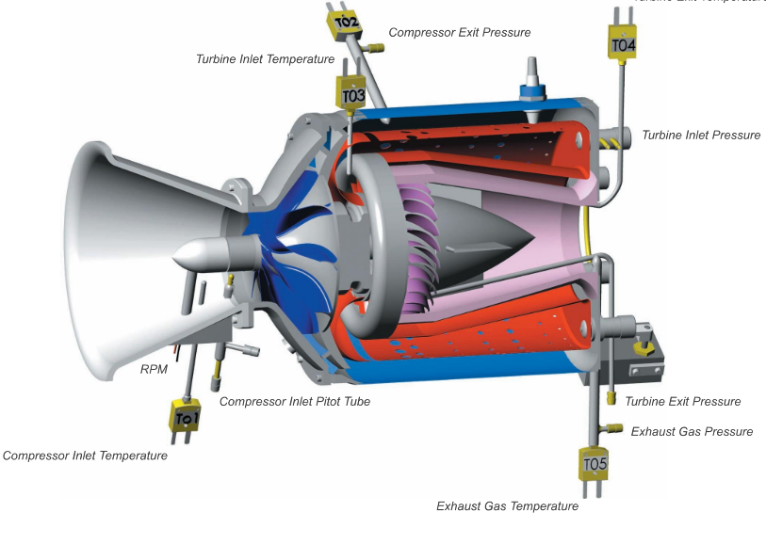

Figure Cut-away of SR-30 engine courtesy of Turbine Technologies Ltd (TTL)

The SR-30 engine is equipped with 5 thermal couple type temperature sensors and 5 pressure sensors. Table 3 show the pressure and temperature sensors in relation to their location in figure 2.

|  |  |
| --- | --- |
| Pressure Sensors | Temperature Sensors |
| P01 – Compressor stage static pressure. | T01 – Compressor inlet static temperature. |
| P02 – Compressor stage stagnation pressure. | T02 – Compressor stage exit stagnation temperature. |
| P03 – Combustion chamber pressure. | T03 – Turbine stage inlet stagnation temperature |
| P04 – Turbine exit stagnation pressure. | T04 – Turbine stage exit stagnation temperature. |
| P05 - Thrust nozzle exit stagnation pressure. | T05 - Thrust nozzle exit stagnation temperature. |

Table 3 SR-30 Pressure and Temperature sensors

* MiniLab TM  Cabinet
* The cabinet consists of a rigid steel chassis mounted on castors. The engine is mounted within the cabinet behind polycarbonate shields for safety and unimpaired viewing.
* The control panel on the front of the cabinet consists of the following gages: digital turbine inlet temperature (TIT), digital turbine exhaust temperature (EGT), digital engine rotational speed (RPM), analog oil pressure, analog engine pressure, and analog air start pressure. The panel also as a master key, green start, red stop, and T-handled power control lever.
* The high speed digital data acquisition system is also housed in the cabinet. The data acquisition system has the ability to have 20 analog inputs and 16 digital in/out threw puts. Along with the sensors mentioned in table 2 and shown in figure 2 there are fuel flow, thrust, and RPM sensors.

3. Experimental Procedure – Richard Le-Nguyen

Before beginning the experiment, all safety procedures from the document “Brayton Cycle” were observed.

During the course of the experiment, Dr. Kassegne interacted with the group to show all of the different components of the SR-30 and how they worked. Prior to starting the experiment, it was ensured that nothing was blocking the intake or exhaust of the engine. pDAQVIEW was then opened on the computer; located on the upper right hand corner of the desktop. “Open” under the “File” tab was selected to begin the new data collection. “Back Up” was then clicked to ensure that all data was new and accurate. The Bar Graph icon was chosen, it was the third icon from the right of the window. The forth icon to the right was clicked to open the window that recorded all data. Once the test rig was setup, the play button was pressed to begin collecting data, once the run was completed, the button was pressed again to finish the data collection.

The data was then exported via the export commend. In the exported state, the data is not usable and was converted from the “Binary” format that the program defaulted to. “Tools” was clicked in the menu bar followed by “Convert Binary Data.” The .BIN extension was selected in the Select Files to convert the file. “Format” was then chosen followed by selecting ASCII TEXT SPREADSHEET and then “OK.” “Yes to ALL” popped up, per lab instructions it was confirmed that this was the proper course of action. Excel was used to verify that each run had the proper data recorded. One person remained on the computer to ensure that the data was logging.

Once the entire data recording was set up, the turbine was then run. The machine was started with the Master Key. The green start button was depressed to start the engine, simultaneously slowly pushing the throttle to 10,000 RPM. Once ignition had completed, the throttle was slowly pushed until the speed indicator read the target speed that had been determined by the professor for each run. The engine was allowed to reach steady state followed by the recording of the data from the T.I.T., E.G.T., pressure, and RPM. Concurrently the exhaust pressure was measured using a laser thermometer. The red button was depressed to stop the run. The experiment was completed six times, with the RPM increasing after each run.

4. Experimental Results – Ryan Levin

**Figure 3. Turbine RPM vs time. This includes the ramping and down-ramping of the turbine. Only the constants sections were used for the data calculations.**

|  |  |  |  |  |  |
| --- | --- | --- | --- | --- | --- |
|  | TARGET RPM | T3 (T.I.T.) | T5 (E.G.T.) | T5 (INFRARED THERMOMETER) | P3 |
| Art | 49,501 | 571 | 454 | N/A | 10 |
| Richard | 55,320 | 592 | 456 | 432 | 10 |
| Sean | 61,315 | 610 | 462 | 438 | 13 |
| Ryan | 71,525 | 635 | 481 | 478 | 19 |
| Kenny | 76,000 | 654 | 498 | 492 | 22 |
| Levi | 78,000 | 679 | 506 | 493 | 25 |
| MAX. | 82,500 | 718 | 525 | 510 | 28 |

**Table 4. The recorded data from each run of the experiment.**

|  |  |  |  |  |  |
| --- | --- | --- | --- | --- | --- |
| Name | RPM | Thermal Efficiency | Turbine Efficiency | Compressor Efficiency | BWR |
| Art | 49501 | 11.06% | 48.39% | 76.76% | 0.545 |
| Richard | 55320 | 16.14% | 58.15% | 94.94% | 0.451 |
| Sean | 61315 | 11.21% | 57.83% | 54.62% | 0.623 |
| Ryan | 71525 | 7.88% | 58.81% | 41.98% | 0.746 |
| Kenny | 76000 | 4.30% | 58.22% | 35.16% | 0.862 |
| Levi | 78000 | 6.69% | 62.27% | 34.12% | 0.796 |

**Table 5. Average data recorded from each run.**

|  |  |  |  |  |  |
| --- | --- | --- | --- | --- | --- |
|  |  | Work (kJ/kg) | | Heat (kJ/kg) | |
| Name | RPM | Compressor | Turbine | In | Out |
| Art | 49501 | 70.8 | 126.1 | 487.3 | 433.4 |
| Richard | 55320 | 73.1 | 157.2 | 502.0 | 421.0 |
| Sean | 61315 | 100.1 | 155.9 | 492.5 | 437.3 |
| Ryan | 71525 | 126.2 | 164.2 | 497.5 | 458.3 |
| Kenny | 76000 | 146.4 | 164.8 | 495.5 | 474.2 |
| Levi | 78000 | 149.7 | 182.7 | 524.2 | 489.1 |

**Table 5 Cont. Average data recorded from each run.**

**Figure 4. Efficiency vs. RPM**

**Figure 5. Work vs RPM**

**Figure 6. BWR vs. RPM**

**Figure 7. Heat vs. RPM**

5. Discussion of Results – Sean Maher

In the Brayton cycle lab we obtained experimental data for the RPM, the temperature and pressure across the compressor and turbine. These values were used to calculate the thermal efficiency, turbine efficiency, compressor efficiency, BWR, compressor and turbine work, as well as the heat in and out of the brayton cycle system. Throughout all of our runs we found the brayton cycle seems to work best around 55,000 rpms with a thermal efficiency around 16%, with thermal efficiencies peaking at this value and declining with the higher RPMʼs. The data from this experiment is wholly contradictory with existing empirical data. As the RPM increases, the thermal efficiency should increase, and the BWR should decrease. This happened in our first two runs, however exactly opposite happened in all following runs. Each run was run the same way by each member with close supervision by Dr. Kassegne. Because of the inconsistency with the data, it is likely that the data was caused by errors in the equipment sensors.

Because of the large trend in errors in this lab, there could be human error in reading and recording the data from the brayton cycle system module, since the system was extremely noisy and all team members were required to wear ear protection. There could have been calibration error with the computer equipment as well as the equipment on the brayton cycle module seeing as we did not calibrate prior to our test runs. There could also possibly be errors with the transducer, or some of the measurements of the thermocouples.

It is interesting to note that the majority of the errors appear to stem from the compressor. The turbine behaves exactly as it should, have a near steady efficiency and increasing power output as the RPM increases. The compressor on the other hand requires more and more power as the RPM increase, as evident by the increasing BWR. Since the data of this lab appears to be extremely flawed, the compressor should be suspect to causing the majority, if not all, of the data errors associated with the lab. The compressor should be inspected to verify that it is operating properly.

6. Lab Guide Questions – Kennith Liljestrom

**1. What can be observed about the turbine engine’s efficiency in relation to its RPM?**

The turbines engine’s efficiency can be directly related to the RPM (rotations per minute). The relationship between the two is defined as an increase in the rotation of the turbine blades per minute, or RPM, causes an increase in the efficiency of the turbine engine. Our experimental results revealed a different scenario, with the turbine efficiency remaining fairly constant throughout all five runs which opposes the theoretical results. We worked very closely with Dr. Kassegne so the likelihood of experiencing operating error of this magnitude is unlikely. We can only assume there is something wrong with the recorded data from the computer software program. Our calculated results show that an error has taken place with either the recording of the data from the computer or human error during the experimental runs. Another place that looks to have corrupted data is the compressor efficiency. The turbine and compressor are linked together via a shaft and rotate together, so the efficiencies should be similar with regards to increasing RPM. This is also contrary to our recorded data as the compressor efficiency also decreases with increasing RPM. Our data of the various efficiencies can be seen plotted in Fig. 4 above.

**2. What type of relationship (constant, linear, exponential, etc.) exists between RPM and thrust?**

The relationship between the RPM and Thrust appears to be exponential according to the Fig. 8 below. These are directly correlated because as you increase the work put into the system, the greater the work out becomes. Our data points, with the exception of data point 5, were fairly accurate in the correlation of the theoretical exponential line. This increase in thrust as the engine performs more work is contrary to a conventional piston engine where the efficiency range is around 40-70% for maximum thrust, whereas the max thrust of a turbojet engine ranges from 85-100% [3].

Figure 8: Thrust vs. RPM chart based on the average thrust of each run plotted against the target RPM of each run

7. Conclusion – Levi Lentz

This lab was run with the upmost attention to detail, safety, and precision while the runs were being conducted. The data obtained from these runs however was completely contrary to what was expected to come from the data. Our compressor actually became less efficient and required more power as the RPM of the turbine increased. This in turn caused out BWR to plummet as we increased the run numbers. Because of the extremely controlled nature of the tests, it is unlikely that human error could have wholly contributed to this large error, especially with the close supervision of Dr. Kassegne. Because of this, the data implies that there is something wrong with the compressor of this system. It should be examined to determine proper functioning. Once this examination has determined that the compressor is in proper working order, it would be necessary to rerun this experiment to determine the proper operating numbers of this turbine.

8. References

[1] Kassegne, S. “ME495 Lab – Brayton Cycle – Lab Number 1." Mechanical Engineering Department. San Diego State University. Fall 2011.

[2] Turbine Technologies. *Turbine Properties*. Accessed October 2, 2011. <http://www.turbinetechnologies.com>

[3] Federal Aviation Administration. *Airplane Flying Handbook*. 2nd ed. New York: Skyhorse Publishing, 2007. Print.