San Diego State University

Mechanical Engineering

ME 495 - Mechanical & Thermal Systems Lab



Brayton Cycle

[2011]

**I. Abstract**

This report reviews the latest research in the areas of characteristics, properties, synthesis, and current applications of carbon nanotubes. Due to the remarkable mechanical and electronic properties carbon nanotubes boast, they have been have seen a steadily growing interest since the early 90’s. The field has been developed rapidly, and the number of publications per year is increasing almost exponentially. Because of this extensive research, many technological advances have been achieved such as the fabrication of flat panel displays, gas storage devices, toxic gas sensors, Li+ batteries, robust and lightweight composites, conducting paints, electronic nanodevices, nano motors and many other applications. Carbon nanotubes are a fundamental component of nanoscience and nanotechnology and because they are so small they are difficult to test and measure. New methods must be developed for synthesis, property characterization and fabrication. The sky is the limit with nanotubes and research will be performed for a long time to come.

**Group D:**

Emmanuel Hernandez (Project Manager)

Victor Sanchez

Rolando Herrera

Fernando Hernandez

Justin Hammerschmidt

Nick Garrett

Professor Sam Kassegne, PhD, PE

March 9th , 2011

Table of Contents

Objectives of the Experiment ……………………………………................................................................3

*Nick Garrett*

Equipment ………………………………………………….…............................................................................5

*Justin Hammerschmidt*

Experimental Procedure …………………………….……………………………………………………………………………5

*Justin Hammerschmidt*

Experimental Results and Calculations ……….…………………………………………………….……………..….....7

*Victor Sanchez*

Discussion of Results ...................................................................................................................13

*Rolando Herrera*

Conclusion ………………………..........................................................................................................16

*Fernando Hernandez*

References ……………………….........................................................................................................17

*Fernando Hernandez*

**Objective of the Experiment**

The objective of this lab was to obtain working, practical knowledge of the Brayton Cycle. An SR-30 turbojet engine (built by Turbine Technologies, LTD) was used to conduct this experiment, and empirical readings were taken at various times and locations throughout the experiment for use in equations. Performing a basic thermodynamic analysis will allow us to understand physically what goes on in a Brayton cycle.

The Brayton cycle uses the cold air standard assumption that specific heats are constant at room temperature, and all processes are internally reversible. This cycle consists of four stages.



**Figure 1:** Standard Brayton Cycle [1]

In the first stage, atmospheric air is brought into the compressor and is compressed isentropically in order to increase the temperature of the air (this high temperature raises the efficiency of the system). Next, this high pressure and temperature air is mixed with fuel in the combustion chamber. This is ignited by spark, and undergoes constant pressure heat addition. This hot gas then enters the turbine region of the apparatus, and expands isentropically, turning the turbine. The gas then undergoes constant pressure heat rejection and is relocated to the air intake from the exhaust. This last step is theoretical; in reality there is a constant source of air intake so the exhaust does not need to be recycled in a closed loop.

In this lab, we will calculate the overall thermal efficiency of the system, which is given by the equation:

*nth,Brayton = 1 – 1 .*

*rP(k-1)/k*

In this equation, *rP* is the pressure ratio, and k is the specific heat ratio of air. We will also be calculating the thermal efficiency of the turbine and compressor at each engine speed using the standard equations derived from the first law of thermodynamics:

*nc* = ( T*out,s –* T*in) / (* T*out,a –* T*in)*

*nT* = (T*out,a –* T*in) / (* T*out,s –* T*in)*

In these equations, Tin is the temperature at the inlet to the device, Tout,s is the ideal (isentropic) outlet temperature, and Tout,a is the actual outlet temperature. We will also be calculating the back work ratio using the following relations:

*bwr* = *wCOMP / wTURB*

- *wTURB = Cp,T (Tt,out – Tt,in)*

*wCOMP = Cp, c (Tc, out - Tc, in)*

The work in the compressor and turbine are calculated using the inlet and exit temperatures of the device, as well as the specific heat, Cp, evaluated at the average of the inlet and exit temperatures.

**Equipment**

The equipment used in this experiment consisted of two components – the test bench and the lab computer. The test bench is a TTL Mini-Lab manufactured by Turbine Technologies Ltd. and the lab computer was a Dell desktop unit. The following components were used during the testing process:

|  |  |  |  |
| --- | --- | --- | --- |
| SR-30 Engine | Pressure Gauges | RPM Readout Gauge | Hearing Protection |
| Thrust Readout Gauge | Controls | Virtual Bench Software | Thermocouples |

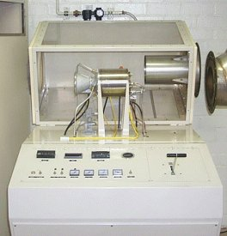

**Figure 3:** SR-30 by Turbine Technologies Ltd. (TTL) [2]

**Figure 2:** TTL Mini-Lab manufactured by Turbine Technologies Ltd. (TTL) [2]

**Experimental Procedure**

This experiment requires great concentration and awareness by the operators to ensure safety when handling the SR-30 turbojet. The first step is to become familiar with the controls and gauges with the turbojet. Ample time must be taken to be sure each phase of the Brayton cycle is understood. Once the operators are familiar with the turbojet’s control the next step is to prepare the computer to record data during the operation. From the desktop of the computer, launch VirtualBench and follow the procedure listed in the lab manual for entering the filename to which the data will be saved.

When this is complete, the experiment is ready to begin. To start the engine, turn on the master key and the el. master key. Make sure the throttle handle is pushed all the way forward. Then simultaneously turn on the ignition and air start switches. The compressed air will start the engine. Once the engine has reached approximately 12,000 RPM, turn on the fuel switch. This injects the fuel, in this case kerosene, into the engine for ignition and the increase in sound will be an indicator that the engine has ignited. Once the engine has ignited, the air switch and ignition can be turned off. At this point, the student designated to the computer data collection is to be signaled to begin recording. Now, using the throttle handle, manipulate the engine until the desired RPM is reached. When this is reached, another student should be manually recording the temperature, engine speed, and fuel pressure to compare with the computer data for errors, as well as for safety. If the temperature exceeds 500 degrees Celsius, the engine must be turned of immediately. When enough data has been recorded, stop the software and turn the engine off by cutting the fuel.

Follow the same procedure for all other desired RPMs. Make sure all the data is saved and power down all equipment.

**Experimental Results and Calculations**

What can be observed about the turbine engine’s efficiency in relation to its RPM?

Figure 3: Turbine vs RPM

There is a linear relationship between turbine efficiency and RPM. Figure 3 illustrates this relationship.

What type of relationship (constant, linear, exponential, etc.) exists between RPM and thrust?

Figure 4: Thrust vs RPM

There is a linear relationship between thrust efficiency and RPM. Figure 4 illustrates this relationship.

**Data Reduction**

Provide a T-s & P-v for the ideal and actual Brayton cycle for each test speed.

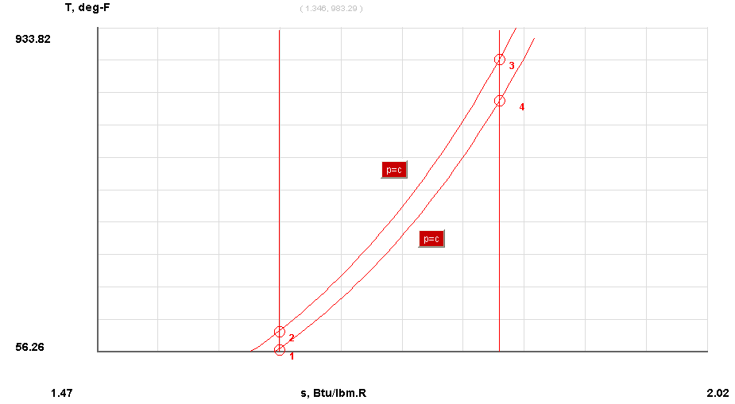

Figure 5: T-s diagram for ideal cycle at ~55000 RPM

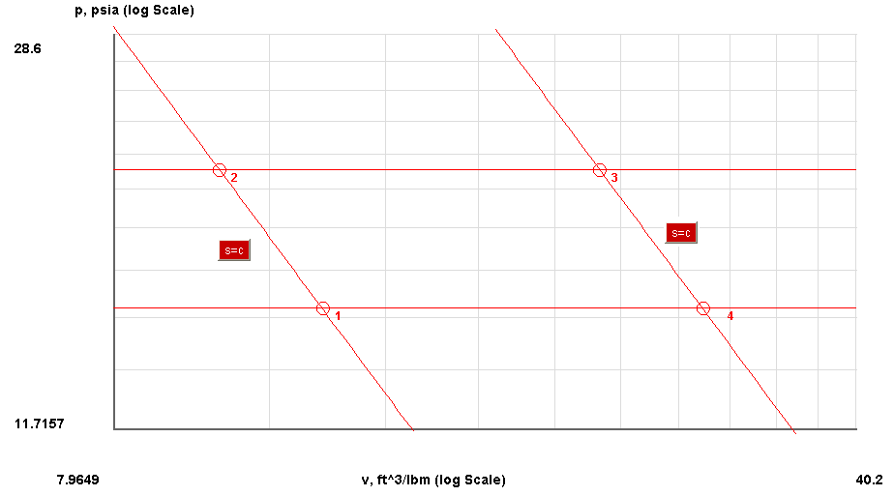

Figure 6: P-v diagram for ideal cycle at ~55000 RPM

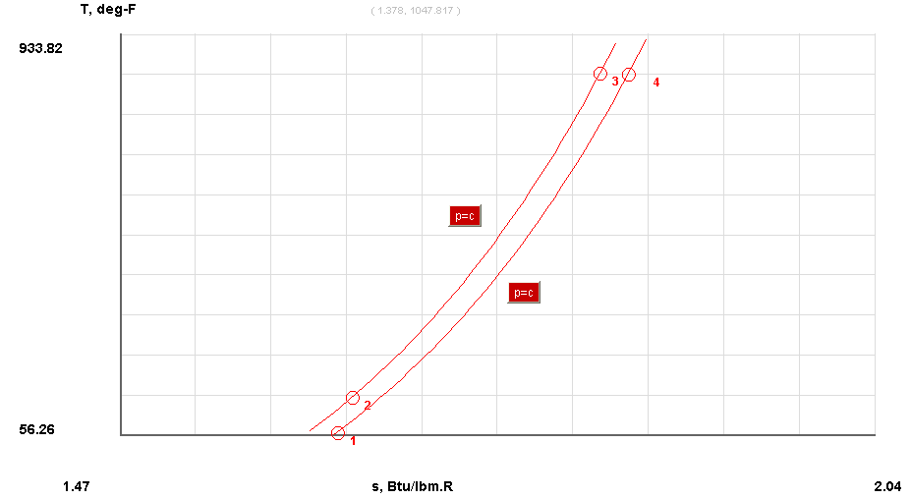

Figure 7: T-s diagram for actual cycle at ~55000 RPM

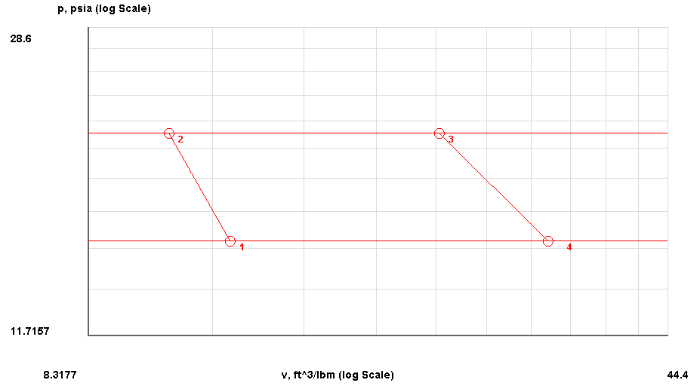

Figure 8: P-v diagram for actual cycle at ~55000 RPM

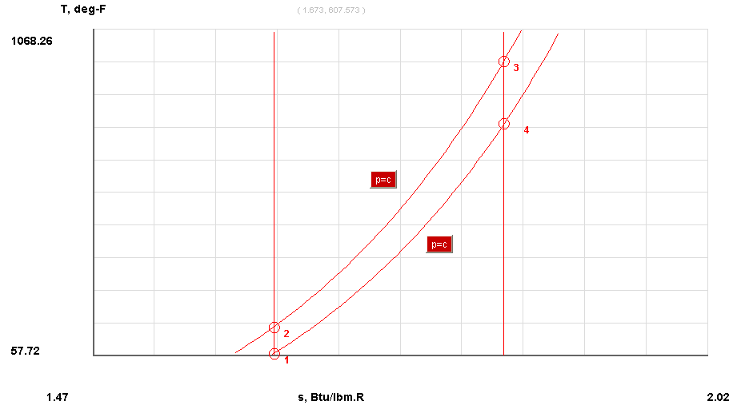

Figure 9: T-s diagram for ideal cycle at ~60000 RPM

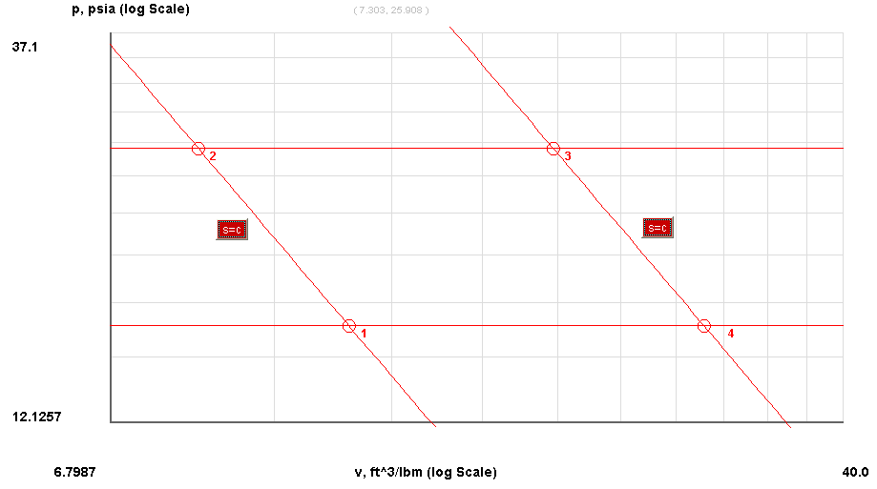

Figure 10: P-v diagram for ideal cycle at ~60000 RPM

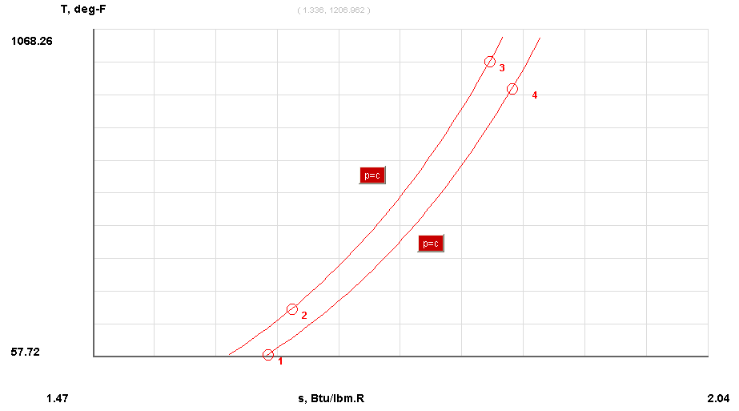

Figure 11: T-s diagram, for actual cycle at ~60000 RPM

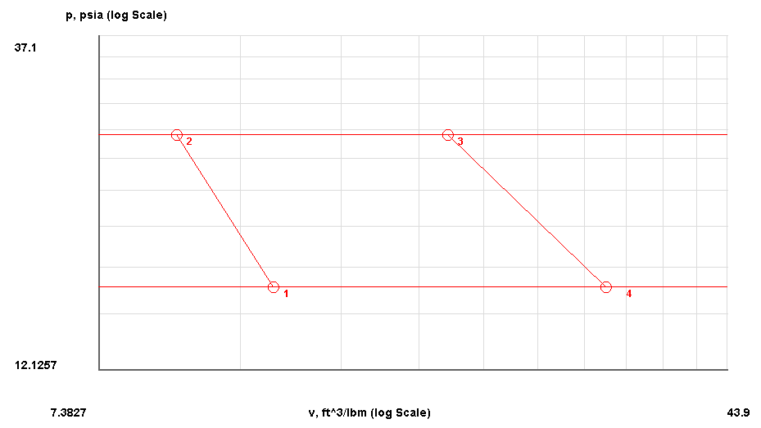

Figure 12: P-v diagram for actual cycle at ~60000 RPM

Calculate the thermal efficiency for the Brayton cycle for each engine speed.

**Engine speed = ~52000 RPM**

Average turbine inlet pressure P3 = 9.2555 psig = 23.9155 psia

Average turbine outlet pressure P4 = 0.9197 psig = 15.5795 psia



### Perform a first law analysis of each section of the SR-30 engine at each engine speed.

**Engine speed = ~52000 RPM**

### *Compressor*

### 

### *Combustor*



***Turbine***



### Calculate the back-work ratio for each engine speed.

### Engine speed = ~52000 RPM



Table 1: Summary of Efficiencies

|  |  |  |  |  |  |
| --- | --- | --- | --- | --- | --- |
|  | **RPM** | **Thermal Efficiency** | **Compressor Efficiency** | **Turbine Efficiency** | **Back Work Ration** |
| RUN 1 | 51718.7289 | 11.52455612 | 70.65889453 | 28.43620087 | 5.992124535 |
| RUN 2 | 55274.4547 | 13.21275831 | 77.07878092 | 60.90369336 | 1.95654517 |
| RUN 3 | 60394.6007 | 13.89029374 | 79.91471667 | 70.46270178 | 1.459487879 |

**Discussion of results**

Figure 13: Efficiency vs RPM

Table 2: Run 1



Table 3: Run 2



Table 4: Run 3



The data was obtained which much difficulty. Out of a total of three runs, only two were fully acceptable for this experiment. Our group and Dr. Kessegne noted that a major pressure loss existed somewhere in the systems that prevented an accurate compression ratio that was needed for this experiment. Luckily, our temperature and pressure readings were within acceptable range.

There were also other possible sources of biased experimental error in this lab. During the first run, our thermocouple and pressure sensor for the inlet conditions of the compressor were fluctuating very rapidly. This run skewed our results but may have helped the following runs. We also observed how the strain gauge showed fluctuation in the thrust, even when no one was touching it. The fluctuation was always negative. This could be due to bad hardware in the strain gauge, or vibrations in the test bench. Fortunately, no other calculations are dependent on thrust. Another source of random error is the fluctuation in the engine speed. The rpm was controlled by group members via a throttle arm, and it was very hard to set the speed exactly where we wanted it and hold it steady. Because of this change in rpm, we have data for several ranges of rpm values, instead of data for individual speeds.

The data in Figure 13 show a linear relationship in both turbine efficiency versus rpm and thrust versus rpm. Thus, at higher rpm you will have a higher efficiency as well as thrust. Compressor and thermal efficiencies also follow a linear relationship with rpm.

**Conclusion**

Although there were plenty of factors present during the experiment that skewed the experimental data, the objective of obtaining working and practical knowledge of the Brayton cycle was still achieved. Moreover troubleshooting techniques were learned during the process of getting the cycle up to par in order to conduct additional runs. Also, the experiment offers a good experience to its users in the sense that concepts learned in thermodynamic classes become tangible.

**References**

1. Kassegne, S. " ME495 Lab - Brayton Cycle Gas Turbine - Expt Number 1." Mechanical Engineering Department. San Diego State University. Spring 2011.
2. "Turbine Technologies - Gas Turbine Lab." *Turbine Technologies - Creating Educational Laboratory Equipment For Tomorrow's Engineer*. Web. 09 Mar. 2011. <http://www.turbinetechnologies.com/gas_turbine.html>.
3. "Turbine Engine Thermodynamic Cycle - Brayton Cycle." *NASA - Title...* Web. 09 Mar. 2011. <http://www.grc.nasa.gov/WWW/K-12/airplane/brayton.html>.
4. "Thermodynamics EBook: Brayton Cycle." *ECourses*. Web. 09 Mar. 2011. <http://www.ecourses.ou.edu/cgi-bin/ebook.cgi?doc=&topic=th&chap_sec=09.1&page=theory>.