

**ME 495 – Mechanical and Thermal Systems Lab**

**Experiment 2: Bomb Calorimeter**

**Group F**

Kluch, Arthur

Le-Nguyen, Richard

Levin, Ryan

Liljestrom, Kenneth

Maher, Sean

Nazir, Modaser

Lentz, Levi – Project Manager

Professor S. Kassegne, PhD, PE

October 12, 2011

i. Table of Contents

i. Table of Contents 2

1. Objective of the Experiment – Modaser Nazir 3

2. Equipment – Arthur Kluch 6

3. Experimental Procedure – Richard Le-Nguyen 9

4. Experimental Results – Ryan Levin 10

5. Discussion of Results – Sean Maher 13

6. Lab Guide Questions – Kennith Liljestrom 14

7. Conclusion – Levi Lentz 15

8. References 16

1. Objective of the Experiment – Modaser Nazir

In this experiment we will use a bomb calorimeter to calculate the heating value from the weight of the fuel used and the change in the temperature of the water. The heating value (HV) of a specific type of fuel helps us measure and describe the energy that is produced by a given type of fuel. The bomb calorimeter is a device that burns a fuel sample and transfers the heat into a known mass of water. The objective of this lab is to determine the HV of not only a solid fuel, but a liquid fuel as well. From this experiment we will also be reiterating the first law of Thermodynamics for a controlled mass.

A bomb calorimeter will be used to calculate the HV of the burning fuel. Figure 1 and 2 show the bomb calorimeter in detail. It consists of a precision scale for weighing fuse and fuel samples, the oxygen bottle with suitable valves, and the bomb calorimeter. Inside the calorimeter is the fuel cup containing the fuel and the cup is held in a wire cradle that hangs from top of the cradle. A fuse wire is attached between the two arms of the cradle and it dips into the fuel but does not hit the sides of the fuel cup. The bomb itself it is rigid constant volume steel vessel and the assembly described earlier is places inside of it. Also inside the bomb, there will be 2000 grams of water and ignition leads are attached to the bomb. Once everything is placed and the cover is closed, the cover has a hole that allows a thermometer to be lowered into the water to measure the temperature. Also, an electrically driven paddle wheel can be used to stir the water and make the temperature of the water constant throughout the bucket.



**Figure 1:** Schematic of the Complete Bomb Calorimeter. [1]



**Figure 2:** Schematic of the Bomb Vessel. [1]

The best way to find the fuels heating value (HV) is in terms of the energy it will produce per unit mass of the fuel. For the most part, when a weighed liquid or solid fuel sample is in a calorimeter, it would be completely burned. Then, all of the heat released would be conducted into a known mass of water. Once the temperature of the water rises, you can calculate the amount of energy released.

The following is the theory from the lab write up titled “ME495 Lab - Bomb Calorimeter - Expt Number 2” by Dr. Kassegne [1]:

The heating value can be determined by using the equation:

 Equation 1

In practice, however, there are complications, which are handled as described below. These complications are accounted for in the equation:

 Equation 2

Complication

The combustion must be contained in a rigid steel vessel or bomb and the water must be held in a bucket. The heat from combustion gets channeled into the bomb, the bucket, the known mass of water and some other miscellaneous parts. Instead of DUwater, one should use a summation of every DU for all of the parts that absorb heat. This would be awkward and accuracy would be difficult. The expressed purpose of equation 1 is to calculate HV when everything on the right hand side is known or measured in the test. Suppose we knew HV for a special fuel sample, and assume that all of the heat released was channeled into an unknown theoretical mass of water. This is the actual procedure used. In the first part of the experiment we will burn a benzoic acid sample for which the heating value is reliably known. During this burn the bucket will actually contain 2000g of water. We then solve equation 2 for the theoretical water mass (m*), which is necessarily greater than 2000g. This theoretical mass is the mass of water that would be required to absorb all of the heat that, in reality, was absorbed by the bucket, the steel bomb, the actual 2000g of water and all of the minor parts that get heated. In the second part of the experiment we actually burn the diesel fuel sample of interest. During this burn we again use an actual 2000g of water, but me use the theoretical mass of water (m*) that was calculated from the first burn.

Complication

The fuel is not the only thing that burns in the bomb calorimeter. Most of the fuse material also burns. Therefore, the fuse wire must be weighed prior to the burn and any remaining fuse material must be weighed after the burn. The amount of heat released from the combustion of the fuse wire must be deducted from the DUwater in equation 2. HVwire is given on the fuse wire package.

Complication

There are heat losses from the calorimeter during the experiment because of its elevated temperature. These losses are small because the calorimeter box is well insulated. We have a semi-empirical way to correct for the heat losses. This is described in the data reduction section. We use a relatively large mass of water so that its temperature rise is small. This minimizes heat losses while preserving accuracy since precision thermometers are used. In very accurate bomb calorimeter work, heat losses from the calorimeter can be almost eliminated by creating an adiabatic situation. The calorimeter is surrounded by water flowing through a jacket. During a test, warmer water is added to this jacket at such a rate that the temperature in the jacket closely follows the rise in the experiment’s 2000 g of water. The warmer water in the jacket loses heat to the surrounding room. There can be little heat loss from the test water jacket water since there is no driving temperature difference.

Complication

Burning hydrocarbon fuel produces water vapor. The heating value determined would depend on whether or not this water vapor is condensed. We must distinguish between the higher and lower heating value. The lower value (LHV) assumes that the water vapor is not condensed. This heating value is lower due to enthalpy of vaporization equal to the amount of steam produced. The higher heating value (HHV) assumes that the entire vapor produced condenses. Ironically, fuel is normally sold based on its HHV, even though in most uses of fuel the LHV gives a more realistic value of what can be expected i.e., the steam in a car or furnace exhaust does not get condensed. With the drive for improved energy efficiency that began with the oil shock of 1973, some modern furnace designs actually do condense the water vapor and usefully extract this energy. In this experiment we will calculate the HHV. Consequently, we must condense all of the steam that is produced by combustion. This condensation is forced by saturating the bomb’s oxygen supply with water prior to combustion. Adding exactly 2 ml of water to the bomb before sealing it does this. If the oxygen is already saturated then any water produced by combustion must condense if the temperature is to remain relatively constant.

Complication

Equation 1 assumes that the measured temperature rise is uniform within the system boundary. A small paddle wheel driven by a drive belt gently stirs the water during the test. This promotes temperature uniformity in the water. The amount of work added by the paddle wheel is negligible. Most of the other parts that get heated are made of steel and are, therefore, good conductors. They should stay at a temperature close to that of the water.

Heating values vary according to ambient temperature and pressure conditions. For accuracy, heating values should be corrected to standard temperature and pressure conditions before comparisons are made.

The above theory will be used to calculate the required values for the lab. The following table describes the names and units of each symbol:

|  |  |
| --- | --- |
| **Term** | **Value** |
| HV | Heating Value [kJ/kg] |
|  | Change in internal energy [kJ] |
|  | Mass of fuel [g] |
|  | Mass [g] |
|  | Specific heat at constant volume [kJ/kg*K] |
|  | Change in Temperature [K] |

**Table 1.** Symbols used in this laboratory.

2. Equipment – Arthur Kluch

The equipment for the Bomb Calorimeter consists of an Ohaus GA200 digital scale, a Fluke 2180A RTD digital thermometer, a 1341 Plain Bomb Calorimeter, a 2901 Parr Bomb ignition unit, and a regulated tank filled with oxygen. Figure 1 Shows the Bomb Calorimeter fully assembled with attachments. At the center of the unit is a nickel-chromium alloy fuel crucible which contains the fuel. The crucible is held in a cradle, which hangs from the lid of the inside of the top of the stainless steel bomb vessel. A wire fuse is attached between the two arms of the cradle, and it is bent so that it touches the fuel. The stainless steel bomb vessel has a compression fitting which allows oxygen to be pumped in.

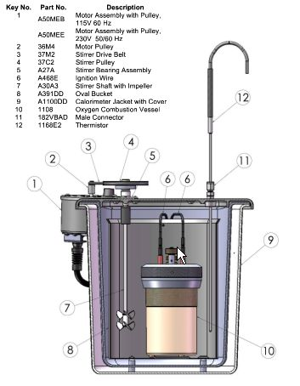

**Figure 3.** Cross-section 1341 Plain Calorimeter [2]

The 1341 Plan Calorimeter has a high strength, molded fiberglass jacket formed with double walls and a double cover to provide an oval chamber for the calorimeter bucket which is surrounded by dead air space. Stirring is provided by a small motor which is attached far enough away as to not add additional heat to the system. A pair of wires with banana plugs is attached to the top of the bomb for the firing circuit. The outside dimensions of the cylinder jacket are 10 - 7/8" in diameter by 10 - 3/4" tall.

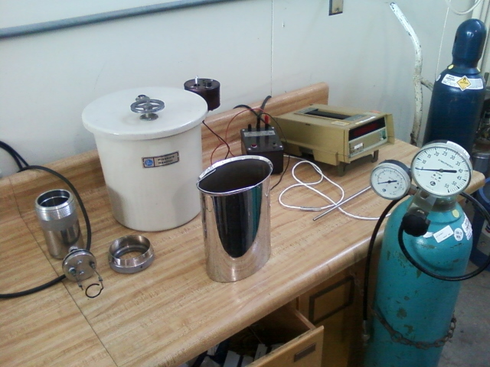

Figure 4. 1341 Plan Bomb Calorimeter with 2910 ignition unit, Fluke 2180A RTD Digital Thermometer, and oxygen tank. Photo courtesy of Joshua Elam

The Fluke 2180A Digital RTD Thermometer lets you switch-select one of 6 different type of RTDs - Four platinum, one nickel, and one copper - and delivers 0.01 degree resolution. The thermometer has a temperature range from -200 to 750° C depending on the type of RTD used.

The 2901 Parr Ignition Unit supplies the proper amount of electrical current for firing the oxygen bomb. The unit is operated on 115 volts and has a push button for ignition and an indicator light for unit operation.

**Ohaus GA200 Scale (figure 5)**

### Specifications / Capabilities:

* Weighing range: 40 g /200 g
* Readability: 0.1 mg
* Taring (by subtraction): 40 g/200 g
* Pan size: 8.89 cm (3.5") diameter
* Below Balance Weighing: Standard
* Weighing chamber: 15.2 cm x 18.8 cm x 25.9 cm (6" x 7.4" x 10.2")
* Dimensions (w x h x d): 20.6 cm x 30.7 cm x 44.5 cm (8.1" x 12.1" x 17.5")
* Operating temperature range: 10 °C - 40 °C

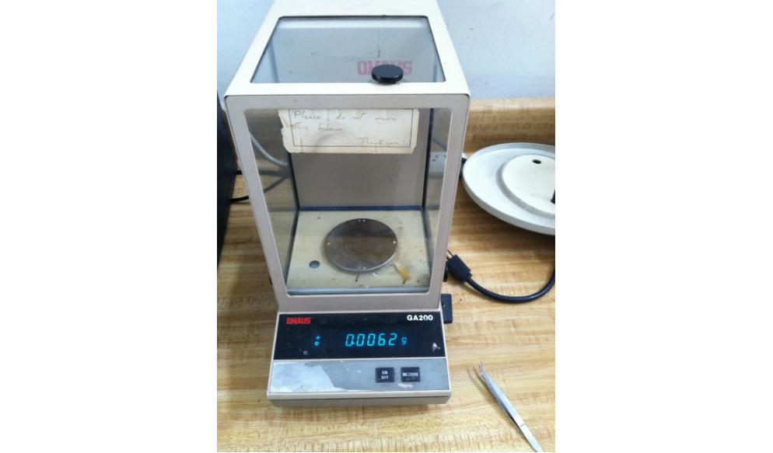

Figure 5. Ohaus GA200 Scale

3. Experimental Procedure – Richard Le-Nguyen

The following is the procedure that our group completed by following the guidelines outlined in the document “Bomb Calorimeter.” We found that we did not have to deviate from the established procedure.

Before beginning the experiment, safety and caution were taken in accordance with the Bomb Calorimeter Lab Document.

First the fuse wire was cut to 10 cm and weighed in the scale. This wire was attached to the leads of the bomb calorimeter at its lead points. The two ends were wrapped and clamped around the leads while the center of the wire was bent towards the cradle. A clean cup and a tablet of benzoic acid pellet were weighed. The benzoic acid was placed into the cup which was then placed into the cradle. The wires were placed to touch the benzoic acid only. 2 ml of de-ionized water was added into the bomb and the cover assembly containing the cup of benzoic acid was lowered into the cup for a snug fit.

The needle valve on the cover of the bomb was opened and the connector from the oxygen tank was attached. Approximately 25 atmospheres (atm) of oxygen was added to the bomb and it was purged for more than 5 seconds to ensure there is only pure oxygen in the bomb’s internal atmosphere. Both the oxygen tank valve and the bomb valve were closed. The connector was removed from the bomb.

2000g of de-ionized water was added to a stainless steel bucket. The bomb was carefully placed, remaining upright, into the bucket. The bomb was properly aligned into the bucket. The temperature of the water was recorded using the thermometer. The bucket with the bomb and the water was lowered into the insulating beige box. The ignition wires within the box, red and black, were connected to the top of the bomb. Use a rubber band as a drive belt and wrap it around the motor and the stirring propeller. The thermometer was placed into the hole on the plastic cover of the beige box and it was lowered all the way down ensuring that it is 3 inches beneath the water. The ignition unit was plugged in.

The ignition button was pressed so the reaction began. Data for the temperature was recorded every 10 seconds. Data was recorded until the temperature started to decrease and reached a constant state. The bomb was removed from the water bucket and the vent valve was loosened to release the pressure. The bomb was carefully disassembled after by lifting the top straight off. The fuse holder was removed from the bomb. The cup and the remaining pieces of the fuse wire weighed and the data was recorded.

After the data is collected, the experiment was repeated with approximately 0.80g of diesel fuel instead of benzoic acid. After the data was collected for the diesel fuel, all of the equipment was dried and cleaned properly and stored in their designated areas.

4. Experimental Results – Ryan Levin

|  |  |  |  |  |  |  |
| --- | --- | --- | --- | --- | --- | --- |
|  |  | Before Burn (Grams) | | | After Burn (Grams) | |
|  | Fuel Name | Fuel Weight | Fuse Weight | Cup Weight | Fuse Weight | Cup Weight |
| Run 1 | Benzoic Acid | 0.988 | 0.0164 | 12.3432 | 0.0132 | 12.3458 |
| Run 2 | Diesel | 0.794 | 0.0162 | 12.3438 | 0.0063 | 12.3478 |

**Table 2.** Recorded weights from each run.

**Figure 5.** Temperature vs. Time of the water for each run.

Equation 2 from Dr. Kassegne’s ME 495 Experiment 2 Bomb Calorimeter [1] will be used to isolate ${m^{*}}_{water}$ by using the given heating value of the benzoic acid pellet, ${HV}_{acid}$. This is done to use a corrected value for the mass of the water in order to solve for the higher heating value for diesel, ${HV}_{diesel}$.

Solving for ${m^{*}}_{water}$,

$${m^{*}}_{water}=\frac{\left[\left({HV}_{acid}* m_{acid}\right)+ (Δm_{wire}* {HV}_{wire)}\right]}{C_{v_{water}}* ΔT_{water}}$$

Now that ${m^{*}}_{water}$ has been isolated the values from Table 3, below, were used to calculate ${m^{*}}_{water}$.

|  |  |  |  |
| --- | --- | --- | --- |
| **Name** | **Variable** | **Value** | **Units** |
| Mass of Acid Pellet | $$m_{acid}$$ | 0.988 | *g* |
| Difference of mass of wire before and after experiment | $${Δm}_{wire}$$ | 0.0032 | *g* |
| Heating Value of benzoic acid pellet | $${HV}_{acid}$$ | 26430 | $$\frac{J}{g}$$ |
| Heating Value of fuse wire | $${HV}_{wire}$$ | 5857.60 | $$\frac{J}{g}$$ |
| Specific heating value of water | $$C_{v_{ water}}$$ | 4.186 | $$\frac{J}{g °C}$$ |
| Temperature change | Δ $T_{water}$ | 2.62 | °C |

**Table 3.** Recorded and calculated values for Bomb Calorimeter Experiment for the benzoic acid pellet run.

Numerically:

$$= \frac{\left\{\left(26430 \left[\frac{J}{g}\right]*0.988 [g]\right)+[\left(0.0032\right)[g]*5857.60 \left[\frac{J}{g}\right]]\right\}}{\{4.186 \left[\frac{J}{g °C}\right]*\left(2.62\right)\left[°C\right]\}}$$

$${m^{*}}_{water}=2382.68 g$$

${HV}_{diesel}$ can now be solved for using the same equation [1]:

$${HV}_{diesel}= \frac{[\left({m^{*}}_{water}*C_{v}*ΔT_{water}\right)- \left({Δm}_{wire}*{HV}_{wire}\right)]}{m_{diesel}}$$

${HV}_{diesel}$ was calculated using the values from Table 4, below.

|  |  |  |  |
| --- | --- | --- | --- |
| **Name** | **Variable** | **Value** | **Units** |
| Mass of diesel fuel | $$m_{diesel}$$ | 0.794 | *g* |
| Difference of mass of wire before and after experiment | $${Δm}_{wire}$$ | 0.0099 | *g* |
| Corrected mass of water | $${m^{*}}_{water}$$ | 2382.68 | $$g$$ |
| Specific heating value of water | $$C_{v_{ water}}$$ | 4.186 | $$\frac{J}{g °C}$$ |
| Temperature change | Δ $T_{water}$ | 3.60 | °C |
| Heating value of fuse wire | $${HV}_{wire}$$ | 5857.60 | $$\frac{J}{g}$$ |

**Table 4.** Recorded and calculated values for Bomb Calorimeter Experiment for the diesel fuel run.

$$= \frac{\left( 2382.68 \left[g\right]*4.186 \left[\frac{J}{g °C}\right]*3.60 [°C]\right)- \left(0.0099 \left[g\right]*5857.60 \left[\frac{J}{g} \right]\right) }{0.794 g}$$

$${HV}_{diesel}=45148.7 \frac{J}{g}=45148.7 \frac{kJ}{kg}$$

**2. Calculate a percent error verses the theoretical value of 46,446kJ/kg for diesel fuel.**

Comparing the calculated value of the higher heating value of the diesel fuel with the theoretical value via the equation for percent error yields,

5. Discussion of Results – Sean Maher

For this experiment we obtained data for temperature change every 10 seconds for a fuel burning inside the bomb calorimeter. We measured results for two different types of fuels, benzoic acid and diesel fuel. With a weight of .988g of benzoic acid, we obtained a total temperature change of 2.62 degrees Celsius. This run was used primarily to calculate the ${m^{*}}_{water}$, hence the empirical HV of Benzoic acid, 26,430 kJ/kg was used. However, with a weight of .788g of diesel fuel gave us a total temperature change of 3.60 degrees celsius and a heating value of 45,148.7 kJ/kg. This shows the diesel fuel to be a more effective source than the benzoic acid pellet.

The experimental error for our lab was small with a value of only 2.79%. Because this experiment was only run for one run, it is difficult to say if the error was human or systemic. Causes for this error could be due to human error or possibly errors from the lab equipment. Any human error would have been caused by timing in the placing of the diesel into the calorimeter as the diesel was quickly evaporating. Errors with the lab equipment may have been caused by the paddlewheel, with low temperature changes and the system running at low temperature the work inputted by the paddlewheel may have cause slight error in our results.

From empirical data, we expected the diesel fuel to have a greater temperature difference and a higher heating value than the benzoic acid tablet. These predictions were correct and confirmed from the experimental data we obtained with a high degree of accuracy.

6. Lab Guide Questions – Kennith Liljestrom

**1. What is m* and how is it different from mwater?**

In the bomb calorimeter experiment, we use ${m^{*}}_{water}$ to define a quantity in which all the necessary components which have absorbed heat in the system due to combustion are taken into account. The heat absorption in the system takes into account the heat absorbed by the cup for holding the fuel, the steel bomb, and other parts of the system that were heated during the combustion process. This differs from the measurable value for the mass of water, $m_{water}$, which was measured to 2000 *g* because it takes into account the various components which absorbed heat during combustion which is why the value of ${m^{*}}_{water}$ is larger than the measured 2000 *g* put into the system which assumes the other components in the system do not absorb heat.

**2. Compare the theoretical and actual heating values for diesel fuel.**

From the calculated data in the Experimental Results section, we used the known heating value of the benzoic acid pellet in order to calculate ${m^{*}}_{water}$ for the system. This let us determine how much heat was absorbed from the components of the system and use a corrected value for the mass of water to account for heat absorption while calculating the heating value of the diesel fuel. From this process we calculated a heating value of 45, 148.7 ${kJ}/{kg}$ compared to the theoretical value of 46,466 ${kJ}/{kg}$ given by Dr. Kassegne in the lab manual [1]. Using the percent error equation yielded an error of 2.79%. This error is small and is probably due to human error, such as temperature recording or weighing the components of the system before and after each run. There is also the possibility of data error discussed in question 3.

**3. Is there any other possible explanation for a different HHV besides experimental error?**

In order for us to determine the most accurate higher heating value (HHV) we need to know what source the theoretical heating value came from. Due to the vast resources available on the internet it is possible for data to become corrupted or vary depending on the source used. We also do not know the type or age of the diesel fuel contained in the container used, which may be a different quality than that of the theoretical HHV given.

7. Conclusion – Levi Lentz

This experiment was successful in introducing the students to the basics of the meaning of the heating value (HV) as well as how to calculate the HV using a bomb calorimeter. The experiment was completed with an extremely high level of accuracy with an error of 2.79% error in calculating the HV of diesel. This is even more impressive when calculating this value was a two-step process involving burning benzoic acid first to calculate the ${m^{*}}_{water}$ and then running it identically again to calculate the HV of the diesel. While this was an extremely accurate run, it is impossible to tell if the error was caused by systemic reasons or if it was user error. In the future it is recommended that more runs be completed to verify that the equipment is working properly over a large range of runs. Because of the high accuracy of the experiment, the data can be used reliably for future calculations.

8. References

[1] Kassegne, S. “ME495 Lab – Bomb Calorimeter– Lab Number 2." Mechanical Engineering

Department.San Diego State University.Fall 2011.

[2] Parr Instruments. “1341 Plain Calorimeter Specifications.” Accessed 10/10/2011. http://www.parrinst.com/