Equipment:

The equipment for the Bomb Calorimeter consists of a Ohaus GA200 digital scale, a Fluke 2180A RTD digital thermometer, a 1341 Plain Bomb Calorimeter, a 2901 Parr Bomb ignition unit, and a regulated tank filled with oxygen. Figure 1 Shows the Bomb Calorimeter fully assembled with attachments. At the center of the unit is a nickel-chromium alloy fuel crucible which contains the fuel. The crucible is held in a cradle, which hangs from the lid of the inside of the top of the stainless steel bomb vessel. A wire fuse is attached between the two arms of the cradle, and it is bent so that it touches the fuel. The stainless steel bomb vessel has a compression fitting which allows oxygen to be pumped in.

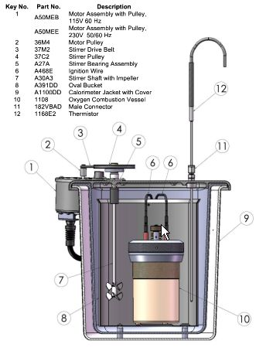
Figure 1 Cross-section 1341 Plain Calorimeter [courtesy of Parr]

The 1341 Plan Calorimeter has a high strength, molded fiberglass jacket formed with double walls and a double cover to provide an oval chamber for the calorimeter bucket which is surrounded by dead air space. Stirring is provided by a small motor which is attached far enough away as to not add additional heat to the system. A pair of wires with banana plugs are attached to the top of the bomb for the firing circuit. The outside dimensions of the cylinder jacket are 10 - 7/8" in diameter by 10 - 3/4" tall.
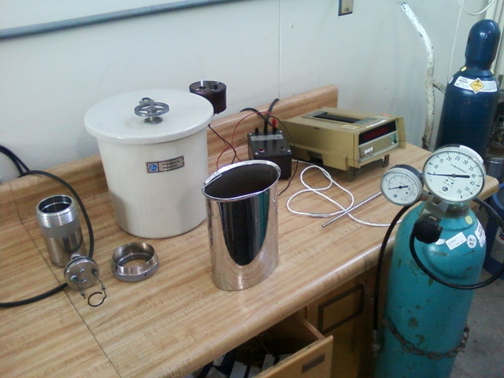
Figure 2 1341 Plan Bomb Calorimeter with 2910 ignition unit, Fluke 2180A RTD Digital Thermometer, and oxygen tank [photo courtesy of Joshua Elam]
The Fluke 2180A Digital RTD Thermometer lets you switch-select one of 6 different type of RTDs - Four platinum, one nickel, and one copper - and delivers 0.01 degree resolution. The thermometer has a temperature range from -200 to 750° C depending on the type of RTD used.

The 2901 Parr Ignition Unit supplies the proper amount of electrical current for firing the oxygen bomb. The unit is operated on 115 volts and has a push button for ignition and an indicator light for unit operation.

Ohaus GA200 Scale (figure 3)

Specifications / Capabilities:
- Weighing range: 40 g /200 g
- Readability: 0.1 mg
- Taring (by subtraction): 40 g/200 g
- Pan size: 8.89 cm (3.5") diameter
- Below Balance Weighing: Standard
- Weighing chamber: 15.2 cm x 18.8 cm x 25.9 cm (6" x 7.4" x 10.2")
- Dimensions (w x h x d): 20.6 cm x 30.7 cm x 44.5 cm (8.1" x 12.1" x 17.5")
- Operating temperature range: 10 °C - 40 °C
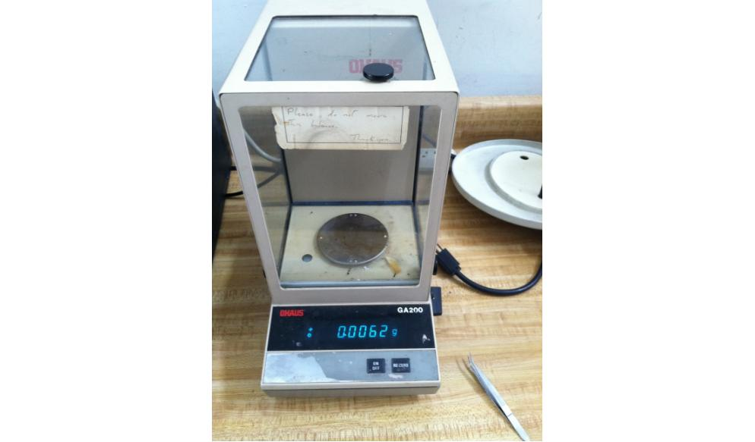
Figure 3 Ohaus GA200 Scale

