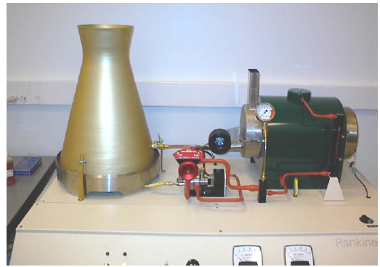

**Figure 1.** RankineCycler Steam Turbine System.

Objective:

In this lab the student will learn how to choose the correct transducer in order to detect and measure the physical properties necessary for calculating the efficiency of a Rankine cycle. The students will be using a “RankineCycler” steam turbine system made by Turbine Technologies Ltd. The turbine will be a working model of steam power plant and will be used so that the students shall apply basic equations for Brayton Cycle analysis. Furthermore, using empirical measurements at different points in the Rankine cycle will do this. The main purpose or objective of this lab exercise it to help students get familiar with the Rankine cycle heat engine.

Background:

The vapor power plant has many uses and can be used for many applications. With that noted, it is mostly used to drive large electrical generators in a power plant. A basic vapor power plant has four major components. First major component is the pump and the second is the boiler. Compressed water is pumped into the boiler at state 1 and the water is heated at constant pressure in the boiler at state 2. The third major component is the turbine. Once the water is heated in the boiler, the hot water vapor is sent to the turbine where is expands isentropically at state 3. As the water vapor expands it performs work by turning the turbine. Furthermore, the turbine is connected to an electric generator by a shaft switch, which in turn produces electrical power. Lastly, the fourth major component is the condenser. The steam now a saturated liquid- vapor mixture enters the condenser at state 4 and undergoes heat rejection at constant pressure. Then, the process starts all over again. (States are shown on Figure 2)



Figure 2: Summary of Rankine Cycle.



Figure 3: *T – s* diagram for a simple Rankine cycle.

* Heat transfer for an internally reversible process is the are under the process curve in the T-s diagram of Figure 3.
* The area under the process curve from state 2 to state 3 is the heat transferred to the water in the boiler.
* The area under the process curve from state 4 to state 1 is the heat rejected in the condenser.
* The difference between the two (the area within the process cycle) represents the net-work produced by the cycle.

To perform the thermodynamic analysis on the cycle, each component is modeled as a control volume. All processes are done in steady-flow sections and can be analyzed as a steady flow process, expressed on a basis of unit mass as *q – w = hexit – hinlet*.

**The following derivation is from the document “Rankine Cycle (Vapor Power Cycle)-LAB 3” written by Dr. Kassegne for the ME495 Laboratory.**

Under consideration of all of these conditions the specific first law analysis for each device is:

Pump – (*q* = 0): *win,PUMP = h2 – h1*

Boiler   (*w* = 0): *qin = h3 – h2*

Turbine  (*q* = 0): *wout,TURB = h3 – h4*

Condenser  (*w* = 0): *qout = h4 – h1*

The thermal efficiency of the Rankine cycle is determined from:

*th* = *wnet* = 1 – *qout*

*qin* *qin*

Where *wnet* = *qin* – *qout = wout,TURB – win,PUMP*

|  |  |
| --- | --- |
| **Term** | **Value** |
| *win,PUMP* | Pump Work in (kJ) |
| *wout,TURB* | Turbine Work out (kJ) |
| *wnet* | Net Work (kJ) |
| *h1-4* | Enthalpy at stages 1-4 (kJ/kg) |
| *qin&out* | Energy in and out (kJ) |
| *th* | Thermal Efficiency (%) |

One major difference between the RankineCycler used in this cycle compared to others is that it does not use the pump to compress water. Instead, the boiler is filled to 75 percent of its capacity before the lab begins. Also, the turbine work drives the electrical generator via a pair of spring shafts connecting the turbine and generator. Lastly, in the final step, the water condenses into a catch tube rather then the cycle starting over again.