Data Reduction

1. **The measured or weighted re-fill mass of water represents the boiler’s total steam production during your run. This can be correlated as the steam rate by dividing the weight of the water replaced by the time duration of your run.**

Given the task of calculating the mass flow rate we first take a look at the equation for which values we need to solve for. We define the mass flow rate $\dot{m}$, as,

$$\dot{m}= \frac{m}{t}$$

Where *m* is the mass of the water and *t* is the time the water is flowing. In order to get the mass of the water we must convert the amount of *mL* added to the system into $m^{3}.$ Taking the 1500 mL of water we measured after our run was finished and using the conversion yields 0.0015 $m^{3}$. We do this in order to compare it to the density of water. Using the value of the density of water, *ρ*, at atmospheric temperature of 25°C is equal to 997 ${kg}/{m^{3}}$. The mass of the water can be defined as the density of water multiplied by the volume.

$$m= ρV$$

= 997 $\left[ \frac{kg}{m^{3}} \right]$* 0.0015 $[m^{3}]$

$$m=1.4955 [kg]$$

We can now divide the mass of the system by the duration of time the process took place which was around 90 *s*. We are now able to obtain the mass flow rate, $\dot{m}$.

$$\dot{m}= \frac{1.4955 [kg]}{90 [s]}$$

$$\dot{m}=0.0166 \left[\frac{kg}{s}\right]$$

**2. Provide a first law analysis of each stage of the actual process.**

The set-up for the Rankine cycle experiment uses a boiler with water fed into it by a supply cylinder rather than having the water pumped into the boiler. The water is then heated up in the boiler until superheated then passed through to the inlet of the turbine. After producing some work, the mixture passes through the turbine and exits into the cooling tower where the collected water is caught in the collector. A diagram of the schematic can be seen in Fig. 1.

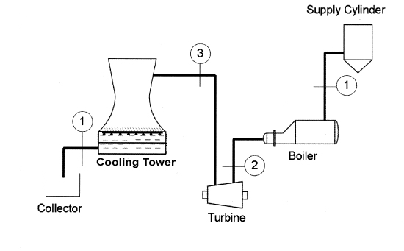

Figure : Diagram of the Rankine Cycle with State Numbers in their appropriate locations.

All data being used is from a previous group as our data was not recorded by the virtual bench. The values being used will be taken as averages in order to simplify the calculations. Thus the efficiency of the turbine will be the average turbine efficiency. The data in Tab.1 shows the values of the average values.

Table : List of average data from the Rankine Cycle Experiment with appropriate conversions for calculations.

|  |  |  |  |  |  |  |  |  |  |  |
| --- | --- | --- | --- | --- | --- | --- | --- | --- | --- | --- |
| **Boiler Pressure [PSIG]** | **Turbine Inlet Pressure [PSIG]** | **Turbine Exit Pressure [PSIG]** | | **Boiler Temperature**  **[°C]** | **Turbine Inlet Temperature [°C]** | **Turbine Exit Temperature [°C]** | | **Fuel Flow $\left[\frac{L}{min}\right]$** | **General Amperage [Amps]** | **General Voltage [Volts]** |
| 81.159 | 13.235 | 4.380 | | 165.971 | 122.078 | 114.432 | | 5.770 | 0.370 | 7.499 |
| **Conversions** | | | | | | | | | | |
| **Boiler Pressure [kPa]** | | | **Turbine Inlet Pressure [kPa]** | | | | **Turbine Exit Pressure [kPa]** | | | |
| 559.572 | | | 91.252 | | | | 30.1990 | | | |

Since most of the data has been taken around the turbine, it would be the most logical place to begin calculations. Some data in this section will be plugged into thermofluids.net in order to obtain the states for the system due to its accurate level of interpolation which is more accurate than reading the enthalpy and entropy from a Tab.1 [1].

**Turbine Inlet (State 2)**

Given the temperature and pressure at the turbine inlet, it is possible to calculate the enthalpy and entropy at the turbine inlet (state 2). Values can be seen in Fig. 2.

$$P_{2}=91.252 \left[kPa\right]$$

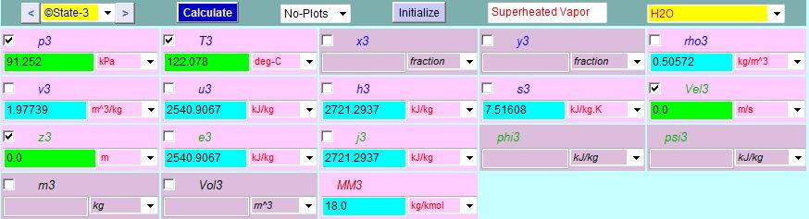 $T_{2}=122.078 \left[°C\right]$

$h_{2}=2721.2937 \left[\frac{kJ}{kg}\right]$

Figure : State 3 Analysis using thermofluids.net daemon for state 3 analysis to obtain enthalpy and entropy values.

$$s_{2}=7.51606 \left[\frac{kJ}{kg*K}\right]$$

**Isentropic Expansion at Turbine Exit (state 3s)**

After recording the data for the pressure at the turbine exit, we can calculate the quality of the mixture passing through the turbine by using the equation for isentropic expansion. We also know that the entropy at state 4s is equal to the entropy at state 3.

$$P_{3}=30.1990 \left[kPa\right]$$

$$s_{3s}= s_{2}=7.51606 \left[\frac{kJ}{kg*K}\right]$$

The quality of the mixture can be calculated as,

$$s_{3s}=\left(1-x\right)s_{f}+ (x)s_{g}$$

Where the quantities $s_{f}$ and $s_{g}$ are the entropy at saturated liquid and is the entropy at saturated vapor respectively. To calculate the quality we use the saturated water tables for pressure and interpolate between the two quantities on each side of the value we want to interpolate. Note that all interpolation values are linear so the precision to the actual value is not perfect. The equation and chart for interpolation was obtained from AJ Design Software [2].

|  |  |
| --- | --- |
| $$x_{1}$$ | $$y_{1}$$ |
| $$x_{2}$$ | $$y_{2}$$ |
| $$x_{3}$$ | $$y_{3}$$ |

$$y_{2}= \frac{(x_{2}- x_{1)}(y_{3}-y_{1)}}{(x_{3}-x_{1})}+ y_{1}$$

Looking at the saturation tables for water at the appropriate pressure, we are able to interpolate for the values of $s_{f}$ and $s_{g}$. The saturation tables are provided by thermofluids.net and can be seen in Fig.2.

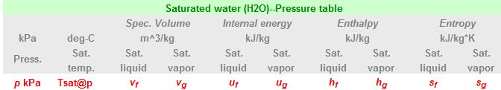

C:\Users\Kenny\Desktop\Capture.JPG

Figure : Saturated Water Pressure Tables provided by thermofluids.net.

After interpolating the following values were obtained.

$s_{f}=0.94553 \left[\frac{kJ}{kg*K}\right]$ $s_{g}=7.76664 \left[\frac{kJ}{kg*K}\right]$

We can now calculate the quality by plugging in the values into the quality formula.

$$s_{3s}=\left(1-x\right)s_{f}+ (x)s_{g}$$

$$7.51606\left[\frac{kJ}{kg*K} \right]=\left(1-x\right)*0.94553 \left[\frac{kJ}{kg*K} \right]+ \left(x\right)* 7.76664 \left[\frac{kJ}{kg*K} \right]$$

Solving the quality of the mixture *x*,

$$x=0.9633$$

We can now use the quality to calculate the enthalpy at state $3_{s}$ via the formula,

$$h_{3s}=\left(1-x\right)h_{f}+ (x)h_{g}$$

We again need to interpolate for the values of $h_{f}$ and $h_{g}$, so looking at Fig.2 and interpolating we obtain the values for the enthalpy at saturated liquid $h_{f}$ and the enthalpy at saturated vapor $h_{g}$.

$h_{f}=289.79416 \left[\frac{kJ}{kg}\right]$ $h_{g}=2625.52885 \left[\frac{kJ}{kg}\right]$

Plugging in these values along with the quality of the mixture, *x,* we calculate the isentropic enthalpy at state $3_{s}$.

$$h_{3s}=\left(1-0.9633\right)*289.79416 \left[\frac{kJ}{kg}\right]+ \left(0.9633\right)*2625.52885 \left[\frac{kJ}{kg}\right]$$

$$h_{3s}=2539.81\left[\frac{kJ}{kg}\right]$$

**Turbine Exit Actual (state 3)**

For the actual turbine exit we can associate the values recorded for the voltage and amperes from the virtual bench since they are directly related to the turbine. Using the definition of turbine work, we can obtain the actual work from the turbine having the units of *Watts*.

$${\dot{W}}_{turbine(actual)}=V*I$$

$${\dot{W}}_{turbine(actual)}=7.499 \left[V\right]* 0.370 [A]$$

$${\dot{W}}_{turbine(actual)}=2.775 [W]$$

Where *V* is the average voltage and *I* is the average amperes recorded from the lab data seen in Tab. 1. By applying a control volume around the turbine we will be able to calculate the enthalpy at state 3. Figure 4 shows the control volume of the turbine.

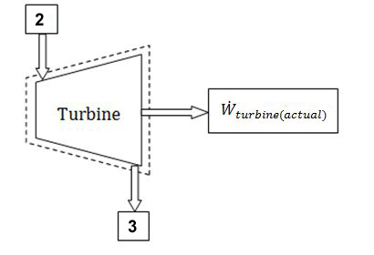

The formula for the work of the turbine is,

$${\dot{W}}_{turbine(actual)}= \dot{m}(h_{2}-h_{3})$$

We can solve for the enthalpy at state 3 by rearranging the equation,

$h_{3}= -1*\left(\frac{{\dot{W}}_{turbine(actual)}}{\dot{m}}- h_{2}\right)$

Figure : Control Volume of the Turbine from the Rankine Cycle.

Using the values for the turbine work and the mass flow rate calculated earlier we can obtain the enthalpy at state 3.

$$h_{3}= -1*\left(\frac{2.775 [W]}{0.0166 \left[\frac{kg}{s}\right]}- 2721.2937 \left[\frac{kJ}{kg}\right]\right)$$

$h_{3}=2554.13\left[\frac{kJ}{kg}\right]$

**Water Inlet (State 1)**

State 1 is known to be at saturated liquid with a quality of *x* = 0. We know the pressure at state 1 is equal to the pressure of state $3_{s}$ at saturated liquid. Therefore,

$$h_{1}= h_{3f}=289.79416 \left[\frac{kJ}{kg}\right]$$

The enthalpy values of the system can be seen in Tab. 2..

Table : Calculated Enthalpy values of the Rankine Cycle experiment.

|  |  |  |  |  |
| --- | --- | --- | --- | --- |
| **State Number** | State 1 | State 2 | State $3_{s}$ | State 3 |
| **Enthalpy Values $$\left[\frac{kJ}{kg}\right]$$** | 289.794 | $$2721.294$$ | 2539.81 | 2554.130 |

**3. Calculate the efficiency for the turbine.**

To calculate the efficiency of the turbine we need to use the calculated enthalpy values of the system. The process for the calculations of the enthalpy of each state can be seen in the previous analysis. The definition of the turbine efficiency is defined as,

$$η_{turbine}=\frac{h_{2}-h_{3}}{h_{2}-h_{3s}}*100\%$$

Using the values in Tab.2, the calculated turbine efficiency is,

$$η_{turbine}= \frac{2721.294\left[\frac{kJ}{kg}\right]-2554.130\left[\frac{kJ}{kg}\right]}{2721.294\left[\frac{kJ}{kg}\right]-2539.81\left[\frac{kJ}{kg}\right]}*100\%$$

$$η_{turbine}=92.11 \%$$

Please note the data obtained in this experiment had to be taken from another group as the virtual bench was not working when we reran the experiment. The only data taken from our experiment was the data for the mass flow rate. Due to this contribution, our efficiency for the turbine is very high.

[1] Bhattacharjee. S. 2009, “Test: The Expert System for Thermodynamics.” Electronic Resource,

Entropysoft, Del Mar, CA. http://www.thermofluids.net

[2] Raymond, Alena. *Linear Interpolation Equation Formula Calculator*. Ed. Alena Raymond. N.p., 2002. Web. 22 Oct. 2011. <http://www.ajdesigner.com/phpinterpolation/linear_interpolation_equation.php>.