

**ME 495 – Mechanical and Thermal Systems Lab**

**Experiment 3: Rankine Cycle Analysis**

**Group F**

Kluch, Arthur

Le-Nguyen, Richard

Levin, Ryan

Liljestrom, Kenneth

Maher, Sean

Nazir, Modaser

Lentz, Levi – Project Manager

Professor S. Kassegne, PhD, PE

October 26, 2011

i. Table of Contents

i. Table of Contents 2

1. Objective of the Experiment – Modasir Nazir 3

2. Equipment – Arthur Kluch 4

3. Experimental Procedure – Richard Le-Nguyen 6

4. Experimental Results – Ryan Levin 7

5. Data Reduction – Kennith Liljestrom 9

5. Discussion of Results – Sean Maher 15

7. Conclusion – Levi Lentz 16

8. References 17

1. Objective of the Experiment – Modasir Nazir

In this lab the student will learn how to operate and take measurements off of a Rankine steam cycle. The students will be using a “RankineCycler” steam turbine system made by Turbine Technologies Ltd. The turbine will be a working model of steam power plant and will be used so that the students shall apply basic equations for Brayton Cycle analysis. Furthermore, using empirical measurements at different points in the Rankine cycle will do this. The main purpose of this lab exercise it to help students get familiar with the Rankine cycle heat engine.

The vapor power plant has many uses and can be used for many applications. With that noted, it is mostly used to drive large electrical generators in a power plant. A basic vapor power plant has four major components. First is the pump and the second is the boiler. Compressed water is pumped into the boiler at state 1 and the water is heated at constant pressure in the boiler at state 2. The third major component is the turbine. Once the water is heated in the boiler, the hot water vapor is sent to the turbine where is expands isentropically to state 3. As the water vapor expands it performs work by turning the turbine. Furthermore, the turbine is connected to an electric generator by a shaft, which in turn produces electrical power. Lastly, the fourth major component is the condenser. The steam, now a saturated liquid- vapor mixture enters the condenser at state 4 and undergoes heat rejection at constant pressure. After this process is completed, liquid water enters the pump at state 1 and the process is repeated.



**Figure 1.** Summary of Rankine Cycle. [1]

Figure 2 above shows the states for an ideal Rankine Cycle. This model is not 100% accurate for our process. As the heat is added to the system via the boiler, it is done at a constant volume, and hence, a constant pressure line will not be followed. This heat addition removes the need for a pump as the water pressure is raised due to the phase change within the constant volume boiler. Additionally, our cycle is not a closed system, as modeled above; rather the water is released to the environment via a condenser.

The equations for this lab were derived from Dr. Kassenge’s lab guide titled “ME495 Lab - Rankine Cycle - Expt Number 3” [1]:

Pump – (*q* = 0): *win,PUMP = h2 – h1*

Boiler - (*w* = 0): *qin = h3 – h2*

Turbine - (*q* = 0): *wout,TURB = h3 – h4*

Condenser - (*w* = 0): *qout = h4 – h1*

The thermal efficiency of the Rankine cycle is determined from:

$$η_{th}=\frac{W_{net}}{Q_{in}}=1-\frac{Q_{out}}{Q_{in}}$$

Where *wnet* = *qin* – *qout = wout,TURB – win,PUMP*

The above equations make use of a perfectly acting thermal machine, ignoring all losses. Table 1 below shows the symbols and units used for the above equations.

|  |  |
| --- | --- |
| **Term** | **Value** |
| *win,PUMP* | Pump Work in (kJ) |
| *wout,TURB* | Turbine Work out (kJ) |
| *wnet* | Net Work (kJ) |
| *h1-4* | Enthalpy at stages 1-4 (kJ/kg) |
| *qin&out* | Energy in and out (kJ) |
| $$η_{th}$$ | Thermal Efficiency (%) |

**Table 1.** Symbols used throughout this lab.

2. Equipment – Arthur Kluch

1. 8000 mL Graduated Cylinder with valve and filler tube
2. Rankine Cycler steam turbine system made by Turbine Technologies Ltd.
   1. LP Boiler, Turbine, Condenser Tower
   2. Propane tank and regulator
   3. Amperage gage
   4. Pressure gage
3. Computer with Virtual Bench software installed
4. Waste water bucket
5. Heat resistant gloves
6. Lubricating oil
7. Deionized Water

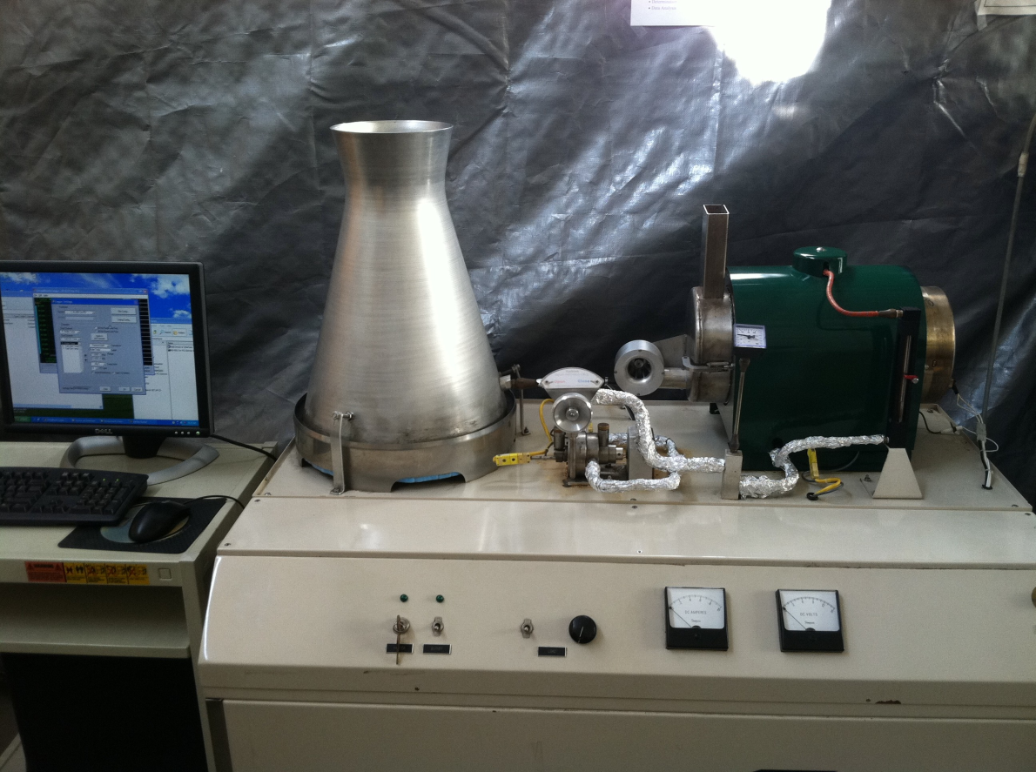

Figure 2. Rankine Cycler TM components.

The Rankine Cycler TM is a complete steam electric power plant. All components are pre-mounted to a portable chassis allowing the system to move for storage or maneuverability. A computer with Virtual Bench software installed is connected via USB to the high speed digital data acquisition system. Below is the list of sensors that provide the data to the computer and have been preinstalled and recalibrated.

* Boiler Pressure and Temperature
* Turbine Inlet Temperature and Pressure
* Turbine Exit Temperature and Pressure
* Turbine RPM
* Fuel Flow
* System Electrical Load
* Generator Voltage Output and Current Draw

|  |  |
| --- | --- |
| Operating Conditions / Requirements | Limitations / Requirements |
| Boiler | Pressure 120 psi, Temperature 482° F |
| Generator | 15.0 Volts, 1.0 Amp |
| Power | 120 V, 60 Hz |
| Fuel | Liquid Propane |

**Table 2.** System Specifications

3. Experimental Procedure – Richard Le-Nguyen

The following is the procedure that our group completed by following the guidelines outlined in the document “Rankine Cycle.” We found that we did not have to deviate from the established procedure.

The steam admission valve was opened and 3500ml of de-ionized water was placed into a graduated cylinder and inserted into the filler tube in the back of the boiler. The steam admission valve was then closed and the casters were locked. The thumbscrews were removed from the turbine in order for oil to be filled to a level of 1/8 inches from the top. The load and burner switches were set to the “OFF” position. The load knob was turned fully counter clockwise. The catch tube behind the cooling tower was disposed of in a drain. The computer was turned on. The valve on the propane tank was opened. The gas valve knob, the master power switch, and the burner switch was turned to “ON.”

The “Virtual Bench” was opened on the computer. The file configuration dialog box was opened and the Filename, Username, Comments, Field Length, Precision, and Number of Lines were filled out. Next Enable Logging and Being Logging on Start were selected. OK was selected and data began logging.

When the boiler pressure approached 110 psig, the steam admission valve was opened slowly to regulate the turbine speed between 7 and 10 volts. The steam admission valve was closed after 20 seconds to rebuild pressure. When the boiler pressure reached 110 psig, the admission valve was opened and the turbine was adjusted to 9 volts. The load switch was turned “ON.” The Load knob and the steam admission valve were adjusted until the voltmeter and ammeter read 9 volts and .04 amps. The steam admission valve was closed. The load knob was turned counter clockwise and the Load switch, burner switch, gas valve, and propane tank were turned “OFF.”

The volume of condensate behind the cooling tower was measured and recorded. The boiler was left to cool down to 10 psig. The load was turned to full and the steam admission valve was opened to allow the boiler to reach atmospheric pressure. The water from the boiler was removed and measured and the steam admission valve was closed.

4. Experimental Results – Ryan Levin

The following graphs represent the recorded data of the experiment.

**Figure 3.** Boiler Pressure vs Time.

**Figure 4.** Turbine Inlet Pressure vs. Time

**Figure 5.** Turbine Exit Pressure vs. Time

**Figure 6.** Generator Output vs. Time

5. Data Reduction – Kennith Liljestrom

Data Reduction

1. **The measured or weighted re-fill mass of water represents the boiler’s total steam production during your run. This can be correlated as the steam rate by dividing the weight of the water replaced by the time duration of your run.**

Given the task of calculating the mass flow rate we first take a look at the equation for which values we need to solve for. We define the mass flow rate $\dot{m}$, as,

$$\dot{m}= \frac{m}{t}$$

Where *m* is the mass of the water and *t* is the time the water is flowing. In order to get the mass of the water we must convert the amount of *mL* added to the system into $m^{3}.$ Taking the 1500 mL of water we measured after our run was finished and using the conversion yields 0.0015 $m^{3}$. We do this in order to compare it to the density of water. Using the value of the density of water, *ρ*, at atmospheric temperature of 25°C is equal to 997 ${kg}/{m^{3}}$. The mass of the water can be defined as the density of water multiplied by the volume.

$$m= ρV$$

= 997 $\left[ \frac{kg}{m^{3}} \right]$* 0.0015 $[m^{3}]$

$$m=1.4955 [kg]$$

We can now divide the mass of the system by the duration of time the process took place which was around 90 *s*. We are now able to obtain the mass flow rate, $\dot{m}$.

$$\dot{m}= \frac{1.4955 [kg]}{90 [s]}$$

$$\dot{m}=0.0166 \left[\frac{kg}{s}\right]$$

**2. Provide a first law analysis of each stage of the actual process.**

The set-up for the Rankine cycle experiment uses a boiler with water fed into it by a supply cylinder rather than having the water pumped into the boiler. The water is then heated up in the boiler until superheated then passed through to the inlet of the turbine. After producing some work, the mixture passes through the turbine and exits into the cooling tower where the collected water is caught in the collector. A diagram of the schematic can be seen in Figure 7.

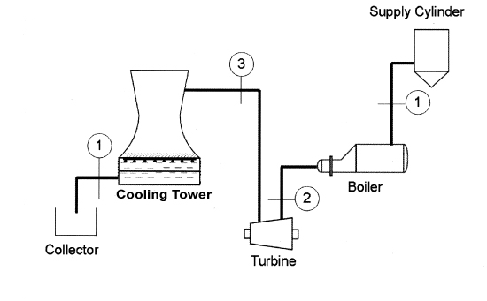

Figure 7. Diagram of the Rankine Cycle with State Numbers in their appropriate locations.

All data being used is from a previous group as our data was not recorded by the virtual bench. The values being used will be taken as averages in order to simplify the calculations. Thus the efficiency of the turbine will be the average turbine efficiency. The data in Table 3 shows the values of the average values.

|  |  |  |  |  |  |  |  |  |  |  |
| --- | --- | --- | --- | --- | --- | --- | --- | --- | --- | --- |
| **Boiler Pressure [PSIG]** | **Turbine Inlet Pressure [PSIG]** | **Turbine Exit Pressure [PSIG]** | | **Boiler Temperature**  **[°C]** | **Turbine Inlet Temperature [°C]** | **Turbine Exit Temperature [°C]** | | **Fuel Flow $\left[\frac{L}{min}\right]$** | **General Amperage [Amps]** | **General Voltage [Volts]** |
| 81.159 | 13.235 | 4.380 | | 165.971 | 122.078 | 114.432 | | 5.770 | 0.370 | 7.499 |
| **Conversions** | | | | | | | | | | |
| **Boiler Pressure [kPa]** | | | **Turbine Inlet Pressure [kPa]** | | | | **Turbine Exit Pressure [kPa]** | | | |
| 559.572 | | | 91.252 | | | | 30.1990 | | | |

**Table 3.** List of average data from the Rankine Cycle Experiment with appropriate conversions for calculations.

Since most of the data has been taken around the turbine, it would be the most logical place to begin calculations. Some data in this section will be plugged into thermofluids.net in order to obtain the states for the system due to its accurate level of interpolation which is more accurate than reading the enthalpy and entropy from a Tab.1 [2].

**Turbine Inlet (State 2)**

Given the temperature and pressure at the turbine inlet, it is possible to calculate the enthalpy and entropy at the turbine inlet (state 2). Values can be seen in Figure 8.

$$P_{2}=91.252 \left[kPa\right]$$

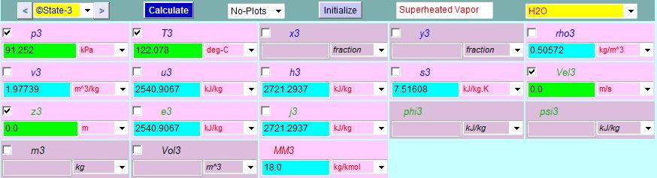 $T_{2}=122.078 \left[°C\right]$

Figure 8. State 3 Analysis using thermofluids.net daemon for state 3 analysis to obtain enthalpy and entropy values.

$$h_{2}=2721.2937 \left[\frac{kJ}{kg}\right]$$

$$s_{2}=7.51606 \left[\frac{kJ}{kg*K}\right]$$

**Isentropic Expansion at Turbine Exit (state 3s)**

After recording the data for the pressure at the turbine exit, we can calculate the quality of the mixture passing through the turbine by using the equation for isentropic expansion. We also know that the entropy at state 4s is equal to the entropy at state 3.

$$P_{3}=30.1990 \left[kPa\right]$$

$$s_{3s}= s_{2}=7.51606 \left[\frac{kJ}{kg*K}\right]$$

The quality of the mixture can be calculated as,

$$s_{3s}=\left(1-x\right)s_{f}+ (x)s_{g}$$

Where the quantities $s_{f}$ and $s_{g}$ are the entropy at saturated liquid and is the entropy at saturated vapor respectively. To calculate the quality we use the saturated water tables for pressure and interpolate between the two quantities on each side of the value we want to interpolate. Note that all interpolation values are linear so the precision to the actual value is not perfect. The equation and chart for interpolation was obtained from AJ Design Software [3].

|  |  |
| --- | --- |
| $$x_{1}$$ | $$y_{1}$$ |
| $$x_{2}$$ | $$y_{2}$$ |
| $$x_{3}$$ | $$y_{3}$$ |

$$y_{2}= \frac{(x_{2}- x_{1)}(y_{3}-y_{1)}}{(x_{3}-x_{1})}+ y_{1}$$

Looking at the saturation tables for water at the appropriate pressure, we are able to interpolate for the values of $s_{f}$ and $s_{g}$. The saturation tables are provided by thermofluids.net and can be seen in Figure 9 below.

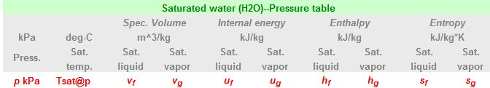

C:\Users\Kenny\Desktop\Capture.JPG

Figure 9: Saturated Water Pressure Tables provided by thermofluids.net.

After interpolating the following values were obtained.

$s_{f}=0.94553 \left[\frac{kJ}{kg*K}\right]$ $s_{g}=7.76664 \left[\frac{kJ}{kg*K}\right]$

We can now calculate the quality by plugging in the values into the quality formula.

$$s_{3s}=\left(1-x\right)s_{f}+ (x)s_{g}$$

$$7.51606\left[\frac{kJ}{kg*K} \right]=\left(1-x\right)*0.94553 \left[\frac{kJ}{kg*K} \right]+ \left(x\right)* 7.76664 \left[\frac{kJ}{kg*K} \right]$$

Solving the quality of the mixture *x*,

$$x=0.9633$$

We can now use the quality to calculate the enthalpy at state $3_{s}$ via the formula,

$$h_{3s}=\left(1-x\right)h_{f}+ (x)h_{g}$$

We again need to interpolate for the values of $h_{f}$ and $h_{g}$, so looking at Figure 8 and interpolating we obtain the values for the enthalpy at saturated liquid $h_{f}$ and the enthalpy at saturated vapor $h_{g}$.

$h_{f}=289.79416 \left[\frac{kJ}{kg}\right]$ $h_{g}=2625.52885 \left[\frac{kJ}{kg}\right]$

Plugging in these values along with the quality of the mixture, *x,* we calculate the isentropic enthalpy at state $3_{s}$.

$$h_{3s}=\left(1-0.9633\right)*289.79416 \left[\frac{kJ}{kg}\right]+ \left(0.9633\right)*2625.52885 \left[\frac{kJ}{kg}\right]$$

$$h_{3s}=2644.97\left[\frac{kJ}{kg}\right]$$

**Turbine Exit Actual (state 3)**

For the actual turbine exit we can associate the values recorded for the voltage and amperes from the virtual bench since they are directly related to the turbine. Using the definition of turbine work, we can obtain the actual work from the turbine having the units of *Watts*.

$${\dot{W}}_{turbine(actual)}=V*I$$

$${\dot{W}}_{turbine(actual)}=7.499 \left[V\right]* 0.370 [A]$$

$${\dot{W}}_{turbine(actual)}=2.775 [W]$$

Where *V* is the average voltage and *I* is the average amperes recorded from the lab data seen in Table 3 By applying a control volume around the turbine we will be able to calculate the enthalpy at state 3. Figure 10 shows the control volume of the turbine.

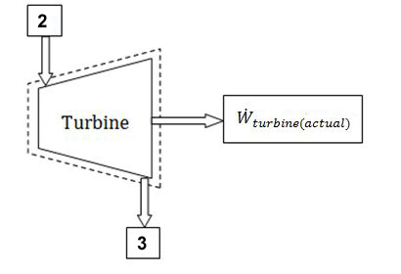

The formula for the work of the turbine is,

$${\dot{W}}_{turbine(actual)}= \dot{m}(h_{2}-h_{3})$$

We can solve for the enthalpy at state 3 by rearranging the equation,

$h_{3}= -1*\left(\frac{{\dot{W}}_{turbine(actual)}}{\dot{m}}- h_{2}\right)$

Figure 10: Control Volume of the Turbine from the Rankine Cycle.

Using the values for the turbine work and the mass flow rate calculated earlier we can obtain the enthalpy at state 3.

$$h_{3}= -1*\left(\frac{2.775*{10}^{-3} [kW]}{0.096167 \left[\frac{kg}{s}\right]}- 2721.2937 \left[\frac{kJ}{kg}\right]\right)$$

$h_{3}=2701.12\left[\frac{kJ}{kg}\right]$

**Water Inlet (State 1)**

State 1 is known to be at saturated liquid with a quality of *x* = 0. We know the pressure at state 1 is equal to the pressure of state $3_{s}$ at saturated liquid. Therefore,

$$h_{1}= h_{3f}=289.79416 \left[\frac{kJ}{kg}\right]$$

The enthalpy values of the system can be seen in Table 4.

|  |  |  |  |  |
| --- | --- | --- | --- | --- |
| **State Number** | State 1 | State 2 | State $3_{s}$ | State 3 |
| **Enthalpy Values $$\left[\frac{kJ}{kg}\right]$$** | 289.794 | $$2721.294$$ | 2644.97 | 2701 |

**Table 4.** Calculated Enthalpy values of the Rankine Cycle experiment.

**3. Calculate the efficiency for the turbine.**

To calculate the efficiency of the turbine we need to use the calculated enthalpy values of the system. The process for the calculations of the enthalpy of each state can be seen in the previous analysis. The definition of the turbine efficiency is defined as,

$$η_{turbine}=\frac{h_{2}-h_{3}}{h_{2}-h_{3s}}*100\%$$

Using the values in Tab.2, the calculated turbine efficiency is,

$$η_{turbine}= \frac{2721.294\left[\frac{kJ}{kg}\right]-2701\left[\frac{kJ}{kg}\right]}{2721.294\left[\frac{kJ}{kg}\right]-2644.97\left[\frac{kJ}{kg}\right]}*100\%$$

$$η_{turbine}=26.5 \%$$

**4. Thermal Efficiency of the Cycle.**

As an added completion to the laboratory, it is worth calculating the thermal efficiency of the cycle:

$$η_{thermal}=\frac{{\dot{W}}_{net\left(actual\right)}}{{\dot{Q}}_{in}}=\frac{{\dot{W}}_{net\left(actual\right)}}{\dot{m}\left(h_{2}-h_{1}\right)}=\frac{2.775}{.09616*\left(2721.294-289.794\right)}*100\%$$

$$η_{thermal}=1.2\%$$

Because of the large difference between the efficiency of the turbine and the thermal efficiency of the cycle, there has to be a large amount of losses within the boiler as it raises the temperature of the water.

5. Discussion of Results – Sean Maher

For this experiment we gathered data from a working Rankine cycle steam turbine power system. In our experiment we gathered data for the boiler pressure, turbine inlet pressure, turbine exit pressure, boiler temperature, turbine inlet and exit temperatures, fluid flow and generated amprige and voltage. All pressures were in PSIG and temperatures were recorded in degree C.

The thermal efficiency of this cycle was extremely low, measuring at a dismal 1.2%. The thermal efficiency of the Turbine, however, was 26.2%. This low overall efficiency is more than likely due to the fact that the boiler was extremely inefficient. The machine also had very poor insulation with all the pipes being surrounded by only aluminum foil. Additionally, the valve prior to the entrance of the turbine was very leaky, inducing more and more compounding errors.

Besides the mechanical problems present in the machine, operator error could have added to the problems with the low efficiency. Among other problems, the water measurement was done on a large graduated cylinder, so the reading was not extremely accurate. Also, the test was only completed on time, leaving no way to separate mechanical from human errors.

7. Conclusion – Levi Lentz

This experiment successfully introduced these mechanical engineering students to the principles behind the Rankine Cycle as well as how to take proper measurements from the experimental rig. After completing the test, we were only able to attain a 1.2% thermal efficiency with a 26.2% turbine efficiency. As the test was run only singularly, there is no way to determine if these low efficiencies were caused wholly by the equipment or if user error significantly contributed to them. In order to provide a correlation, it would be imperative to do the test multiple times so that a trend could be established to determine the baseline performance of the cycle irrespective of human error. Even with these low efficiencies, this was a very successful lab in introducing the mechanical engineering students to the principles of the Rankine thermal process.

8. References

[1] Kassegne, S. “ME495 Lab – Rankine Lab– Expt Number 3." Mechanical Engineering

Department.San Diego State University.Fall 2011.

[2] Bhattacharjee. S. 2009, “Test: The Expert System for Thermodynamics.” Electronic Resource, Entropysoft, Del Mar, CA. http://www.thermofluids.net

[3] Raymond, Alena. *Linear Interpolation Equation Formula Calculator*. Ed. Alena Raymond. N.p., 2002. Web. 22 Oct. 2011. <http://www.ajdesigner.com/phpinterpolation/linear_interpolation_equation.php>.