Objective:

In this lab students will use a HT30XC Heat Exchanger Unit and a HT31 Tubular (tube-in-tube) Heat Exchanger. These are test devices created by Armfield Limited, Ringwald, Hampshire England for use in physics and engineering laboratories. The objective of this lab exercise is to get the students comfortable with heat transfer in heat exchangers. Also, the students will familiarize themselves with the different transducers used to detect and measure the physical properties used when finding the heat transfer between the hot and cold medium in the heat exchanger. Lastly, the students will determine the heat transfer coefficient because this will help us review the performance of the heat exchanger.

Intro:

The tubular heat exchanger consists of two concentric (coaxial) tubes and is the simplest form of any heat exchanger. If there is a temperature difference across the wall of the metal tube it will result in the transfer of heat between the two streams of fluid. The outer part of the tube (acrylic annulus) carries the cold fluid, and the inner metal tube carries a hot fluid. Thus, the inner tube’s outer surface is in direct contact with the cold fluid. Therefore, the hot water flowing through the inner tube will be cooled and the cold water flowing through the outer annulus will be heated.

A thermocouple is a device consisting of two different conductors that produce a voltage proportional to the temperature difference across the pair of conductors. In this lab a thermocouple is placed at the center location along the heat exchanger length and at entrance and exit of both the hot and cold fluid streams. The students control temperature of the hot fluid and the flow rate of both hot and cold streams of fluid. Also, Tubular Heat exchangers can me modified so that the flow of the two fluids can have a parallel flow (enter from same side) or a counter flow (enter from opposite sides of exchanger).



**Figure 1:** Parallel flow heat exchanger

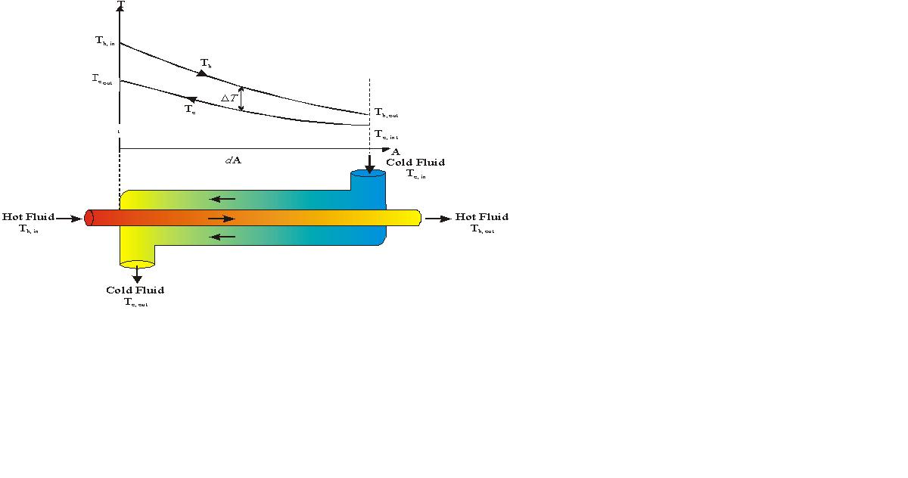

T6

T1

T4

T3

**Figure 2:** Counter flow heat exchanger

Since the difference in temperature between the hot and cold fluids in Counter flow is relatively constant, it is the preferred flow. Also, because extreme temperature differences are eliminated in Counter flow, it becomes yet another reason why this flow is more beneficial as opposed to parallel flow. Extreme temperature differences can also thermally stress the heat exchanger.

## The following relationships will be used in this lab exercise.

Mass flow rate: *mdot* = Volume flow rate (*Vdot*) × density of the fluid (**)

Heat power: *Q = mdot* × *cp* ×* **T*

*cp* ∴constant specific heat

Heat emitted from the hot fluid: *Qe = mhcp,h*(*T1  T3*)

Heat absorbed by the cold fluid: *Qa = mccp,c*(*T6  T4*)

Overall Efficiency for the system: ** = (*Qa* / *Qe*) ×100%

Theoretically, *Qe*  *Qa* . However, this does not hold true due to heat loss given by *Qf*  = *Qe*  *Qa*

Overall Heat Transfer Co-Efficient U= *Qe* /( A * ∆T*lm* )

A= 0.02 m2

∆T*lm*= (ΔT1 - ΔT2) / ln(ΔT1/ΔT2)

ΔT1 = (T3 – T4)

ΔT2 = (T1 – T6)

|  |  |
| --- | --- |
| **TERM** | **VALUE** |
| *mdot* | Mass Flow Rate |
| *Vdot* | Volume Flow Rate |
| *Qe* | Heat emitted/absorbed |
| *cp* | Pressure Constant |
| h |  |
| ** | Overall Efficiency |
| U | Overall Heat Transfer Coefficient |
| A | Area (m^2) |
| T | Temperature (K) |