

**ME 495 – Mechanical and Thermal Systems Lab**

**Experiment 4: Tubular Heat Exchanger**

**Group F**

Kluch, Arthur

Le-Nguyen, Richard

Levin, Ryan

Liljestrom, Kenneth

Maher, Sean

Nazir, Modaser

Lentz, Levi – Project Manager

Professor S. Kassegne, PhD, PE

November 02, 2011

i. Table of Contents

i. Table of Contents 2

1. Objective of the Experiment – Modasir Nazir 3

2. Equipment – Arthur Kluch 6

3. Experimental Procedure – Richard Le-Nguyen 8

4. Experimental Results – Ryan Levin 9

5. Discussion of Results – Sean Maher 13

6. Lab Guide Questions – Kennith Liljestrom 13

7. Conclusion – Levi Lentz 14

8. References 16

1. Objective of the Experiment – Modasir Nazir

In this lab students will use a HT30XC Heat Exchanger Unit and a HT31 Tubular (tube-in-tube) Heat Exchanger. These are test devices manufactured by Armfield Limited, Ringwald, Hampshire England for use in physics and engineering laboratories. The objective of this lab exercise is to familiarize students comfortable with heat transfer in heat exchangers. Also, the students will familiarize themselves with the different transducers used to detect and measure the physical properties used when finding the heat transfer between the hot and cold medium in the heat exchanger. Lastly, the students will determine the heat transfer coefficient because this will help us review the performance of the heat exchanger.

The tubular heat exchanger consists of two concentric (coaxial) tubes and is the simplest form of any heat exchanger. If there is a temperature difference across the wall of the metal tube it will result in the transfer of heat between the two streams of fluid. The outer part of the tube (acrylic annulus) carries the cold fluid, and the inner metal tube carries a hot fluid. Thus, the inner tube’s outer surface is in direct contact with the cold fluid. Therefore, the hot water flowing through the inner tube will be cooled and the cold water flowing through the outer annulus will be heated. The flows also run counter to each other. This counter flow is present to ensure the greatest amount of heat transfer across the length of the tube. If the flow was run parallel, the flows would eventually reach an equal temperature, and no heat transfer would be possible.

A thermocouple is a device consisting of two different conductors that produce a voltage proportional to the temperature difference across the pair of conductors. In this lab a thermocouple is placed at the center location along the heat exchanger length and at entrance and exit of both the hot and cold fluid streams. From the temperature changes in each fluid, it can be calculated how much heat is transferred from each fluid. In theory, these temperature changes should be equal; however in a real world setting the two heat transfers will not be equal.

Below is a graphical representation of the theory behind the heat transfer:



**Figure 1:** Parallel flow heat exchanger [1]

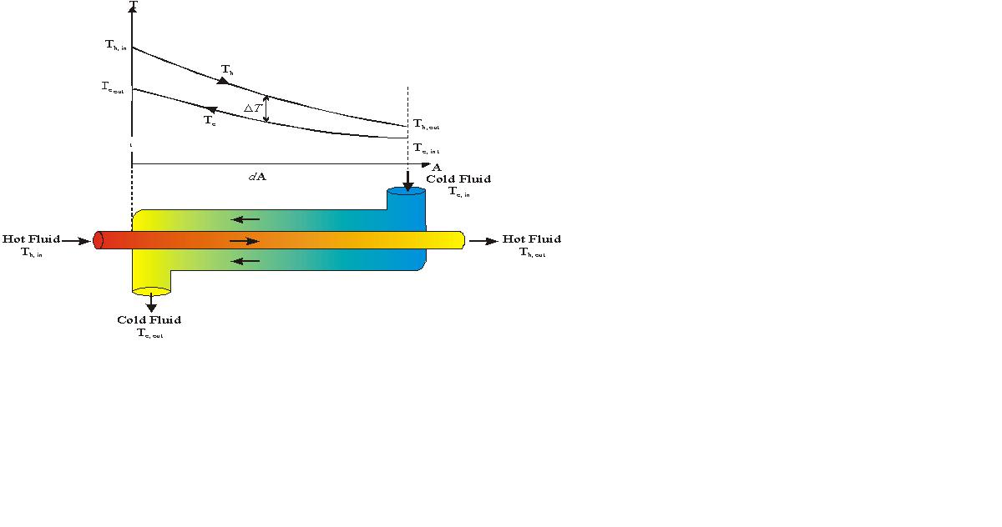

T6

T1

T4

T3

**Figure 2:** Counter flow heat exchanger [1]

Since the difference in temperature between the hot and cold fluids in Counter flow is relatively constant, it is the preferred flow. Also, because extreme temperature differences are eliminated in Counter flow, it becomes yet another reason why this flow is more beneficial as opposed to parallel flow. Extreme temperature differences can thermally stress the heat exchanger.

The following equations were derived in the document titled “Experiment 4 – Tubular Heat Exchanger” By Dr. Kassegne [1]:

Mass flow rate: $\dot{m}=\dot{V}*ρ$

Heat power: *Q = mdot* × *cp* × *ΔT*

*cp* ∴constant specific heat

Heat emitted from the hot fluid: *Qe = mhcp,h*(*T1 - T3*)

Heat absorbed by the cold fluid: *Qa = mccp,c*(*T6 -T4*)

Overall Efficiency for the system: $η$ = (*Qa* / *Qe*) ×100%

Theoretically, *Qe* =*Qa* . However, this does not hold true due to heat loss given by *Qf*  = *Qe* - *Qa*

Overall Heat Transfer Co-Efficient U= *Qe* /( A * ∆T*lm* )

A= 0.02 m2

∆T*lm*= (ΔT1 - ΔT2) / ln(ΔT1/ΔT2)

ΔT1 = (T3 – T4)

ΔT2 = (T1 – T6)

**Table 1.** Terms used in the calculations found in this report.

|  |  |
| --- | --- |
| **TERM** | **VALUE** |
| $$\dot{m}$$ | Mass Flow Rate [kg/s] |
| $$\dot{V}$$ | Volume Flow Rate [m3/s] |
| *Q* | Heat emitted/absorbed [kW] |
| *cp* | Pressure Constant [kJ/kg*k] |
| h | Specific Enthalpy [kJ/kg] |
| $$η$$ | Overall Efficiency [unitless] |
| U | Overall Heat Transfer Coefficient [W/(m2K)] |
| A | Area [m2] |
| T | Temperature [K] |

2. Equipment – Arthur Kluch

1) Armfield HT30XC Heat Exchanger Unit

2) Armfield HT31 Tubular Heat Exchanger

3) Thermocouples

4) Computer

5) Glass beaker

6) De-ionized water

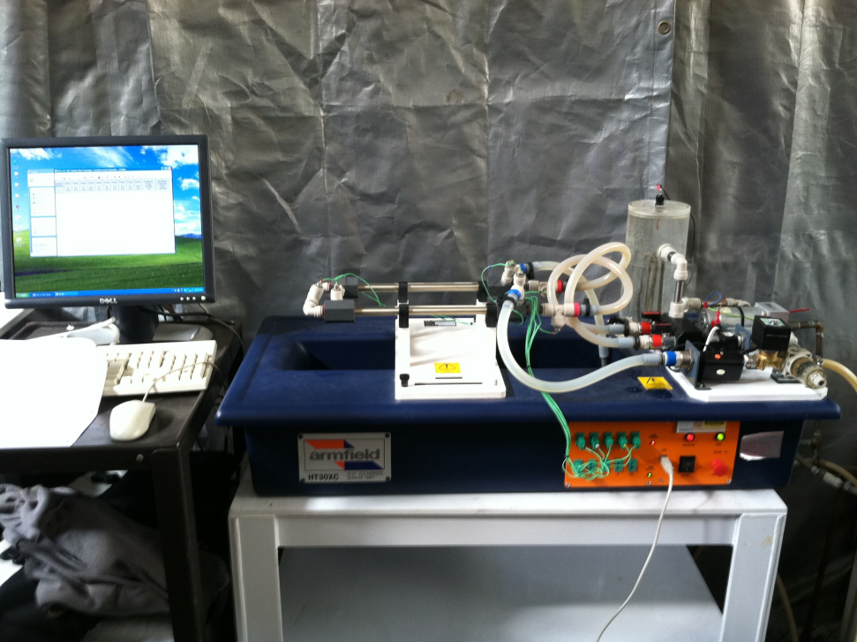

Figure 2. Armfield HT30XC Heat Exchanger Unit with HT31 Tubular Heat Exchanger mounted on top and the computer.

1) The HT30XC Heat Exchanger Unit is a complete self-contained system for use in engineering labs. The unit contains an acrylic hot water vessel with a 2 kW heater with thermostat, hot water recirculation pump, cold water recirculation pump, cold water filter, computer interface, space for up to 10 thermocouples and 2 flow meters.

2) The HT31 Heat Exchanger consists of two concentric tubes for carrying hot and cold fluid. This unit can be used for both parallel and counter flow setups.

3) There were seven thermocouples used in this experiment. Six of which were placed at different points along the tubular heat exchanger and the seventh was placed in the water tank. Temperature measurements from the heat exchanger were taken for both hot and cold inlet and exit as well as in the middle.

4) A PC was used to collect thermocouple data, control the heater for the water reservoir, and control the water flow rates for the hot and cold valves as a percent opening. The PC has "Armfield Tubular Heat Exchanger Software" installed and running.

5) A glass beaker was using to prime the water vessel.

6) De-ionized water was used for the hot side during this experiment.

3. Experimental Procedure – Richard Le-Nguyen

The following is the procedure that our group completed by following the guidelines outlined in the document “Tubular Heat Exchanger.” We found that we did not have to deviate from the established procedure. Before beginning the experiment, the system was properly prepared by following the “System Set-Up” section according to the Tubular Heat Exchanger document.

After the system was set-up, the Armfield HT31 Tubular heat exchanger software was loaded from the desktop of the computer. “Countercurrent flow” was selected and the “load” button was pressed. The “how water flow” tab was opened within the “view diagram” table. “Automatic” was chosen for the mode of operation. Under hot water flow rate set point, 2.5 lit/min. Save, apply, and ok were selected respectively.

The “heater” button was selected on the right side of the screen. “Automatic” was chosen for the mode of operation. The hot water inlet and outlet valves were turned 90 degrees to the open positions. The temperature was set to 50 degrees Celsius. Save, apply, and ok were selected respectively.

The “power on” button was selected on the left of the main screen under the controls section. This started the motor and heater. When the hot water temperature reached 50 degrees Celsius, the cold water supply valve was turned on. The cold water flow rate percentage valve opening was set to 100%. The cold water flow rate was recorded. The “go” button was selected to enable the computer to collect data on a table. The data was saved after the cold water reached a steady temperature. The experiment was repeated for a cold water flow rate percentage valve opening of 75% and 50%. The data was saved, the equipment was turned off, disconnected, and the water was drained.

4. Experimental Results – Ryan Levin

Sample Calculations for 100% @ data sample 1:

The heat emitted from the hot fluid:



The heat absorbed from the cold fluid:



Mass flow rate for the hot fluid:



Mass flow rate for the cold fluid:



The heat lost from the system:



Overall Heat Transfer Co-Efficient: A=.02m2



The mean temperature efficiency:



The overall efficiency for the system:



Hot fluid volume flow rate:



Cold fluid volume flow rate:



**Table 2.** Tabulated data from the experiment.

|  |  |  |  |
| --- | --- | --- | --- |
| **Data Type** | **100%** | **75%** | **50%** |
| Qe [W] | 0.997 | 0.990 | 0.829 |
| Qa [W] | 1.008 | 1.030 | 0.856 |
| Mdot Hot [kg/s] | 0.041 | 0.041 | 0.041 |
| Mdot Cold [kg/s] | 0.043 | 0.039 | 0.027 |
| Qf [W] | -0.024 | -0.040 | -0.028 |
| U [W/m2.K] | 2.050 | 1.973 | 1.702 |
| Mean Temp Efficiency [%] | 21.424 | 21.665 | 23.019 |
| Vdot Hot [m3/min] | 4.161E-05 | 4.165E-05 | 4.177E-05 |
| Vdot Cold [m3/min] | 4.277E-05 | 3.942E-05 | 2.674E-05 |

**Figure 3.** Graph of power vs data sample.

**Figure 4.** Average heat at each run.

**Figure 5.** Average change in temperature for each run.

**Figure 6.** Overall Efficiency for each run. Note that they are each over 100%.

5. Discussion of Results – Sean Maher

.Each run was completed in accordance with the provided lab manual. After reducing the data, there appears to be an error with the recording. The primary problem is that the overall efficiency for each run was over 100%. Because the way the efficiency is calculated, with the heat absorbed being divided by the heat emitted, this could be just be due to extra heat being added to the system due to fluid losses along the length of the pipe. The pipe containing the water is also acrylic, meaning that any ambient radiation would have no problem heating the water. At the exit the temperature was 20.4C, meanwhile ambient temperature was 25C. This temperature difference could have added heat to our system.

Another error with the runs was that the highest flow rate should have the largest amount of heat emitted and absorbed, however the highest amount of heat is the lowest flow. There also appears to be a discontinuity with the flow rate at 50% as it has an uncharacteristically high change in temperature. These errors cannot be readily explained for, they do, however, point to the fact that the data is suspect of being unreliable.

These errors point to the fact that the lab needs to be rerun. The biggest error is that the runs are only done one time. This makes it nearly impossible to draw a conclusion as to if the errors are systemic or operator-induced. Each run was run with the highest attention to accuracy. The primary operator error would have come from not allowing enough time for the water to reach steady-state operation. All other errors would have been due to systemic errors with the measurement equipment.

6. Lab Guide Questions – Kennith Liljestrom

**1. Did the heat exchanger remove more or less heat from the hot stream as the flow rate of the cold water decreased?**

To determine if the heat exchanger removed more or less heat from the hot stream as the flow rate of the cold water decreased, we refer to the heat absorption equation from Dr. Kassegne’s Lab 4 document [1].

$$Q= \dot{m_{c}}c_{p}∆T= \dot{m_{c}}c_{p}(T_{6}-T_{4})$$

The heat loss, *Q*, is a function of the mass flow rate of the cold water, $\dot{m_{c}}$. Thus if the flow rate of the cold water decreases, the heat loss through the system will decrease resulting in a higher temperature of the hot water. If the cold water moves at a slower rate, the hot water will be able to increase the temperature of the cold water making the difference in temperature, *ΔT*, smaller which will also reduce the heat loss through the system.

**2. Did the system efficiency increase or decrease as the cold water flow rate decreased?**

The efficiency of the system is described as the heat absorbed by the system divided, $Q_{absorbed},$ by the heat emitted from the system, $Q_{emitted}$.

$$η= \frac{Q_{absorbed}}{Q_{emitted}}*100\%$$

The values for the heat absorbed and the heat emitted move linearly with each other so the efficiency will stay around the same value. As the mass flow rate decreases, the heat absorbed decreases and the heat emitted decreases. Thus the ratio between the two values stayed fairly constant. The efficiencies for the 100%, 75%, and 50% flow of the cold water were recorded as 102.52%, 104.08%, and 103.38% respectively. The values can be seen in Tab. 1.

**3. Why is it necessary to find the heat transfer co-efficient for the heat exchanger?**

The heat transfer coefficient, *h*, needs to be calculated for any apparatus where heat loss is important because the heat transfer coefficient directly affects the systems’ ability to transfer heat. For heat exchangers, the heat transfer coefficient measures how well the heat exchange between two fluids or gases or different temperatures is. If the value of the heat transfer coefficient is low, the heat transfer will be low and if the value is high then a better heat transfer is obtained in the system.

**4. Were there any systematic or random errors that affected your measurements? Discuss in detail and suggest innovative ways to minimize such errors.**

During the experiment, we noticed the filter at the inlet of the cold water flow was filled with algae which may have infiltrated the system or impeded the flow of the cold water which may have made the pump do more work. It is recommended the filter be removed and cleaned, or if damaged then replaced. Another parameter that should be noted is that our system efficiencies for various flow rates exceeded 100% which may reflect an error in the thermocouples of the system. Due to the constant replacing of the tubular and plate heat exchangers, some thermocouples may have been damaged in transport or may need to be recalibrated. Fixing the thermocouples would result in more accurate temperature readings and a more realistic system efficiency.

7. Conclusion – Levi Lentz

After completing this experiment, the students of this group learned the basics of counter-flow heat exchangers. After completing the experiment, it appears that the collected data is fundamentally wrong. This could have been from a variety of sources from the fact that it was an abnormally hot day to errors in the measurement equipment. However, because the run was only completed one time, it is nearly impossible to tell if the problem arose from the measurement equipment or if it was due to operator error. In order to ascertain if the problem was indeed an error with the equipment, the lab would need to be completed again, correlating the two together to establish a trend in the data. Overall, this lab presented a great way to learn the basics of counter-flow heat exchangers and was a great learning opportunity.

8. References

**[1]** Kassegne, S. "ME495 Lab - Tubular Heat Exchanger - Expt Number 4." Mechanical Engineering Department. San Diego State University. Fall 2011.