**PLATE HEAT EXCHANGER**

**OBJECTIVE**

The objective of this experiment is to demonstrate indirect heating or cooling by transfer of heat from one fluid stream to another when separated by a solid wall (fluid to fluid heat transfer).Students will determine heat transfer co-efficient, which is the measure of heat exchanger performance.In this exercise, HT30XC Heat Exchanger Unit and HT32 unit (Plate Heat Exchanger) are used.The HT30XC and HT32 are test devices created for use in physics and engineering laboratories by Armfield Limited, Ringwald, Hampshire England.

**INTRODUCTION**

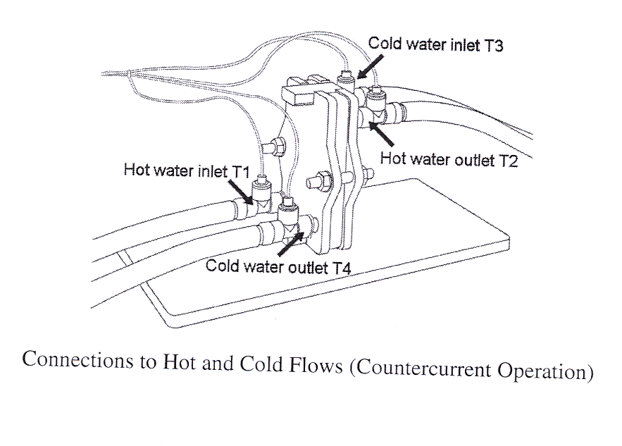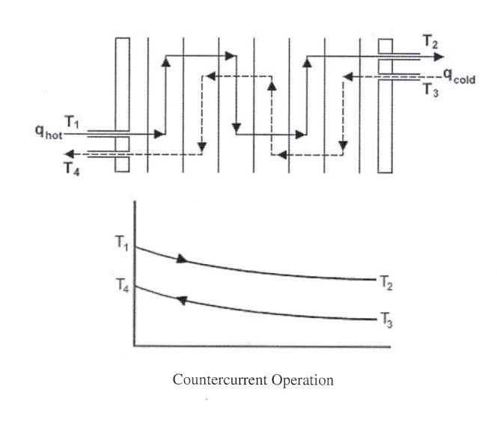In Plate Heat Exchanger experiment, the hot and cold fluids flow between channels on alternate sides of the plates. Each stream passes three times in series across the plates. Any temperature difference across the metal plates will result in the transfer of heat between the two fluids streams. As the streams passes through the pack of plates the hot water will be cooled and the cold water will be heated.

**Figure 1.** Plate Heat Exchanger Unit.

**Note :** For this demonstration, the Heat Exchanger is configured with the two streams flowing in the opposite directions (Countercurrent Flow).

**SYSTEM SET-UP**

1. Ensure that the plate heat exchanger HT 32 is properly mounted to the HT30XC Heat Exchanger Service Unit. Also make sure that HT30XC unit is connected to the computer through a USB port.
2. Prime the water cylinder manually. This just requires filling up the cylinder if it is empty or half-full.
3. Turn on the Main Power supply switch. The switch is a rocker switch located on the lower right front of the test set. Check that the green and red LEDs are illuminated.
4. Connections for Experiment. **Refer to Figure 2.**

* **Hot Water Inlet**

Connect the flexible tube from the front left hand tapping on the sliding end plate (adjacent to sensor T1) to the quick release hot water outlet connector on the HT30XC (front connector with red collar).

* **Hot Water Return**

Connect the flexible tube from the rear right hand tapping on the fixed end plate (adjacent to sensor T2) to the quick release hot water return connector on the HT30XC (center connector with red collar.)

* **Cold Water Inlet**

Connect the flexible tube from the rear left hand tapping on the fixed end plate (adjacent to sensor T3) to the quick release cold water outlet connector on the HT30XC rear connector with blue collar).

* **Cold Water Outlet**

Connect the flexible tube from the front right hand tapping on the sliding end plate (adjacent to sensor T4) to a suitable drain.

* **Temperature Sensors**

Connect the miniature thermocouple plug from each of the four temperature sensors to the appropriate socket on the front of the service unit ensuring that the numbers on the plugs and sockets are compatible.

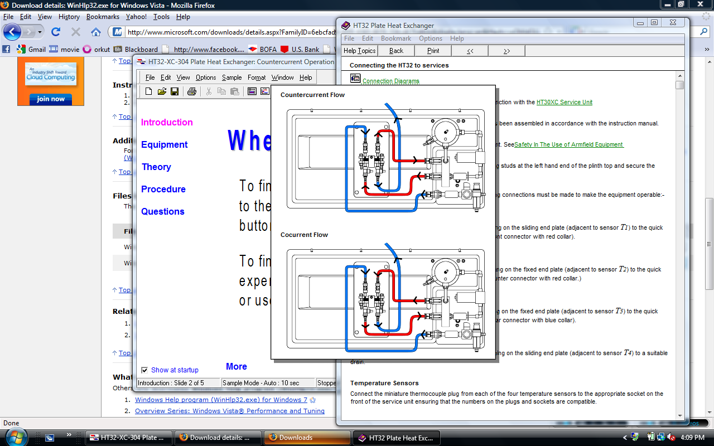

**A**

**B**

**Figure 2.** Connections for Experiment.

## Lab Exercise

The objective of this exercise is to perform an energy balance across a plate heat exchanger and calculate the overall efficiency at different fluid flow rates. This will be done using thermocouples placed along the length of the tubes, one in the hot stream and one in the cold stream. The thermocouples will indicate the temperature of the fluid stream at each location. The energy transferred to and from each stream will be calculated and used to determine the overall efficiency.

**Caution: be sure that the expected and actual placement of each thermocouple is the same in the theory as it is in the lab setup. If an error is found, notify the instructor.**

**Procedure**

1. The starting point for all of the following tests assumes that the system has been primed as defined above in System Set-up.
2. Start the **Armfield** **HT32 Plate heat exchanger** software from the Menu.
3. Select ‘**countercurrent flow’** and click on ‘**Load’** button.
4. Click on the ‘**view diagram’** icon.
5. Click on the ‘**hot water flow’** tab.
6. Select the mode of operation as ‘**automatic’**.
7. Set the hot water flow rate as **2.5 lit/min** in the ‘**set point’** tab.
8. Click on ‘**save’** and then the ‘**apply’** button. Then, press ‘**ok’**.
9. On the right side of the main screen click on the ‘**heater’** tab.
10. Select the mode of operation as ‘**automatic’**.
11. Turn on the hot water inlet and outlet flow valves indicated as ‘**A’** and ‘**B’** in Figure 3.
12. Set the temperature at **50** degree Celsius.
13. Keep the remaining settings the same.
14. Click on ‘**save’** and then the ‘**apply’** button. Then, press ‘**ok’**.
15. On the left side of the main screen in ‘**controls’**, press ‘**power on’**.
16. Now, the motor and heater will start.
17. Wait until the display indicates the temperature reaching the value set for the hot water in Step 11.
18. Once the set hot water temperature is achieved, turn on the main cold water supply valve on HT30XC.
19. Next, the cold water flow rate is adjusted by setting the percentage valve opening to 100%. Read the actual corresponding cold water flow rate from ‘**cold water flow’** box.
20. On the main screen, click on the ‘**go’** button. This will start enabling collecting data.
21. Press the ‘**view table’** tab and save the data collected as shown on the screen.
22. Repeat the procedure (step 18-20) for 2 more different **cold water flow rates**, i.e., corresponding to percentage valve openings of **75%** and **50%.** Read the corresponding cold water flow rates from ‘**cold water flow’** box.
23. This brings you to the end of the experiment. Make sure you have collected all the three sets of data. Turn the power off by pressing the ‘**power off’** button.
24. Disconnect all the connections and drain the water.

## DATA REDUCTION

1. Note the following for each set of data:
2. Temperature T1
3. Temperature T2
4. Temperature T3
5. Temperature T4
6. Calculate the following for each set of data:
7. Hot fluid volume flow rate = (Fhot)(1.667×10-5) m3/min.
8. Cold Fluid volume flow rate = (Fcold )(1.667×10-5) m3/min.
9. Reduction in hot fluid temperature = ∆Thot = T1 – T2
10. Reduction in cold fluid temperature = ∆Tcold = T4 – T3.
11. Heat emitted from the hot fluid: *Qe = mhcp,h*∆Thot
12. Heat absorbed by the cold fluid: *Qa = mccp,c*∆Tcold
13. Overall Efficiency for the system: ** = (*Qa* / *Qe*) ×100%
14. Theoretically, *Qe*  *Qa* . However, this does not hold true due to heat loss given by *Qf*  = *Qe*  *Qa*
15. Overall Heat Transfer Co-Efficient U= *Qe* /( A * ∆T*lm* )

A= 0.04 m2

∆T*lm*= (ΔT1 - ΔT2) / ln(ΔT1/ΔT2)

ΔT1 = (T1 – T4)

ΔT2 = (T2 – T3)

1. Plot and graph
   1. flow rate Vs ∆T for both cold fluid and hot fluid and
   2. flow rate Vs overall efficiency of the system

**Questions**

1. Did the heat exchanger remove more or less heat from the hot stream as the flow rate of the cold water increased?
2. Did the system efficiency increase or decrease as the cold water flow rate increased?
3. Were there any systematic or random errors that affected your measurements in this experiment? Discuss in detail and suggest innovative ways to minimize such errors.

**Appendix**

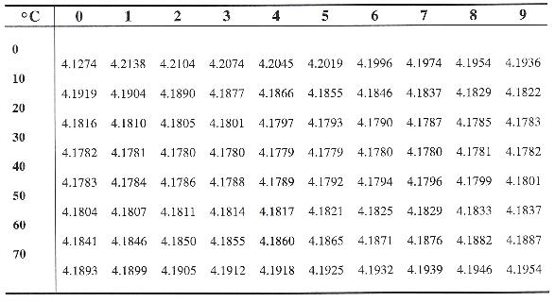**Table 1.** Specific heat capacity of water (Cp kJ/kg˚K)

**Table 2.** Density of water (ρ kg/m3)

