

**ME 495 – Mechanical and Thermal Systems Lab**

**Experiment 8: Flat Plate Heat Exchanger**

Group F

Kluch, Arthur

Le-Nguyen, Richard

Levin, Ryan

Liljestrom, Kenneth

Maher, Sean

Nazir, Modaser

Lentz, Levi – Project Manager

Professor S. Kassegne, PhD, PE

November 11, 2011

i. Table of Contents

i. Table of Contents 2

1. Objective of the Experiment – Modaser Nazir 3

2. Equipment – Arthur Klutch 4

3. Experimental Procedure – Richard Le-Nguyen 5

4. Experimental Results – Ryan Levin 6

5. Discussion of Results – Sean Maher 9

6. Lab Guide Questions – Kennith Liljestrom 9

7. Conclusion – Levi Lentz 10

8. References 11

1. Objective of the Experiment – Modaser Nazir

In this experiment students will determine the heat transfer coefficient which helps show the performance of the heat exchanger. The objective of this experiment is to show indirect heating and cooling by transfer of heat from one fluid stream to another. A solid wall separates the fluid streams. The devices used in this experiment are created by Armfield Limited, Ringwald, Hampshire England for use in physics and engineering laboratories. The devices are the HT30XC Heat Exchanger Unit and HT32 unit (Plate Heat Exchanger).

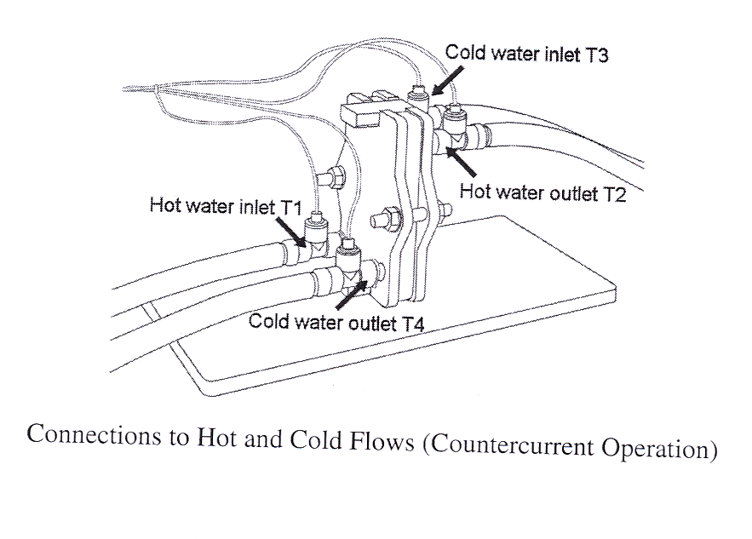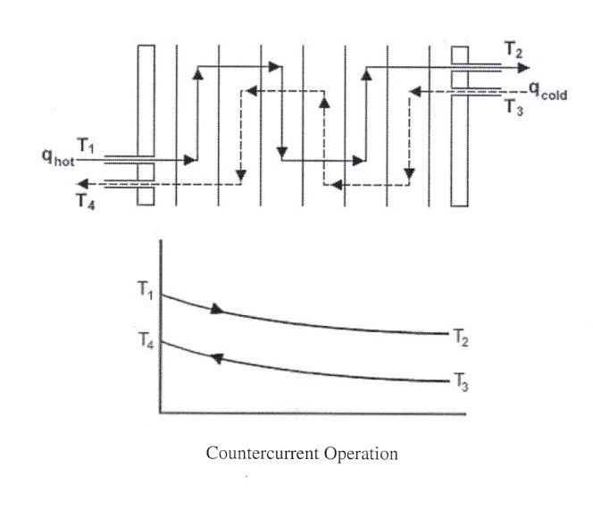The way a Plate Heat Exchanger works is that the hot and cold fluids flow on alternate sides of the plates. The stream passes in series across the plates three times. When there is a temperature difference across the metal plates it results in the transfer of heat between the two streams. Thus, as the streams pass through the plates, the cold water will be warmed and the hot water will be cooled.

Figure 1 Left, schematic of Heat Exchanger. Right, description of counter flow. [1]

The following equations, derived from Dr. Kassegne’s document titled “ME495 Lab – Plate Heat Ecxchanger – Expt Number 5” [1], were used for all calculations in this lab:

1. Hot fluid volume flow rate = (Fhot)(1.667×10-5) m3/min.
2. Cold Fluid volume flow rate = (Fcold )(1.667×10-5) m3/min.
3. Reduction in hot fluid temperature = ∆Thot = T1 – T2
4. Reduction in cold fluid temperature = ∆Tcold = T4 – T3.
5. Heat emitted from the hot fluid: *Qe = mhcp,h*∆Thot
6. Heat absorbed by the cold fluid: *Qa = mccp,c*∆Tcold
7. Overall Efficiency for the system: ** = (*Qa* / *Qe*) ×100%
8. Theoretically, *Qe*  *Qa* . However, this does not hold true due to heat loss given by *Qf*  = *Qe*  *Qa*
9. Overall Heat Transfer Co-Efficient U= *Qe* /( A * ∆T*lm* )
10. Where:
    1. A= 0.04 m2
    2. ∆T*lm*= (ΔT1 - ΔT2) / ln(ΔT1/ΔT2)
       1. ΔT1 = (T1 – T4)
       2. ΔT2 = (T2 – T3)

From the above equations, Tab 1, below, outlines what each symbol means with its associated units.

Table 1. Values used in computations for this lab.

|  |  |
| --- | --- |
| **TERM** | **VALUE** |
| $$\dot{m}$$ | Mass Flow Rate [kg/s] |
| $$\dot{V}$$ | Volume Flow Rate [m3/s] |
| *Q* | Heat emitted/absorbed [kW] |
| *cp* | Heat Transfer Coefficient at Constant Pressure [kJ/kg*k] |
| h | Specific Enthalpy [kJ/kg] |
| $$η$$ | Overall Efficiency [unitless] |
| U | Overall Heat Transfer Coefficient [W/(m2K)] |
| A | Area [m2] |
| T | Temperature [K] |
| ∆T*lm* | Log-mean Temperature [K] |

2. Equipment – Arthur Klutch

1) Armfield HT30XC Heat Exchanger Unit

2) Armfield HT32 Plate Heat Exchanger

3) Thermocouples

4) Computer

5) Glass beaker

6) De-ionized water

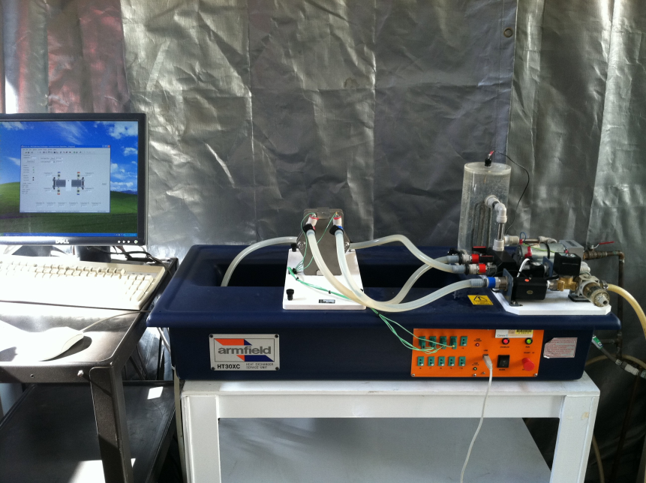

Figure 2 Armfield HT30XC Heat Exchanger Unit with HT32 Plate Heat Exchanger mounted on top and the computer.

1) The HT30XC Heat Exchanger Unit is a complete self-contained system for use in engineering labs. The unit contains an acrylic hot water vessel with a 2 kW heater with thermostat, hot water recirculation pump, cold water recirculation pump, cold water filter, computer interface, space for up to 10 thermocouples and 2 flow meters.

2) The HT32 Heat Exchanger rests on top on the Heat Exchanger Service Unit overflow drainage area. The exchanger consists of a group of plates with sealing gaskets held together in a frame between end plates. Hot and cold water flows between channels on alternate sides of the plates to promote heat transfer.

3) There were five thermocouples used in this experiment. Four of which were placed at different points along the plate heat exchanger and the fifth was placed in the water tank. Temperature measurements from the heat exchanger were taken for both hot and cold inlet and exit.

4) A PC was used to collect thermocouple data, control the heater for the water reservoir, and control the water flow rates for the hot and cold valves as a percent opening. The PC has "Armfield Tubular Heat Exchanger Software" installed and running.

5) A glass beaker was using to prime the water vessel.

6) De-ionized water was using for the hot side during this experiment.

3. Experimental Procedure – Richard Le-Nguyen

The following is the procedure that our group completed by following the guidelines outlined in the document “Plate Heat Exchanger.” We found that we did not have to deviate from the established procedure. Before beginning the experiment, the system was properly prepared by following the “System Set-Up” section according to the Plate Heat Exchanger document.

After the system was set-up, the Armfield HT31 Tubular heat exchanger software was loaded from the desktop of the computer. “Countercurrent flow” was selected and the “load” button was pressed. The “hot water flow” tab was opened within the “view diagram” table. “Automatic” was chosen for the mode of operation. Under hot water flow rate set point, 2.5 lit/min. Save, apply, and ok were selected respectively.

The “heater” button was selected on the right side of the screen. “Automatic” was chosen for the mode of operation. The hot water inlet and outlet valves were turned 90 degrees to the open positions. The temperature was set to 50 degrees Celsius. Save, apply, and ok were selected respectively.

The “power on” button was selected on the left of the main screen under the controls section. This started the motor and heater. When the hot water temperature reached 50 degrees Celsius, the cold water supply valve was turned on. The cold water flow rate percentage valve opening was set to 100%. The cold water flow rate was recorded. The “go” button was selected to enable the computer to collect data on a table. The data was saved after the cold water reached a steady temperature. The experiment was repeated for a cold water flow rate percentage valve opening of 75% and 50%. The data was saved, the equipment was turned off, disconnected, and the water was drained.

4. Experimental Results – Ryan Levin

Table Tabulated results from the experiment.

|  |  |  |  |
| --- | --- | --- | --- |
| **Data Type** | **100%** | **75%** | **50%** |
| Qe [W] | 1296.029 | 1465.676 | 1303.070 |
| Qa [W] | 1135.220 | 1314.349 | 1130.405 |
| Mdot Hot [kg/s] | 0.041 | 0.041 | 0.041 |
| Mdot Cold [kg/s] | 0.029 | 0.029 | 0.019 |
| Qf [W] | 160.809 | 151.327 | 172.665 |
| U [W/m2.K] | 3531.077 | 3382.922 | 2978.389 |
| Mean Temp Efficiency [%] | 44.48% | 45.86% | 48.16% |
| Vdot Hot [m3/min] | 4.148E-05 | 4.139E-05 | 4.175E-05 |
| Vdot Cold [m3/min] | 3.401E-05 | 2.900E-05 | 1.871E-05 |

Figure 3 Power emitted and absorbed in achieving steady state operation.

Figure Heat emitted and absorbed at flow rate percentage.

Figure Change in temperature for each run.

Figure Efficiency of each run.

5. Discussion of Results – Sean Maher

After completion of the experiment, several of the results seem to be counter intuitive. During each run, the change in temperature should increase as the flow rate increased. This is due to the fact that there is more mass traveling through the system per second than in the lower flow sections. However, the lowest speed run has the highest change in temperature (14C) of the hot fluid. Additionally, it has the lowest efficiency of any of the runs (86.7%). The fastest run has the lowest change in fluid temperature (8C).

If this is truly an error, it was due to a variety of factors. The primary suspect would be the equipment itself. There is not clear trend to establish what is happening with the efficiencies, as they do not follow the same decreasing nature at each flow rate in a similar manner that the temperature changes do. This lack of correlation points to the fact that the equipment may have been measuring data incorrectly. Correlation between other group’s experiments would show if it was operator-induced error.

6. Lab Guide Questions – Kennith Liljestrom

**1. Did the heat exchanger remove more or less heat from the hot stream as the flow rate of the cold water decreased?**

To determine if the heat exchanger removed more or less heat from the hot stream as the flow rate of the cold water decreased, we refer to the heat absorption equation from Dr. Kassegne’s Lab 5 Plate Heat Exchanger document [1].

$$Q= \dot{m_{c}}c_{p}∆T= \dot{m_{c}}c_{p}(T_{4}-T_{3})$$

The heat loss, *Q*, is a function of the mass flow rate of the cold water, $\dot{m_{c}}$. Thus if the flow rate of the cold water decreases, the heat loss through the system will decrease resulting in a higher temperature of the hot water. If the cold water moves at a slower rate, the hot water will be able to increase the temperature of the cold water making the difference in temperature, *ΔT*, smaller which will also reduce the heat loss through the system.

**2. Did the system efficiency increase or decrease as the cold water flow rate decreased?**

The efficiency of the system is described as the heat absorbed by the system divided, $Q_{absorbed},$ by the heat emitted from the system, $Q_{emitted}$.

$$η= \frac{Q_{absorbed}}{Q_{emitted}}*100\%$$

The values for the heat absorbed and the heat emitted move linearly with each other so the efficiency will stay around the same value. As the mass flow rate decreases, the heat absorbed decreases and the heat emitted decreases. Thus the ratio between the two values stayed fairly constant. The efficiencies for the 100%, 75%, and 50% flow of the cold water were recorded as 86.9%, 89.3%, 86.7% respectively. The values can be seen in Table 2.

**3. Were there any systematic or random errors that affected your measurements? Discuss in detail and suggest innovative ways to minimize such errors.**

During the experiment, we noticed the filter at the inlet of the cold water flow was filled with algae which may have infiltrated the system or impeded the flow of the cold water. It is recommended the filter be removed and cleaned, or if damaged then the filter should be replaced. Calibration of the thermocouples is recommended to ensure the most accurate readings possible for this experiment so the overall efficiencies are more accurate.

7. Conclusion – Levi Lentz

Through the completion of this laboratory, we gained a greater understanding of the properties associated with flat plate counter flow heat exchangers. The experiment appears to have a slight measurement error as the correlation between changes in temperature does not follow empirical results. Because this experiment was run the same way for all three runs, it appears that this is because of equipment error, however comparing our results with other groups would be necessary to determine if the error was due to operator error. Overall, this was a great experiment that showed us how to calculate the heat transfer and efficiencies knowing only the mass flow and the temperatures.

8. References

**[1]** Kassegne, S. "ME495 Lab - Tubular Heat Exchanger - Expt Number 4." Mechanical Engineering Department. San Diego State University. Fall 2011.