**Design Criteria**

Q = 232.6 m^3/s = 3,686,787 gal/min

H = 236.87 km = 777,133 ft

Best pump found: *Gould Pump 3498x24x30-36*

|  |  |
| --- | --- |
| Qpump = 30,000 gal/min  Hp = 265 ft  Efficiency = 87% | Power = 85.8 MW = 115 hp  N = 890 rpm **see below** |

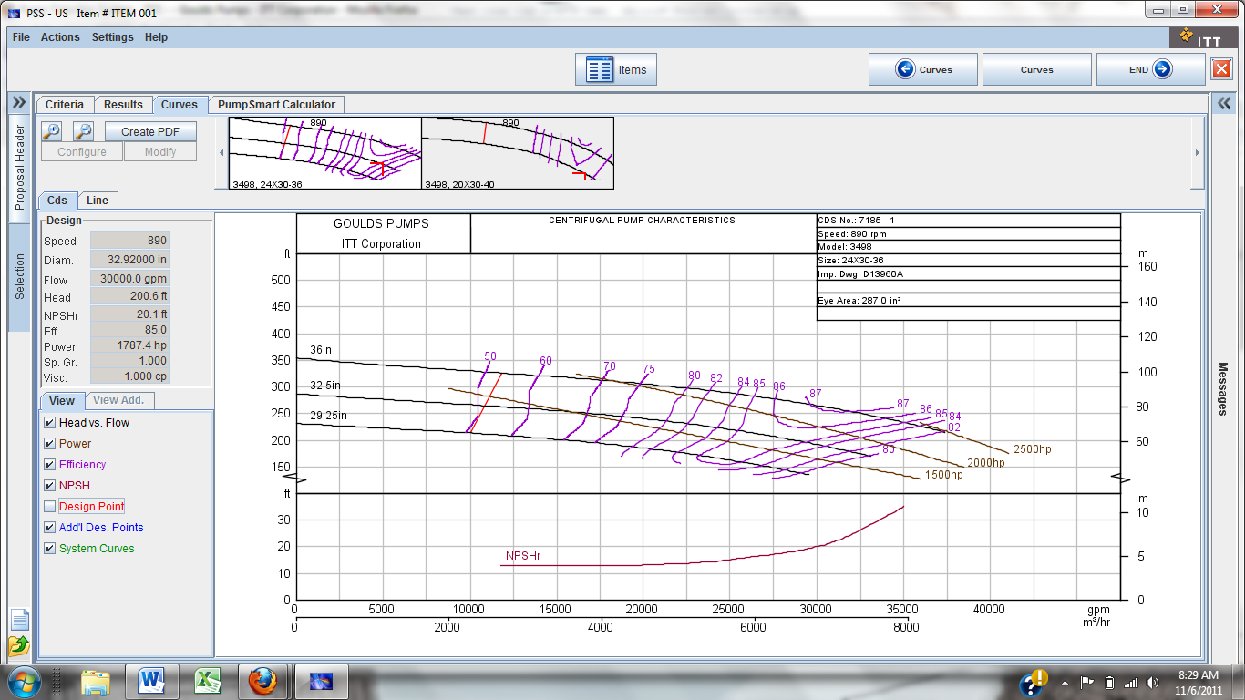

Required # of pipes = Q/Qpump =123

Required # of pumps along one pipe = H/Hpump = 2933

TOTAL # of pumps = 390,000 **(eff that!)**

See next page

Some DA to make things a little better

Change to 1800 rpm

Q1/Q2 = N1/N2

Q2 = 30000*1800/890 = **60674 gal/min**

H1/H2 = N1^2/N2^2

H2 = 265*1800^2/890^2 = **1084 ft**

TOTAL # of pipes from this = **43,732**

Double rotor diameter

Q1/Q2 = N1/N2

Q2 = 60674*2 = **121348 gal/min**

H1/H2 = D1^2/D2^2

H2 = 1084*72^2/36^2 = **4336 ft**

TOTAL # of pipes with this = **5,556**