

**ME 555 – Thermal Systems Design**

**Report on Power System Design for UCEC**

Berkeley, Gregory

Lentz, Levi

Ritchey, Amber

Professor A. Beyene, PhD

November 07, 2011

i. Table of Contents

i. Table of Contents 2

ii. List of Figures 3

iii. List of Tables 3

1.0 Abstract 4

2.0 Background of Problem 4

3.0 Concept Development 4

4.0 Scope of Design 6

5.0 Design 6

5.1 Existing System 6

5.2 Combustion Analysis 8

5.3 Base Case Design 9

5.4 Off-Design Performance Analysis 12

5.5 Control System Design 15

5.5.1 Control of Electrical Loading 15

5.5.2 Control of Thermal Loading 16

5.6 Component Selection 16

6.0 Results 17

6.1 Feasibility 17

6.2 Cost Analysis 17

7.0 Future Design Considerations 19

8.0 Conclusion 19

9.0 Acknowledgements 20

10.0 References 21

Appendix I 22

Appendix II 24

ii. List of Figures

Figure 1 Current System Power 7

Figure 2 Proposed System Design 10

Figure 3 Standby System Proposed 12

Figure 4 Overall Efficiency vs Ambient Temperature 13

Figure 5 Net Work Output vs Ambient Temperature 13

Figure 6 Back Work Ratio vs Ambient Temperature 14

Figure 7 Outlet Temperature vs Ambient Temperature 14

Figure 8 Overall Efficiency vs Thermal Load Percentage 15

Figure 9 Analysis of Combustion System 22

Figure 10 Analysis of Turbine System 23

Figure 11 Analysis of Turbine System 23

iii. List of Tables

Table 1 Decision Matrix for Power System Design 5

Table 2 Decision Matrix for Fuel Used in Design 5

Table 3 Species Present in Products 9

Table 4 System Parameters at Ambient Conditions 10

Table 5 Overall costs associated with the system 18

Table 6 Terms used to calcuate the yearly operating costs 18

Table 7 Part 1 of the Variant System Problems 24

Table 8 Part 2 of the Variant System Properties 25

Table 9 Part 3 of the Variant System Properties 26

1.0 Abstract

The University of El Cajon requires a power output or 19MW by the year 2020. After analysis, this report has detailed a system that is capable of providing a 19MW electrical output with a thermal capacity of 8.5MW. This allows a thermal efficiency of 74%. After off-design performance was analyzed, the thermal efficiency only varies by 3% over the year. The proposed design uses a Vectra 40G engine to provide all power and thermal requirements. This design will cost approximately 15M$ to implement with a yearly operating cost of 7M$. Overall, the design incorporates several control systems to respond to the changing thermal and electrical loads. This design is therefore recommended for review by UCEC.

2.0 Background of Problem

The University of California at El Cajon (UCEC) is anticipating an increase in their energy demands over the next decade. This will require the University to upgrade their current power system in order to meet these demands.

One of the primary sources of energy required by UCEC is thermal power to produce both heating and cooling via a space heater and absorption chiller, respectively. The University currently has a cooling load requirement of 2,370 tons. Their combined heating and power system (CHP) system is also comprised of an absorption chiller cable of producing 120 tons of cooling. The remaining thermal load of 2,250 tons required for UCEC is then purchased from SDG&E.

Another primary source of energy required by UCEC is electrical power to produce lighting, cooling, and powering laboratory equipment. The University currently has a peak electrical load of about 8MW. Their combined heating and power (CHP) system is able to produce 2.59 MW total from two reciprocating engines. The remaining electrical load of 5.41 MW required for UCEC is then purchased from SDG&E.

The thermal requirement of the system is not expected to change over the next 10 years; however UCEC is expecting an increase of demand for electrical power of 19 MW. This will require a new power system to be implemented into the University in order to reach their new power demands. It is also important to mention that the peak electrical requirements during their summer sessions will drop to approximately 5 MW and will be considered in this report.

3.0 Concept Development

In order to choose the proper design to proceed with for the site, a concept development is necessary to determine the best system for UCEC. One way of determining the best design is to use a decision matrix as shown below in Tab 1. From the table it is possible to determine what type of system would work best for this location. The table compares seven systems in six different categories, with different scales for each category. All categories are then added for each system giving a net worth for each system. Therefore, the system with the largest total is the best design.

Table 1 Decision Matrix for Power System Design

|  |  |  |  |  |  |  |  |  |
| --- | --- | --- | --- | --- | --- | --- | --- | --- |
| **Systems** | **Cost**  (1-7) | **Reliability**  (1-7) | **Availability /Space**  (1-10) | **Safety**  (1-8) | **Environment**  (1-8) | **Sustainability** (1-9) | **Efficiency**  (1-10) | **Totals** |
| Brayton/CHP | 6 | 4 | 10 | 7 | 4 | 5 | 8.5 | 44.5 |
| Rankin/CHP | 5.5 | 4 | 10 | 7 | 4 | 5 | 8 | 43.5 |
| Duel | 5 | 4 | 10 | 7 | 3.5 | 5 | 8.5 | 43 |
| Nuclear | 4 | 5 | 3 | 6 | 3 | 5 | 8 | 34 |
| Geothermal | 3 | 4 | 2 | 4 | 4 | 8 | 7 | 32 |
| Wind | 4 | 3 | 4 | 5 | 8 | 9 | 7.5 | 40.5 |
| Solar | 3 | 3.5 | 4 | 7 | 7 | 9 | 4 | 37.5 |

From the above table, it is clear that a Brayton CHP system is the best design for this project. This design is additionally ideal for the site because it has a low size requirement and no necessity for an external water source, which is not present in El Cajon. Since this system requires an external fuel source, it is necessary to concept screen a fuel necessary to power the system. This concept screening is provided in Tab 2, below.

Table 2 Decision Matrix for Fuel Used in Design

|  |  |  |  |  |  |  |  |
| --- | --- | --- | --- | --- | --- | --- | --- |
| **Fuel** | **Cost**  25 | **Availability**  20 | **Safety**  10 | **Environment**  20 | **Sustainability**  12 | **HHV**  17 | **Total** |
| Octane | 10 | 0 | 10 | 15 | 5 | 9 | 49 |
| Methane | 25 | 20 | 10 | 20 | 8 | 17 | 100 |
| Dodecane | 15 | 15 | 10 | 15 | 7 | 12 | 74 |
| Butane | 5 | 2.5 | 10 | 20 | 4 | 10 | 51.5 |
| Propane | 10 | 15 | 10 | 20 | 8 | 15 | 78 |

From the above table, it becomes apparent that methane is the clear choice to power our system. This gas is additionally ideal because SDG&E has gas lines present that readily provide natural gas, a mixture comprised mainly of methane. This fuel is relatively cheap and also burns very clean [1]. The final design will be reliant on a CHP brayton cycle running off of methane provided by SDG&E.

Upon examining the natural gas lines in El Cajon, there is a ready supply of both High Pressure (HP) and Low Pressure (LP) gas [2]. The location of the university will dictate if additional piping will be required of SDG&E, however this would be a minor part of the overall design.

4.0 Scope of Design

Given the supplied requirements of the system, several assumptions will have to be made to complete the design. For the sake of simplicity, minor and major losses in the piping system will not be considered. Additionally, all efficiencies that we not supplied are estimated within standard operating efficiencies. The existing power system present on site will be integrated into the design of the new system. The existing system will be assumed to have a constant output as supplied in the problem statement.

5.0 Design

The design process used for this design was concurrent design, all aspects of the design was completed concurrently with all group members. Additionally, a DFX (Design for X) approach was used where a design for constant electrical power output was of utmost importance, due to the specification that the electrical output varied the least. This section will outline the steps followed to arrive at the base case design. Once this design was arrived upon, off-system analysis was performed.

5.1 Existing System

The current system comprises two reciprocating engines, supplying 2.3MW and .290MW of electrical power while a 120 Absorption chiller is also present. This design is graphically represented in Fig 1, below. While these are very small generators compared to the 19MW system to be designed, for environmental reason, it is prudent to recycle these components into the future design.

2.59MW work output

120 tons (.422 MW) evaporative cooler

Figure 1 Current System Power

Given that our system will be designed to a 19MW peak design, this allows no room for the system to perform at a greater demand than 19MW; if the demand exceeds 19MW, the system will require overflow power from SDG&E. Given the existence of these systems, it is prudent to incorporate these into the final design. This will be discussed in section 5.3.

5.2 Combustion Analysis

From Section 3.0, it has been determined that Methane will be used as the combusting gas. Like all combusting elements, this has a max burning temperature that is affected by several factors including Air Fuel Ratio (AF) and insulation. The chemical balance of this with theoretical air can be seen in Eq (1) below:

$CH_{4}+2\left(O_{2}+3.76N_{2}\right)\underset{→}{}CO_{2}+4H_{2}O+7.52N_{2}$ (1)

This chemical equation can supply all required values on a per mass basis of fuel. The primary reason this is needed is to determine the adiabatic flame temperature of the combustion process. This is simply the max temperature that can be gained by combusting the gas, with no heat losses or pressure losses. This can be described in the following equation:

$T_{af}=T_{i}+\frac{-∆h_{c}^{o}}{c_{p}[1+AF]}$ (2)

The above equation relies on knowing the enthalpy of combustion, $-∆h_{c}^{o}$, as well as assuming that the reaction is complete. This assumption will overestimate the temperature of the reaction. Realistically, this is the temperature that is leaving the combustion chamber, and entering the turbine. The best way to estimate the temperature is by minimizing the Gibbs function for each side of the reaction. This was done using the RIA daemon on Dr. Bhattacharjee’s website, thermofluids.net [3]. This is documented in Appendix I. From this, the adiabatic flame temperature for theoretical air is:

$T_{af}=2223K$ (3)

However, due to material limitations of the turbine, this temperature cannot exceed 1550K. Additionally, when theoretical air is combusted, a large percentage of your fuel will remain un-combusted. To account for this, the percentage of theoretical air was increased until the required temperature was reached. This lead to the following chemical equation:

$CH_{4}+3.64\left(O_{2}+3.76N_{2}\right)\underset{→}{}CO_{2}+4H_{2}O+13.69N_{2}+{1.64O}_{2}$ (4)

This yields a percentage of theoretical air of 182% and an AF ratio of 31.16, on a mass basis. Using the RIA daemon again, this yields an adiabatic flame temperature of:

$T_{af}=1572K$ (5)

Assuming minor losses in heat and pressure, it can be easily assumed that the temperature entering the turbine is 1550K. While it has been established that methane burns very clean, the combusted products contain very little greenhouse emissions outside of CO2. The products can be seen below in Tab 3.

Table 3 Species present in products

|  |  |
| --- | --- |
| Species | Rate of generation (kg/s) per kg of fuel |
| N2 | 23.8733 |
| H2O | 1.38 |
| O2 | 3.2489 |
| CO2 | 2.744 |
| NO | .04 |
| OH | .0027 |

From these products, the most harmful product produced in any amount is the carbon dioxide; this implies that the calculated temperature is low enough to prevent the formation of nox or carbon monoxide in large amounts. This is an extremely good design point from an environmental standpoint.

5.3 Base Case Design

The base case design was to integrate a 19MW CHP system into the existing 2.6MW CHP system. The new design is shows below in Fig 2.

Regenerator

Combustion Chamber

Steam Generator

Valve

Absorption Chiller

Space Heater

*WT*

*WC*

*WP*

*Qout*

*Qout*

Pump

*Air Intake*

*Gas Exhaust*

Condenser

③

④

⑤

⑥

⑦

⑧

⑨

⑩

⑪

⑫

⑬

⑭

⑮

*Gas Intake*

⑯

①

②

Compressor

Turbine

Figure 2 Proposed System Design

The basic operating procedure is a brayton cycle to provide the electrical demand. Additionally, a heat recovery system is implemented to provide for the thermal and refrigeration loads of the university. A valve is operated in the thermal system to divert water flow between the absorption chiller and the space heater as demand requires. The mathematical analysis is shown in Appendix I.

From analysis of the system, it is possible to determine all required parameters of the system. While operating at ambient temperature of 300K, and an ambient pressure of 101kPa, Tab 4, below, show all required important parameters of the system.

Table 4 System Parameters at Ambient Conditions

|  |  |
| --- | --- |
| **Parameter** | **Value** |
| Air Flow | 55 kg/s |
| Fuel Flow | .8004 kg/s |
| Water Flow | 3.04 kg/s |
| Water Pressure | 20 BAR |
| Power Supplied to Heat System | 8.5MW |
| Output Power | 19.306MW |
| BWR | 0.48457 |
| Compressor Power | 18.151MW |
| Turbine Output | 37.456MW |
| Thermal Efficiency | 74.00% |
| Exhaust Temperature | 583K |

It is worth noting that the large efficiency is calculated using the following equation:

$η_{system}=\frac{W_{net}+P_{Heat}}{Q_{In}}$ (6)

Because the amount of heat recovered into the chiller and heating systems, this leads to an overall efficiency of 74%. If the CHP system was only utilized as a power system, this efficiency would drop to 48.2%; clearly the CHP system is necessary to recover as much energy as possible from the system.

The above system will act independently of the existing system; however both systems will act in parallel. Since the power output is maintained at 19MW with the control system described in section 5.6, it becomes necessary to have some system to provide an overflow capacity. If the site requires additional power beyond 19MW, SDG&E would be required to supply the excess, or the standby, power. This incurs a large fee to the site, and should be avoided. To prevent this, the existing onsite engines will be run parallel to the new large power system. This design will be detailed below.

Additionally, site demand drops drastically over the summer. As opposed to requiring a peak of 19MW, the system will only require a peak of 5MW. Due to the size of our system, a power output of this small will cause the efficiency of our system to drop drastically, causing extra cost to be incurred by the site. To solve for this, it is also recommended to install an additional 2.6MW reciprocating generator for use just during the summer. This system is shown below in Fig 3. This will allow the large 19MW CHP system to be shut down during the summer months and allow maintenance to be performed on it, adding to the longevity of the system.

Figure 3 Standby System Proposed

5.19 MW work output for standby and summer operation

5.4 Off-Design Performance Analysis

While the area of El Cajon has only mild temperature ranges, with a yearly low of 4.4C and a high of 32C, it is still important to characterize the off-design system performance. The main variance in this area is the temperature. Due to the low yearly precipitation, the air humidity can be assumed to remain constant year round and have little effect on the system.

The off-design performance was analyzed by varying the ambient temperature from 277K to 305K. This analysis was done first on the power system, then on the thermal load system. The results are shown in Fig 4 through 7, below. The data for these graphs can be seen in Appendix II.

Figure 4 Overall Efficiency vs. Ambient Temperature

Figure 5 Net Work Output vs. Ambient Temperature

Figure 6 Back Work Ratio vs. Ambient Temperature

Figure 7 Outlet Temperature vs. Ambient Temperature

Since the thermal load will be variable, while the electrical load will be constant, it is also necessary to characterize the system performance as the thermal load decreases. At a maximum, the thermal demand is 8.33MW, but this will regularly decrease past this point. Plotted below are the system efficiencies as the thermal load decreases. This is modeled as the mass flow through the thermal system decreasing.

Figure 8 Overall Efficiency vs. Thermal Load Percentage

5.5 Control System Design

The final design will need to dynamically adjust to the thermal and electrical requirements of UCEC. Implementing an electromechanical control system will allow the power plant to vary its loading requirements based on the desires of the University. Through feedback control theory, several thermocouples will be placed strategically within the power system to monitor any varying temperatures. Actuated control valves will be placed strategically throughout the system to communicate with these sensors to maintain the both electrical and thermal loading requirements.

5.5.1 Control of Electrical Loading

The ambient temperature of the inlet air flow of the compressor has an effect on the work of the compressor and thus an effect of the power output of the system. Temperature sensors will be placed at both the inlet and outlet of the compressor as well as pre-combustion. There will also be a wattage sensor placed for the electrical generator to read the power output of the turbine. This will allow for electronic monitoring of state values that will correlate to both the amount of energy the system is producing and the amount of air flow to maintain 19 MW in real time.

Initially, temperature readings will be collected from both the inlet and outlet of the compressor. This will allow our control system to calculate the amount of work that the compressor must generate and will be compared to the amount of electrical power output of the turbine. The difference of the two will be the actual net power output of the system. If this value does not match the desired output of 19 MW an error signal is produced and to separate actuations occur. First, the flow rate of air will be adjusted as necessary through a variable frequency drive (FVD). Second, the flow rate of fuel into the combustion chamber will vary to maintain a desirable fuel-to-air ratio. This will provide the system with a method for achieving approximately 19 MW of power in the event of varying environmental condition such as the changing ambient air temperature.

5.5.2 Control of Thermal Loading

The need for heating and cooling will be varied throughout the day as well as over the entire year. A control system should be implanted to better generate the amount of water that is being heated and cooled for the thermal loading power system. The desired amount of energy from space heating or the absorption chiller will be monitored via thermostats placed throughout the campus. As the need for more heat is required a valve will be adjusted to allow more water flow to enter the space heater, allowing more energy to be used for heating the campus. As the need for more cooling is required the same valve will be adjusted to allow more water flow to enter the absorption chiller, allowing more energy to be used for cooling the campus.

5.6 Component Selection

Currently the University of California at El Cajon (UCEC) has a power plant that produces 2.59MW. They anticipate an increased need over the next ten years to a total of 19MW. After the above design selection, as a preliminary recommendation, the Vectra 40 turbine is recommended. [3]

The Vectra 40G is a jet turbine engine modified for power output. It runs at 6,200rpm and is capable of producing 34.3 MW. This gives the option for potential growth beyond what is currently desired. The Vectra 40G system includes a compressor, combustor, jet turbine, and generator. It is important to mention that within the design the system has a gear box. This allows the parameters of the electrical output, such as the frequency or amperage, to be varied as needed. The price of this system is approximately $15, 000, 000. [3]

6.0 Results

6.1 Feasibility

After analysis of the required system, it is possible to have an efficient system capable of generating the power necessary. The proposed design will use a Vectra 40G turbine to generate 19MW of power and handle an 8.33MW thermal load. The power load is nearly constant year round; however the thermal load will be variable. To account for this variation, a control system is installed on the waste heat recovery system that will redirect flows from a vapor chiller that provides cooling to a heat exchanger that will provide space heating. This allows the system to handle changes in the required thermal load.

The largest design recommendation is to keep the existing reciprocating power system and add an additional 2.8MW engine identical to the current reciprocating engine. This will provide a net power output of 5.39MW. During normal operation, this would provide excess power to stop the need for SDG&E power in the event that the required load exceeds the supplied 19MW. Additionally, this would provide enough power to supply the summer demand. This would allow the large CHP system to be taken down for maintenance without the need to tap into the SDG&E standby power.

6.2 Cost Analysis

Since this analysis has found the mass flow required of the system, as well as the cost of implementation, it is possible to determine the rough cost of the system to be implemented. The real cost of the system may be higher, or lower, this section is meant only to serve as a guide for the final cost of the system.

Table 5 Overall costs associated with the system

|  |  |
| --- | --- |
| Estimated Energy Savings | 33,782,400 kWh/yr |
| Estimated Demand Savings | *Varies with Load* |
| Implementation Cost | $25,000,000 |

The Power savings, P, can be calculated as follows:

|  |  |  |
| --- | --- | --- |
| *P* | = | Power Usage per year kWh/yr |
|  | = | 33.78x106 kWh/yr |

(7)

The implementation cost for this recommendation is the cost of the 34.3MW Vectra 40G system and an approximated install cost. The cost of the 40G turbine system is $15,000,000 [3]. This amount only covers the amount of the equipment and not the infrastructure, piping, or the installation. The installation generally runs between $8,000,000 and $10,000,000 [6]. It is hard to determine the total implementation amount but it may be as high as the cost of the system it’s self [5] [6]. Therefore, the implementation cost for the 34.3 MW system cannot be determined at this time without knowledge of the current infrastructure and piping. The implementation cost is beyond the scope of the project and should be looked at further to determine a more accurate number.

The recommended system runs on Methane and will require no further power generation assistance from SDGE. The price of Methane in 2010 was $0.1859/m3 [4]. The plants annual cost will increase from $2,600,000 for the cost of the power from SDG&E to $7,024,400 for the cost of the Methane. By increasing our system the power will also increase of 19MW. After careful calculations the methane demand was approximately with a flow rate of 0.8(kg/s). Furthermore, we were able to determine annual operating costs of $7,024,400 as calculated below. This price does not include maintenance. Therefore; the annual yearly cost will vary.

Table 6 Terms used to calculate the yearly operating costs

|  |  |  |
| --- | --- | --- |
| OC | = | Operating cost |
| C | = | Cost per therm |
| m | = | Mass flow rate |
| k | = | Conversion factor from second to year |
| d | = | Density |

The operating costs are calculated below using the terms defined in Table 6, above. This is show below:

|  |  |  |
| --- | --- | --- |
| OC | = | [(C) (m) (k)] /(d) |
| OC | = | [(.1859) (0.8) (31,556,926)] / (.668) per yr |
|  | = | $7,024,400/yr |

7.0 Future Design Considerations

The finalized design is capable of providing all desired design inputs. The main drawback with this system is still the difficulty of the system to respond to varying thermal and electrical loads. This design incorporated several valves and redirects to account for the variance in the thermal capacity. The power generation, however, only has a VFD attached to the compressor to account for the changes in electrical load. While this will provide for major changes in output load, minor differences would be difficult to account for. A more robust control system would need to be added to this system to allow the fuel flow, air flow, and RPM of the system to change dynamically enough to allow for minor changes in load.

Conversely, a systems max efficiency is when the system is operating at max load. Another design would be to allow the power system to operate at max load, while storing the system power in some way. This could involve working a deal with SDG&E to supply fuel at a reduced rate in exchange for the power supplied to the grid. SDG&E will not allow selling back of energy, but a reduced rate for fuel may work out to be cheaper than the efficiency loss associated with varying the load on the thermal system.

8.0 Conclusion

This report successfully outlined the design to supply a constant electrical output of 19MW. A Vectra 40G turbine system is recommended with an additional 2.6MW reciprocating engine to be used in tandem with the existing systems. The finalized design was able to produce a thermal load of 8.5MW with a thermal efficiency of 74%. Additionally, off-design analysis was performed and was found that the system parameters do not change significantly over the yearly temperature range present in El Cajon. Given the yearly cost of operating the turbine of 7.02M$/year, it is an excellent business move by UCEC. Overall, this report server as an excellent first iteration of the design required by UCEC.

9.0 Acknowledgements

This group would like to thank Dr. Beyene for providing us with the opportunity to approach such a complex engineering problem with the skills that he has taught in his class.

We would also like to thank Bill of Vectra for providing this group with a cost estimate of the Vectra 40G

10.0 References

[1] NA, *Natural Gas and the Environment.* Retrieved from http://www.naturalgas.org/environment/naturalgas.asp

[2] NA, *Natural Gas Lines in El Cajon.* Retrieved from http://regarchive.sdge.com/safety/naturalgas/map.shtml

[3] Dresser-Rand, *Gas Turbine Solutions.* Retrieved from http://www.dresser-rand.com/literature/turbo/85209-GasTurbineBro.pdf

[4] U.S. Energy Information Administration, *Natural Gas Prices*. Retrieved from http://www.eia.gov/dnav/ng/ng_pri_sum_dcu_nus_a.htm

[5]Company, R. S. M. (1997). Means repair & remodeling cost data 1998, commercial/residential. Robert s Means Co.

[6]Kluch, A. (2011, December 05). Interview by A Ritchey [Personal Interview]. Turbine installation. Solar Turbine

Appendix I

The combustion chamber was analyzed with the equilibrium RIA in ThermoFluids.net. This is shows in Fig 9, below:

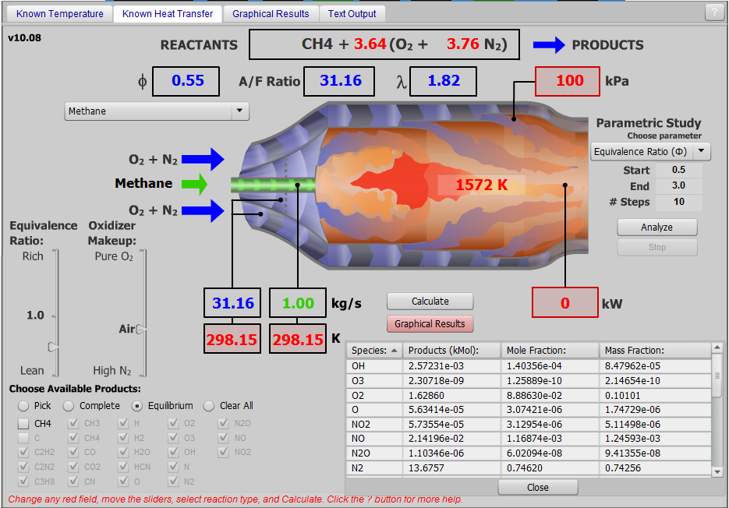

Figure 9 Analysis of Combustion System

The system is analyzed as an ideal system with no pressure losses. This is shown in Fig 10, below:

Figure Analysis of Turbine System

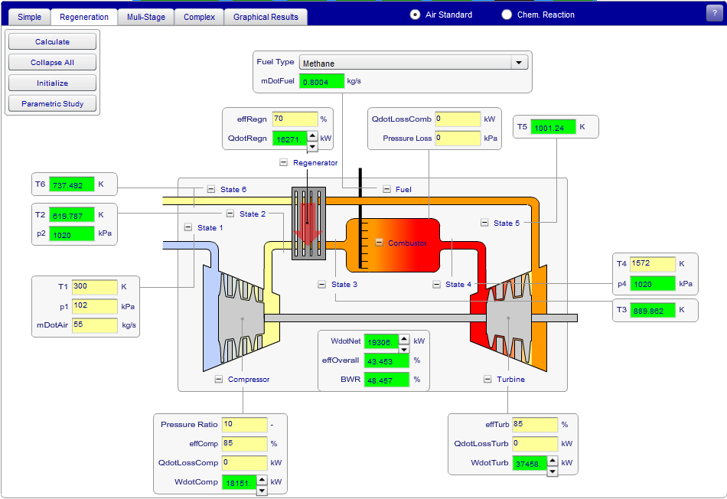

Figure 11 Analysis of Turbine System

Note that the efficiency show is just for the power system. In the full system, the efficiency is given as:

$η_{system}=\frac{W_{net}+P_{Heat}}{Q_{In}}$ (7)

Equation (6) yields an efficiency of 76% as the majority of the heat is used in the system. Additionally, 8.33MW is extracted from the hot air to power the thermal heating and cooling systems. This reduces the output temperature to 585.63K, providing the 76% efficiency calculated.

Appendix II

Through completing the off-design analysis, several quantities outputted, that were used to plot the figures in Section 5.4. These values are shown in Tab 7, 8, and 9, below.

Table 7 Part 1 of the Variant System Problems

|  |  |  |  |  |  |  |  |
| --- | --- | --- | --- | --- | --- | --- | --- |
| Ambient Temperature | Changing System Properties | | | | | | |
| T1 [K] | T2 [K] | p2 [kPa] | T3 [K] | mDotFuel [kg/s] | p4 [kPa] | T5 [K] | T6 [K] |
| 278.5 | 577.0944214 | 1010 | 877.8224 | 0.813803 | 1010 | 1001.24 | 708.4408 |
| 279.825 | 579.7835083 | 1010 | 878.578 | 0.812961 | 1010 | 1001.24 | 710.2648 |
| 281.15 | 582.47229 | 1010 | 879.3336 | 0.81212 | 1010 | 1001.24 | 712.0887 |
| 282.475 | 585.1607056 | 1010 | 880.0893 | 0.811279 | 1010 | 1001.24 | 713.9128 |
| 283.8 | 587.8375244 | 1010 | 880.8448 | 0.810438 | 1010 | 1001.24 | 715.7365 |
| 285.125 | 590.526001 | 1010 | 881.6036 | 0.809593 | 1010 | 1001.24 | 717.5682 |
| 286.45 | 593.1096191 | 1010 | 882.3328 | 0.808782 | 1010 | 1001.24 | 719.3284 |
| 287.775 | 595.692627 | 1010 | 883.0618 | 0.80797 | 1010 | 1001.24 | 721.0881 |
| 289.1 | 598.2764893 | 1010 | 883.791 | 0.807158 | 1010 | 1001.24 | 722.8486 |
| 290.425 | 600.859436 | 1010 | 884.5201 | 0.806347 | 1010 | 1001.24 | 724.6083 |
| 291.75 | 603.4432983 | 1010 | 885.2484 | 0.805535 | 1010 | 1001.24 | 726.3626 |
| 293.075 | 606.0217285 | 1010 | 885.9745 | 0.804724 | 1010 | 1001.24 | 728.1145 |
| 294.4 | 608.5938721 | 1010 | 886.701 | 0.803912 | 1010 | 1001.24 | 729.8668 |
| 295.725 | 611.1660156 | 1010 | 887.4274 | 0.8031 | 1010 | 1001.24 | 731.6191 |
| 297.05 | 613.8369141 | 1010 | 888.1817 | 0.802257 | 1010 | 1001.24 | 733.4387 |
| 298.375 | 616.5095215 | 1010 | 888.9363 | 0.801414 | 1010 | 1001.24 | 735.2595 |
| 299.7 | 619.182373 | 1010 | 889.6912 | 0.80057 | 1010 | 1001.24 | 737.0804 |
| 301.025 | 621.8547363 | 1010 | 890.4459 | 0.799727 | 1010 | 1001.24 | 738.9009 |
| 302.35 | 624.5275879 | 1010 | 891.2007 | 0.798883 | 1010 | 1001.24 | 740.7219 |
| 303.675 | 627.1903076 | 1010 | 891.9555 | 0.79804 | 1010 | 1001.24 | 742.5427 |
| 305 | 629.8512573 | 1010 | 892.7103 | 0.797197 | 1010 | 1001.24 | 744.3636 |

Table 8 Part 2 of the Variant System Properties

|  |  |  |  |  |
| --- | --- | --- | --- | --- |
| Ambient Temperature | Changing System Properties | | | |
| T1 [K] | WdotComp [kW] | WdotTurb [kW] | QdotRegn [kW] | WdotNet [kW] |
| 278.5 | 16863.14 | 37458.04 | 18010.13 | 20594.90374 |
| 279.825 | 16945.14 | 37458.04 | 17901.18 | 20512.90644 |
| 281.15 | 17027.12 | 37458.04 | 17792.23 | 20430.9237 |
| 282.475 | 17109.12 | 37458.04 | 17683.27 | 20348.92529 |
| 283.8 | 17191.08 | 37458.04 | 17574.34 | 20266.95946 |
| 285.125 | 17273.73 | 37458.04 | 17464.92 | 20184.31775 |
| 286.45 | 17350.21 | 37458.04 | 17359.78 | 20107.82995 |
| 287.775 | 17426.67 | 37458.04 | 17254.67 | 20031.37579 |
| 289.1 | 17503.17 | 37458.04 | 17149.51 | 19954.87016 |
| 290.425 | 17579.63 | 37458.04 | 17044.4 | 19878.416 |
| 291.75 | 17656.13 | 37458.04 | 16939.24 | 19801.91037 |
| 293.075 | 17732.59 | 37458.04 | 16834.13 | 19725.45812 |
| 294.4 | 17809.08 | 37458.04 | 16728.98 | 19648.96835 |
| 295.725 | 17885.56 | 37458.04 | 16623.84 | 19572.48059 |
| 297.05 | 17967.82 | 37458.04 | 16514.67 | 19490.22476 |
| 298.375 | 18050.17 | 37458.04 | 16405.42 | 19407.87027 |
| 299.7 | 18132.54 | 37458.04 | 16296.16 | 19325.5 |
| 301.025 | 18214.88 | 37458.04 | 16186.92 | 19243.15927 |
| 302.35 | 18297.25 | 37458.04 | 16077.66 | 19160.78894 |
| 303.675 | 18379.61 | 37458.04 | 15968.41 | 19078.43244 |
| 305 | 18461.98 | 37458.04 | 15859.15 | 18996.06017 |

Table 9 Part 3 of the Variant System Properties

|  |  |  |  |  |
| --- | --- | --- | --- | --- |
| Ambient Temperature | Changing System Properties | | | |
| T1 [K] | effOverall of Power System [%] | BWR [%] | T7 [K] | Overall Efficiency |
| 278.5 | 45.58747 | 45.01874 | 556.9863 | 75.76% |
| 279.825 | 45.45295 | 45.23765 | 558.8102 | 75.63% |
| 281.15 | 45.31818 | 45.45651 | 560.6342 | 75.49% |
| 282.475 | 45.1831 | 45.67542 | 562.4583 | 75.36% |
| 283.8 | 45.0478 | 45.89424 | 564.282 | 75.23% |
| 285.125 | 44.91092 | 46.11486 | 566.1137 | 75.09% |
| 286.45 | 44.78563 | 46.31906 | 567.8739 | 74.97% |
| 287.775 | 44.66016 | 46.52317 | 569.6336 | 74.85% |
| 289.1 | 44.53433 | 46.72741 | 571.394 | 74.73% |
| 290.425 | 44.40835 | 46.93152 | 573.1538 | 74.60% |
| 291.75 | 44.28202 | 47.13576 | 574.9081 | 74.48% |
| 293.075 | 44.15554 | 47.33986 | 576.66 | 74.36% |
| 294.4 | 44.02873 | 47.54406 | 578.4123 | 74.23% |
| 295.725 | 43.90166 | 47.74826 | 580.1646 | 74.11% |
| 297.05 | 43.76309 | 47.96785 | 581.9842 | 73.97% |
| 298.375 | 43.62404 | 48.18771 | 583.8049 | 73.83% |
| 299.7 | 43.48466 | 48.40761 | 585.6259 | 73.69% |
| 301.025 | 43.34504 | 48.62743 | 587.4464 | 73.56% |
| 302.35 | 43.20507 | 48.84733 | 589.2674 | 73.42% |
| 303.675 | 43.06484 | 49.06719 | 591.0881 | 73.28% |
| 305 | 42.92427 | 49.2871 | 592.9091 | 73.14% |