

**ME 555 – Thermal Systems Design**

**Report on Replacing the Flow Lost After the Hoover Dam with**

**Desalinated Water**

Berkeley, Gregory

Lentz, Levi

Ritchey, Amber

Professor A. Beyene, PhD

November 07, 2011

Table of Contents

Table of Contents 2

List of Figures 3

List of Tables 3

1.0 Abstract 4

2.0 Background of Problem 4

3.0 Objective 4

4.0 Scope of Design 4

5.0 Mathematical Model 5

5.1 Route 5

5.2 Piping System 7

5.3 Pumping System 8

5.4 Desalination Design 10

6.0 Results 13

6.1 Feasibility 13

6.2 Cost Analysis 14

7.0 Future Design Considerations 15

8.0 Conclusion 16

9.0 Acknowledgements 16

10.0 References 17

List of Figures

Figure 1 The route required if the desalination plant would be place in San Diego. The route is 242 km long with a max elevation of 1.22 km. 6

Figure 2 The route of the desalination plant was placed in the Gulf of California. The route would be 163 km long with a max elevation of .12 km. 6

Figure 3 The first section of the pumping system required for one pipe, immediately following the desalination plant. The right hand of the design will repeat across the length of the pipe four times. 10

List of Tables

Table 1 Gould’s Pump 3498x24x30 – 36 Parameters @ 890 rpm, rotor diameter 36 in from data provided by Gould [6] 9

Table 2 Energy requirements for global scale desalination. Used from data obtained from industry research on UK desalination [9]. 12

Table 3 Definition of terms used. 13

Table 4 Estimation of cost to install piping system 14

Table 5 Operating costs per year without cost of labor and maintenance. 15

1.0 Abstract

This report will lay out the proposed design for a desalination system to pump 232.6 m3/s of water from the Pacific Ocean to five miles north of the border of Mexico and the United states. The desalination plant was put in the Gulf of California with 105 Gould pumps and a piping system 163km in length. The total cost of startup was found to be $6.4B with yearly operating costs of $6.08B. While the yearly operating cost is excessive, this equates to a cost of .32 ¢/gal. The recommended design change will be to pump the water directly into Mexico’s piping system as opposed to the Colorado River.

2.0 Background of Problem

In order to meet treaty obligations set out by the International Boundary and Water Commission (IBWC), the Government of Mexico is required to receive a minimum flow from the Colorado River of 1.5 million acre-feet per year [1]. Currently the IBWC records that 24 cubic meters per second (cms) of water enters Mexico [2], below the necessary average flow rate of 58.6 cms. In order to replenish this requirement, it is desired to create a pumping system that will replenish the flow entering Mexico to the flow rate at the Hoover Dam, a flow well above the legal requirement.

3.0 Objective

The objective of this project is to design a cost-effective pumping system to supply a flow equal to the difference between the flow from the Hoover Dam and the Border of Mexico. From United States Bureau of Reclamation [3] and IBWC [2], the flow rate required of the system is 236.2 cms. This system will require a desalination plant as well as a piping system to move the water from the Pacific Ocean to a point approximately five miles north of the border of Mexico and the United States, placing the exit of system in Yuma, Arizona.

4.0 Scope of Design

This report aims only to lay out the requirements for desalinating and pumping the water from a designed point along a designed path. This report will not examine the material properties of the pipe, or the thermal changes in both flow and material properties due to heat transfer. In order to be a complete design, these will have to be examined and addressed in future reports.

5.0 Mathematical Model

The following sections will describe the theory behind each section of the piping. The overall design will consist of three main systems:

1. Piping System
2. Pumping System
3. Desalination System

As opposed to having the water pumped to a reservoir after the desalination process, the entire system will remain closed to stop the loss of flow due to evaporation. The desalination process, additionally, will pull all its own water in from the ocean due to the nature of the process, described in 4.4, below. After the desalination plant, a combination parallel and series system of pumps will pump the water the entire length of the route to the location in Yuma, Arizona. Because thermal properties are being neglected, the system will be modeled as completely reversible and adiabatic. Future revisions would need to take this into account to obtain better design parameters. To account for this, a Factor of Safety (FS) of two will be employed throughout the design.

5.1 Route

The route of that the piping system travels is one of the most important design aspects of the system as it will represent the largest losses of the system. An ideal route would be the shortest route possible that avoids major population centers as well as minimizing elevation changes. Given the location where the water has to be pumped, there are only two viable spots where water can be removed from the Pacific Ocean: Imperial Beach, San Diego, CA and the Gulf of California, Mexico. The San Diego route and the Mexican route, along with elevation changes are shown below in Fig 1 and 2, respectively.

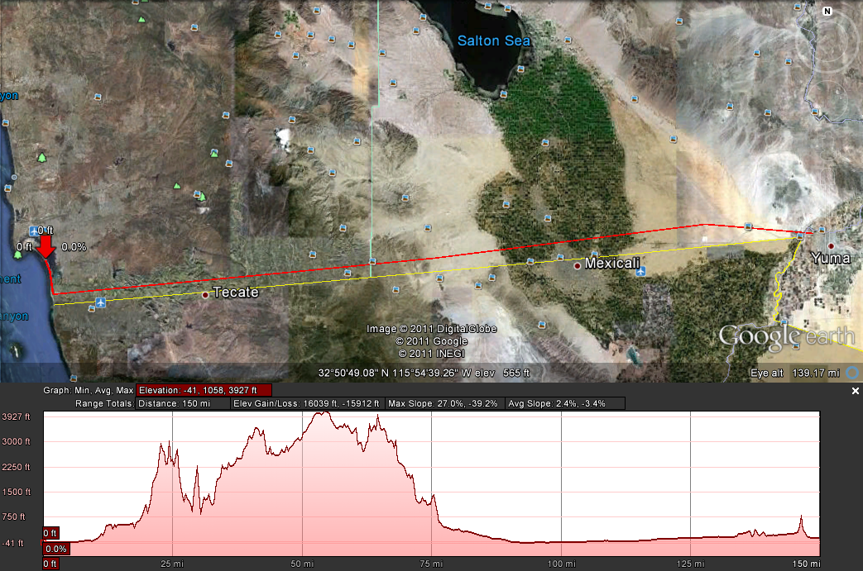

Figure The route required if the desalination plant would be place in San Diego. The route is 242 km long with a max elevation of 1.22 km.

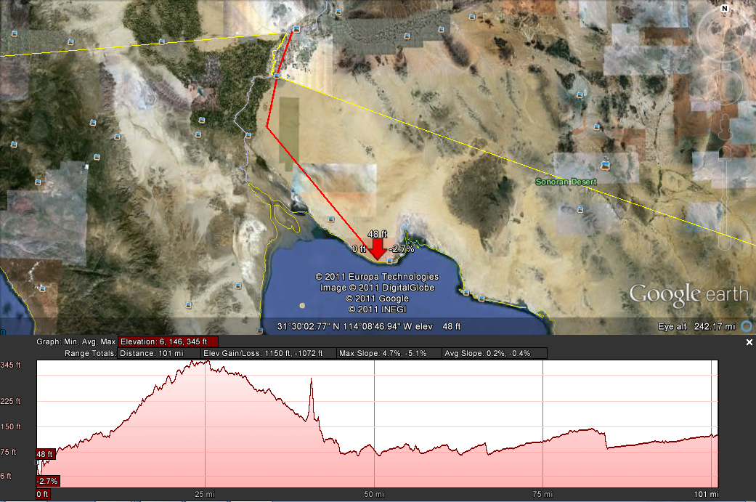

Figure The route of the desalination plant was placed in the Gulf of California. The route would be 163 km long with a max elevation of .12 km.

From the above routes plotted in Google Earth, it becomes evident that the proper route to use, simply from a distance and an elevation standpoint, would be from the Gulf of California to Yuma. This route contains a distance of 163km and an elevation change of .12km. The San Diego route, meanwhile, has a distance of 242km, and an elevation change of 1.22km. Further credibility is lent to the Mexican route as there are no large population centers associated with it as opposed to the San Diego route that has two large population centers (San Diego and El Centro) that would prove expensive to install this pumping system around. The Baja Route will therefore be the chose route used for the piping system. Because of the IBWC treaty requirement, this entire project will need to be funded by the United States Government. The legalities of the U.S. Government working within Mexico are outside the scope of this document.

5.2 Piping System

Due to the large rate of flow, a parallel piping system will be used to decrease the head loss across the system. Steel pipe would be preferable, with a large cross sectional diameter, as it would have a low roughness and would be able to handle the required large flow rates. The maximum standard pipe that is readily available is the National Pipe Size (NPS) 88, also referred to as the Diameter Nominal (DN) 2200 [4]. This pipe has an internal diameter of 2132mm (84in). These pipes would work for the design, but the number that would be required for minimal losses makes them prohibitive. Additionally, the majority of pipes used in this size are concrete, with a high internal roughness. Instead, Pipe Industries located in Commerce City, Colorado, can make custom steel pipes with an internal diameter 4677mm (184in) [5]. Because they can readily offer these in steel, this will be the pipe used for the length of the system.

As stated, the piping system will be run in parallel. Due to the cost of the pipes, and their overall size, four pipes will be run in parallel. This will create a footprint that is 18.7m across, much less than what would be required for a similar headloss with concrete piping. The commercial steel has an internal roughness of .09mm. Eq (1) through (3), below, are calculating the head loss per pipe over the length of the system.

$Q_{pipe}=\frac{Q}{4}=\frac{232.6}{4}=58.16\frac{m^{3}}{s}$ (1)

$V=\frac{Q_{pipe}}{A}=\frac{58.16}{{2.34}^{2}π}=3.389\frac{m}{s}$ (2)

$Re=\frac{VD}{ν}=\frac{3.389*2.132}{1.004*{10}^{-6}}=1.58*{10}^{7}$ (3)

The Swamee and Jain equation will be used to determine the friction factor inside of the piping system as it returns the highest friction factor. The calculation is shown in Eq (4), below.

$f=\frac{.25}{{\log\left(\frac{ϵ}{3.7D}+\frac{5.74}{{Re}^{0.9}}\right)}^{2} }=\frac{.25}{{\log\left(\frac{0.09}{3.7*4677}+\frac{5.74}{\left(1.58*{10}^{7}\right)}\right)}^{2}}=.0068$ (4)

From Eq (4) above, Eq (5), below can be used to calculate the major headloss for one pipe.

$h_{l,Major}=f*\frac{L}{D}*\frac{V^{2}}{2g}=.0068*\frac{163km}{4.677m}*\frac{{3.389}^{2}\frac{m^{2}}{s^{2}}}{2*9.81\frac{m}{s^{2}}}=139m$ (5)

Because it is impossible to know in a preliminary report how many fittings will be required, the assumption will be made that the total coefficients of minor losses will be 100. The total minor losses are calculated in Eq (6), below.

$h_{l,minor}=∑C*\frac{V^{2}}{2g}=100*\frac{{3.389}^{2}\frac{m^{2}}{s^{2}}}{2*9.81\frac{m}{s^{2}}}=58.5m$ (6)

Eq (5) and (6) will sum to our total head loss of the system. To account for any errors in design, a Factor of Safety (FS) of 2.0 is employed. The total headloss is showin in Eq (7), below.

$h_{L,Tot}=FS*\left(h_{l,Major}+h_{l,minor}\right)=2*197.5m=395m$ (7)

5.3 Pumping System

The required pump was selected in response to the rated flow capacity as well as the head loss. Gould’s Pump 3948x24x30-36 was chosen to provide the requirements for adding an additional water supply across the international border. This selection was based on this pumps high flow rate and relatively high head capability. Unfortunately, the pump only operates at one speed as they do not possess a variable speed drive. This pump is able to manage a flow of 16.08 m3/s (255000 gpm) with a head of 61m (200 ft) with an exit diameter of .914m (36in). The selection for this pump was based on the performance chart provided by the company on their spec sheet [6]. Permission was not given to reproduce this chart. The given specs are reproduced in Tab 1, below.

**Design Criteria**

Eq (8), below, shows the design criteria for the pumping system.

 (8)

Table Gould’s Pump 3498x24x30 – 36 Parameters @ 890 rpm, rotor diameter 36 in from data provided by Gould [6]

|  |  |
| --- | --- |
| Qpump = 255,000 gal/min = 16.08 m3/s |  |
| Hpump = 200 ft = 61 m | N = 890 rpm |
| = 87% | Centrifugal, Single stage, Double Suction |

Since the current design requires a total head of 400m and a flow rate outside the flow capacity of the pumps, the piping system will have to be designed in part in series and in part parallel. Since parallel pumping systems flow rates are additive, the number of parallel pumps can be determined from Eq (9), below:

$Number of pumps=\frac{Q_{T}}{Q_{Pump}}=\frac{232.6}{16.08}=15 pumps$ (9)

The design for flow rate will therefore call for 15 pumps in parallel. These will be 15 in parallel with exit diameters of 36 in. These pumps will be attached to the four pipes by a necking system to connect four pumps to three of the steel pipes and three pumps to the final pipe.

To account for the loss in head, substations with identical pumps will need to be placed along the length of the route. In series systems, the head is additive. Therefore Eq (10), below, derives the number of substations required:

$Number of substations=\frac{H_{T}}{H_{P}}=\frac{395}{61}=7 substations$ (10)

This means that there will need to be a total of 105 pumps to accomplish moving this flow to the Colorado River with three parallel systems of 4 sets of parallel pumps with 7 identical clusters of pumps in series at regular intervals along the pipe. The first two sections of one pipe are shown below in Fig 3. One possible design would be to place the pumps equidistant along the length of the pipe to save space at the desalination plant. This requires each substation to be placed every 23.4km. This design would be ideal to account for the elevation changes, however it would make it difficult to diagnose which pump fails in a failure scenario as the distance between pumps is relatively large.

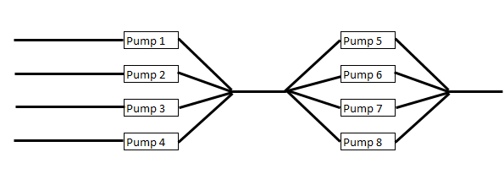

Figure The first section of the pumping system required for one pipe, immediately following the desalination plant. The right hand of the design will repeat across the length of the pipe four times.

Total energy requirement for 105 pumps identical pumps is calculated below in Eq (11).

$E_{P}=N_{P}*P=105*11.06=1.2GW$ (11)

5.4 Desalination Design

**Major Assumption**

Because the desalination process is still being heavily developed, all realtionships regarding design are done so with linear scaling. For example, this manifests itself in the fact that if an estimate of area for a given flow rate is supplied, the designed plant’s area will be a simple multiple based on the scale of the flow rate.

Additionally, the below desalination plant is supplied with water at atmospheric pressure and outputs it at atmospheric pressure. Due to this, our piping system will actually be after the plant, with all calulations for the plant being inclusive of pumping power required to get the water into, and out of, the plant.

**Design Description**

The largest cost of our system will be the desalination of the salt water to fresh water. Desalination is currently being used throughout the world with the United States is supplying only 6.5% of its fresh water this way [7]. As more research is conducted into desalination methods, this percentage will rise in the coming years.

There are several methods of desalinization, however, many of them can be costly and produce small flow rates. The two most common methods are Multi-Stage Flash (MSF) desalinization and Reverse Osmoses (RO). MSF is a method that uses temperatures reaching almost boiling to create a phase change. The lighter H2O partials that have turned to vapor are then caught and pushed through a membrane. This process is repeated several times until you are left with fresh water exiting through piping connected to the membrane. The waste water is called brine and is composed of 7% salt by volume [7]. RO desalination is done by increasing pressure in the system to push the smaller H2O molecules through a semi-permeable membrane, thereby both filtering and desalinating the water. Both methods have its advantages and disadvantages that are outlined below.

When choosing a system the trend has been to stick with MSF systems but this is mainly due to their reliability and high flow rates. When energy consumption rates were compared in the two systems, savings were apparent in the RO system. On average the MSF consumed 19.5 $\frac{kWh}{m^{3}}$ [8], whereas the RO method consumed on average 3.75 $\frac{kWh}{m^{3}}$ as shown in Tab 2, below [9]. Both systems are extremely expensive but clearly the economically correct choice is RO to decrease the cost of the water produced. In addition, Tab 2 has water consumption rates and power estimates readily available as it is the more established system.

Table Energy requirements for global scale desalination. Used from data obtained from industry research on UK desalination [9].

|  |  |  |  |
| --- | --- | --- | --- |
|  |  | Low scenario | Maximum scenario |
| Peak world population (circa 2050) |  | 9.2 bn | 9.2 bn |
| Water consumption | (m3/capita/yr) | 130 | 1730 |
| Desalination energy | (kWhm-3) | 2.5 | 5 |
| Fraction of water from desalination |  | 10% | 100% |
| Power for desalination (*globally)* | (GW) | 34 | 9100 |
| Additional price of water per capita | (UKP/capita/yr) | $5.33 | 1390 |

Due to the sheer size of the required flow rate (232.6 cms) the plant will need to implement various systems to ensure that all energy recovery systems are applied. With the help of multiple turbines to capture the high pressured exiting fresh water and brine the plant can reduce its energy losses as the high pressure fluid expands to atmospheric pressure. This energy is used to run the pumps in the plant making the external energy need lower and ideally keeping the energy need closer to 2.5 $\frac{kWh}{m^{3}}$ verses the maximum 5 $\frac{kWh}{m^{3}}$ shown in Tab 2 [9]. Because the water both enters and leaves at atmospheric pressure, the head losses for this system can be neglected [11].

Since there are currently no plants that are capable of producing the needed flow rate a comparison was made to several plants; two of the largest plants currently in production (Ashkelon SWRO and Saudi Arabia’s) [12] [8] and two plants that are being designed with the possibility of greater flow rates (Coquina Coast seawater desalinization project and Texas’s Lavaca River project) [15] [9]. Based on the energy needs vs. the water output a sizing for a desalinization plant was estimated to be $26 billion dollars. What this includes is a facility that would be on a plot of land no smaller than 4,935,000 m2, assuming a 1:1 relationship between the area and the flow rate, with a four story infrastructure housing 6,909 pressure vessels, 2,632 membranes, multiple turbines and pumps, and a vast number of diffusion sites for the brine to be remixed with seawater so that the seawater salinity is not increased more than local environmental standards allow; which are normally about 1% above its original salinity [13]. The definition of each term used in the calculations is shown below in Tab 3.

Table 3 Definition of terms used.

|  |  |  |
| --- | --- | --- |
| QH | = | Flow Rate at Hoover Dam (m3/s) |
| QM | = | Flow Rate into Mexico (m3/s) |
| QN | = | Need Flow Rate into Mexico (m3/s) |
| PC | = | SWO Plant Cost ($) |
| PN | = | Difference in Need ($) |
| PT | = | Total New Design Cost ($) |
| C | = | Cost of Energy ($/kWh) |
| K | = | Conversion from Seconds to Hours (3600 s/h) |
| H | = | Energy cost per volume of water (kWh/m3) |
| EkWh | = | Energy Cost for Every kWh |

**Energy Usage**

Eq (12) through (14), below, show the required energy to desalinate this much water with the chosen method of RO. All terms are defined in Tab 3, above.

$E_{T}=K*Q_{N}*H \left[\frac{s}{h}*\frac{m^{3}}{s}*\frac{kWh}{m^{3}}=kW\right]$ (12)

$E_{T}=3600*232.6*3.75 kW$ (13)

$E_{T}=3.139 GW$ (14)

6.0 Results

6.1 Feasibility

After running all analysis, it appears that the system is indeed feasible from a purely mechanical standpoint. The piping system that will be required will need four pipes over a distance of 163 km. It will take 105 Gould 3498 pumps running in a combination of series and parallel to move this large amount of flow rate. The largest problem with the design is the need for a desalination plant. The technology behind the desalination is still relatively new, and the required amount of desalination would equate to approximately half of the current world demand for desalinated water. The estimated size of the plant, at 4.935 square kilometers, is also exceedingly large because of the large flow rate required. This could be split into multiple plants to reduce the size of one gigantic plant. Placing this plant in the largely uninhabited portion of the Gulf of California allows for this plant to remain feasible due to the ease of getting large tracts of land in the area.

6.2 Cost Analysis

The Austrailian Government, in 2007, has completed a project of similar magnitude desiging a piping system that pumps approximately 8.4 cms of water over a distance of 1000 km [16]. Their found cost of labor will be used to estimate how much it will cost to install the piping system. Their estimate for piping cost will also be used, however they used reinforced concrete meaning the actual cost of this piping system will be significantly less as the pipes selected is rolled steel which is comparatively cheaper to manufacture. Tab 4, below, shows the cost estimate to create the entire pumping system.

Table Estimation of cost to install piping system

|  |  |  |  |  |  |
| --- | --- | --- | --- | --- | --- |
| Item | Description | Unit | Quantity Required | Rate ($M/Unit) | Cost ($M) |
| 1 | 4 * 163" Steel Piping | km | 652 | 2.65 | $ 1,727.80 |
| 2 | Average-Difficulty Installment (No urban areas) | km | 290 | 7.3 | $ 2,117.00 |
| 3 | Desalination Plant (inclusive of all labor) | Per Plant | 1 | 2500 | $ 2,500.00 |
| 4 | 105 * Number of 3498 pumps | Per Pump | 105 | 0.25 | $ 26.25 |
|  |  |  |  | Total | $ 6,371.05 |

In Tab 4 above, it is worth noting that the estimation for the cost of the plant is based on linearly scaling the cost of the SWO plant. The SWO plant cost $387M to create and install. Our plant has a capacity of 68.5 times that capacity. Multiplying the SWO plant cost by this factor yielded the cost of the designed desalination plant.

Tab 5, below, shows what the system will cost per year to operate. The cost per kilowatt-hour of energy comes from the local San Diego Gas and Electric top teir estimates for energy usage. [17].

Table Operating costs per year without cost of labor and maintenance.

|  |  |  |  |  |  |
| --- | --- | --- | --- | --- | --- |
| Item | Description | Unit | Quantity Required | Rate ($M/Unit) | Cost ($M |
| 1 | 27.5 TWh/year for Desalination Plant | TWh | 27.5 | 160 | $ 4,400.00 |
| 2 | 10.5 TWh/year for 105 pumps | TWh | 10.5 | 160 | $ 1,680.00 |
|  |  |  |  | Total | $ 6,080.00 |

Once the intitial plant has been paid for, the water itself will have a cost associated with it. From the total operating cost presented in Tab 5, above, the total cost per gallon of water can be calculated as show in Eq (15), below.

$Cost per gallon of water=\frac{Yearly Cost}{Total Water Pumped}=\frac{\$6.08B}{1.9Tg}=.32\frac{¢}{gal}$ (15)

From Eq (15) it is clear to see that the large cost of operating the plant actually has a very low cost per gallon for operation. The large cost incurred is due to the large amount of water that is being desalinated and pumped.

7.0 Future Design Considerations

The primary future design consideration would be to appeal to IBWC to change the requirements of the flow. The current stipulation is simply that the Colorado River be replenished to a predetermined flow rate [1]. The majority of the water is then siphoned off for commercial and agricultural use. Since the goal of this plant is to replenish that flow and the plant is planned to be placed Mexico, a better design would be to supply the flow to the existing piping systems as opposed to back into the natural environment. This would allow more flexibility for the use of the water by the Mexican Government. This would need to be a legalistic change that would significantly reduce the power and complexity of the system as it would drastically reduce the cost associated with the pumping system.

The pumping system also relies on the assumption that there are no failures among the pumps. Any failure of the individual Gould 3498 pumps would cause significant losses in head and flow rate, especially with the series nature of the flow. Redundancy would be key to preventing this from happening. Additionally, while the Gould 3498 pump performs marvelously for this project, it should be examined if custom-designed pumps could be created to decrease the number required.

8.0 Conclusion

After complete analysis, this reports is a preliminary design for a desalination plant to be placed in Mexico to pump water from the Gulf of California to north of the US-Mexican Border. The estimated cost of the system would be $6.4B with an average operating cost of $6.08B per year. The system is comprised of a 4.95 square km desalination plant, 105 Gould 3498 pumps, and a 163km length four-pipe system of diameter 4.677m. This design is feasible and could work to satisfy treaty obligations, however, a reworking of the treaty in a way that would allow the water to be pumped directly into the Mexican piping system would severely reduce the power and cost associated with the system.

9.0 Acknowledgements

We would like to thank Jerry Salsano at DSV Consulting for personally explaining via telephone the current desalination plant that DSV is designing for operation in Florida. We would also like to thank Dr. Beyene for assigning a project that encourages application of engineering theory.

10.0 References

[1] *Utilization of Waters of the Colorado and Tijuana Rivers and of the Rio Grande.* (1946). Retrieved from http://www.usbr.gov/lc/region/g1000/pdfiles/mextrety.pdf

[2] *Flow rate at Rockwood Weir.* (2011, October). Retrieved from http://www.ibwc.gov/wad/522000_a.txt

[3] *Hourly Hoover Release Data.* (2011, November). Retrieved from http://www.usbr.gov/lc/region/g4000/hourly/hourly.html

[4] *Nominal Pipe Sizes (NPS).* (n.d.). Retrieved from http://www.engineeringtoolbox.com/

[5] *Rolled and Welded Carbon Steel Piping.* (n.d.). Retrieved from http://www.pipeindustries.com

[6] *3498 Pump Specifications*. (n.d.). Retrieved from http://www.gouldspumps.com.

[7] *Desalination: Drink a cup of seawater? - US Geological Survey*. (n.d.). Retrieved from http://ga.water.usgs.gov/edu/drinkseawater.html

[8] Dow. (2002). *Ashkelon - water technology*. Water Technology. Retrieved from http://www.water-technology.net/projects/israel/

[9]Battle. (2008, April). *Large scale desalination: is there enough energy to do it?*. Retrieved from http://lightbucket.wordpress.com/2008/04/04/large-scale-desalination-is-there-enough-energy-to-do-it/

[10]*Bureau of reclamation: Lower colorado region*. (n.d.). Retrieved from http://www.usbr.gov/lc/region/g4000/hourly/hourly.html

[11] Bureau of Reclamation Homepage (n.d.). Retrieved from http://www.usbr.gov/pmts/hydraulics_lab/pubs/REC/REC-OCE-70-16.pdf

[12]Oman, M. (n.d.). *Saudi arabia opens world*. Retrieved from http://www.greenprophet.com/2009/05/saudi-arabia-desalination/

[13]*Conquina coast seawater desalination project*. (n.d.). Retrieved from http://coquinacoastdesal.org/Uploads/Coquina Coast fact sheet 8.12.11 Lo Res FINAL.pdf

[14]Eckhardt, G. (2000, April). *Desalination*. Retrieved from http://www.edwardsaquifer.net/desalination.html

[15] Battle. (2008, April). *Large scale desalination: is there enough energy to do it?*. Retrieved from http://lightbucket.wordpress.com/2008/04/04/large-scale-desalination-is-there-enough-energy-to-do-it/

[16] *Direct Connection Pipeline – Burdekin to South East Queensland.* (2007, October). Retrieved from http:// www.derm.qld.gov.au

[17] *Tiered Rates*. (n.d.). Retreived from http://www.sdge.com/customer/rates/tierCosts.shtml