Introduction

The name of this experiment is Herschel Venturi. The objective is to determine the coefficient of discharge (C) as a function of Reynolds Number (Re) and overall head loss as a function of maximum head differential, and to compare each with accepted empirical results. This experiment is a requirement for the Fluids Laboratory (EM341) as part of the Engineering Curriculum offered at San Diego State University (SDSU). The experiment was performed by a group of Engineering students, majoring in Mechanical and Civil Engineering. It was conducted on September 22, 2010 at 10:00AM in the Fluids Laboratory in the Fluids Laboratory at SDSU. This lab report was written by Levi Lentz with the data obtained by Group E.

Theory

The Herschel Venturi pipe used in this experiment is a form of a Venturi meter that is used to measure the flow of the water through the pipe by measuring the pressure difference between two sections of the pipe. In this particular experiment, the cross-section of the pipe varies linearly from a diameter of D = 26mm to a diameter of d = 16mm. Because of the continuity condition, the velocity of the flow through the pipe will increase as the diameter decreases, offset by a proportional pressure drop of the fluid. These pressure drops coupled with the continuity condition can tell us both about the headloss of the pipe, as well as give us the coefficient of discharge (C) and the Reynolds Number (Re). The accepted empirical values can be determined from the following chart.

|  |  |
| --- | --- |
| Re | C |
| 2000 | .910 |
| 5000 | .940 |
| 10000 | .955 |
| 20000 | .965 |
| 50000 | .970 |

During the experiment, we had to use several equations to obtain the numerical answer. All of the following equations can be derived from Bernoulli’s equation, assuming that the fluid is under steady flow, it is incompressible, and it is only one dimensional. Bernoulli’s equation describes energy conservation.

**Bernoulli’s equation:**

$${\left(\frac{p}{γ}+Z+\frac{v^{2}}{2g}\right)}_{1}={\left(\frac{p}{γ}+Z+\frac{v^{2}}{2g}\right)}_{2}+h_{L_{1-2}}$$

**Coefficient of Discharge:**

$$C=\frac{Q_{exp}}{Q_{theo}}$$

**Where:**

$$Q_{exp}=\frac{V}{t}(\frac{m^{3}}{s})and Q_{theo}=A_{T}\sqrt{\frac{2g∆h_{1-t}}{1-{\left(\frac{d}{D}\right)}^{4}}} (\frac{m^{3}}{s})$$

**Reynolds Number:**

$$R_{e}=\frac{ρvD}{μ}=\frac{vD}{ν}$$

**Kinematic Viscosity:**

$$ν=\frac{μ}{ρ} (\frac{m^{2}}{s})$$

The above equations can be evaluated with the following definitions:

|  |  |  |
| --- | --- | --- |
| $$g=gravity (\frac{m}{s^{2}})$$ | $$t=time (sec)$$ | $$A_{T}=area of the throat (m^{2})$$ |
| $$d=throat diameter (m)$$ | $$D=entrance diameter (m)$$ | $$∆h_{1-T}=change in fluid height (m)$$ |
| $$ρ=Density of fluid (\frac{kg}{m^{3}}) /ty c tions can be evaluated with the following definitions:using the following constants and definitions:$$ | $$V=Volume (m^{3})$$ | $$μ=Dynamic viscosity (N\frac{s}{m^{2}})$$ |
| $$γ=Specific Gravity (\frac{N}{m^{3}})$$ | $$Z=Elevation above referenc (m)$$ | $$T=Temp (°C)$$ |

From the experimental procedure, we obtained the following constants from measurement:

|  |  |
| --- | --- |
| $$T_{avg}=21.5°C$$ | $$ν\left(21.5°C\right)=0.8834x{10}^{-6}\frac{m^{2}}{s}$$ |
| $$γ\left(21.5°C\right)=9789\frac{N}{m^{3}}$$ | $$g=9.795\frac{m}{s^{2}}$$ |
| $$d=16 mm$$ | $$D=26 mm$$ |

Test Procedure and Equipment

The procedure consists of using a Herschel Venturi meter using , shown in Figure 1 below, to drive the flow through the Venturi Meter. Before the experiment can begin, all air needs to be removed from the system. To do this, the operator turns on the hydraulic bench, opening the Flow Control Valve slightly as shown in Figure 2 below. The user then tilts the entire Herschel Venturi Meter until all of the air bubbles are out. Once this is done, the operator then opens the Flow Valve completely open, manipulating the Air Purge Valve until the water level at the throat reads zero. The experiment is then completed by manipulating the Flow Control Valve so that the $∆h_{1-T}$ changes by 35mm each datum point. At each datum, the volume flow is recorded as well as $∆h_{1-2}$.

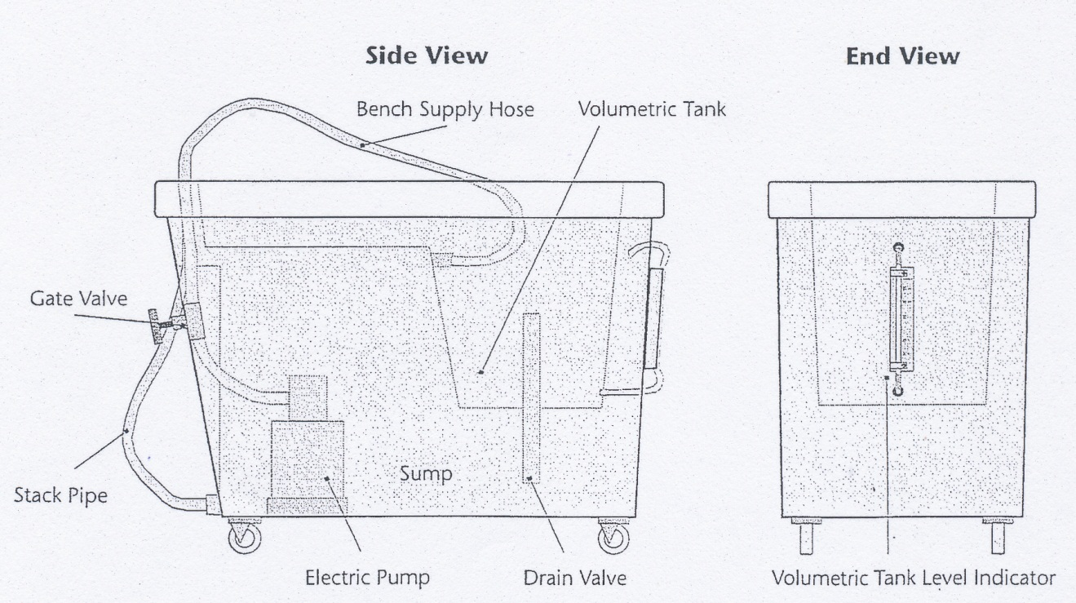

Fig. 1. TQ Volumetric Hydraulic Bench used to power water flow.

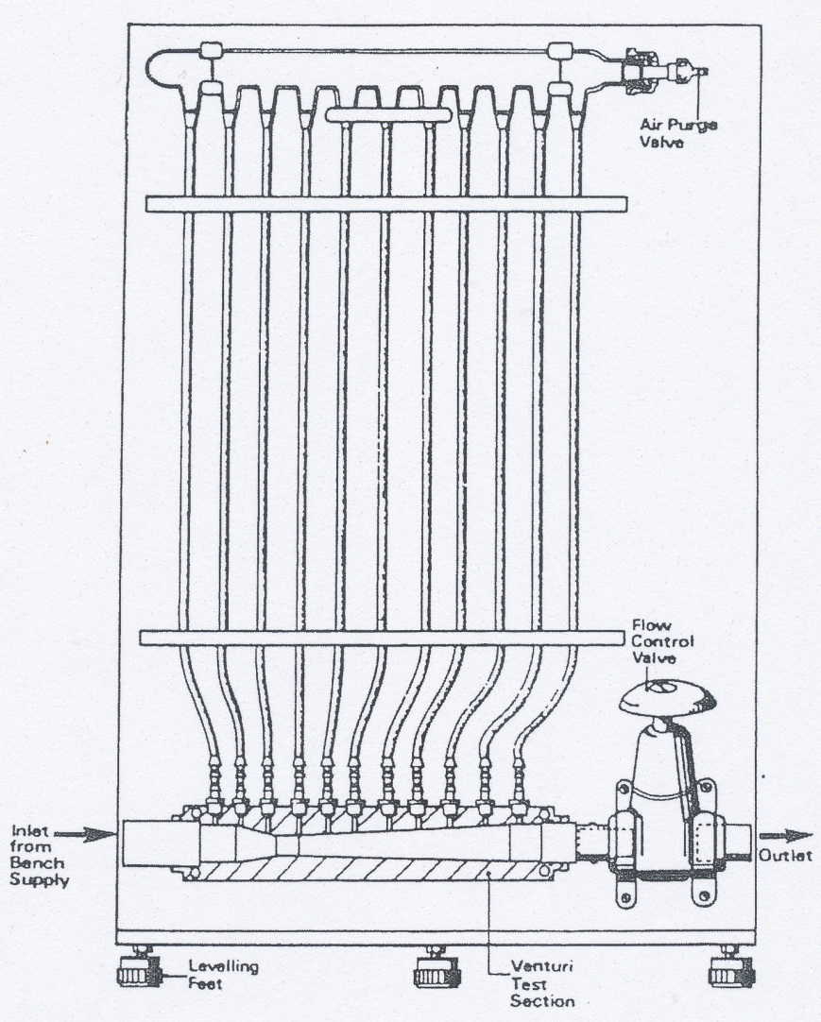

Fig. 2. Herschel Venturi Meter used in the experiment

Results and Discussion

While examining our C vs Re graph, we can notice that our data is slightly biased above that of the empirical data. The points themselves have a relatively high scatter, with the points not conforming to a straight line as the empirical data shows. The error between the calculated C and the empirical C can be determined from using the values from the line of the empirical data. From this calculation, we get an average error of 1.69%. This error and relatively random scatter would have come about from operator and procedural error. The main areas that we had errors came from measuring the height of the fluid. Because the machine was constantly running, there was a certain rhythm to the top point of the fluid; this causes problems when taking an accurate measurement of the height. Another issue we had was in the time measurement, out data uses exact seconds, which could have induced an error into the results. Other errors could have been caused by improperly zeroing the testing equipment or allowing air bubbles to remain inside of the Venturi tube, where we could not see them. The experiment as a whole, however, seems to confirm the previously found empirical data.

The second set of data that we obtained was that of the relationship between of $∆h_{1-2} vs. ∆h_{1-T}$. In an idealized world, there would be no headloss and would necessitate that $∆h_{1-2}=0$, making the slope of our graph be equal to zero with no bias. In our physical world, energy is lost due to a variety of interactions such as friction and variances in physical measurements, such as density or pressure. Empirical results show that the slope should be .1, or 10%, indicating an average loss of 10%. In our test, our least square fit line came very close to meeting this requirement with a slope of .1264, or 12.64%. The additional 26.4% of error would come from the way the experiment was conducted. This could range from user error to problems with the testing equipment. The user error that happened would have been due to measurement issues with the heights. The measurement of the height caused an error as the height of the fluid fluctuated due to the flow of the fluid, causing the group to have to make estimation as to where the height was. The error could also have come from minor changes in the assumptions required to use Bernoulli’s equation, such as the density or variance in the height of the tube from one side to the other. These errors would have also affected the bias of the graph.

**Tabulated Data**

Percent Error in C at Measured Points (%)

|  |  |  |  |  |  |  |  |  |  |  |  |
| --- | --- | --- | --- | --- | --- | --- | --- | --- | --- | --- | --- |
|  | 1 | 2 | 3 | 4 | 5 | 6 | 7 | 8 | 9 | 10 | Avg |
| C vs. Re | 4.81 | 4.56 | 1.07 | -2.40 | 1.21 | -0.01 | 3.24 | 3.66 | 1.85 | -1.10 | 1.69 |

**Tabulated Data Continued**

Calculated Data for Headloss Graph

|  |  |  |  |  |  |
| --- | --- | --- | --- | --- | --- |
|  | Least Square Fit Slope (exp) | Least Square Fit Bias (mm) | Average Scatter (mm) | Max Scatter (mm) | Deviation from Empirical (%) |
| $$∆h_{1-2} vs. ∆h_{1-T}$$ | 0.1264 | -2.8904 | 0.521 | 1.09 | 26.4% |