Introduction

The name of this experiment is Pipe Flow. The purpose of this lab is to observe the variation of head loss with velocity for the flow of water through a small diameter pipe over a range of Reynolds numbers including both laminar and turbulent flow, and to compare the variation of friction factor with Reynolds number with published results. This experiment is a requirement for the Fluids Laboratory (EM341) as part of the Engineering Curriculum offered at San Diego State University (SDSU). The experiment was performed by a group of Engineering Students, majoring in Mechanical and Civil Engineering. It was conducted on October 20, 2010 at 10:00AM in the Fluids Laboratory at SDSU. This lab report was written by Levi Lentz with the data obtained by Group E.

Theory

The lab is conducted to show the effects of several different aspects of fluid dynamics. The main purpose is to show how the Reynolds (Re) number changes with the velocity. While the Reynolds is less than 2000 (Re < 2000), the flow is said to be laminar. If the Reynolds number is above 2000 (Re > 2000), the flow is said to be turbulent. During the experiment, the head loss, or the energy lost due to friction, is measured and will be plotted verses the velocity of the fluid. From this measurement, as well as the Reynolds number, we can find the friction factor (*f*). Plotting Re vs. *f* on a Moody Diagram will allow us to calculate the relative roughness of the interior of the pipe from existing empirical data. The pipe roughness will not affect the flow while it is laminar due to the boundary layer forming in the absence of turbulence, but when the flow becomes turbulent, the roughness of the pipe will have an appreciable effect on energy of the fluid. It is therefore of great importance to determine the roughness of the pipe being used in any application.

The following terms and equations will be used to complete the theory of the lab:

Definition of Terms:

*f* = Friction Factor

L = Length of tube

D = Diameter of tube (3mm)

*v* = Velocity of fluid

g = gravity = 9.795m/s2

~~V~~  = Volume

A = Cross-sectional area of tube

$ν$ = kinematic viscosity

$$ν\left(20°C\right)=1.00E-06\frac{m^{2}}{s}$$

$$γ_{W}=9795\frac{N}{m^{3}}$$

$f=64/Re$ (For laminar flow)

L = .524m (Length of the test tube)

The head loss of an incompressible flow:

$h_{L}=f\frac{L}{D}\frac{v^{2}}{2g}$

The flow-rate:

$Q=\frac{V}{t}$

The velocity is defined as:

$v=\frac{Q}{A}$

The Reynolds Number is defined as:

$Re=\frac{vD}{ν}$

Density of mercury compared to water:

$γ_{M}=13.6 γ_{W}$

Test Procedure and Equipment

The test procedure consists of using a manometer tube manufactured by TecQuiptment, shown in Figure 1 below, that is powered by a TQ Volumetric Hydraulic Bench (H1d), shown in Figure 2 below. The temperature of the water must be recorded at the beginning and the end of the experiment to interpolate the density and kinematic viscosity of the water. The manometer must also initially be zeroed out. This involves removing all air bubbles from the apparatus by tilting the manometer until the air leaves the system. The height of the fluid must then be zeroed; to zero this you must turn off the bench, and adjust the air valve until the height of the fluid in the second tube is equal to zero. Then when running the experiment, the initial run has a height difference, or plainly called the height, of 50mm. Each consecutive run height is then the previous run height multiplied by 1.25. Eventually the height of the water will become excessive, at which point the mercury manometer height must be used. Once the head loss reaches 180mm, the height must then be multiplied by 1.5. During each run, the volume flow is measured by recording the volume in a beaker as well as the time of the run. The theoretical results can then be calculated from the experimental values.

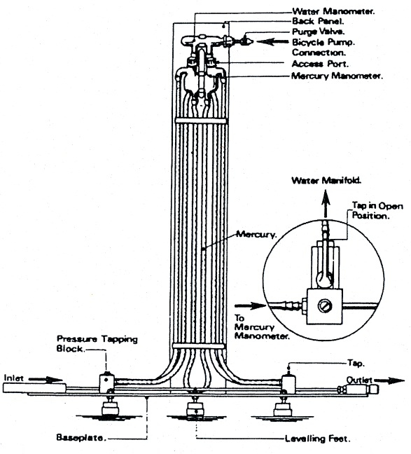

Figure 1. TecQuiptment Manometer

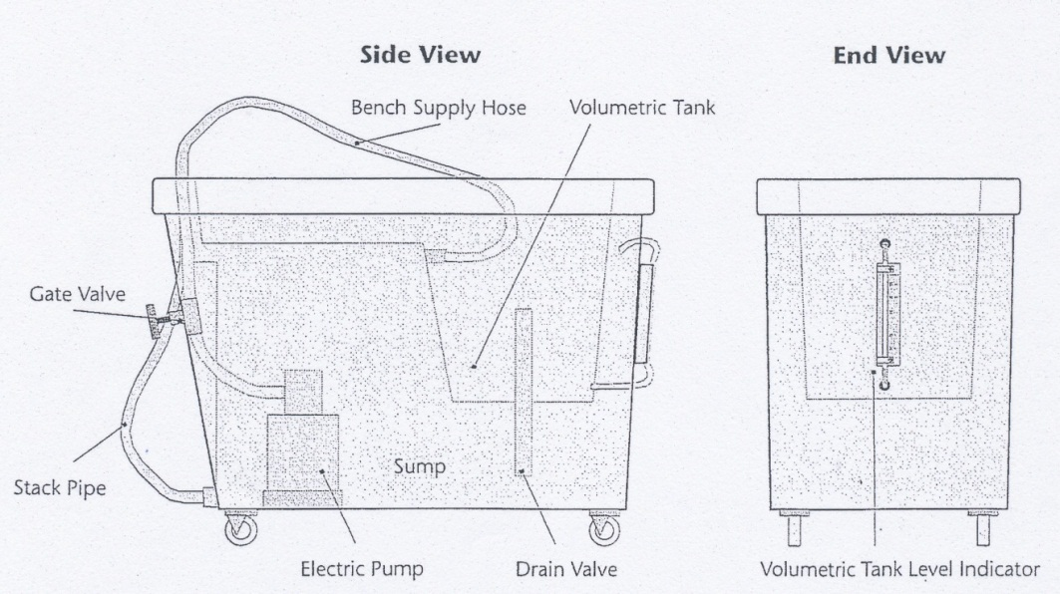

Figure 2. TQ Volumetric Hydraulic Bench

Results and Discussion

The results from this lab are contradictory in nature. The reason is because of the graph of the *f* vs. Re on the Moody Diagram to determine the roughness of the pipe. All of the points plotted on the graph held a very close range to the empirical value when the flow was laminar, however when plotting the turbulent area, all values of the flow were below the lowest pipe roughness, implying that the roughness is 0, or a perfectly smooth pipe. This seems to contradict with the empirical results for the experiment. Because both *f* and Re are dependent on measured values, this implies that this inconsistency is due to measurement error. This could be due to inaccuracy with measuring the height difference of the fluid, or because of errors in measuring the volume flow as a new beaker was used during this part of the experiment.

The plotting of log(hL )vs.log( v), inversely, corresponded very accurately with the empirical results. All of the points plotted were within a negligible distance from the drawn slope, implying an insignificant scatter of all the points. The laminar flow portion of the pipe had a slope of .981 while the empirical slope was 1.0, giving an error of 1.89%. During the turbulent portion of the pipe, the empirical slope of the line was given as 2.0, yet the experimental slope was 1.92, yielding an error of 4.03%. Both errors could easily be described by simple experimental error due to a variety of human errors including error in time measurement as well as volume measurement. These results confirm the accepted way of determining both laminar and turbulent flow as well as determining the Reynolds Number. The tabulated results can be seen in Table 1, below.

|  |  |  |  |
| --- | --- | --- | --- |
| Graph | Theoretical Slope | Experimental Slope | Percent Error (%) |
| Log(hL )vs.Log(V) | Laminar = 1.0 | Laminar = .981 | Laminar = 1.9% |
| Turbulent = 2.0 | Turbulent = 1.92 | Turbulent = 4.0% |

Table 1. Tabulated results from the experiment.

There are two points worth examining after doing the experiment. One of which is how the Moody Diagram has a linear relationship for the laminar flow and a quadratic relationship for the turbulent flow. This is because the graph is a function of 1/v2, however, this reduces to 1/v for laminar flow. On a half-log graph, this yields a linear relationship for the laminar flow and a quadratic relationship for the turbulent flow.

The other relationship is on the log-log graph of hL vs. velocity. The laminar section of the pipe has a slope of 1, while the turbulent section has a slope of 2. These slopes come from the fact that the head loss is a function of the velocity where: $h_{L}=f\frac{L}{D}\frac{v^{2}}{2g}$. In the laminar section, the velocity squared in the numerator becomes a simple velocity. When the log of this function is taken, the exponent of the velocity can be taken out of the log function. This gives the slope of 1 for the laminar section and the slope of 2 for the turbulent flow. This derivation can be seen below:

Laminar:

$$\log\left(h_{L}\right)=\log\left(f\frac{L}{D}\frac{v^{2}}{2g}\right)=\log\left(\frac{32μLv}{γD^{2}}\right)=\log\left(v\right)+log⁡(\frac{32μL}{γD^{2}})$$

$$\log\left(h_{L}\right)=\log\left(v\right)+\log\left(\frac{32μL}{γD^{2}}\right) ⟹m=1$$

Turbulent:

$$\log\left(h_{L}\right)=\log\left(f\frac{L}{D}\frac{v^{2}}{2g}\right)=2\log\left(v\right)+log⁡(f\frac{L}{D2g})$$

$$\log\left(h_{L}\right)=2\log\left(v\right)+\log\left(f\frac{L}{D2g}\right) ⟹m=2$$