

PISTON REDESIGN FOR FORMULA ONE

*Final Report on Use of Silicon Nitride to Increase Engine Efficiency*

Javier Banuelos

Greg Berkeley

Christian Igartua

Art Klutch

Levi Lentz

Report Compiled by Levi Lentz

December 2010

Submitted to Professor Kline

San Diego State University

San Diego, CA 92115

Table of Contents

1.0 Executive Summary 3

1.1 Summary 3

1.2 Conclusions 3

1.3 Recommendations 3

2.0 Introduction 3

3.0 Background of Problem 3

4.0 Theory of Design 4

5.0 Material Selection 4

5.1 Other Materials Considered 4

5.2 Benefits of Silicon Nitride 4

6.0 Thermal Analysis 5

6.1 Summary of Thermal Analysis 5

6.2 Engine Efficiency 6

6.3 Current Thermodynamics of Formula One 6

6.4 Thermal Conductivity Analysis 7

6.5 Heat Transfer 8

6.5.1 Heat Transfer through Aluminum 8

6.5.2 Heat Transfer through Silicon Nitride 8

6.7 Silicon Nitride Thermal Benefits 8

6.8 Conclusion of Thermal Analysis 9

7.0 Material Analysis 9

7.1 Internal Pressure 9

7.1.1 Acceleration 9

7.1.2 Ignition Temperature 9

7.1.3 Hoop Stress and Longitudinal Stress 10

7.2 Thermal Stress 11

7.3 Failure theory 12

7.5 Finite Element Analysis 12

7.6 Cyclic Loading 14

7.7 Crack Length 15

7.8 Material Conclusion 15

8.0 Material Manufacture 16

9.0 Cost Analysis 17

10.0 Future Design Considerations 17

11.0 Conclusion 17

12.0 Appendices 18

Works Cited 22

1.0 Executive Summary

1.1 Summary

Formula One racing is an exceedingly competitive sport that forces engine manufactures to research every conceivable way to increase the performance of their design. Because of strict Formula One rules, the displacement of the engines is closely regulated. Therefore, the only way to increase the performance would be to choose a material that is better in a specific performance-related property. Our analysis focuses on a material that has the potential to increase the overall engine efficiency. After extensive analysis, Silicon Nitride was chosen because of its thermodynamic and strength properties.

1.2 Conclusions

After the analysis of the hoop stress, thermal strain, cyclic loading, and crack length, Silicon Nitride passed all the tests to show that it can be used in the complex environment inside of a Formula One engine. Because of the thermodynamic properties of the material, it also has been shown to give the engine a 7% boost in overall efficiency. Because of these great properties, it can also be considered a good candidate for high-performance domestic use. The main limiting factor of using the material will be the cost of manufacture as well as its fatigue life.

1.3 Recommendations

Now that the material has been proven to work in a theoretical environment, it should be tested in a real world application. Because of the Formula One precedence to use aluminum materials, further research should be done to determine if there is an aluminum-type material that has similar thermodynamic properties. Further research needs to be done to simplify the manufacture process as well as reduce the cost associated with it.

2.0 Introduction

Formula Racing is one of the largest spectating racing sports in the world. As part of this heavy competition, every avenue is explored to decrease the lap time for the driver. The current approach is to increase the horsepower of the engine. This approach has been hampered as Formula 1 has made several specifications to limit the horsepower available to the drivers by limiting the displacement of the engines. Another way to increase the horsepower is to increase the overall efficiency of the engine. This can be accomplished by increasing the internal temperature of the engine, or by decreasing the heat lost to the environment. The purpose of this report is to outline a method of increasing the efficiency of a Formula 1 engine with the end goal being selecting a new material to be used as a piston as well as a better insulator for the piston sleeve. The ideal material will be able to withstand the complex loads on the system as well as stop excessive heat from being lost to the surroundings. The report will outline preliminary findings including the calculations and simulation of selected materials. This report contains a Background of Problem, Theory of Design, Material Selection, Thermal Analysis, Material Analysis, Material Manufacture, Cost Analysis, Future Design Considerations, Conclusion, and Appendices section.

3.0 Background of Problem

Formula One racing grew out of the European Grand Prix motor racing, getting its official start in 1946. From then on, there was a never ending race to achieve higher and higher horsepower in the name of decreased lap time. This ended in 1994 after a sequence of driver deaths lead the Fédération Internationale de l'Automobile (FIA) to severely restrict the horsepower output of the F1 engines by limiting their displacement capability.

These restriction have led to each individual car having the same horsepower output. In the drive to decrease lap times, the next logical step will be to increase the efficiency of the engine. This increase in efficiency can either be used to use less fuel, and therefore conserve weight, or boost the horsepower output as less heat is lost to the surroundings. To increase the efficiency, we are required to pick a material that has a high heat capacity as well as low thermal conductivity. It must also be capable of withstanding the complex loading present inside of a Formula One engine.

4.0 Theory of Design

The modern automobile engine is, at its core, simply a heat engine. Because of this, 100% efficiency can never be obtained. In a standard engine, the efficiency can be determined from the following:

$η_{Th}=1-\frac{{\dot{Q}}_{out}}{{\dot{Q}}_{in}}$ (1)

Where ${\dot{Q}}_{in}$ is the heat transfer due to combustion and ${\dot{Q}}_{out}$ is the heat transfer lost to the atmosphere, either through the engine block or the exhaust. From this equation, you can see that in order to make the engine more efficient, at a constant input, we would need to decrease the amount of heat loss to the surroundings. One big way to do this would be to reduce the heat leaving the engine through the engine block. In order to accomplish this, we need to find a material that can act as an insulator in the cylinder wall. Because of strict FIA rules on displacement, the overall geometry of the piston and cylinder sleeve cannot change. These dimensions can be seen in Appendix 1. Because of this limitation on the design, we must therefore work within existing parameters to find a material that can withstand the loading as well as provide to be a better insulator to the combustion process.

5.0 Material Selection

Material Selection completed by Javier Banuelos

Current Formula One design uses a variety of aluminum alloys in their engine design. While this is an easy to manufacture material, it does not have properties that would maximize the engine’s efficiency. There were many properties that needed to be taken into account; with the possible increase in heat and pressure due to the increase in efficiency, a suitable material had to be chosen that could withstand high heat, high stresses, and possess good insulation properties. Among the materials under review were several magnesium alloys that are being used in automotive applications. Zinc alloys, which are heavier and stronger than their Magnesium alloy counterparts, were also considered due to their increased strength. Additionally, traditional 6061 aluminum, with its well-rounded properties, presented itself as a possible candidate. An additional material was considered because of its exceedingly good strength and thermal properties: Silicon Nitride (Si3N4) was considered because it possessed an almost ideal set of parameters for the design constraints. These materials, and their respective properties, can be seen in Appendix 2.

5.1 Other Materials Considered

While all materials were considered, all but one had a limiting factor large enough to discredit their use in the engine. The Magnesium and Zinc alloys, despite their favorable strengths and low fabrication costs, have very low melting points at around 380-420 °C. The temperatures inside the cylinder can reach temperatures in average of 500°C which will rule out both alloys for use in the engine block. Aluminum, though inexpensive and readily available shares similar properties with the Magnesium and Zinc alloys, with one major difference being in a higher melting point. Aluminum alloys are currently in use in various automotive applications, and has proven time and time again that it can be used in the required conditions. Since the purpose of this project was to seek an alternative material for marked improvement, Aluminum is shown merely as a benchmark. Si3N4 is therefore the only material that possesses both the strength and thermal conductivity required of the project.

5.2 Benefits of Silicon Nitride

The main goal for this project was to increase engine efficiency by reducing heat loss within the piston cylinder thus increasing pressure and reducing the amount of fuel needed for each combustion cycle. In comparison to the other proposed materials, Si3N4 displayed the lowest thermal conductivity, excellent for insulating the cylinder, along with a high thermal shock resistance and low thermal expansion rate which would mitigate the thermal stresses the piston and sleeve would be subject to. Additionally the high strength values inherent in the material ensure the part would endure the complex environment it would be subject to. While the other materials did have high enough strength and toughness values to withstand wear and mechanical stresses, it was in their thermal properties that they ultimately failed. Their high thermal conductivities would not allow us to properly insulate the engine to achieve an ideal efficiency. While cost was considered, the target market for Si3N4 was for high performance race engines, and therefore the cost was a negligible issue.

6.0 Thermal Analysis

Thermal Analysis completed by Gregory Berkeley

The thermodynamics of an automotive engine are very complex and require a high degree of understanding to perform any type of precise analysis. This will be an attempt to simplify the thermal interactions in order to produce results for a more energy efficient engine for Formula One Racing. Prior to introducing any theory and mathematics it is first important to understand the interworking mechanisms inside of an engine.



It is first important to mention that all of the proceeding research will be conducted at the maximum allowable power in Formula One Racing, 19,250 rpm of the engines crankshaft. This is equivalent to about 750 horsepower with a torque of 279 . The goal of this study is to conjuncture a method that will allow for another 100 horsepower by utilizing the low thermal conductive property of Silicon Nitride (Si3N4).

6.1 Summary of Thermal Analysis

Since we are modeling at 19,250 rpm, the entire four-stroke cycle repeats every 6 milliseconds. This process happens so rapidly that the energy coming in from the spark plug, and ensuing combustion, can be described as a constant rate of heat transfer into a system. The work coming out of the system, due to rotation of the crankshaft, can then be expressed as constant shaft power and the remaining heat is lost due to material heat conduction as well as exhaust. This allows for the use of a closed steady state model. The following diagram gives a representation of the energy interactions in the system.







**Heat loss through exhaust**

**Work produced by crankshaft**

**Heat transfer delivered combustion**

**Heat loss through material**

**Figure 1.** Closed Steady State Model

Due to the first law of thermodynamics we know that the energy can neither be created nor destroyed but only converted from one form to another. For any system the First Law states that the net result of heat or work will be a change in the energy of the system (Obert 47). The general equation for energy can be algebraically expressed by the following:



|  |
| --- |
|  |

By definition of a system at steady state we know the change in energy of the system must be equal to zero. By simplifying the First Law and taking a time derivative we can show that the output power will equal the net heat transfer.

$$\dot{W}=\dot{Q}$$

$\dot{W}={\dot{Q}}_{in}-{\dot{Q}}_{out}$ (2)

We now have a relationship between the energy interactions in our model (Figure 1).Before we continue in the analysis it will be critical to understand another aspect of our system, its thermal efficiency. This combined with the above equation can be used to determine the increase of power in our system. The following section will discuss the conditions for determining values for engine efficiency, allowing us to provide a numerical representation for our research.

6.2 Engine Efficiency

The efficiency of an engine is determined by the amount of work being produced compared with the amount of heat (energy) put into the system (Moran 66). This was expressed in Formula (1) above.

By inspection of this equation we see that by decreasing the heat loss while still maintaining a constant heat transfer into the system will allow for a more efficient engine. The heat being lost during the working cycles of the piston can be separated into two forms: material heat conduction and exhaust. This analysis will pertain explicitly to the heat transfer through the material as an attempt to achieve an increase in horsepower.

6.3 Current Thermodynamics of Formula One

Let us first consider how much power is being produced when the vehicle is traveling at maximum power. The work done by a torque in rotating a shaft is related to its displaced angle of orientation (Bhattacharjee 25). Taking a time derivative of the expression for work will provide an equation for the power being produced at a given rpm.

 (3)

T in Formula (3) is the torque exerted on the crankshaft and  is its angular velocity in rpm. By applying 19,250 rpm we are able to find a measurement of power being produced. Keep in mind the torque that is exerted at this rotational rate is 279 .



Formula One engines run at roughly 33% thermal efficiency (“Formula One Engines”). This means that one-third of the heat produced by the combustion stroke generates as work through the piston rotating the crankshaft. Since two-thirds of the heat produced by the engine is lost after the full four-stroke cycle we can conclude the following by using our previous equation:





 (4)

This tells us that 1,124.8 kW of heat is being lost through either the material or exhaust stroke of the engine. Let us now take a closer look at how the heat is being lost through the material. The following section will utilize accepted methods of thermal analysis in order to give this quantity a numerical representation for both the use of current cylinder material as well as a prototype made of Silicon Nitride. By comparing the results we will be able to determine an increase in our power output.

6.4 Thermal Conductivity Analysis

At every instant in the model there is a flow of heat along the cylinder walls throughout its volume. The amount of heat that travels through the cylinder is dependent on the thermal conductive property of the material. The thermal transfer through the material walls is given by Formula (5) below

 (5)

where *k* is the thermal conductivity, *A* is the inner area of the cylinder and *dT/dx* is the temperature gradient at any point throughout the cylinder’s thickness. However, the temperature must be the same throughout each cross section in order for the state to remain steady. In other words, *dT/dx* is a constant. If this were not so, the quantity of heat flowing into an element of the cylinder would not be the same as the heat flowing out. The heat would then accumulate inside the cylinder walls and its temperature would change, contradicting the definition of steady state (Sears 348).

This allows us to simplify the above equation to something much more feasible:

 (6)

Where *TH* is the hot temperature inside of the system due to combustion, *TC* is the cold temperature in the system’s surroundings, and *L* is the thickness of the cylinder wall.

With this expression as well as empirical equations of heat transfer, we are able to achieve a clear approach for increasing engine efficiency with a material of considerably lower thermal conductivity. Let us now determine values for the rate of energy lost through both a cylinder made of Aluminum Alloy as well as Silicon Nitride.

6.5 Heat Transfer

Table 1, below, shows the values for the Aluminum and Silicon Nitride that are required to solve Equation (6). Aluminum is used in order to compare the gains in thermal efficiency by using Silicon Nitride.

|  |  |  |  |  |  |
| --- | --- | --- | --- | --- | --- |
|  | *k* | *A* | *TH* | *TC* | *L* |
|  | Thermal Conductivity | Inner Surface Area | Internal Temp | Ambient Temp | Thickness |
| Aluminum | 120 W/m.K | 0.01225 m2 | 500° C | 30° C | 0.005 m |
|
| Silicon Nitride | 30 W/m.K | 0.01225 m2 | 500° C | 30° C | 0.005 m |
|

**Table 1.** Properties required to calculate the heat transfer through the cylinder wall. See Appendix 3 for and explanation of TH and TC



6.5.1 Heat Transfer through Aluminum

By inserting the values from Table 1 into Equation (6), we are able to evaluate the rate of heat being lost through the walls of an Aluminum Alloy cylinder as the engine performs at 750 hp. Knowing that the sum of the heat lost through material conduction and through the exhaust we are also able to determine the amount of heat lost through exhaust.

$${\dot{Q}}_{out,mat}=120\frac{W}{mK}\left(0.01225 m^{2}\right)\frac{500°C-30°C}{0.005 m}$$

${\dot{Q}}_{out,mat}=138 kW$ (7)

6.5.2 Heat Transfer through Silicon Nitride



Again, by inserting the values for Silicon Nitride from Table 1 into Equation (6), we are able to evaluate the rate of heat being lost through the walls of a Silicon Nitride cylinder. It is important to notice that the heat being lost through exhaust will not differ for this analysis since we are not changing the heat being provided to the system. The heat that is stored through insulation will instead be transferred as additional work being produced by the engine.

 $${\dot{Q}}_{out,mat}=30\frac{W}{mK}\left(0.01225 m^{2}\right)\frac{500°C-30°C}{0.005 m}$$

(8)

6.7 Silicon Nitride Thermal Benefits

We now have obtained all of the data necessary to demonstrate an increase in power output as well as energy efficiency for a Formula One engine. Using Equation (2) with the calculated values from Equation (8) we are able to evaluate how much more power a Formula One car will produce by implementing a Silicon Nitride cylinder.

 (9)

Using Equation (1) we are able to determine the new engine efficiency:



 (10)

6.8 Conclusion of Thermal Analysis

Decreasing the rate of heat being lost through the cylinder has allowed for a greater power output from the engine. The heat that is stored from implementing a more thermally insulated material is allowing for more pressure to be exerted on the piston causing an increase of torque on the crankshaft. Using Silicon Nitride as a replacement material selection for Formula One race cylinders will increase the engine’s maximum power by 150 hp and provide a 7% raise in engine efficiency.

7.0 Material Analysis

Material Analysis completed Levi Lentz

Now that we have found a material to use in the piston and cylinder sleeve, as well as proved that it has an increase in overall efficiency, the question then becomes whether it can handle the complex loading of an internal combustion engine. The goal of this section is to prove whether or not it can handle this through both hand calculations as well as through the Finite Element Analysis capability in SolidWorks. This section contains an Internal Pressure, Thermal Stress, Failure Theory, Cyclic Loading, Crack Length, and Material Conclusion section.

7.1 Internal Pressure

Next to the thermal stress, the largest stresses felt on both the piston as well as the piston sleeve will be due to the internal pressure from the combustion of the gasoline. This combustion will be cyclic in nature, and therefore will cause the internal stresses to vary with time. In order to gain an accurate estimation of the internal pressure, we need to use two methods to find the internal pressure: the pressure as a result of the acceleration as well as the pressure due to the ignition temperature. Both of these pressures should be nearly equal to each other.

7.1.1 Acceleration

One method to approximate the internal pressure of the cylinder would be to find the acceleration of the piston. The max acceleration will happen at either extreme of the piston cycle, with the largest magnitude happening at Top Dead Center. Once we have the acceleration of the piston, we can approximate the internal pressure by replacing this force by a distributed load on the top of the piston. The analysis of this can be found in Appendix 3. The tabulated results can be found below in Table 2. This table represents only the maximum pressure, the actual loading will by cyclic in nature.

|  |  |  |  |
| --- | --- | --- | --- |
| Engine Speed | Max Acceleration | Max Force | Max Internal Pressure |
| 19,250 RPM | 9843.9g | 21.245kN | 2.8165MPa |

**Table 2.** Data from the acceleration model for max internal pressure.

7.1.2 Ignition Temperature

Section completed by Art Klutch

One method to correlate the ignition process with a temperature would be to use the ideal gas law: $P=ρRT$ (11)

This equation will yield the initial pressure just after combustion. The pressure is then approximated due to the change in volume of the cylinder. Because of the complexities of the combustion cycle, this is just an approximation for the internal stress. In reality, there would be a discontinuity at the inlet of the gas and the exhaust of the fumes. The max pressure that we have found was 2.98MPa, within 10% of our acceleration model. The correlation of the two models shows that we have obtained a close approximation. However, due to the higher load with the ideal gas model, it will be used to obtain a higher factor of safety.

The benefit of this model is that, like the acceleration, it can be shown to be shown to vary with time. The graph of the internal pressure vs time can be seen below in Figure 2. This pressure is useful for finding the load on the piston as well as the load on the cylinder wall.

**Figure 2.** Graph of internal Pressure vs. Time.

7.1.3 Hoop Stress and Longitudinal Stress

The largest stress that the cylinder wall will be under, due to the internal load, will be from the so called hoop stress. This is a stress normal to the radial direction that is a consequence of the internal pressure. Because of the geometry of the cylinder, the shear stress on the material can be neglected. The hoop stress can be determined from the following equation:

$σ=\frac{Pr}{t}$ (12)

This stress, like the internal stress, will be cyclic in nature. Figure 3 shows how the hoop stress varies with time. Notice that it is similar in shape to Figure 2, just in a higher magnitude. This is because the hoop stress is simply the internal stress multiplied by the geometric property r/t (radius/thickness).

**Figure 3.** Hoop Stress vs. Time

This graph implies that the stress felt in the radial direction varies between 23.01MPa and 2.09MPa, implying a change in stress of 20.92MPa. This change in stress will dictate the life of the cylinder sleeve.

Because the cylinder is constrained on the top and bottom, there is also a longitudinal stress in the axial direction. All longitudinal stresses correspond to the same time and position to the hoop stresses. This stress varies between 5.75MPa and .52MPa. The longitudinal stress change therefore changes 5.23MPa in each cycle.

7.2 Thermal Stress

The largest stress that the material will be under will be from the thermal expansion as the sleeve is constrained on the top and bottom. If we use super position, we can derive the following relationship, shown in Appendix 5:

$σ_{th}=α∆TE$ (13)

Since the average operating temperature has been shown to be 500°C, we can find that the stress to be 480.8MPa in compression. This large thermal stress is due in part because of the large modulus of elasticity. This stress can be reduced if a slight gap was allowed to exist between the cylinder sleeve and the engine block. This would allow the material to expand unconstrained, effectively lowering the amount of stress that the sleeve will be under due to the thermal expansion.

Because of the constraint, the thermal strain in the radial direction should be taken into account. However, the way the piston has been designed allows a 1mm gap between the cylinder sleeve and the piston. The Poisson effect will not close this gap. This gap is therefore closed by the piston rings. These rings are normally made of hardened steel and have a radius larger than the piston to close the gap between it and the sleeve. It has an angular gap cut in a radial manner that serves two purposes. The first is to allow the ring to be inserted onto the piston; the tight fit does not allow it to be attached any other way. The second, and more important, purpose is to allow the ring to have a constant radius as it warms to the steady-state temperature. As the ring warms, the gap closes due to thermal expansion, allowing the rings outer and inner radius to remain constant. This design eliminates the need to closely match the thermal strain of both the piston and cylinder sleeve, allowing most designs to use a different material for each part.

7.3 Failure theory

Picking a proper failure theory will be crucial to determining if our selected material can handle the applied stresses. While it is not the most conservative theory, the Von Mises Failure theory is a convenient theory to use to choose as we can verify that our part does not fail with common Finite Element Analysis software that commonly use the Von Mises Criterion.

The Theorem states the following:

$\frac{\sqrt{2}}{2}*{\left[{\left(σ_{1}-σ_{2}\right)}^{2}+{\left(σ_{1}-σ_{3}\right)}^{2}+{\left(σ_{2}-σ_{3}\right)}^{2}\right]}^{\frac{1}{2}}<σ_{y}$ (14)

Using the current loading supplied we can find that:

$$σ_{1}=-475MPa$$

$$σ_{2}=23MPa$$

$$σ_{3}=0$$

Where the 1-direction is in the longitudinal direction and represents the addition of the thermal stress and the longitudinal stress of a cylinder; the 2-direction is the hoop stress in the radial direction. From the above stresses and the Von Mises failure theory, we can determine that our yield stress needs to be. We find it to be:

$σ_{y}>490MPa$ (15)

This is a very high stress, yet the yield stress of Silicon Nitride far exceeds this value. The vast majority of this stress is also in compression; like all ceramics, Silicon Nitride handles compressive loads very well and could handle this load fairly easily, with the yield stress in compression being between 600MPa-3GPa; this value varies considerably based on what type of manufacturing process the material undergoes.

While Silicon Nitride can handle this stress, it is found to be so high because of the geometric constraints on the part. If a slight gap was allowed under for the piston sleeve to expand prior to touching the engine block, the stress would be significantly lower.

7.5 Finite Element Analysis

Solidworks analysis completed by Christian Igartua

In order to verify that our hand calculations are correct in their finding that the material will not fail under the static loading presented in the preceding sections. This is achieved by using the Finite Element Analysis (FEA) in Solidworks 2010. After the running of the tests, the parts were found to have not failed. The results can be seen below. Additionally, FEA was run on aluminum parts, but due to length restrictions, it is not included in this report.

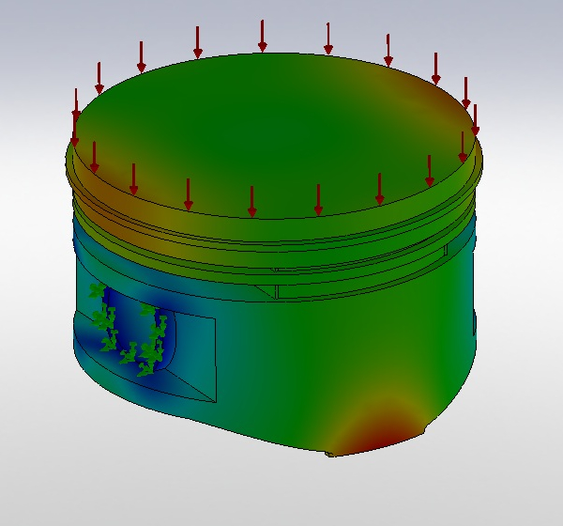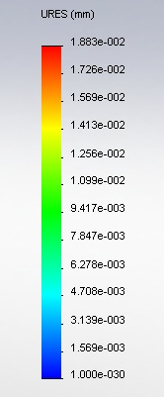**Figure 4.** Displacement results for a static load on a Silicon Nitride Piston

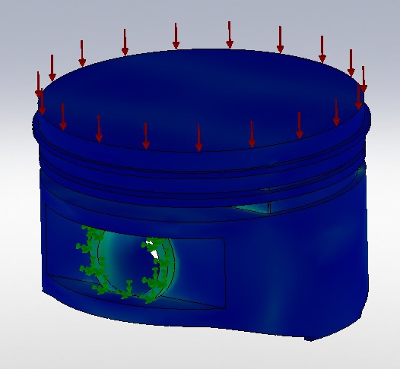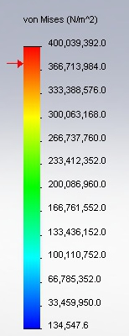

**Figure 5.** Stress on Silicon Nitride Piston

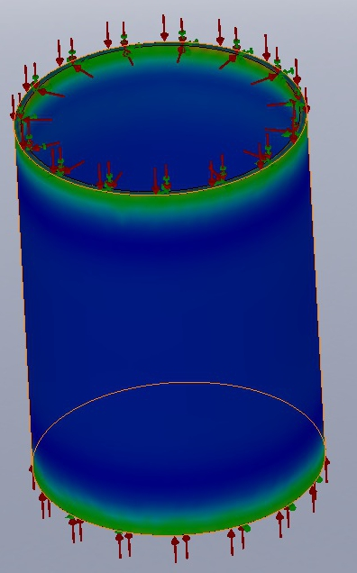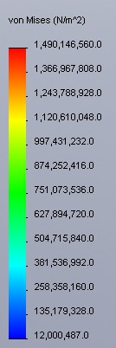

**Figure 7.** Compressive load as well as internal pressure on the Silicon Nitride Sleeve.

7.6 Cyclic Loading

As Figure 2 and 3 show, the piston and cylinder sleeve are going to be under a cyclic load each and every engine cycle. As we have chosen Silicon Nitride for our material of choice, we have to examine the fatigue life of the material.

Because Silicon Nitride is used in high temperature applications primarily, most of the data that was readily accessible came from tests performed on much higher temperatures (Mutoh, 3939-44). From these values we can obtain the following relationship, the derivation of which can be seen in Appendix 6.

$∆σN_{f}^{.0637}=135.889$ (16)

The graph of which can be seen in Figure 8 below. Note that under the temperatures the piston operates at, the real graph will be higher, giving us more cycles to failure. Also, as with most ceramics, there is no clear endurance limit; eventually our parts will fail under any amount cyclic loading.

**Figure 8.** A log-log graph of the Wöhler curve for Silicon Nitride.

From the Wöhler curve, we can deduce that the cylinder sleeve can last approximately 5.715*1012 cycles. In terms of the engine cycles, this will be half as the load is applied twice every revolution. This implies that the engine can last 2.85*1012 revolutions. Assuming the engine could run at 19,250 RPM the entire race, there are 193.25*106 revolutions per race. These numbers show that our cylinder sleeve will outlast the life of the engine by several orders of magnitude. This adds credibility to Silicon Nitride being used in domestic applications.

7.7 Crack Length

As with all materials, a large consideration needs to be placed on the critical crack length of the material. This is the max length that a crack can be in a material without failing under the load. The Irwin modification to the Griffith equation, shown below in Equation (17), provides us a way to relate the critical crack length with the applied strength.

$σY\sqrt{πa}=K_{IC}$ (17)

Since Silicon Nitride has a low fracture toughness of 6.1 MPa $\sqrt{m}$, the crack length is going to be small. Solving the above for “a” with our maximum applied stress we obtain that:

$$σY\sqrt{πa}=K_{IC}$$

$$480MPa*1*\sqrt{πa}=6.1MPa\sqrt{m}$$

$⇒a=.05mm$ (18)

This means that we can have a center crack length of .1mm (as a center crack has a length of 2*a). It is important to note that this crack length is only critical on the piston sleeve, and therefore a higher tolerance must be observed while manufacturing it. While this is a relatively short crack length, the manufacture of Silicon Nitride will allow the part to be made with a max crack length less than this value due to the sintering process, as will be discussed in Section 8.0.

7.8 Material Conclusion

After analysis through both hand calculations as well as through the Finite Element Analysis it was shown that the material can withstand the internal loading required of it. The last limiting factor will be the cost associated with the manufacture of the material which will be discussed in Sections 8 and 9.

8.0 Material Manufacture

Material Manufacture and Cost Analysis completed by Javier Banuelos

Si3N4 has several fabrication methods each which impart the material with different mechanical properties. Hot Pressed Silicon Nitride (HPSN), Reaction-Bonded Silicon Nitride (RBSN), Sintered and Reaction-Bonded Silicon Nitride (SRBSN), and Sintered Silicon Nitride (SSN) are the four fabrication methods more commonly seen.

Hot Pressed Silicon Nitride, developed in the 1960s and 1970's, is a way to take advantage of the material's excellent mechanical properties. Flux is added, usually magnesia, to the pure Si3N4 powder and the material is then passed through a die at 1800 °C and 40MPa of pressure. It allows for a dense billet with high quality properties (Sinternational Syalons). However, the two drawbacks to this method are the fabrication costs as pure Si3N4 powder is very expensive ($80/kg) (Mikijelj, B.) and the process allows only for simple shapes that require grinding and machining to get into the necessary shape, limiting its possible applications.

Sintered Silicon Nitride has all but replaced HPSN. It allows for more complex shapes as Si3N4 powder, mixed with various sintering additives, is densified at 1750 °C in a nitrogen atmosphere. This process also harbors its own drawbacks. Even though the manufacturing process is cheaper, this cost is offset by the fact that pure Si3N4 is required. Lastly it also displays significant shrinkage ranging from 17 to 21% (Mikijelj, B.) which may result in increased need for grinding or machining to attain the right part dimensions.

Reaction-bonded Silicon Nitride is the process by which Silicon 'dough' is meticulously nitrided allowing Si3N4 to grow within the porosity of the dough (Sinternational Syalons). The benefit to this process is the fact that the Si3N4 displays little to no shrinkage allowing a near accurate part reducing the need for machining or grinding significantly. Additionally its low relative cost is desirable as it allows for a greater profit margin. The main drawback to this process comes in the increased porosity which reduces the strength quality of the material, making it inferior to Si3N4 made through the other methods.

Sintered and Reaction-Bonded Silicon Nitride became the fabrication method chosen for this design. It is a favorable combination of the high quality properties of SSN and the low production costs of RBSN. The process is very similar to the steps used in sintering and reaction-bonding the Si3N4. The only variation comes in the addition of sintering additives to the starting powder that allows for sintering after the reaction-bonding process (Sinternational Syalons). The sintering reduces the porosity induced by the reaction-bonding, though it introduces shrinkage to the material. However, this shrinkage is significantly lower than that of SSN (10-12% as opposed to 17-21% (Mikijelj, B.)) which gives more control over part dimensions and still maintains a reduced need for further grinding or machining (Sinternational Syalons). The reduced porosity increases the strength of SRBSN to compare to that of HPSN and SSN making it the desired manufacturing technique for this design.

Using the current fabrication methods SRBSN makes the material remarkably self-reinforcing. The process begins with a Silicon powder compact doped with Yttrium Oxide, Aluminum Oxide (both sintering additives) and beta-Silicon Nitride seeds. The compact is then placed into a tube furnace and nitridation begins (Lee, J. S. 897-905). The system is closely monitored to maintain a 120KPa control pressure; as gas is absorbed due to the formation of Si3N4, decreasing the pressure, a pressure transducer then sounds the alert for more gas to be fed into the furnace (Lee, J. S. 897-905). Slowly the temperature is increased in a multi-step process until it reaches 1450 C, the whole process taking approximately over 30 hours to complete. It is then that post-sintering is performed to further increase densification.

Some common sintering additives are Yttrium Oxide (Y2O3), Aluminum Oxide (Al2O), and Magnesium Oxide (MgO). The purpose of the sintering additives is to promote densification and keep thermal conductivity low due to the increased amount of secondary phases (Zhu, X. 5581-91). Additionally hardness and wear resistance, in part, also depend on the presence of additives (Wani, M. F. 52-59).

Beta-seeding is another means to improve Silicon Nitride properties. Beta phase seeds also improve material density and, if closely monitored, have a positive effect of fracture strength and toughness. When coupled with a larger Si compact grain size (7 micrometers as opposed to 2 micrometers) nitridation percentages are increased, due to the lower SiO2 levels in the original Silicon powder. Additionally higher fracture strengths and fracture toughness are seen in the beta-seeded course powder because of rapid growth of large elongated grains (Lee, J. S. 897-905).

9.0 Cost Analysis

Due to the wide array of applications of Silicon Nitride, a universal cost estimate for these parts is very difficult to procure. Reaction-sintered Silicon Nitride was the cheapest of the manufacturing processes, but was still significantly more expensive than traditional metal manufacturing techniques. An estimate attained through contacting several different manufacturing companies gave the cost per kilogram to be around $450, including all material, machining, and labor. With all profits and a wide margin of risk, the estimated cost per piston is $650. Due to the relatively large budgets of Formula One race teams, this is a more than reasonable price, especially for the increase in performance.

10.0 Future Design Considerations

This report proves that Silicon Nitride can work as a viable material under the complex loading of a Formula One engine. However, in the past, the FIA has moved to make significant material improvements illegal, and has instead established a precedence to use aluminum materials in the entire engine design. As part of this, it would be beneficial to find an aluminum-type material that would have similar thermodynamic properties. This would also help with the manufacturing process as it would decrease the amount of initial investment needed to create the Silicon Nitride parts as well as decrease the cost per part. Based on current research, there is no aluminum type material with similar thermo properties; it would have to be a composite of some sort. Because of this fact, Silicon Nitride may be the only way to increase the efficiency of the engine from a purely material stand point.

11.0 Conclusion

After all of the complex analysis required for the project, we have shown that Silicon Nitride can work as an alternative material for inside of the cylinder block of a F1 engine. Using this new material will give the engine an overall boost of 7% efficiency and approximately 150 more horsepower. These gains are worth an unimaginable amount to the competitive performers of the Formula One race scene. As the natural trend of F1 technology is to transition into the field of high-performance sports cars, our analysis also implies that the material can be used in a domestic application, possibly paving the way to more powerful and efficient high-performance engines. The main limiting factors are the fatigue life as well as the relatively small max crack length. Future research needs to be done to determine if there are ways to mitigate these limitations though the creation of a Silicon Nitride composite or through an entirely new material with similar thermal conductivity properties.

12.0 Appendices

**Appendix 1**

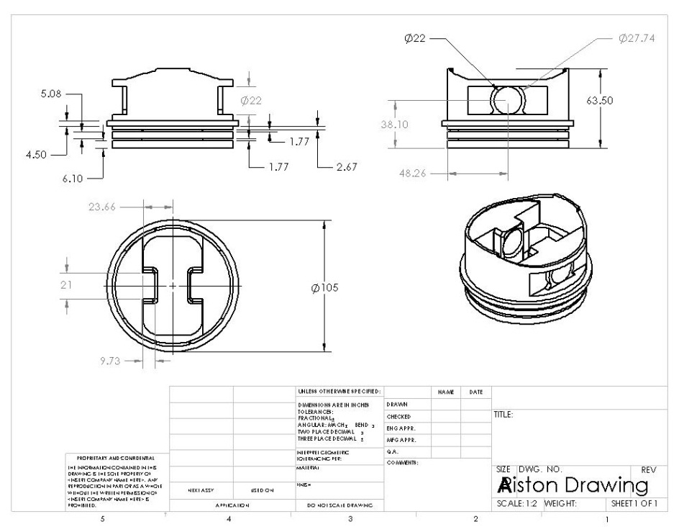

**Figure 9.** Dimensions for Piston, to current FIA specifications. All dimensions are in millimeters.

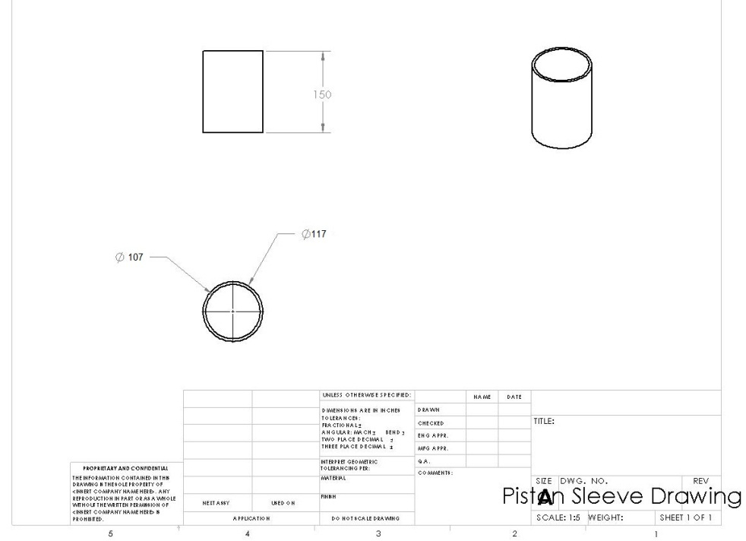

**Figure 10.** Drawing of the piston sleeve, all dimensions in millimeters

**Appendix 2**

|  |  |  |  |  |  |  |  |  |  |  |
| --- | --- | --- | --- | --- | --- | --- | --- | --- | --- | --- |
|  | | Si3N4 | | | | | | Zinc Alloys | | |
|  | | Sintered-Reaction Bonded | | Sintered | | Hot Pressed | | Zamak 3 | | Zamak 5 |
| Modulus of Elasticity | | 300 Gpa | | 300 Gpa | | 300 Gpa | | 130 Gpa | | 130 Gpa |
| Shear Modulus | | 148 Mpa | | 140MPa | | 145MPa | | 214 Mpa | | 262 Mpa |
| Fracture Toughness | | 5.0-8.0 Mpa-sqrt(m) | | 7.5 Mpa-sqrt(m) | | 4.5 Mpa-sqrt(m) | | 12.3MPa*sqrt(m) | | 21MPa-sqrt(m) |
| Yield Strength | | 3 GPa (C) @ 600 °C | | .7GPa (C) @ 600°C | | .6 GPa (C) @ 600°C | | 210 MPa | | 240 MPa |
| Thermal Expansion | | 3.4 micro-m/m.K | | 3.1 micro-m/m.K | | 3.2 micro-m/m.K | | 27 micro-m/m.K | | 27 micro-m/m.K |
| Thermal Conductivity | | 27 W/m-K | | 22 W/m-K | | 26 W/m-K | | 113 W/m*K | | 110 W/m*K |
| Density | | 3.31 g/cm3 | | 3.24 g/cm3 | | 3.2 g/cm3 | | 6.6g/cm3 | | 6.7g/cm3 |
| Melting point | | 1500+ °C | | 1500+ °C | | 1500+ °C | | 380-387 °C | | 380-386 °C |
|  | |  | |  | |  | |  | |  |
|  | | Mg Alloys | | | | Aluminum | |
|  | | AZ91A | | AZ91D | | 6061 | |
| Modulus of Elasticity | | 45 GPa | | 45 GPa | | 68.9 GPa | |
| Shear Modulus | | 17 GPa | | 17 GPa | | 26 GPa | |
| Fracture Toughness | | 22.9 MPa-sqrt(m) | | 28 MPa-sqrt(m) | | 29 MPa-sqrt(m) | |
| Yield Strength | | 150 MPa | | 150 MPa | | 276 MPa | |
| Thermal Expansion | | 26 microm/m*K @ 20-100°C | | Same as AZ91A | | 25.2 microm/m.K | |
| Thermal Conductivity | | 72W/m-K @ 100-300degC | | Same as AZ91A | | 167 W/m-K | |
| Density | | 1.81g/cm3 | | 1.81g/cm3 | | 2.7 g/cm3 | |
| Melting point | | 421 °C | | 421 °C | | 582-652 °C | |

**Table 3.** Properties of materials considered for the project.

**Appendix 3**

The primary function of the spark plug is to ignite the air/fuel mixture within the combustion chamber under any operating condition. The two most common causes of spark plug problems are carbon fouling (occurs below 450° C) and pre-ignition (occurs above 800° C). Carbon fouling occurs when deposits from combustion start to form on the tip of the spark plug. Pre-ignition occurs when the average temperature from the spark plug is high enough to prematurely cause the fuel/air mixture to combust, damaging the engine.. The optimum heat range for spark plug ignition lies between these two temperatures as it helps to self-clean itself of combustion deposits. If the engine is to be operated at high RPM, under a heavy load, or at high temperatures for long periods a colder ignition will be required. For Formula One race engines, there optimum combustion temperature is approximately 500° C due their high rates of speed for extensive periods of time. Figure 11, below, demonstrates the relationship between ignition temperature and engine speed of a Formula One car. (Sears 482)

450° C

800° C

Vehicle Speed (RPM)

**Pre-Ignition**

**Self-Cleaning**

**Carbon Fouling**

**Figure 11** Temperature vs Vehicle Speed for Formula One

**Appendix 4**

L1

L2

X

**Figure 12.** Four-bar link representation of the piston assembly

In order to solve for the acceleration of the piston, shown in Figure 12 above, we need to determine the acceleration of X ($\ddot{X}$). In order to find this, we need to first form a closed vector loop which can be seen below in Equation 1:

$L_{1}\left(cosθ\vec{i}+sinθ\vec{j}\right)+L_{2}\left(cosϕ\vec{i}-sinϕ\vec{j}\right)+X\vec{i}=0$ (19)

By taking the derivative of (19) once, we can find the velocity, and twice, we can find the acceleration which can be seen below in Equations (20) and (21), respectively.

$$L_{1}\left(-\dot{θ}sinθ\vec{i}+\dot{θ}cosθ\vec{j}\right)+L_{2}\left(-\dot{ϕ}sinϕ\vec{i}-\dot{ϕ}cosϕ\vec{j}\right)+\dot{X}\vec{i}=0$$

$⇒\dot{X}=L_{1}\dot{θ}sinθ+L_{2}\dot{ϕ}sinϕ$ (20)

$$⇒\dot{ϕ}=\frac{L_{1}\dot{θ}cosθ}{L_{2}cosϕ}$$

Differentiate once more:

$$L_{1}\left(\left[-\ddot{θ}sinθ-{\dot{θ}}^{2}cosθ\right]\vec{i}+\left[\ddot{θ}cosθ-{\dot{θ}}^{2}sinθ\right]\vec{j}\right)+L_{2}\left(\left[-\ddot{ϕ}sinϕ-{\dot{ϕ}}^{2}cosϕ\right]\vec{i}+\left[-\ddot{ϕ}cosϕ+{\dot{ϕ}}^{2}sinϕ\right]\vec{j}\right)+\ddot{X}\vec{i}=0$$

$⇒\ddot{X}=L_{1}(\ddot{θ}sinθ+{\dot{θ}}^{2}cosθ)+L_{2}(\ddot{ϕ}sinϕ+{\dot{ϕ}}^{2}cosϕ)$ (21)

$$⇒\ddot{ϕ}=\frac{\ddot{θ}cosθ-{\dot{θ}}^{2}sinθ+{\dot{ϕ}}^{2}sinϕ}{cosϕ}$$

Using these equations, we can find the max acceleration to be at the point when $θ=ϕ=0$. When modeled at 19,250 RPM, we find this to be 9843.9g.

**Appendix 5**

When a material is allowed to undergo thermal strain in a completely unconstrained manner, this leads to all dimensions expanding proportionally to their Coefficient of Thermal Expansion. Since our piston sleeve is constrained in the axial direction, we can use the superposition principle to determine the stress on our sleeve:

$$δ_{th}-δ_{st}=0$$

$$δ_{th}=\frac{PL}{AE}$$

$$α∆TL=\frac{PL}{AE}$$

$⇒σ_{th}=α∆TE$ (20)

Solving when $∆T=470C$

$$⇒σ_{th}=-480.8MPa$$

**Appendix 6**

Using the S-N curve relationship, we obtain the following relationship:

$∆σN_{f}^{a}=C$ (21)

From the data performed on Silicon Nitride at 1200C (Mutoh, 2):

$$∆σ=70MPa, N_{f}=3.33*{10}^{4}$$

$$∆σ=76MPa, N_{f}=9.1575*{10}^{3}$$

Yielding:

$$a=.0637$$

$$c=135.889$$

Giving:

$$∆σN_{f}^{.0637}=135.889$$

When $∆σ=20.92MPa$; $N_{f}=5.715*{10}^{12}$

Works Cited

Sears, Francis Weston. Mechanics, Heat and Sound. Addison-Wesley Press, Inc: Cambridge. 1952.

Obert, Edward F. Thermodynamics. McGraw-Hill Book Company, Inc: New York. 1948.

Moran, Michael J. Fundamentals of Engineering Thermodynamics. John Wiley & Sons, Inc: USA. 2008.

Bhattacharjee, Subrata. Classical Thermodynamics. Pearson Education, Inc: Upper Saddle River. 2004.

Mutoh, Y., T. Tanaka, T. Niwa, and N. Miyahara. "Fracture toughness of silicon nitride determined by cyclic-fatigue-cracked specimens." *JOURNAL OF MATERIALS SCIENCE.* 23. (1988): 3939-44. Print.

"Silicon Nitride Advanced Ceramics." Sinternational Syalons. N.p., 2010. Web. 6 Dec 2010. <http://www.syalons.com/resources/guides/siliconNitride.php>.

Mikijelj, Biljana, and John Mangels. "SRBSN MATERIAL DEVELOPMENT FOR AUTOMOTIVE APPLICATIONS." Costa Mesa, Ceradyne. 2000. Print.

Lee, Joo-Sin, Ji-Hun Mun, Byung-Dong Han, and Hai-Doo Kim. "Effect of b-Si3N4 seed particles on the property of sintered reaction-bonded silicon nitride." Ceramics International. 23. (2003): 897–905. Print.

Wani, M. F., Z. A. Khan, and M. Hadfield. "Effect of Sintering Additives and Reinforcement on Microhardness Values of Si3N4 Ceramics and Composites." Journal of Advanced Research in Mechanical Engineering. 1.1 (2010): 52-59. Print.

Zhu, Xinwen, Yoshio Sakka, You Zhou, and Kiyoshi Hirao. "Processing and properties of sintered reaction-bonded silicon nitride with Y2O3–MgSiN2: Effects of Si powder and Li2O addition." Acta Materialia. 55. (2007): 5581-91. Print.

"Formula One Engines." F1Technical . F1Technical.net, 2009. Web. 6 Dec 2010. <http://www.f1technical.net/articles/4>.