Control theory

*“A lot of people think we are moving mass around or using spinning gyros but that’s not it at all. . . we basically ride it like a human does.”*

*-UC Berkeley, Blue Team*

What the students at the University of California, Berkeley are talking about regarding their own unmanned motorcycle is that they drive their prototype the same way a person riders their bike. Although this phenomenon may be intuitive to the rider and outside of their consciousness, the fact is that people stabilize their motions on a motorcycle by turning the front wheel. Of course the rider may slightly shift their mass in order to counter-balance themselves but the primary mechanism that allows for stability, especially at higher speeds, is front wheel manipulation. In short, rotating the front wheel causes the motorcycle to turn with a certain radius. This motion generates centripetal force at the motorcycle’s center of gravity which creates a moment about the contact point, which can prevent the bike from falling in the opposite direction.

The motorcycle has similar dynamics to that of an inverted pendulum and will be modeled as such. Consider the following free body diagram.

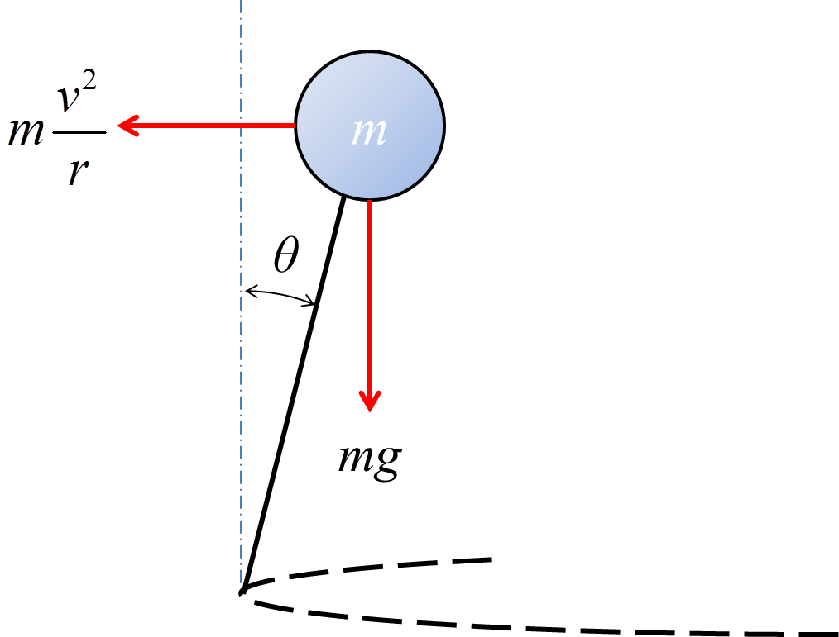

Figure XX

Calculating a torque balance about the center of gravity provides



Simplifying and linearizing the above equation gives an expression for the radius needed to balance the motorcycle.



Now that the required radius has been calculated it can now be related to the steering angle that will generate it. Consider the geometry of the motorcycle as it turn about a radius *r*.

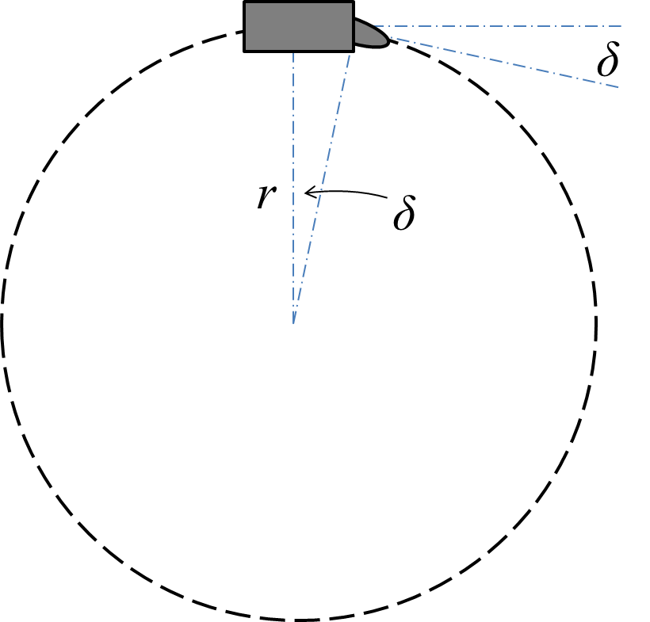

Figure XX

The radius of curvature can be related to the steering angle *δ* by the following expression



Where the distance of the motorcycle’s center of mass to the front wheel’s contact point is 0.405 meters. Now by substituting the expression for the radius we develop a relationship between the steering angle, velocity, and orientation of the prototype.



This is the governing equation for stability based on the AUTOMOTO’s velocity and orientation error that are sensed by their respective encoders within the system. This will allow AUTOMOTO to get in the neighborhood of the proper steering angle plus any PID effects in microcprocessing. Since there is a 3.5 gear ratio between the steering column and the stepper motor, our equation used within the control algorithm becomes

