

**ME 490A – Senior Design**

**Project Title: Automoto – Self-Stabilizing Motorcycle**

**Group 16:**

Greg Berkeley, Levi Lentz

**Sponsor:**

|  |  |  |
| --- | --- | --- |
| Contact Person: | Dr. Kee Moon |  |
| Company Name: | San Diego State University |  |
| Company Address: | College of Engineering  5500 Campanile Drive  San Diego, CA 92115 |  |
| Phone Number: | 619-594-8660 |  |

**Advisors:**

Dr. Kee Moon: Kmoon@mail.sdsu.edu

Dr. Matthew Graham: matthew.graham0@gmail.com

Mr. George Mansfield: gmansfield75@gmail.com

i. Table of Contents

i. Table of Contents 2

ii. List of Figures 2

iii. List of Tables 2

1.0 Abstract 3

2.0 Introduction 3

3.0 Literature Review 3

4.0 Design Concepts and Final Design 6

4.2.1 Math Model 7

4.2.2 Physical Design 11

5.0 Conclusion and Recommendations 13

6.0 Acknowledgements 14

7.0 References 15

ii. List of Figures

Figure 1 Self-righting scooter designed in Israel. [2] 4

Figure 2 Patent documenting a CG-Manipulating Device for personal Automation. [3], [4] 4

Figure 3 A mechanical device to manipulate the CG. [5] 5

Figure 4 The C-1 concept self-stabilizing bike manufactured by Lit Motors. 5

Figure 5 The mass that will change the CG. The motor would have to be sufficiently massive enough to affect the CG of the bike. 6

Figure 6 The original bike design with the CG manipulator installed. 7

Figure 7 Required dimensions for the math model from the Side, Back, and Top 8

Figure 8 Root Locus at 5 m/s 11

Figure 9 Control system diagram for Automoto 12

Figure 10 Exploded and unexploded views of the final design 12

Figure 11 Stabilizing wheel bar 13

Figure 12 Hinge connecting to bike frame 13

iii. List of Tables

Table 1 Description of variables 8

1.0 Abstract

The Automoto is a proof-of-concept RC motorcycle designed to operate indefinitely without the need for external support. This senior design project reverse engineered the current design to examine the existing problems and determine why previous groups were unsuccessful. This led to the discovery that the design was not using PID controllers to maintain stability nor was there a low-speed stabilization mechanism. This group is proposing a design that implements PID control of the motorcycle as well as retractable stabilization wheels to provide stability at low speed. Future work includes determining the method to actuate the stability wheels and fully development of PID dynamics.

2.0 Introduction

This report will outline the senior design project that will be the redesigning an existing RC motorcycle to provide self-stabilizing control. The motivation for this project is a proof-of-concept to expand the knowledge base of the robotics field. A self-righting motorcycle has several military applications including the ability to get vehicles and supplies into areas where a large four-wheeled vehicle would not be able to access. Additionally, the military could use this as a platform for mobile terrain reconnaissance missions. In the civilian sector, as robotics become more and more advanced, the need to have a robot that is able to operate on a two-point-of-contact basis is becoming increasingly demanded. This ability would allow a wider range of applications related to the service-based industry. A self-righting motorcycle would be able to prove one way in which this would be accomplished for a translating device.

The proposed project will be a redesign of an electrical motorcycle that will operate as an RC-controlled self-righting vehicle. The goal of this project will be to successfully re-engineer the existing prototype so that it is able to drive indefinitely without the need for external support. As of now, the motorcycle can only drive for approximately ten feet before falling over. This is due in part to slow response time in the controller that manipulates the balance of the motorcycle.

3.0 Literature Review

There have been two projects that have successfully made a self-righting motorcycle. The first was a submission by a Berkeley team to the DARPA Autonomous Vehicle challenge [1]. This group successfully made a motorcycle that could drive itself without external input and placed in the DARPA challenge. The other was by a Master’s Thesis candidate in Technion, Israel [2]. This project made a RC-controlled scooter that would self-right itself, even against significant external disturbances. The Israel design is shown below in Fig 1. Both projects maintained stability by manipulating the front wheel rapidly to cause the vehicle to torque upright. Each project, additionally, used linear approximations for their control theory.

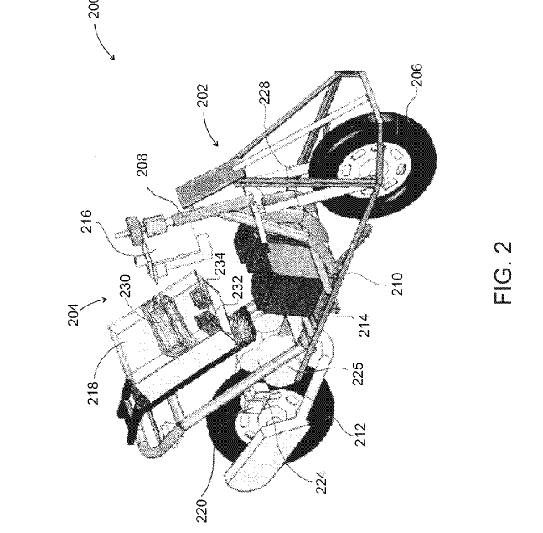

Figure 1 Self-righting scooter designed in Israel. [2]

Given the theoretical nature of this project, there was very little patented information available. The primary patents are listed below in Fig 2 and 3. The initial design approach for the Automoto was to model the system as an inverted pendulum. These patents were chosen to explore this concept.

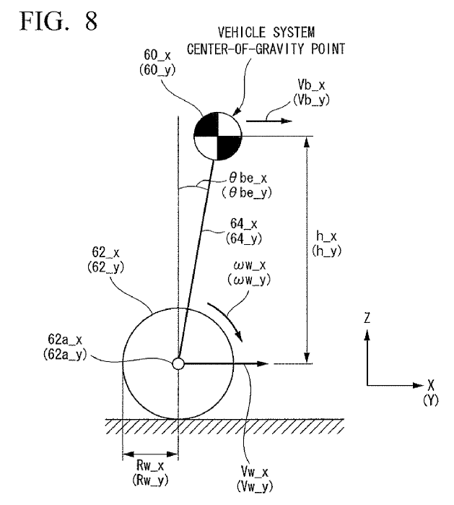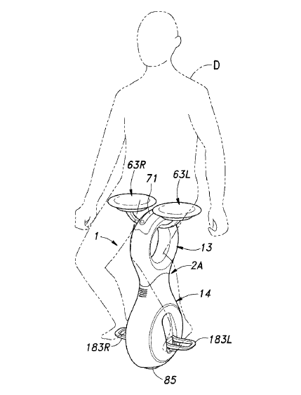

Figure 2 Patent documenting a CG-Manipulating Device for personal Automation. [3], [4]

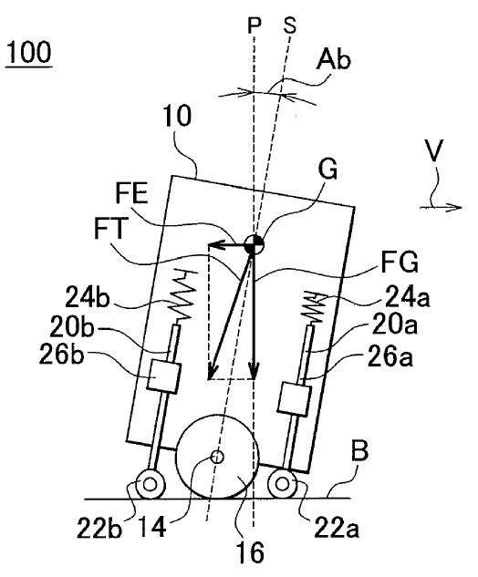

Figure 3 A mechanical device to manipulate the CG. [5]

The large difference between these patents and the initial design approach was that the center of gravity manipulation for all current designs is in the direction of motion. The Automoto design will have to manipulate the CG in the perpendicular direction as this is the direction the bike will fall. It was proven later that this method was unfeasible for control of the motorcycle.

In industry, there is currently only one commercially available self-righting motorcycle. Currently in beta testing, the C-1 is manufactured by Lit Motors [6]. This design relies heavily on the use of large gyroscopes to maintain the vehicle’s uprightness. A diagram of the vehicle can be seen below. This design was never examined by this group in huge detail due to the overall complexness and size requirements for the gyroscopes to maintain stability.

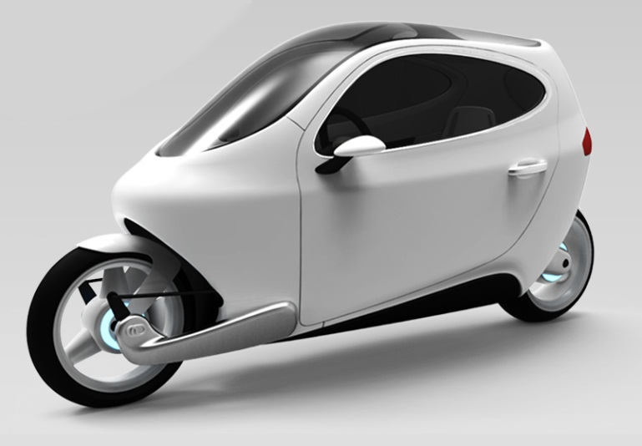

Figure 4 The C-1 concept self-stabilizing bike manufactured by Lit Motors.

4.0 Design Concepts and Final Design

This section will detail the initial design concept followed by the final design description. The process was iterative in nature, with the final design being a result of failed mathematical models for previous designs.

4.1 Design Concepts

Through the course of the design process, the Automoto went through several iterations to the current final design. Originally, the bike designed relied on manipulation of the front motor to torque the bike up. After examining the present code on the bike, the controller used to control the stepper motor was a simple proportional gain controller. This was extremely limiting as the gain was never adaptive to the increased angle of the bike. To overcome this design, several design iterations were assessed to manipulate the center of gravity of the bike. The final Model of the CG-manipulation design is shown below in Fig 5 and 6. As the motor would change position, the CG of the bike would also change. The idea was that this would happen until stability was achieved.

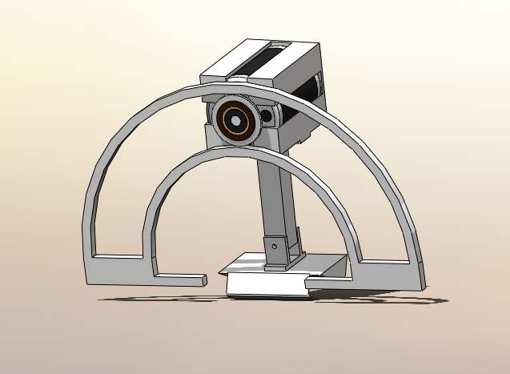

Figure 5 The mass that will change the CG. The motor would have to be sufficiently massive enough to affect the CG of the bike.

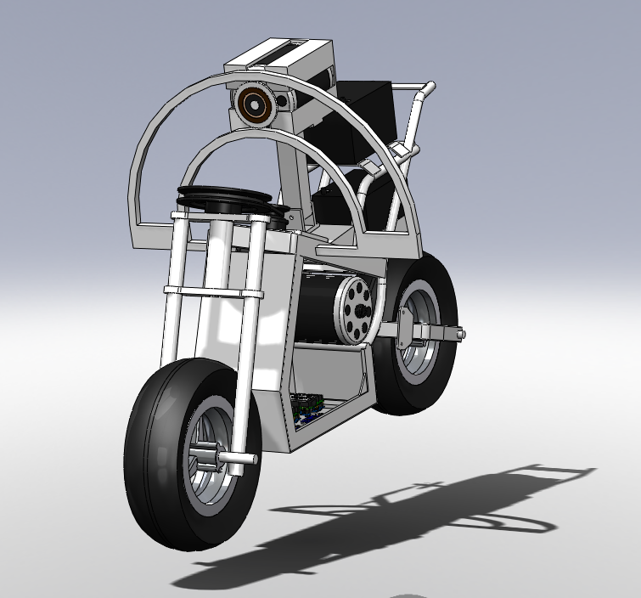

Figure 6 The original bike design with the CG manipulator installed.

This design was ultimately abandoned because there was no way move the motor without having adverse effects on the bike. As the bike would fall to the left, the motor would have to rotate along its track to the right. This would cause reaction forces in the left direction, actually forcing the bike into the ground.

4.2 Final Design

Through these iterations, it became apparent that manipulating the center of gravity would not allow the motorcycle to remain upright as there would be reaction forces on the bike that would actually “push” the bike into the ground. Because of this, it became apparent that the best way to control the bike would be through the manipulation of the front wheel as the original group had done. Prior to designing this, a mathematical model was developed to determine stabilization criteria. After examining this model, it appeared that there were two distinct ranges of motion: low speed and high speed. This lead to our eventual final design with stabilization wheels at low speed, to be detailed in 4.2.2

4.2.1 Math Model

Motorcycles have interesting dynamic behavior and are statically unstable, much like inverted pendulums. However, under certain conditions, a motorcycle will become stable in forward motion. Modeling motorcycle dynamics produces several nonlinearities due to geometry and kinetic interactions with the road and tires. A detailed model of a motorcycle is complex because the system has many degrees of freedom and there are several constraints from the geometry. Several assumptions will be taken into account to simplify the motorcycle model.

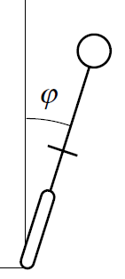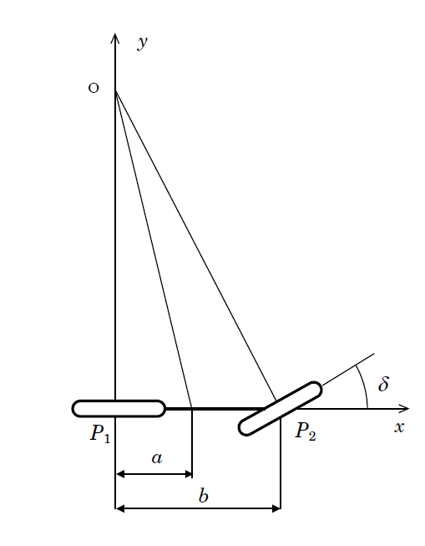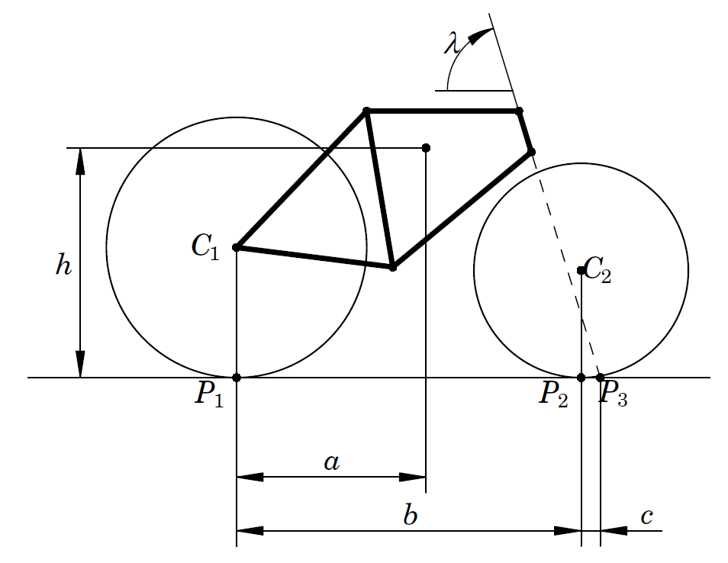

Figure 7 Required dimensions for the math model from the Side, Back, and Top

Table 1 Description of variables

|  |  |  |
| --- | --- | --- |
| **Description** | **Symbol** | **Value** |
| Centroid Distance (x direction) | *a* | 32cm |
| Wheelbase | *b* | 72.5cm |
| Trail | *c* | 5.965mm |
| Height of Centroid | *h* | 21.5cm |
| Head Angle | *λ* | 60.4 |
| Mass of Bike | *m* | 31.75kg |
| Rear Wheel Contact Point | *P1* | - |
| Front Wheel Contact Point | *P2* | - |
| Steering Angle | *δ* | Variable |
| Roll Angle | *φ* | Variable |

Successful control and maneuvering of a motorcycle depends critically on the forces between the wheels and the ground. A good understanding of these forces is necessary to make appropriate assumptions about valid models of motorcycle rolling conditions. Acceleration and braking require longitudinal forces, however balancing and turning depend on lateral forces. It is for this reason that control from acceleration and braking will not be considered in this model.

We assume that the motorcycle consists of four rigid parts; two wheels, a frame, and a front fork with handlebars. The influence of other moving parts, such as pedals, chain, brakes, on the dynamics and control characteristics is thus disregarded for the purposes of this work. The parameters that describe the geometry of a motorcycle are defined in Fig 7. The key parameters are: wheelbase *b*, steering angle λ and trail *c*. Trail is defined as the horizontal distance *c* between the contact point and the steer axis when the motorcycle is in the upright reference configuration with a zero steer angle. The riding properties of the motorcycle are strongly affected by the trail; a large trail improves the stability but makes the steering less agile.

*Coordinates and Second Order System*

The coordinate system *xyz* has its origin at the contact point *P1* of the rear wheel. The x axis is along the longitudinal direction of the motorcycle. The y axis is along the lateral direction and the z axis is along the vertical direction. Note that the roll angle *φ* of the rear frame is positive when leaning to the right and the steering angle is positive when steering left.

The second order models were derived based on several simplifying assumptions. It was assumed that the motorcycle rolls about the x axis and that the forward velocity at the rear wheel *V* is assumed constant. The steering angle *δ* is the control variable and the system has two degrees of freedom. All angles are assumed to be small so that the equations can be linearized.

The torques acting on the system are due to gravity and centrifugal action. The angular momentum balance becomes



Where *m* is the mass of the motorcycle and *g* is the gravitational constant. By making the approximations that *Jxx* = *mh2* and *Jxz* = *mah* the differential equation simplifies to



*Relationship of Front Wheel Torque*

The design of the front fork has a major impact on motorcycle dynamics. The front fork assembly was modeled by a static torque balance. The contact forces between tire and road exert a torque on the front fork assembly when there is a tilt. Under certain conditions these forces turn the front fork towards the lean. The centrifugal force acting on the motorcycle then counteracts the lean and can under certain circumstances stabilize the system. Considering both friction and normal forces the relationship of static torque of the front wheel to the steering angle becomes



There is also an additional torque produced by the normal force as the front wheel is rotated. The center of mass of the frame is shifted when the steering wheel is turned which gives the torque



Combining these equations provides the necessary differential equation:

 

*Critical Velocity*

A very important aspect of defining the mathematics for our prototype’s behavior was the ability to determine the “self-stabilizing” or *critical velocity*. This is the velocity where one could ride a motorcycle with no hands, on in other words no applied torque to the handlebars and still maintain a zero roll angle. By setting the values of the roll and torque to zero and solving for velocity provides



At a velocity greater than or equal to this value will cause the motorcycle to become balanced and stable by virtue of its own momentum, considering that there are only displacements of small roll angles.

*Transfer Function and Root Locus*

The Transfer Function for the differential equation defined above for a velocity of 5 m/s is defined as



This provides the relationship of the input torque of our system to the output roll angle. It is critical to determine if this Transfer Function will provide stability at 5 m/s. A Root Locus was made from the above function and is shown in Fig 8, below.

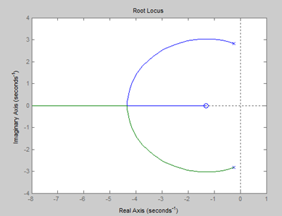

Figure 8 Root Locus at 5 m/s

Since the Root Locus lies entirely in the left hand plane, our model suggests that the bike will be stable at 5 m/s. However, in order for the motorcycle to become balanced it must initially be stable as it approaches the critical velocity. This will be the primary focus of the design for motorcycle stabilization.

4.2.2 Physical Design

After examining the mathematical derivation, it becomes apparent of the necessity of a system to control the bike at low speed. During low speed, the stepper motor has to move prohibitively fast to provide stabilization. In the high speed, the dynamics of the motorcycle, as proven above, will allow more control of the motorcycle from the stepper motor. To facilitate this transition, a design using retractable stabilization wheels will be used. At low speed, these wheels will be touching the ground, allowing the bike to have three points of contact, providing stabilization. At a medium speed, determined by our math model, above, the wheels will retract and the vehicle will become a true motorcycle.

A large part of our design was redesigning the controller that the previous group had used. Below, in Fig 9, is the feedback logic that will be used in the final design. This will use all existing equipment, save for the stabilizing wheels and their control. Depending on the actuator used, this may require an additional controller board added to the existing two Arduinos.

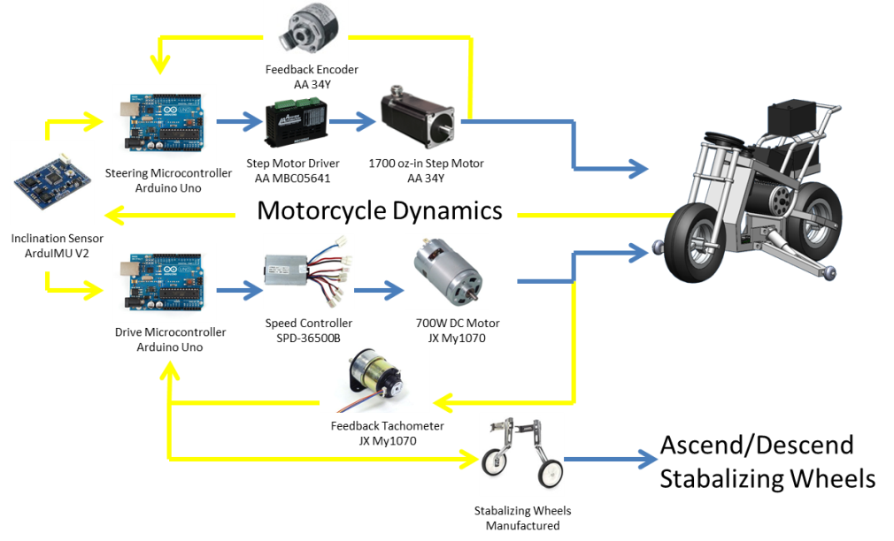

Feedback Signal

Actuating Signal

Figure 9 Control system diagram for Automoto

Below, in Fig 10, is the cad model of the final design both exploded and unexploded:

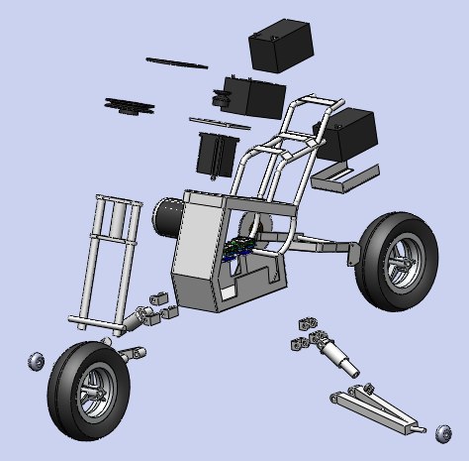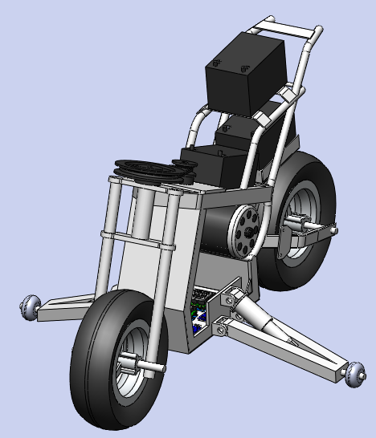

Figure 10 Exploded and unexploded views of the final design

The main mechanism that needs to be manufactured will be the stabilizing wheels. Initially, the actuator will be a rigid member until stability can be achieved by the control system. Then a linear actuator will be chosen. The manufacturing involves not only the bracket, but also the hinges to connect to the current frame. These drawings are shown in Fig 11 and 12, below. The wheels at the end will be off the shelf wheels that are two inches in diameter. When the mechanism is fully extended, the stabilizing wheels will be 1/4” above the ground, allowing the motorcycle to rest on only three total wheels. As the bike gains speed, the stepper motor will be able to act independently of the wheels, at which point the stabilizing wheels will raise.

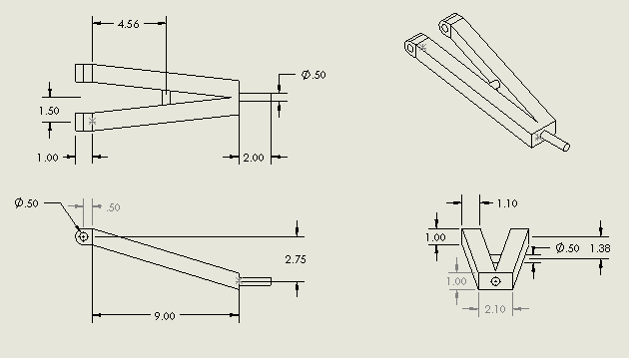

Figure 11 Stabilizing wheel bar

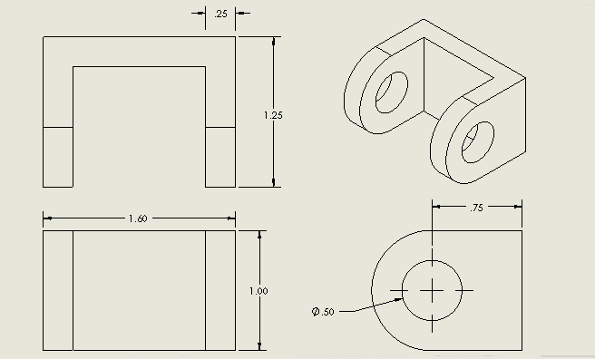

Figure 12 Hinge connecting to bike frame

All connections will be made with .5” bolts with a loose tolerance. This will allow the wheels to raise and lower with relatively low friction at the hinges.

4.2.3 Design Changes For Final Prototype.

Several design changes had to be made for the final prototype. These design changes came principally to our stability wheels. As the design was refined, a pneumatic cylinder was selected that had the approximate stroke length that we needed. Because there was no cylinder that accurately replicated our design stroke and motion, our design needed to be slightly modified to fit the physical limitations of the cylinder.

The chosen cylinder was a Nitra A17020DP that had a 2” stroke and a 1 1/16” bore. This stroke was less than our

5.0 Conclusion and Recommendations

Through the completion of this design, this group reverse engineering the current design of the Automoto to examine the issues with the design. Through this work, we learned the problems associated with the current design. This included the current controller being a simple proportional controller and no mechanism for low speed stability. After completing the final design, this design serves as an excellent starting point for the build stage of the senior design project, 490B. The design takes into account the issues related with low speed stability as well as solves the previous controller limitations by proposing a PID controller that will be significantly more robust than the proportional controller implemented in the original design.

While the design is finalized, there is several major areas that need to be improved prior to, and during, the build. The primary design needs to be on the PID control. This involves solving for the dynamics of the system and implementing the design into the Arduino boards. Additionally, the stabilization wheels will need an actuator chosen. This will be dependent on the type of actuation needed. Prior to choosing this actuator, testing will be conducted to develop the PID control. To this end, the wheels will have a ridged member placed in lieu of the actuator to make the bike have three points of contact. Once the PID is perfected, the actuator will be implemented and full system testing will be conducted.

The current strengths of the project can be found in the completeness of the base frame design. The previous groups should be commended on the effort they put into making a great base to build a self-stabilizing motorcycle. The current weakness is the current electrical and control systems. The current design has nearly no documentation on the wiring of the controllers or the code that is placed on them. As such, there is still much work that needs to be done to make the current Arduinos operational. A final resort will be to explore other microcontrollers to control the bike.

All in all, this project has the potential to be very successful over the course of the next semester. Once completed, it will prove the theory behind low speed and high speed control of a two wheeled vehicle. In the future this will be used for completely autonomous control and the means for more robust robots capable of two wheeled motion.

6.0 Acknowledgements

This project would not have been possible if it were not for the continuous support of Dr. Kee Moon. His funding and ideas will prove vital towards the completion of this project.

Mr. George Mansfield was imperative towards the completion of the preliminary control theory as well as verifying the assumptions for the mathematical model. We look forward to working with Mr. Mansfield next semester.

Dr. Matthew Graham was vital in providing feedback to the mathematical finalization.

Mr. Eric Miller was influential in transitioning the project to our group.

7.0 References

[1] Berkeley’s Blue Team. *Ghostrider* University of Berkeley, 12 Dec. 2011 <http://journalism.berkeley.edu/projects/mm/zack/index.html>

[2] U. Nenner, R. Linker, P Gutman. 2008. *Robust Stabilixation of an Unmanned Motorcycle.* Master’s Thesis, Technion – Israel Institute of Technology

[3] Takenaka, Teru, et al. “Inverted Pendulum Type Moving Body.” Patent Publish Number US 2011/0071752 A1. 24 March 2011.

[4] Gomi, Hiroshi, et al. “Inverted Pendulum Type Vehicle.” Patent Publish Number US 2001/0067938 A1. 17 Sept. 2010

[5] Koide, Mitsuo, et al. “Wheeled Inverted Pendulum Mobile Unit.” Patent Publish Number US 2009/0223728 A1. 10 Sept. 2009.

[6] Lit Motors. “The ‘C-1’ (Codename) ‘Rolling Smart Phone.’” Lit Motors, 5 Dec. 2011 <http://litmotors.com/c1/>