Mathematical Model

*Motorcycles have interesting dynamic behavior and are statically unstable, much like inverted pendulums. However, under certain conditions, a motorcycle will become stable in forward motion. Modeling motorcycle dynamics produces several nonlinearities due to geometry and kinetic interactions with the road and tires. A detailed model of a motorcycle is complex because the system has many degrees of freedom and there are several constraints from the geometry. Several assumptions will be taken into account to simplify the motorcycle model.*

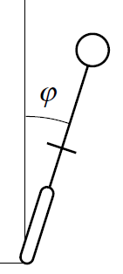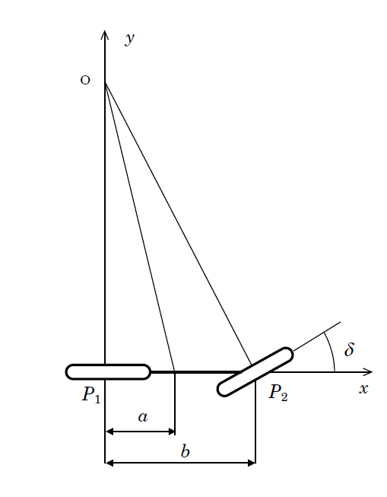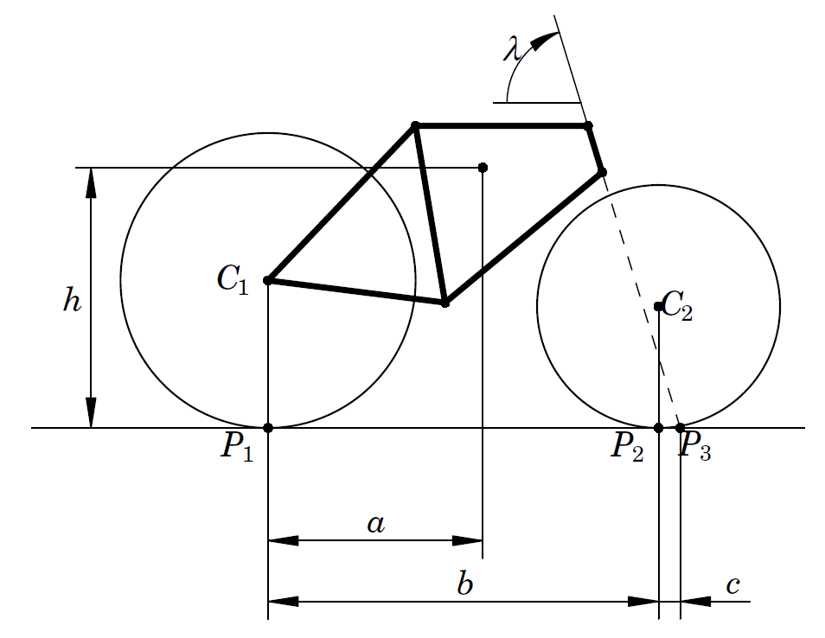

1. b) c)

Figure XX a) Side View b) Rear View c) Top View

**Introduction**

Successful control and maneuvering of a bicycle depends critically on the forces between the wheels and the ground. A good understanding of these forces is necessary to make appropriate assumptions about valid models of motorcycle rolling conditions. Acceleration and braking require longitudinal forces, however balancing and turning depend on lateral forces. It is for this reason that control from acceleration and braking will not be considered in this model.

We assume that the bicycle consists of four rigid parts; two wheels, a frame, and a front fork with handlebars. The influence of other moving parts, such as pedals, chain, brakes, on the dynamics and control characteristics is thus disregarded for the purposes of this work. The parameters that describe the geometry of a bicycle are defined in Figure XX. The key parameters are: wheelbase *b*, steering angle λ and trail *c*. Trail is defined as the horizontal distance *c* between the contact point and the steer axis when the bicycle is in the upright reference configuration with a zero steer angle. The riding properties of the bicycle are strongly affected by the trail; a large trail improves the stability but makes the steering less agile.

**Coordinates and Second Order System**

The coordinate system *xyz* has its origin at the contact point *P1* of the rear wheel. The x axis is along the longitudinal direction of the motorcycle. The y axis is along the lateral direction and the z axis is along the vertical direction. Note that the roll angle *φ* of the rear frame is positive when leaning to the right and the steering angle is positive when steering left.

Second order models will now be derived based on several simplifying assumptions. It is assumed that the bicycle rolls about the x axis and that the forward velocity at the rear wheel *V* is assumed constant. The steering angle *δ* is the control variable and the system has two degrees of freedom. All angles are assumed to be small so that the equations can be linearized.

The torques acting on the system are due to gravity and centrifugal action. The angular momentum balance becomes



Where *m* is the mass of the motorcycle and *g*  is the gravitational constant. By making the approximations that *Jxx* = *mh2* and *Jxz* = *mah* the differential equation simplifies to



**Relationship of Front Wheel Torque**

The design of the front fork has a major impact on bicycle dynamics. The front fork assembly will be modeled by a static torque balance. The contact forces between tire and road exert a torque on the front fork assembly when there is a tilt. Under certain conditions these forces turn the front fork towards the lean. The centrifugal force acting on the motorcycle then counteracts the lean and can under certain circumstances stabilize the system. Considering both friction and normal forces the relationship of static torque of the front wheel to the steering angle becomes



There is also an additional torque produced by the normal force as the front wheel is rotated. The center of mass of the frame is shifted when the steering wheel is turned which gives the torque



The substitution of Equations XX provides the differential equation

 

**Critical Velocity**

A very important aspect of defining the mathematics for our prototype’s behavior was the ability to determine the “self stabilizing” or *critical velocity*. This is the velocity where one could ride a bicycle with no hands, on in other words no applied torque to the handlebars and still maintain a zero roll angle. Consider Equation XX. By setting the values of the roll and torque to zero and solving for velocity provides



At a velocity greater than or equal to this value will cause the motorcycle to become balanced and stable by virtue of its own momentum, considering that there are only displacements of small roll angles.

**Transfer Function and Root Locus**

The Transfer Function for Equation XX for a velocity of 5 m/s is defined as



This provides us with the relationship of the input torque of our system to the output roll angle. It is critical to determine if this Transfer Function will provide stability at 5 m/s. A Root Locus was made from the above function and is defined as

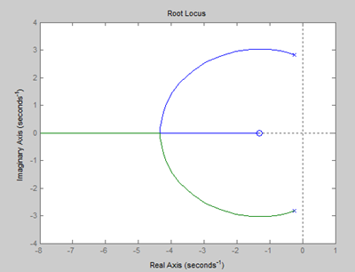

Figure XX Root Locus at 5 m/s

Since the Root Locus lies entirely in the left hand plane, our model suggests that the bike will be stable at 5 m/s. However, in order for the motorcycle to become balanced it must initially be stable as it approaches the critical velocity.