The Nitra A17020DP, a 1 1/16” pneumatic cylinder was chosen to actuate our Training Wheels. These cylinders can handle a pressure of 150PSI, a pressure well within our design specs. Our final design actuation is shown below.

(below are the images for you and how I would like them laid out: )

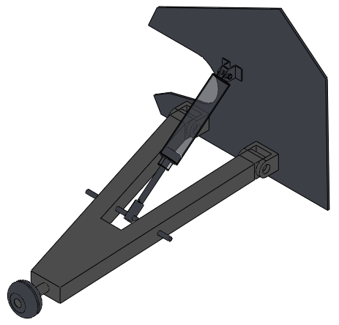

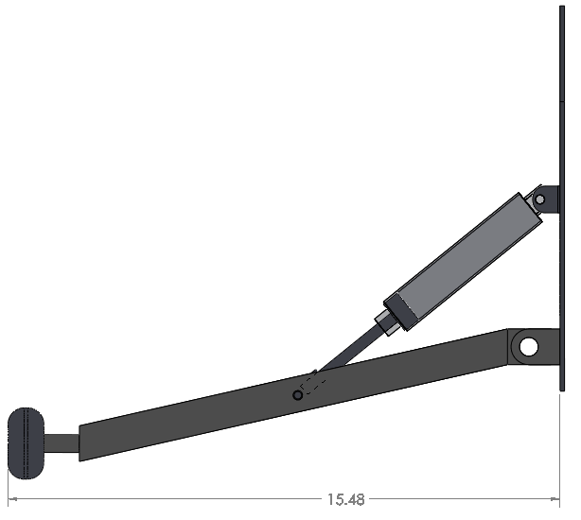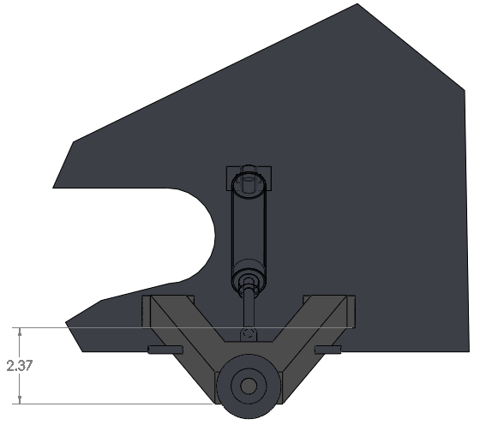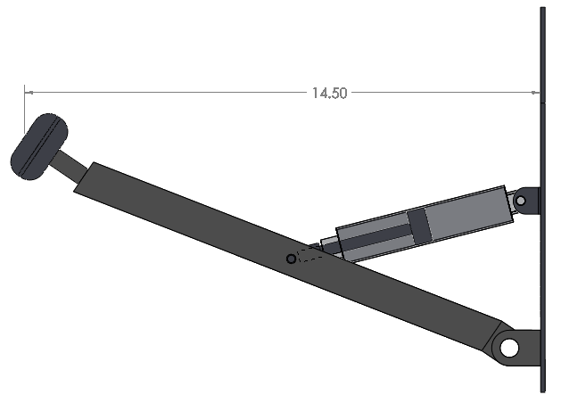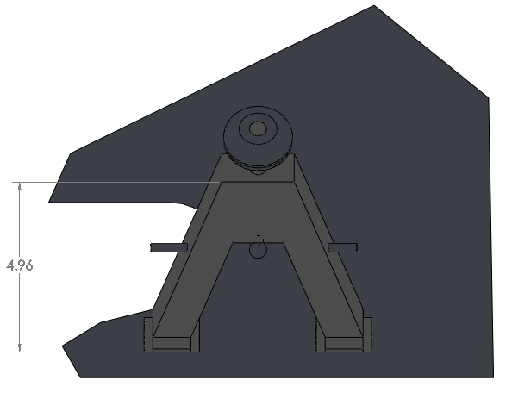

From the free body diagram of the bike with a 2° tilt yields a force in the cylinder of 17lbs. Since:

$$P*A=F*FS$$

$$P=\frac{F*FS}{A}$$

Assuming a FS of 2, we can calculate the pressure required of the cylinder:

$$P=\frac{23lbs*2}{\frac{π*{(1.0625)}^{2}}{4}}≅40psi$$

The pressure vessel used to hold the compressed air has an internal volume of 14.4 cu inches. We will compress this to 140psi. The pressure is then regulated down to 40psi. Since the mass of the system will be conserved:

$$m_{vessel}=ρ*V=\frac{P}{R_{Specific}*T}*V=2.17*{10}^{-3}kg$$

Likewise for both cylinders:

$$m_{cylinders}=ρ*2V=2*\frac{P}{R_{Specific}*T}*V=1.874*{10}^{-4}kg$$

On a mass basis, we will get the following amount of cycles per fully compressed cylinder:

$$\frac{m_{vessel}}{m_{cylinders}}=\frac{2.17*{10}^{-3}kg}{1.874*{10}^{-4}kg}≅11actuations$$