33. A chamber contains a mixture of 2 kg of oxygen and 2 kmol of hydrogen. (a) Determine the average molar mass of the mixture in kg/kmol. (b) If the specific volume of the mixture is 2 m³/kg, determine the volume of the chamber in m³.
(2.9, 11.9) 10+10
Schematic is yet to be uploaded...

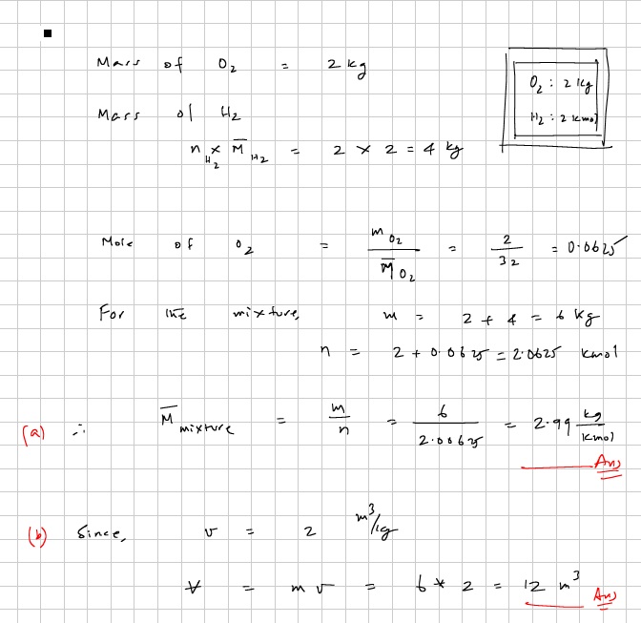

34. The nutrition label on a granola bar, which costs $1.00, reads - Serving size 42 g; Calories Per Serving 180 . Determine (a) the heating value in MJ/kg, and (b) price in cents per MJ of heat release. (c) If gasoline with a heating value of 44 MJ/kg and a density of 750 kg/m³ costs $2.50 a gallon, what is the gasoline price in cents/MJ?
(18, 132, 2) 10+5+10
Schematic is yet to be uploaded...

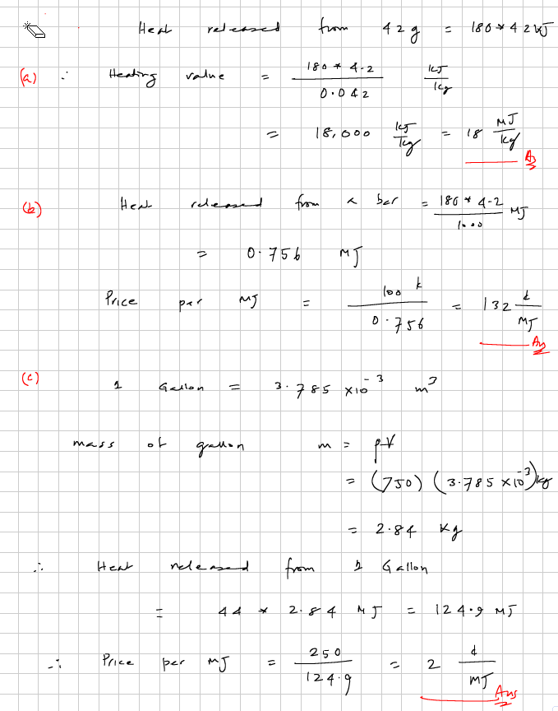

35. (a) What is a system with no mass transfer called?
(b) What is a system with no heat transfer called?
(c) What is a system with no mass or energy transfer called?
(closed, adiabatic, isolated) 10+10+10
Schematic:

Solution:

36. A rigid chamber contains 100 kg of water at 500 kPa, 100ºC. A paddle wheel stirs the water at 1000 rpm with a torque of 100 N.m. while an internal electrical resistance heater heats the water, consuming 10 amps of current at 110 Volts. Because of thin insulation, the chamber loses heat to the surroundings at 27ºC at a rate of 1.2 kW. Determine
(a) the rate of shaft work transfer in kW,
(b) the electrical work transfer in kJ in 10 s,
(c) what must be the the rate of heat transfer in kW so that the system does not receive or lose any net energy?
(You must include sign).
(-10.47, -11, -11.57) 10+10+20
Schematic:
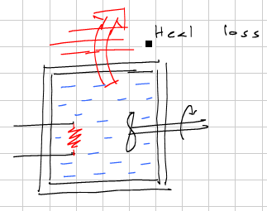

[Sample Solution] Solution to the Question is.........

37. An insulated piston-cylinder device contains steam at 300 kPa, 200 deg-C, occupying a volume of 1 m³, and having a specific volume of 0.716 m³/kg. It is heated by an internal electrical heater until the volume of steam doubles due to an increase in temperature.
(a) Determine the final specific volume of steam in m³/kg.
(b) If the diameter of the piston is 20 cm and the outside pressure is 100 kPa, determine the mass of the weight placed on the piston to maintain a 300 kPa internal pressure.
(c) Calculate the boundary work (magnitude only) done by the steam in kJ.
(d) Calculate the amount of work (magnitude only) transferred into the weight in kJ.
(e) If you are asked to choose one of the three values - 1300 kJ, 300 kJ, 200 kJ - as your guess for the magnitude of the electrical work transfer, which one will you pick? (enter magnitude only).
(1.432, 640.5, 300, 200, 1300) 10+20+20+15+15
Schematic:
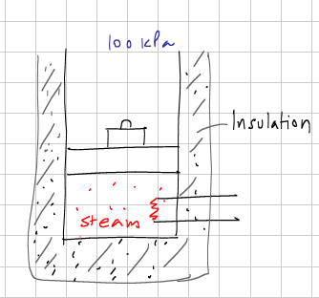

Solution:

38. Betz law states that only 53% of the kinetic energy transported by wind can be converted to shaft work by a perfect wind turbine. For a 50 m diameter turbine in a 20 mph wind, determine (a) the mass flow rate of air (in kg/s) intercepted by the turbine? (b) the specific kinetic energy of the flow (in kJ/kg), (c) the rate of transport of kinetic energy (kW), and (d) the maximum possible shaft power? Assume density of air as 1.1 kg/m³. (1 mph = 0.447 m/s).
(19000, 0.03, 700, 360) 10+5+10+5
Schematic is yet to be uploaded...

[Sample Solution] Solution to the Question is.........
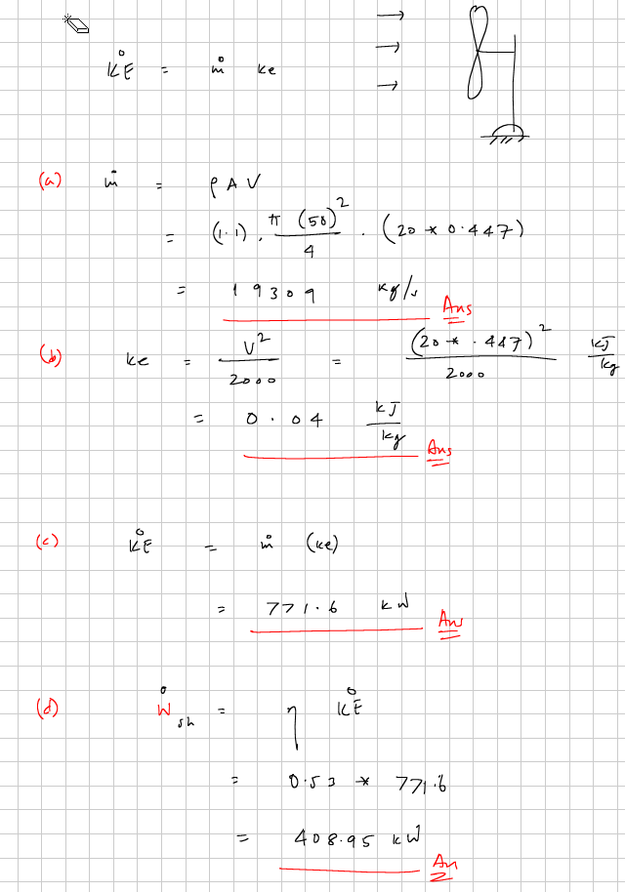

39. A closed system interacts with its surroundings and the following data are supplied: Wdot_sh= -10 kW, Wdot_el = 5 kW, Qdot = -5 kW. If there are no other interactions, determine dE/dt.
(0 kW) 15
Schematic is yet to be uploaded...

[Sample Solution] Solution to the Question is.........

40. A gas trapped in a piston-cylinder device is heated as shown in figure. The load on the massless piston of area 0.2 m² is such that the initial pressure of the gas is 200 kPa while the outside pressure is 100 kPa. Also, the initial temperature is 300 K. When the temperature of the gas reaches 600 K, the piston velocity is measured as 0.5 m/s and dE/dt is measured as 30 kW. At that instant, determine (a) the rate of boundary work transfer, (b) the rate of external work transfer, (c)the rate of heat transfer, and (d) the load (in kg) mass on the piston. Assume the ambient atmospheric pressure to be 100 kPa. (e) What type of system is this?
(20 kW, 20 kW, 50 kW, 2039, unsteady) 15+5+10+10+10(-10)
Schematic is yet to be uploaded...

States {
State-1: Air;
Given: { p1= 200.0 kPa; T1= 600.0 K; Vel1= 0.0 m/s; z1= 0.0 m; m1= 1.0 kg; }
State-2: Air;
Given: { p2= "p1" kPa; Vel2= 0.0 m/s; z2= 0.0 m; m2= "m1" kg; Vol2= "Vol1+.1" m^3; }
}

41. A rigid cylindrical tank stores 100 kg of a substance at 500 kPa and 500 K while the outside temperature is 300 K. A paddle wheel stirs the system transferring shaft work at a rate of 0.5 kW. At the same time an internal electrical resistance heater transfers electricity at the rate of 1 kW. (a) Do an energy analysis to determine the rate of heat transfer Qdot in kW for the tank. (b) Determine the absolute value of the rate at which entropy leaves the internal system (see attached diagram). (c) Determine the rate of entropy generation for the system's universe.
(-1.5, 0.003, 0.005) 10+10+15
Schematic is yet to be uploaded...

Type in solution here...

42. A horizontal piston-cylinder device contains air at 90 kPa while the outside pressure is 100 kPa. This is made possible by pulling the piston with a hanging weight through a string and pulley arrangement. If the piston has a diameter of 20 cm, (a) determine the mass of the hanging weight in kg. (b) The gas is now heated using an electrical heater and the piston moves out by a distance of 20 cm. Determine the boundary work in kJ. (c) What fraction of the boundary work performed by the gas goes into the hanging weight?
(32, +0.565, 0%) 10(-5)+15+10(-5)
Schematic is yet to be uploaded...

[Sample Solution] Solution to the Question is.........

43. Steam flows into a steady adiabatic turbine at 10 MPa, 600°C and leaves at 58 kPa and 90% quality. The mass flow rate is 9 kg/s. Additional properties at the exit that are known are: A = 1.143 m², v = 2.54 m³/kg, u = 2275.2 kJ/kg, e= 2275.4 kJ/kg, h=2422.4 kJ/kg. If the turbine produces 1203 kW of shaft power, determine at the exit (a) the velocity in m/s. (b) the rate of flow of kinetic energy, (c) the rate of transfer of stored energy, and (d) the rate of transfer of flow energy. Neglect potential energy.
(20, 1.8 kW, 20.48 MW, 21.80 MW) 10+10+10+10
Schematic is yet to be uploaded...

Type in solution here...

